LEAP Review Tools
  - How the process works, and how to use it
3 August 2026

What this is
Two LEAP review tools — the Common ESTO dashboard and the balance-review workbook — can now be run in two different ways by two different kinds of user, from the same code.
Developer mode is for the maintainer. It runs directly against the live leap_initialisation, leap_mappings, and leap_dashboard working copies. A fix made in any of those repositories takes effect on the very next run, with no build step.
Portable release mode is for a colleague. It is a versioned Windows folder built from an exact, tested set of repository commits. The colleague needs no Python, no Conda, no Git, and none of the three repositories — they unzip a folder and run an executable.
The important design property is that these are not two programs. They are one program with two ways of finding its own parts.
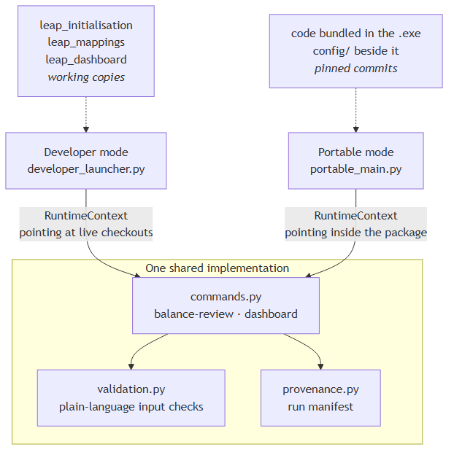
Because both modes call the same commands.py, they cannot drift apart in behaviour. The only thing that differs is a small object called the RuntimeContext, which answers four questions for a run: where the code is, where the configuration is, where outputs go, and what provenance to record.

The two tools, and what they actually need
This is the part most worth understanding before using either tool, because the inputs are not what people usually assume.

The balance-review workbook
The workbook’s entire content is a comparison between what LEAP produced and what the source data says. That comparison is not in the LEAP export — it is computed by a separate balance diagnostics step, which reads the export alongside the mapping codebook and the ESTO and 9th-edition source tables.
A fresh LEAP export is enough to produce a workbook. Getting there is two steps, not one, and only the second is in the portable release.
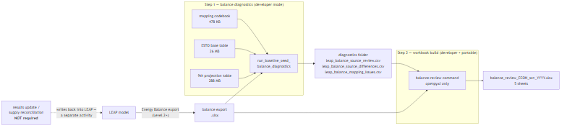
_PRESET_REVIEW_ONLY in balance_update_workflow.py runs both steps in one call, with the results update switched off. So in developer mode a new export goes straight to a workbook.
A results update / supply reconciliation run is not required. That workflow writes values back into LEAP and is a separate, optional activity; producing a review workbook does not involve it.
The portable release ships step 2 only, and the reason is data size: step 1 reads 314 MB of source tables, which would take the download from roughly 110 MB to roughly 450 MB. Step 1 is otherwise read-only with no LEAP COM dependency at run time, so including it is a size decision rather than a technical blocker.
The workbook that comes out has five sheets:
Sheet | What it shows
LEAP Values | the balance exactly as LEAP produced it, converted to PJ
LEAP - Source Error | LEAP minus source, red where they disagree
Correct Source Values | what the source says the value should be
Full Expected Source | the same, with structurally absent cells greyed
Missing Combinations | every comparison that could not be made, and why

The Common ESTO dashboard
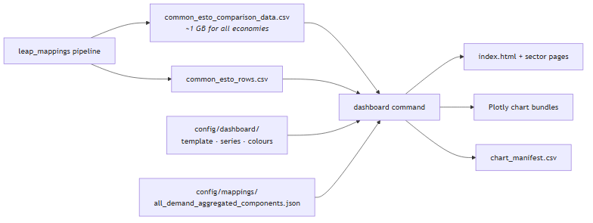
The comparison file is close to a gigabyte for the full economy set, so it is a run input, not part of the package. Validation streams it row by row rather than loading it, so asking for an economy it does not contain is reported in seconds rather than after a long load.
Three dashboard pages are deliberately not in the portable release — the mapping-diagnostics page, the full mapping tree explorer, and the capacity-unmet convergence page. Each reads leap_mappings or leap_initialisation artifacts that a package does not carry. Use the full workflow script for those.

What happens during a run
Every run of either tool, in either mode, follows the same sequence. The validation step comes first and completely: a colleague finds out that a file is missing, is the wrong kind of file, or does not cover the economy they asked for before anything slow starts.
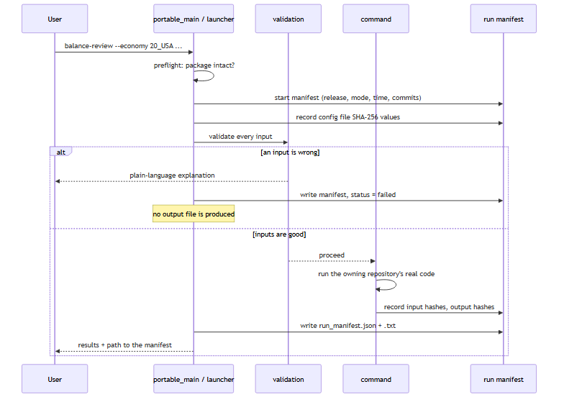

The run manifest
Every run writes a dated folder containing its results, run_manifest.json, run_manifest.txt, and validation_report.txt. The manifest answers the questions someone asks weeks later:
- which release version and which mode;
- when it ran;
- which input files, with size and SHA-256 — so “was it the file I think it was?” has an answer;
- which mapping and configuration files were in force, by SHA-256;
- which repository commits the code came from;
- in developer mode, whether each working tree was dirty — a dirty tree means the run used code that is in no commit and cannot be reproduced.

The support bundle
Adding --support-bundle produces a ZIP containing the run manifest, the validation report, the effective settings, and the logs. It deliberately contains no input data — it is meant to be emailed, and the manifest already records each input’s identity by hash.

Using developer mode

One-time setup
Developer mode reads exactly one settings file, and nothing is inferred from the current working directory. That means the launcher behaves identically from a notebook, a terminal, or an IDE run configuration.
"C:/Users/Work/miniconda3/python.exe" -c "import sys; sys.path.insert(0,'.'); from codebase.portable_release.settings import write_example_settings; print(write_example_settings())"
This writes %LOCALAPPDATA%\leap-review-tools\developer_settings.toml, pre-filled with the repositories it can detect. Edit the paths if needed. The file lives outside the repositories on purpose: it holds machine-specific absolute paths that must not be committed.

Check before you run
from codebase.portable_release import developer_launcher as dev
dev.print_status()
This prints the resolved repositories, the configuration files it will read, the output folders, a preflight result for every required location, and each repository’s commit and dirty state.

Run a tool
result = dev.run_balance_review(
economy="20_USA",
scenario="Target",
year=2022,
balance_export_workbook=r"...\20_USA\TGT 0308.xlsx",
diagnostics_directory=r"...\results_update_preview_20260803_usa_tgt",
)
result = dev.run_dashboard(
economy="20_USA",
comparison_data_path=r"...\common_esto\common_esto_comparison_data.csv",
common_rows_path=r"...\common_esto\common_esto_rows.csv",
)
developer_launcher.py also has a #%% notebook block at the bottom: set RUN_DEVELOPER_LAUNCHER = True, choose DEVELOPER_ACTION, fill in the constants, and run the cell.

Updating the repositories safely
Nothing pulls silently. Plain git pull in each checkout remains perfectly good; if you would rather drive it from the launcher:
dev.plan_repository_update() # shows what it would do, fetches nothing
dev.update_repositories() # prints the plan, still pulls nothing
dev.update_repositories(confirm=True) # fast-forwards, skipping dirty repos
It refuses any repository with uncommitted changes and any branch with no upstream, and only ever runs git pull --ff-only.

Using a portable release
Extract the folder anywhere and run the executable. There is no installer.
leap-review-tools-0.1.0/
leap-review-tools.exe the program
_internal/ its bundled Python runtime — do not edit
config/ approved mapping and template files — editable
input/ put your input files here
output/ one dated folder per run
logs/ run logs
licenses/ third-party licence texts
README.md
release_manifest.json exactly which commits this was built from
Double-click the executable for a guided flow that lists the commands, explains each input, and asks for them one at a time. Or drive it from a terminal:
leap-review-tools.exe info
leap-review-tools.exe selfcheck
leap-review-tools.exe balance-review --economy 20_USA --scenario Target --year 2022 --balance-export-workbook "input\TGT 0308.xlsx" --diagnostics-directory "input\usa_tgt_diagnostics"
leap-review-tools.exe dashboard --economy 20_USA --comparison-data-path "input\common_esto_comparison_data.csv" --common-rows-path "input\common_esto_rows.csv"
selfcheck imports everything a run needs, confirms each standard-library module it relies on is the real one, and checks that every configuration file and package folder is present. Run it first if anything looks wrong — it is also what the builder runs against a freshly frozen executable before accepting it.

Windows prerequisites
- Excel is not required. The workbook is written with openpyxl and the dashboard is HTML and JavaScript. Excel is only needed to open the resulting workbook, which recalculates its formulas on first open.
- SmartScreen. The executable is not code-signed, so Windows shows “Windows protected your PC” on first run. Choose More info → Run anyway, or have an administrator whitelist it.
- Antivirus. PyInstaller builds are occasionally flagged by heuristic scanners. Distribute as a ZIP from a trusted internal location.
- Path length. Extract somewhere short, such as C:\Tools\leap-review-tools-0.1.0, rather than deep inside a OneDrive tree.

Changing mappings and settings without rebuilding
This is the part that saves the most time in practice.
Everything under a release’s config/ folder is read at start-up, and its SHA-256 is recorded in every run manifest.
File | Role
config/dashboard/common_esto_dashboard_template.json | page rules, chart generation, sign semantics
config/dashboard/series_config.json | series labels, visible-series rules, economy list
config/dashboard/code_colors.json | per-axis ESTO code colours
config/mappings/all_demand_aggregated_components.json | which demand sectors have no separately modelled LEAP detail
Replacing one of these with an approved newer version changes the next run’s behaviour immediately, with no rebuild — and the change is never invisible, because the new hash appears in that run’s manifest.
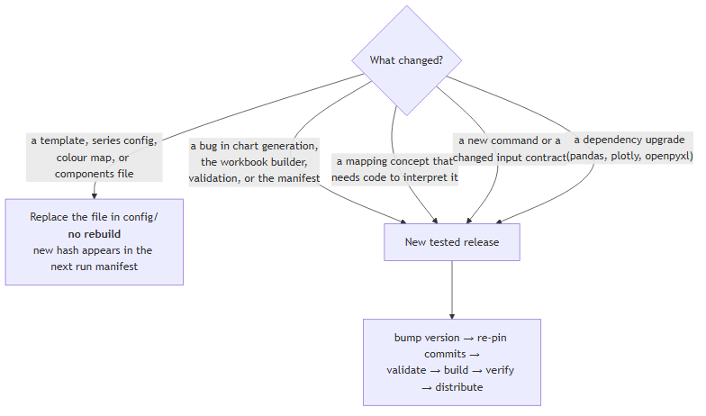
The canonical mapping workbooks themselves are never embedded in the executable and are not edited by any of this. Update them in leap_mappings as normal.
One detail worth knowing: developer mode reads these files from the live checkouts (CRLF line endings on Windows) while a release reads them from Git blobs (LF). The same logical file therefore has a different SHA-256 in the two modes. That is expected — the hash identifies the bytes actually read.

How a release is built
The release contract is a single reviewed file, config/portable_release_manifest.toml. It declares the semantic version, the exact 40-character commit of every participating repository, every source path that may be copied, every external configuration asset, the supported commands and their input/output contracts, and the runtime packages.
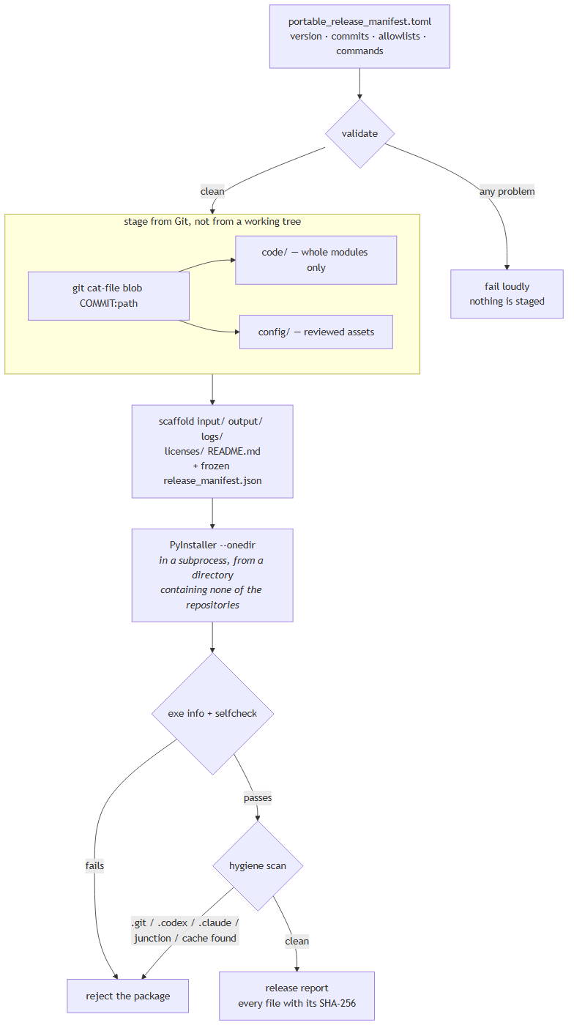
Two properties are worth calling out because they were learned the hard way.
Everything is read out of Git at the pinned commit. The builder never checks out, resets, stashes, or otherwise touches a working tree, so uncommitted work-in-progress cannot reach a colleague’s copy — and a release is reproducible from the manifest alone.
PyInstaller runs in a subprocess, from a directory containing none of the repositories. PyInstaller resolves imports through the build process’s own import environment as well as the spec. Running it in-process from a checkout silently baked the maintainer’s live codebase package into the executable, which then failed at start-up on a machine with no LEAP COM API. Isolation fixes this; the selfcheck step catches it if it ever recurs.

Validation is strict on purpose
The manifest validator rejects a release before anything is staged if:
- a commit is abbreviated rather than a full 40-character SHA;
- a referenced commit or file does not exist;
- a path escapes a repository root, or sits under a private, generated, or cache directory (.git, .codex, .claude, node_modules, outputs, data, …);
- a source allowlist entry is not a whole Python module — configuration and templates must go in config_assets so they stay replaceable;
- a configuration asset is over 8 MB, which almost always means generated data has been allowlisted by mistake;
- a declared command has no implementation.

Release and rollback
Rolling back is simply rebuilding an older manifest:
git show <commit>:config/portable_release_manifest.toml > rollback.toml
then build_release.build("rollback.toml"). Because every commit is pinned, the rebuild is identical in source content regardless of what the repositories look like now. To identify what a colleague is running, read release_manifest.json in their package folder.
Do not overwrite a released version number with different content — bump the patch version instead, so a run manifest always identifies exactly one build.

Known limitations
- The balance-diagnostics step is developer-mode only, for size reasons. A release builds a workbook from an existing diagnostics folder; it does not generate one from a LEAP export, because that needs 314 MB of source tables. A reconciliation run is not required for either.
- Three dashboard pages are not in the release — mapping diagnostics, the full mapping tree explorer, and capacity-unmet convergence. They read leap_mappings and leap_initialisation artifacts a package does not carry.
- No upstream data refresh. The release renders from the comparison data it is given; it never recomputes it.
- Sheet-image previews are unavailable. The Python workbook builder writes XLSX and verifies it structurally, but does not render sheet images. This is the one capability the earlier Node-based builder had that is not replaced.
- A full dashboard render takes a few minutes per economy, dominated by writing Plotly chart bundles.
- The executable is not code-signed — see SmartScreen, above.

Codex-only functionality
There is none left in the supported commands, and this was checked rather than assumed. The balance-review workbook builder was migrated off @oai/artifact-tool and Node.js to pure Python and openpyxl; leap_mappings migrated its own workbook builders the same way. The only casualty of that migration is preview rendering, above.
What was verified: the release’s declared dependency closure contains no Node.js package and no Codex-managed component; the built package contains a Python runtime and nothing else executable; and both supported commands run from the frozen executable, whose bundle has no Node.js in it.

Where things live
What | Where
Launcher, builder, runtime, validation, provenance, portable entry point | leap_initialisation/codebase/portable_release/
Release contract | leap_initialisation/config/portable_release_manifest.toml
Developer settings example | leap_initialisation/config/leap_review_tools_settings.example.toml
Full reference documentation | leap_initialisation/docs/leap_review_tools.md
Packageable dashboard render entry point | leap_dashboard/codebase/common_esto_dashboard_portable.py
Module and config a release consumes from mappings | leap_mappings/codebase/mapping_tools/source_branch_preflight.py, leap_mappings/config/all_demand_aggregated_components.json
Generated staging, build, and package trees (git-ignored) | leap_initialisation/release_build/

Tests
"C:/Users/Work/miniconda3/python.exe" -m pytest tests/test_portable_release.py tests/test_portable_release_golden_balance_review.py tests/test_portable_release_package.py -q
Test module | What it defends
test_portable_release.py | manifest parsing and validation, path safety, developer settings, run manifest, runtime context, input validation messages
test_portable_release_golden_balance_review.py | the USA 2022 golden case: structural contract, selected core values, exact reproduction of the historical reference workbook, and that no source input was modified
test_portable_release_package.py | a staged package: layout, no private or generated content, no imports from the live repositories, a real run’s outputs and manifest, config-edit detection, invalid-input behaviour
The golden and package tests skip cleanly on a machine without the large local inputs, which are not tracked in Git.
In leap_dashboard:
"C:/Users/Work/miniconda3/python.exe" -m pytest tests/test_common_esto_dashboard_portable.py -q

