## Osemosys cloud allows us to run the solving process on the cloud easily and quickly.

Since the whole file will run you will have to run main.py twice. Once to get the input data for Osemosys cloud, and once to extract that data to a results csv/xlsx. Don’t worry, you can run the whole file as it will stop you during the process by asking you if you’ve put the zip files into the tmp directory. If you say ‘n’ then it will just prepare the inputs for you to input into osemosys-cloud.com. If you say ‘y’ then it will just extract the data from the zip file and produce the results. MAGIC!

## Instructions for using osemosys-cloud.com:

1. You need to set up an account on <osemosys-cloud.com>
2. A picture containing shape

   Description automatically generated
3. Create New model. Then press it’s name.
4. Graphical user interface

   Description automatically generated with medium confidence
5. Create New version. Then press it’s name
6. 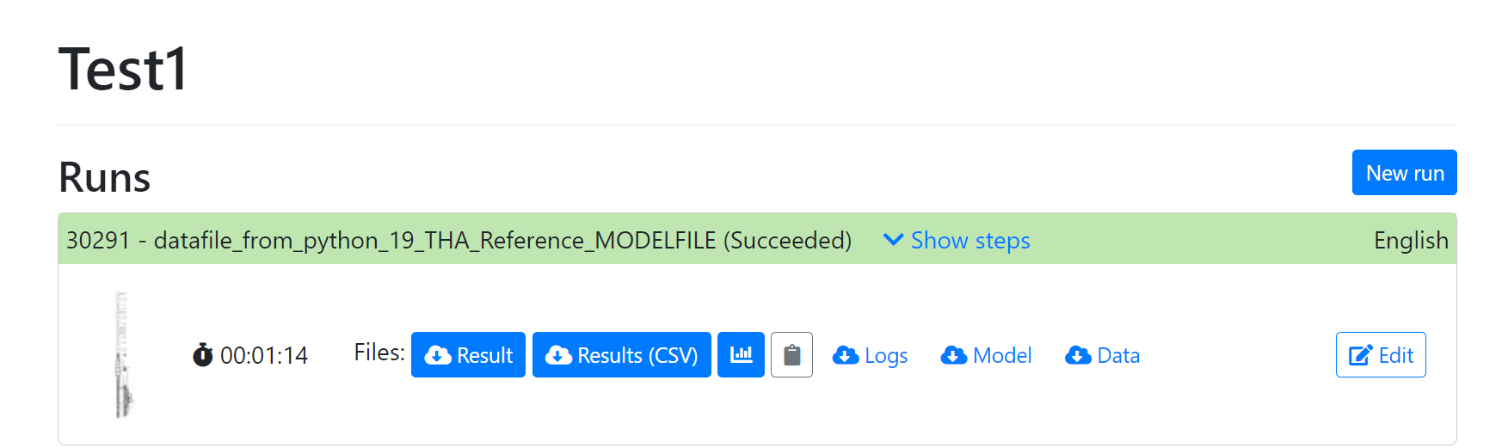
7. Create New run. This will be a bit more complicated:
   1. For **model file** use the config/osemosys_fast.txt file. These are the instructions for how the server should solve the model.
      1. This file can be recognized as it says ‘# OSeMOSYS FAST‘ at the top line.
   2. For **data file** use the *path_to_input_data_file = {tmp_directory}/datafile_from_python_{economy}_{scenario}.txt* file that is produced from the function *prepare_data_for_osemosys().*
      1. Eg. *power-model\tmp\19_THA\cloud_Reference\datafile_from_python_19_THA_Reference.txt*
      2. This file can be recognized as it says ‘# Model file written by *otoole*’ at the first line of the .txt file.
   3. Set the rest of the details to what you like. I suggest filling in the Details text box with the details from the model_run_specs.txt file.
8. Once the process has run you should pressA picture containing graphical user interface

   Description automatically generated to get a zip file of the results. Then put it in the tmp_directory folder.
   1. tmp_directory folder should be named like \power-model\tmp\{economy} \cloud_{scenario}
      1. eg. \power-model\tmp\19_THA\cloud_Reference
9. Run the main.py file again

# Why use osemosys cloud?

Because glpsol is slow, as. And coin-cbc quite often doesn’t work with Windows, based on if your organization has some weird stuff going on with how they set up your computer for you!

Osemosys cloud is generally the more clicky option but it still works. Also, since you can only input the model.txt file and data.txt file , you may find you cannot customize the model how you’d like. But if you are interested the code for the server can be found here: https://github.com/ClimateCompatibleGrowth/osemosys-cloud