I implemented the algorithm of Graph printing. As an input the data set from file graph_printing.csv is given. The columns contain the following informations: time, srcIp, protocol, dstIp, sPort, dPort, toBytes.

First of all i build the graphlet H(directed, weighted multigraph with coloured edges) for different time windows. I suppose that each of them lasts 29s, therefor it will give the time windows as follow: 0-29,30-59, 60-89 etc. Here we have the edges of example graphlet H fo the time window of 0-29s: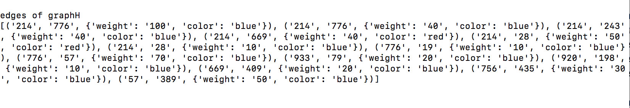

After, i transform graphlet H into graphlet G which is directed, unweighted graph with coloured edges. Here is the example of the graphlet G for the time window of 0-29s:

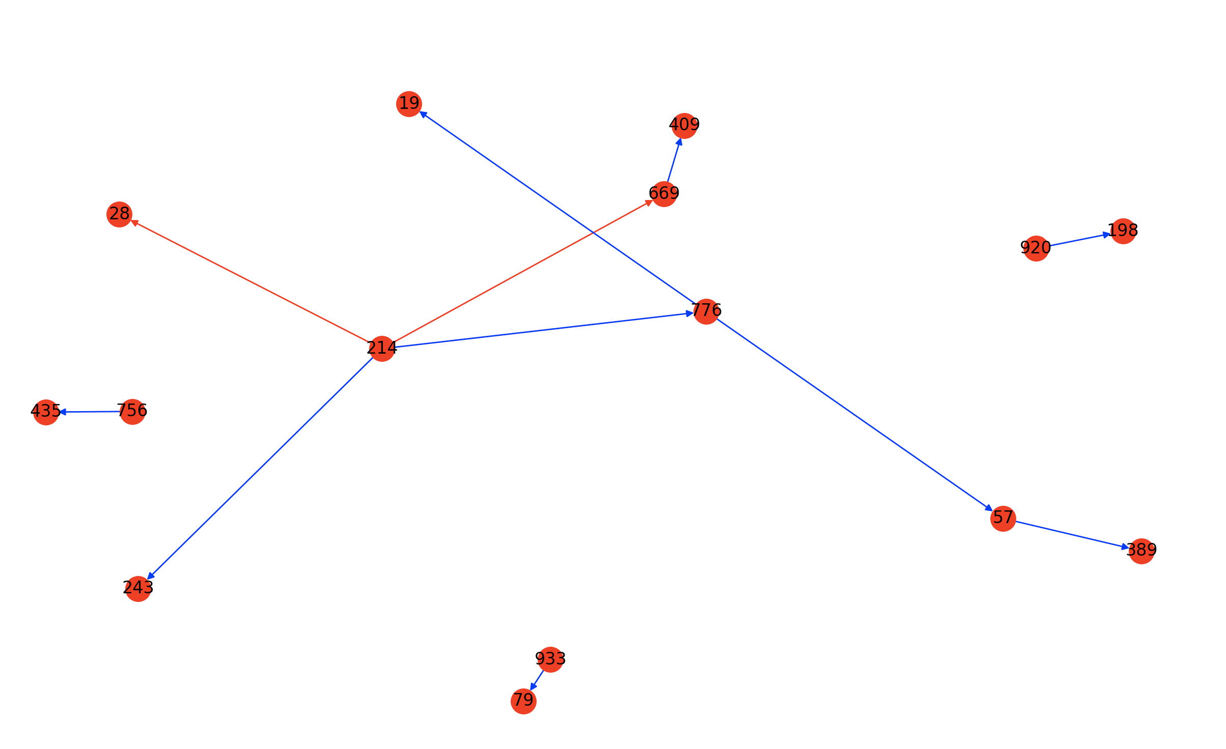

Once we, have got this we can pass to graphlet and orbit counting. I implemented graphlet counting only for following subgraphs:

-1 path :

* 2 path :
* 4 star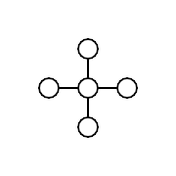

I obtained those results for the graphlet G in time window 0-29s: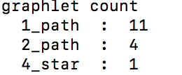

Then, for orbit counting i implemented following subgraphs: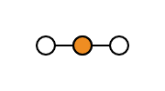

* interior

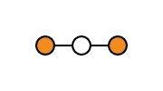

* terminal

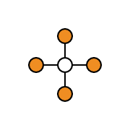

* 4 star leaf

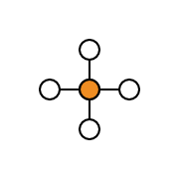

- 4 star center

And those are the results of orbit counting for graphlet G in time window 0-29s

