************How Webpage works *********************

- internet global network of computers and devices
- each has IP address assigned by internet provider 73.158.6.61
- private local IP address router has a public IP
- computers talk with eachother using the TCP/IP protocol
- HTTP handles web traffic (requests/responses)
application layer protocol
browser and server
one of more FTP, SMTP,

Websides files stored on computers that run a piece of software called a web server (Apache, Nginx)

Hosting companies provide space on a server for your websa you can have yur own computer but it is expensive get a server, shared hosting

domain name - can be purchased fro registrars and linked to your hosting account

DNS is used to map IP addresses to domain names

type address in web brownes DNS server maps isthe name with address and does the HTTP request to the server Server will send the response

OVERWHELMING
HTML CSS - building blocks
- HTML Hypertext Markup Language
- markup for creating webpages/documents
- visual
- IMPORTANT
- content
- compiled sure HTML markup

CSS Cascading Style Sheets
- stylesheet Language
- Visual style the contenct
- Variables, calculation
- Saas and Less extentions

HTML CSS - human body
language - brain

Build static websites: Portfolios, small business sites, informational & brochure websites ect
(no accounts)

Build the visual part of anything

****************** Tag Syntax **********************

ntag - ending tag
<br> line break no content self closing
<br /> XHTML not used anymore much

index.html - homepage. In host it will load a index.html as home

**************** Standart Valid HTML doc ************

1) DocType
<!DOCTYPE html> what kind of html doc it is = HTML5
2) html tag
3) head - meta information about the page
4) title - goes to tab

commenting
<!-- This is the format of the comment -->

ctrl + / - commenting our automtically works like toggle

LiveServer -autoreload

basic htm structure in atom: html + Enter

**************** ATOM LIFE SERVER *******************************

ctrl-alt-l launch live server on port 3000.

ctrl-alt-q stop live server.

ctrl-alt-3 launch live server on port 3000.

ctrl-alt-4 launch live server on port 4000.

ctrl-alt-5 launch live server on port 5000.

ctrl-alt-8 launch live server on port 8000.

ctrl-alt-9 launch live server on port 9000.

<meta charset="UTF-8">
<meta name="viewport" content="width=device-width, inicial-scale=1.0">
- important for responsive websites

************** META tags and Search engines *********

not in the body
charset = def "UTF-8"
viewport tag - responsive to different dashboard_queriessizes
content "width=device-width, initial-scale-1.0"
http-equiv - to make it workig in IE
0.3% uses edge hahahahaha

title will be showed in google searcher

Good title example:
Miami Website Design Company | Digital Agency | Fuze

<meta name ="description" content=""> what will show up in google description

<meta name="robots" content="NOINDEX, NOFOLLOW"> - if this meta is present the page wont be indexed in the search engine

***************** Headings Paragraphs, Topography******
ctrl + Enter : going to new line wvwn if you are in the middle of the word.

1) one h1 per page
blog post h1

write down lorem (the lorem latin text will show up!!!!)

lorem500

<strong> - by default but with css you can change the stylig
- semantic should stand out

<em> - italics
<br>
<del> strike through (styling in css)

<a href="#"></a> -any a needs a href
target="_blank" - opens the link in the new tab

ctrl + arrow lefr right go to the beggining and the end of a world

cursor in line + arrow up and down move the line up and down arround

<img src="" alt=""> - source and alternative text

<li>Item 1</li>
<ol type="A">
<li>Item 1</li>
<li>Item 2</li>
<li>Item 3</li>
<li>Item 4</li>
</ol>

type A, I i, a, 1

Tables were used to table layout 10 years ago
tables serves for tabular data

Thanks to hoisting variables are set to udefined in the creation process

*************** FORMS Inputs ************************

submit a form
this happens in the backend
serverside programming languages process the form

<form class="" action="index.html" method="post">

action - the file with php for example

name used on the server side

no label tags necesarry in radio just write it after

placeholder
<input type="email" name="email" id="email" value="" placeholder="Enter an email">

ctrl + d
choose the next matching word

************** Block and Inline elements************

levels

tags element

W3Schools

Block level elements in HTML:
<address>
<article>
<aside>
<blockquote>
<canvas>
<dd>
<div>
<dl>
<dt>
<fieldset>
<figcaption>
<figure>
<footer>
<form>
<h1>-<h6>
<header>
<hr>
<li>
<main>
<nav>
<noscript>
<ol>
<p>
<pre>
<section>
<table>
<tfoot>
<ul>
<video>

Inline elements in HTML:
<a>
<abbr>
<acronym>
<b>
<bdo>
<big>
<br>
<button>
<cite>
<code>
<dfn>
<em>
<i>
<img>
<input>
<kbd>
<label>
<map>
<object>
<output>
<q>
<samp>
<script>
<select>
<small>
<span>
<strong>
<sub>
<sup>
<textarea>
<time>
<tt>
<var>

Difference:
block level element will go across the whole page next element will go to the next line.

inline take up a space defined next element will go just after it

****************** Divs and Spans *********************
09_id_class.html

class
can be repeated

id
idividual no repetitions

advice

div - pushes a next thing down vs span

semantic tag
header
nav
secction

******************8 HTML Entities *********************

****************** semantic tags ******************
helps people with disabilities
importants to use instead of divs

header - self explanatory
footer- self explanatory
nav - unordered list grabbed in nav
main - main content of the page
section -
article - blog post, article post can be inside the section
aside - side bar, ad, category section

11_html5_semantics.html

*************** CSS **********************************

*************** Implementing CSS *********************

<!-- Inline css -->
<h1 style="color: red"name="">Heading One</h1>
<h2>Heading Two</h2>
<h3>Heading Three</h3>
</body>

Internal Inside the file:
<style media="dashboard_queries">
h2{
color: green;
}
</style>

syntax

a{background-color: yellow;}

a selector
{ - declaration start
} - declaration end
background-color: - propery
yellow: value

/* */ - comments in CSS

external css

<link rel="stylesheet" href="css/style.css">

***************** Selectors *************************

h2#green-heading{
color: green;
}

****************** id selector ****************
#green-heading{
color: green;
}

.green-heading{
color: green;
}

naming conventions

/* Multiple selectors */
#welcome, #about, h2{
border: 1px solid #ccc;
padding: 10px;
margin-bottom: 5px;
}

*************** Dev tool in Chrome ***********************

Ctrl + Shift + I

Elements tab
- html + css

every browser has its default styling for elements. You can recognize it by 'user agent stylesheet'

**************** Fonts in CSS ***************************

Font family
web safe fonts.

Set font family in the body

if font family is not site safe we would need to include it in a file to our browser or access it remotely

sans-serif : flater looking
serif: more line times new rman traditional from book

Non standart fonts
fonts.google.com
ex roboto
link tag
or import into css - better.

<link href="https://fonts.googleapis.com/css2?family=Libre+Baskerville&display=swap" rel="stylesheet">

************** font size *******************************

defoult is 16px
space in between the line (in em)
line-height: 1.6em;

Absolute units:
cm Centimeters
mm Milimeters
in Inches
px Pixels(1px = 1/96th of 1in)
pt Points (1pt = 1/72 of 1in)
pc Picas pias(1pc = 12pt)

Relative Units:
% To parent element
em To font size of paret element multiplayer
rem To font size of root element (html by default 16px)
vw To 1% of viewport width
vh To 1% of viewport height

font-weight
font-style

#welcome p span{

}

technicaly the p is no needed but it is better to use it

************************* colors ***********************
By name
rgb(0,0,0) red green blue max for each is 255
all 255 white
all 0 black
hexadecimal
numbers 0-9 or and letters A-F
all 0 black
all f whites
six simbols

ff - red ff - green ff - blue
all the same we can cut by half
ex black #000000 = #000
ex dark grey #333333 = #333

color-hex.com
shades and tints of the colours
htmlcolorcodes

****************** BACKGROUNDS & BORDERS ***************

transparent files:
jpeg they can be transparent
png can be transparent

div is block so if we will set the background it will go across the page

#box-1{
background-color: coral;
}

Border has three properties:

#box-1{
border-width: 3px;
border-color: red;
border-style: solid;
}
style dotted dashed solid

or just border
border: 3px solid red;

rounding corners
you can choose which corners to round: border-top-left-radius: 10px;

image background
background-image: url('./img/stars.jpg')

#box-3{
background-image: url('./img/stars.jpg');
color: #fff;
height: 300px;
width: 600px
}

small images repeat to fill the whole page
background-repeat: no-repeat;

background-position: move the image aroung axis x and y
background-position: center center; moving the image around the background
show the whole image
background-size: cover;

using one property
size /cover (slash)

background: url('./img/stars.jpg') no-repeat center center/cover;

fixed backgrounget
bigger it will be cut
fixed when scrolling

browser has default marf=gin and padding
body has margin as well

css reset gets off all of the styling

*{
margin: 0;
padding: 0;
}

padding is added to the entire width of the thing

to prevent that we need to add a box-sizing property
box-sizing: border-box;

different values per site

everything down overights the up

padding-top: 10px;
padding-right: 20px;
padding-bottom: 10px;
padding-left: 20px;

the same properties

DESIGN and Ideas
Photoshop design from the designer
bootstrap themes

In case of the links the color should be added specifically

Custom selectors:
#navbar ul li a:hover,
#navbar ul li a.current {
background: #444;
color: #f7c08a;
}

notice that when specifying the class of anchor tag there is no space.

Nowaydays we want the bacgrounds of thing to gocross the whole paga in earli 2000 we had two white stripes (of some funny ones) at the sides. So we will use the container inside the tags where we have declarated thebackgrounds

.container {
margin:auto;
max-width: 1100px;
}

container utility class will be used in many ocasions
background-size: cover;

contain
Scales the image as large as possible without cropping or stretching the image.
cover
Scales the image as large as possible without stretching the image. If the proportions of the image differ from the element, it is cropped either vertically or horizontally so that no empty space remains.

give a section individual id
use dashes with more than one word

hidden classon the overflow property will cut the content when it is to long for the placeholder. div

Media Queries

/* Smartphones */
@media(max-width: 500px) {
body {
background: red;
}
}

@media only dashboard_queries and (max-width: 500px) {
body {
background: red;
}

media typs: dashboard_queries rint ect

my dashboard_queries has 1920 px

em rem units

em - multiplyier refers to the parent parent (or the element in some cases
if we will add a size to the actual elementthe padding will go acording to this one, not to the parents

- problem with nested elements

rem - root element (html)

font size and margin by dfault will be 1em

16 *1.7 = 18.72 for headings

it is good to set the root font size to 10px to facilitate
or 62.5% = 10px

asesibility and browser settings (in the browser you can set wery wide letters - changing the root element font sizes)

*****************View Port height and View port width**************************

whole area inside the browser
slice across, there will be always 100 of them

and viewport width also 100 viewports

body just wraps what t has in the content 100% is the whole content

you can put a color as background and then set the image on top

Small changes needed

FLEXBOX

aligning things easily
+css Grid

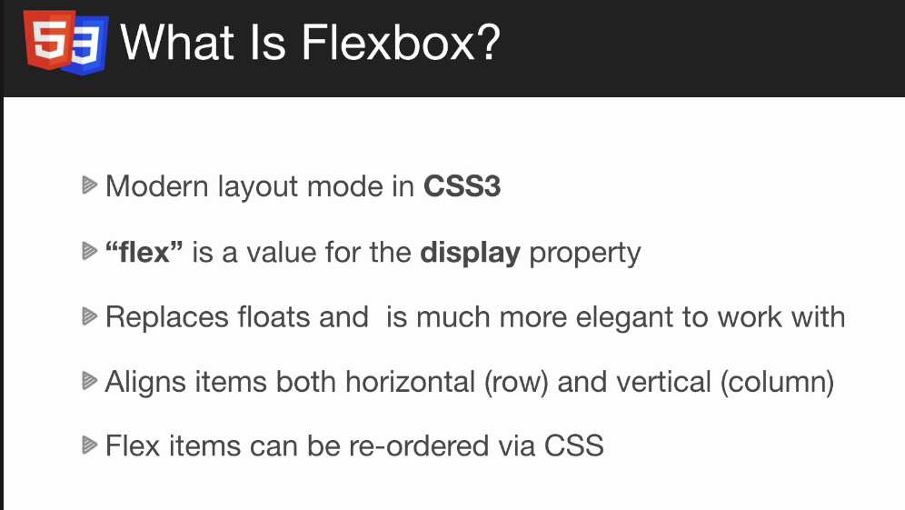

display: flex
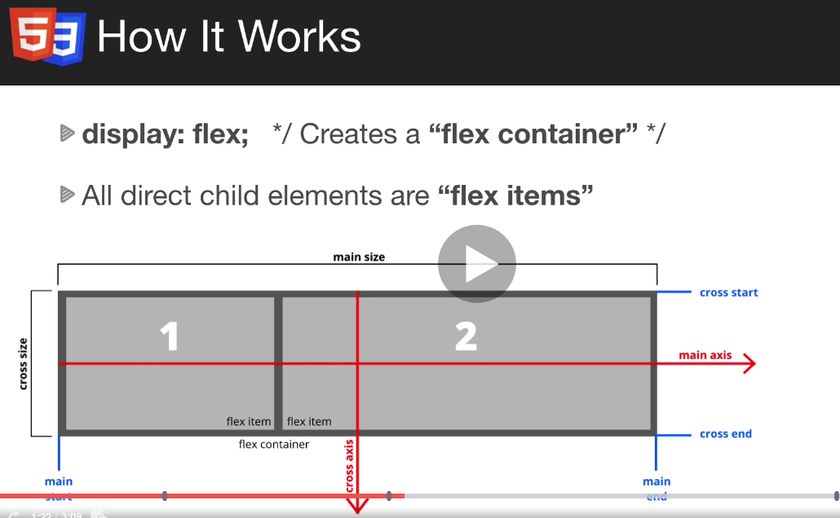

creates flex container
- all direct child elements will be a flex item
- align horizontaly

possible to align vertically
axes (cross and main

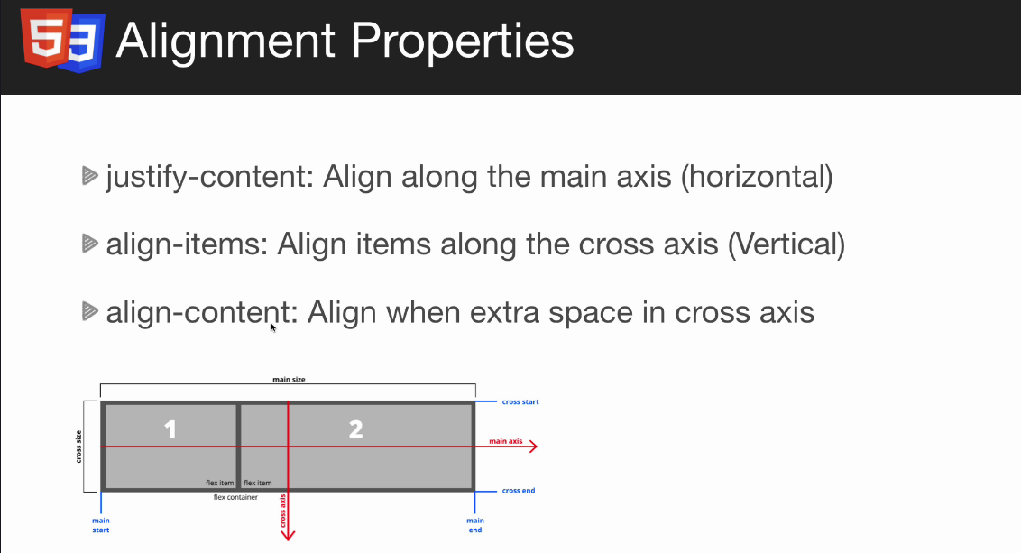

.flex-container {
display: flex;
flex-direction: column-reverse;

}

flex-direction
flex-wrap: wrap; - when shrinking at some pont the boxes will go to the next line

FLEX properties

.item-1 {
flex-shrink: 0;
}

when the size is change the item is not etting smaller.

.item-2 {
flex-grow: 1;
}

the item will take the remaining space. Can be set on the arent div (like that the iall the items will take all the space

flex basis : setting the width – specifies the initial size of the flex item

flex: 1 in the main div = flex grow 1

flex: 1 0 200px; grow,srink,basis

Aligment and justify properties of flexbox

align aligning on the crossaccess
- added in the div parent.

.flex-container {
background-color: #f4f4f4;
display: flex;
flex-direction: row;
align-items: center;
height: 50vh;

}

elements alligned on the crossaxis
flex-start
flex-end

aligning always on the cross axis (not main)

align-items: stretch (going throught the whole parent div)

justify-content
Main axis align

space-around = on the borders
between

aign-self on the element will overrride aligment

Questions:
General questions about the project:
- Who is the user/ Who are the users (access types)
- topview = dashboard (dashboard is what user sees first after opening the webapp) and dashboard list = reports? (charts set of data ect.)
- What are feeds

Edge Ledger – project

Hero image
favicon ico file
Overlay using sudo before.
Image is darker so that the letters are more visible.
.hero::before
- adding content before or after the element
.hero::before {
/* Content is needed lets leave it empty */
content: '';
/* In thehero we set position relative absolute, parent needs to be relative */
position: absolute;
top: 0;
left: 0;
width: 100%;
height: 100%;
/* a for thetransparency */
background: rgba(0,0,0,0.6);
}

And z-index on the text part because the overlay is before the text as well

.hero * {
/* The heigher the z-index is the closer to you on the dashboard_queries */
z-index: 10;
}


Three icons in a row centered

.flex-items {
display: flex;
text-align: center;
justify-content: center;
}
DIRECT CHILD DIV
.flex-items > div {

}
flex-basis -specifies the inititial size of flex item

flex: 1;
Specifies how a flex item will grow or shrink as to fit the space available in its flex container
object-fit: cover
- specifies how a replaced element like img or video should be resized to fit its container (cover – the picture wont be resized. )
Hover effect
.cases img:hover {
opacity: 0.7;
}
.flex-columns.flex-reverse {

}

