************How Webpage works *********************

- internet global network of computers and devices
- each has IP address assigned by internet provider 73.158.6.61
- private local IP address router has a public IP
- computers talk with eachother using the TCP/IP protocol
- HTTP handles web traffic (requests/responses)
application layer protocol
browser and server
one of more FTP, SMTP,

Websides files stored on computers that run a piece of software called a web server (Apache, Nginx)

Hosting companies provide space on a server for your websa you can have yur own computer but it is expensive get a server, shared hosting

domain name - can be purchased fro registrars and linked to your hosting account

DNS is used to map IP addresses to domain names

type address in web brownes DNS server maps isthe name with address and does the HTTP request to the server Server will send the response

OVERWHELMING
HTML CSS - building blocks
- HTML Hypertext Markup Language
- markup for creating webpages/documents
- visual
- IMPORTANT
- content
- compiled sure HTML markup

CSS Cascading Style Sheets
- stylesheet Language
- Visual style the contenct
- Variables, calculation
- Saas and Less extentions

HTML CSS - human body
language - brain

Build static websites: Portfolios, small business sites, informational & brochure websites ect
(no accounts)

Build the visual part of anything

****************** Tag Syntax **********************

ntag - ending tag
<br> line break no content self closing
<br /> XHTML not used anymore much

index.html - homepage. In host it will load a index.html as home

**************** Standart Valid HTML doc ************

1) DocType
<!DOCTYPE html> what kind of html doc it is = HTML5
2) html tag
3) head - meta information about the page
4) title - goes to tab

commenting
<!-- This is the format of the comment -->

ctrl + / - commenting our automtically works like toggle

LiveServer -autoreload

basic htm structure in atom: html + Enter

**************** ATOM LIFE SERVER *******************************

ctrl-alt-l launch live server on port 3000.

ctrl-alt-q stop live server.

ctrl-alt-3 launch live server on port 3000.

ctrl-alt-4 launch live server on port 4000.

ctrl-alt-5 launch live server on port 5000.

ctrl-alt-8 launch live server on port 8000.

ctrl-alt-9 launch live server on port 9000.

<meta charset="UTF-8">
<meta name="viewport" content="width=device-width, inicial-scale=1.0">
- important for responsive websites

************** META tags and Search engines *********

not in the body
charset = def "UTF-8"
viewport tag - responsive to different dashboard_queriessizes
content "width=device-width, initial-scale-1.0"
http-equiv - to make it workig in IE
0.3% uses edge hahahahaha

title will be showed in google searcher

Good title example:
Miami Website Design Company | Digital Agency | Fuze

<meta name ="description" content=""> what will show up in google description

<meta name="robots" content="NOINDEX, NOFOLLOW"> - if this meta is present the page wont be indexed in the search engine

***************** Headings Paragraphs, Topography******
ctrl + Enter : going to new line wvwn if you are in the middle of the word.

1) one h1 per page
blog post h1

write down lorem (the lorem latin text will show up!!!!)

lorem500

<strong> - by default but with css you can change the stylig
- semantic should stand out

<em> - italics
<br>
<del> strike through (styling in css)

<a href="#"></a> -any a needs a href
target="_blank" - opens the link in the new tab

ctrl + arrow lefr right go to the beggining and the end of a world

cursor in line + arrow up and down move the line up and down arround

<img src="" alt=""> - source and alternative text

<li>Item 1</li>
<ol type="A">
<li>Item 1</li>
<li>Item 2</li>
<li>Item 3</li>
<li>Item 4</li>
</ol>

type A, I i, a, 1

Tables were used to table layout 10 years ago
tables serves for tabular data

Thanks to hoisting variables are set to udefined in the creation process

*************** FORMS Inputs ************************

submit a form
this happens in the backend
serverside programming languages process the form

<form class="" action="index.html" method="post">

action - the file with php for example

name used on the server side

no label tags necesarry in radio just write it after

placeholder
<input type="email" name="email" id="email" value="" placeholder="Enter an email">

ctrl + d
choose the next matching word

************** Block and Inline elements************

levels

tags element

W3Schools

Block level elements in HTML:
<address>
<article>
<aside>
<blockquote>
<canvas>
<dd>
<div>
<dl>
<dt>
<fieldset>
<figcaption>
<figure>
<footer>
<form>
<h1>-<h6>
<header>
<hr>
<li>
<main>
<nav>
<noscript>
<ol>
<p>
<pre>
<section>
<table>
<tfoot>
<ul>
<video>

Inline elements in HTML:
<a>
<abbr>
<acronym>
<b>
<bdo>
<big>
<br>
<button>
<cite>
<code>
<dfn>
<em>
<i>
<img>
<input>
<kbd>
<label>
<map>
<object>
<output>
<q>
<samp>
<script>
<select>
<small>
<span>
<strong>
<sub>
<sup>
<textarea>
<time>
<tt>
<var>

Difference:
block level element will go across the whole page next element will go to the next line.

inline take up a space defined next element will go just after it

****************** Divs and Spans *********************
09_id_class.html

class
can be repeated

id
idividual no repetitions

advice

div - pushes a next thing down vs span

semantic tag
header
nav
secction

******************8 HTML Entities *********************

****************** semantic tags ******************
helps people with disabilities
importants to use instead of divs

header - self explanatory
footer- self explanatory
nav - unordered list grabbed in nav
main - main content of the page
section -
article - blog post, article post can be inside the section
aside - side bar, ad, category section

11_html5_semantics.html

*************** CSS **********************************

*************** Implementing CSS *********************

<!-- Inline css -->
<h1 style="color: red"name="">Heading One</h1>
<h2>Heading Two</h2>
<h3>Heading Three</h3>
</body>

Internal Inside the file:
<style media="dashboard_queries">
h2{
color: green;
}
</style>

syntax

a{background-color: yellow;}

a selector
{ - declaration start
} - declaration end
background-color: - propery
yellow: value

/* */ - comments in CSS

external css

<link rel="stylesheet" href="css/style.css">

***************** Selectors *************************

h2#green-heading{
color: green;
}

****************** id selector ****************
#green-heading{
color: green;
}

.green-heading{
color: green;
}

naming conventions

/* Multiple selectors */
#welcome, #about, h2{
border: 1px solid #ccc;
padding: 10px;
margin-bottom: 5px;
}

*************** Dev tool in Chrome ***********************

Ctrl + Shift + I

Elements tab
- html + css

every browser has its default styling for elements. You can recognize it by 'user agent stylesheet'

**************** Fonts in CSS ***************************

Font family
web safe fonts.

Set font family in the body

if font family is not site safe we would need to include it in a file to our browser or access it remotely

sans-serif : flater looking
serif: more line times new rman traditional from book

Non standart fonts
fonts.google.com
ex roboto
link tag
or import into css - better.

<link href="https://fonts.googleapis.com/css2?family=Libre+Baskerville&display=swap" rel="stylesheet">

************** font size *******************************

defoult is 16px
space in between the line (in em)
line-height: 1.6em;

Absolute units:
cm Centimeters
mm Milimeters
in Inches
px Pixels(1px = 1/96th of 1in)
pt Points (1pt = 1/72 of 1in)
pc Picas pias(1pc = 12pt)

Relative Units:
% To parent element
em To font size of paret element multiplayer
rem To font size of root element (html by default 16px)
vw To 1% of viewport width
vh To 1% of viewport height

font-weight
font-style

#welcome p span{

}

technicaly the p is no needed but it is better to use it

************************* colors ***********************
By name
rgb(0,0,0) red green blue max for each is 255
all 255 white
all 0 black
hexadecimal
numbers 0-9 or and letters A-F
all 0 black
all f whites
six simbols

ff - red ff - green ff - blue
all the same we can cut by half
ex black #000000 = #000
ex dark grey #333333 = #333

color-hex.com
shades and tints of the colours
htmlcolorcodes

****************** BACKGROUNDS & BORDERS ***************

transparent files:
jpeg they can be transparent
png can be transparent

div is block so if we will set the background it will go across the page

#box-1{
background-color: coral;
}

Border has three properties:

#box-1{
border-width: 3px;
border-color: red;
border-style: solid;
}
style dotted dashed solid

or just border
border: 3px solid red;

rounding corners
you can choose which corners to round: border-top-left-radius: 10px;

image background
background-image: url('./img/stars.jpg')

#box-3{
background-image: url('./img/stars.jpg');
color: #fff;
height: 300px;
width: 600px
}

small images repeat to fill the whole page
background-repeat: no-repeat;

background-position: move the image aroung axis x and y
background-position: center center; moving the image around the background
show the whole image
background-size: cover;

using one property
size /cover (slash)

background: url('./img/stars.jpg') no-repeat center center/cover;

fixed backgrounget
bigger it will be cut
fixed when scrolling

browser has default marf=gin and padding
body has margin as well

css reset gets off all of the styling

*{
margin: 0;
padding: 0;
}

padding is added to the entire width of the thing

to prevent that we need to add a box-sizing property
box-sizing: border-box;

different values per site

everything down overights the up

padding-top: 10px;
padding-right: 20px;
padding-bottom: 10px;
padding-left: 20px;

the same properties

DESIGN and Ideas
Photoshop design from the designer
bootstrap themes

In case of the links the color should be added specifically

Custom selectors:
#navbar ul li a:hover,
#navbar ul li a.current {
background: #444;
color: #f7c08a;
}

notice that when specifying the class of anchor tag there is no space.

Nowaydays we want the bacgrounds of thing to gocross the whole paga in earli 2000 we had two white stripes (of some funny ones) at the sides. So we will use the container inside the tags where we have declarated thebackgrounds

.container {
margin:auto;
max-width: 1100px;
}

container utility class will be used in many ocasions
background-size: cover;

contain
Scales the image as large as possible without cropping or stretching the image.
cover
Scales the image as large as possible without stretching the image. If the proportions of the image differ from the element, it is cropped either vertically or horizontally so that no empty space remains.

give a section individual id
use dashes with more than one word

hidden classon the overflow property will cut the content when it is to long for the placeholder. div

Media Queries

/* Smartphones */
@media(max-width: 500px) {
body {
background: red;
}
}

@media only dashboard_queries and (max-width: 500px) {
body {
background: red;
}

media typs: dashboard_queries rint ect

my dashboard_queries has 1920 px

em rem units

em - multiplyier refers to the parent parent (or the element in some cases
if we will add a size to the actual elementthe padding will go acording to this one, not to the parents

- problem with nested elements

rem - root element (html)

font size and margin by dfault will be 1em

16 *1.7 = 18.72 for headings

it is good to set the root font size to 10px to facilitate
or 62.5% = 10px

asesibility and browser settings (in the browser you can set wery wide letters - changing the root element font sizes)

*****************View Port height and View port width**************************

whole area inside the browser
slice across, there will be always 100 of them

and viewport width also 100 viewports

body just wraps what t has in the content 100% is the whole content

you can put a color as background and then set the image on top

Small changes needed

FLEXBOX

aligning things easily
+css Grid

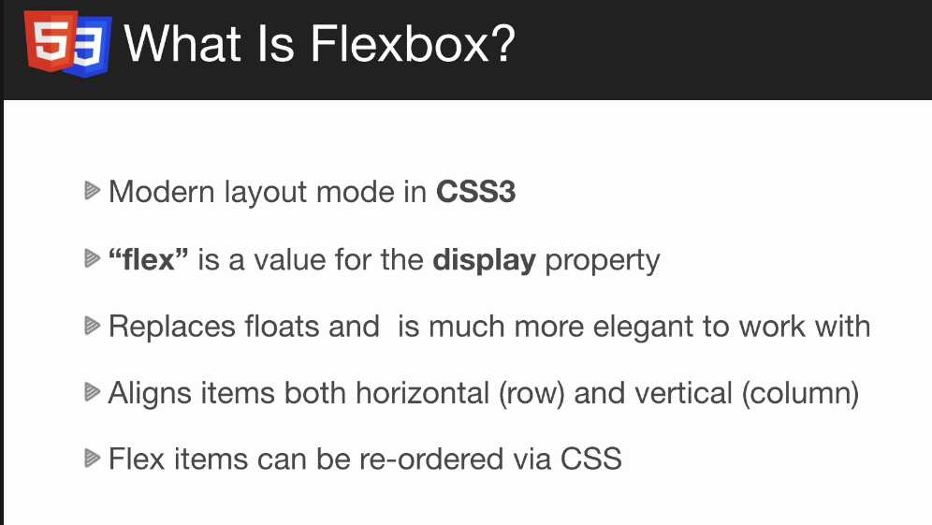

display: flex
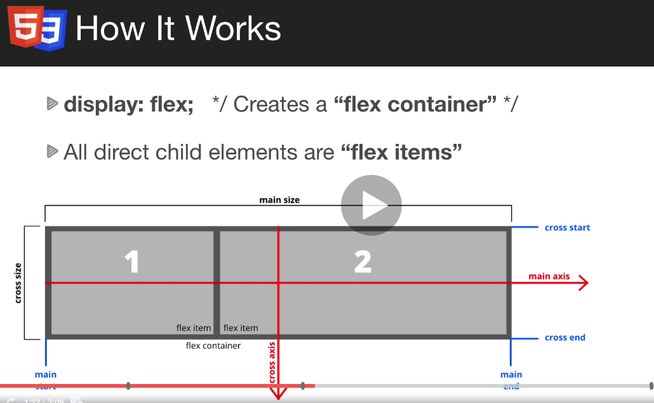

creates flex container
- all direct child elements will be a flex item
- align horizontaly

possible to align vertically
axes (cross and main

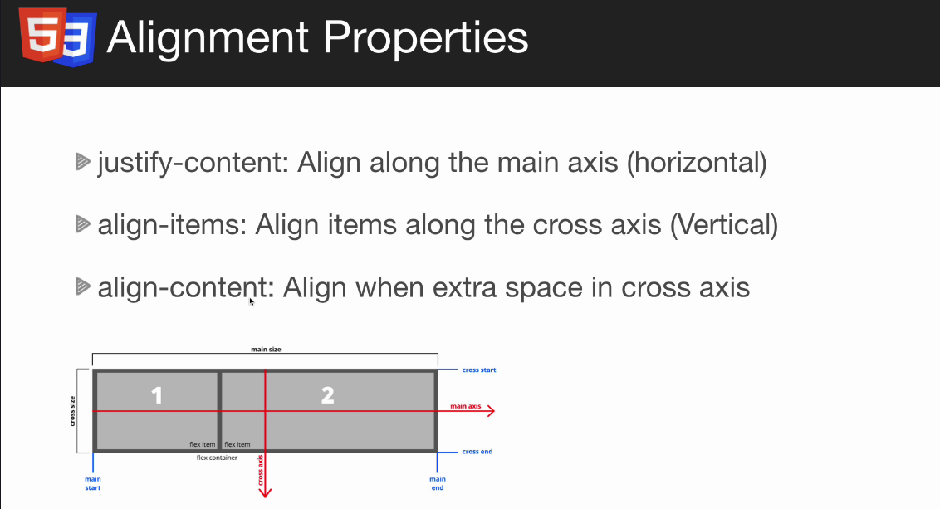

.flex-container {
display: flex;
flex-direction: column-reverse;

}

flex-direction
flex-wrap: wrap; - when shrinking at some pont the boxes will go to the next line

FLEX properties

.item-1 {
flex-shrink: 0;
}

when the size is change the item is not etting smaller.

.item-2 {
flex-grow: 1;
}

the item will take the remaining space. Can be set on the arent div (like that the iall the items will take all the space

flex basis : setting the width – specifies the initial size of the flex item

flex: 1 in the main div = flex grow 1

flex: 1 0 200px; grow,srink,basis

Aligment and justify properties of flexbox

align aligning on the crossaccess
- added in the div parent.

.flex-container {
background-color: #f4f4f4;
display: flex;
flex-direction: row;
align-items: center;
height: 50vh;

}

elements alligned on the crossaxis
flex-start
flex-end

aligning always on the cross axis (not main)

align-items: stretch (going throught the whole parent div)

justify-content
Main axis align

space-around = on the borders
between

aign-self on the element will overrride aligment

Questions:
General questions about the project:
- Who is the user/ Who are the users (access types)
- topview = dashboard (dashboard is what user sees first after opening the webapp) and dashboard list = reports? (charts set of data ect.)
- What are feeds

Edge Ledger – project

Hero image
favicon ico file
Overlay using sudo before.
Image is darker so that the letters are more visible.
.hero::before
- adding content before or after the element
.hero::before {
/* Content is needed lets leave it empty */
content: '';
/* In thehero we set position relative absolute, parent needs to be relative */
position: absolute;
top: 0;
left: 0;
width: 100%;
height: 100%;
/* a for thetransparency */
background: rgba(0,0,0,0.6);
}

And z-index on the text part because the overlay is before the text as well

.hero * {
/* The heigher the z-index is the closer to you on the dashboard_queries */
z-index: 10;
}


Three icons in a row centered
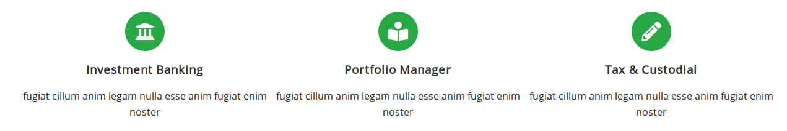
.flex-items {
display: flex;
text-align: center;
justify-content: center;
}
DIRECT CHILD DIV
.flex-items > div {

}
flex-basis -specifies the inititial size of flex item

flex: 1;
Specifies how a flex item will grow or shrink as to fit the space available in its flex container
object-fit: cover
- specifies how a replaced element like img or video should be resized to fit its container (cover – the picture wont be resized. )
Hover effect
.cases img:hover {
opacity: 0.7;
}
.flex-columns.flex-reverse {

}

ADDING FALVICON
dynamic drive falvcon
convert the icon into ico file with this online tool copy link and past it just above the link tags in html

HOW TO GET A WEBSITE ONLINE?
Shared Hosting
- Cheapest 3-15 $ monthone of many accounts on server suitable for small websites small amount of users. Local business. Most includes email FTP PHP databases software
- examples: Inmotion Hosting, Hostgator, Bluehost
VPS Hosting
- wirtual Private Server
- your own virtualized serwerMultiply shared accounts possible
- more access and privilage login as root ssh
- for more than one websites
- examples: Inmotion Hosting, Hostgator, Bluehos
Dedicated Server
- your own actual server
- renting a physical machine
- full access and priviledges
- powerfull but harder to manage
- 100- 400 $
- large apps with tons of users
- devops person needed
Resseler Hosting
- create and manage multiple shared accounts
-can sell shared accounts to your own customers
- similar to VPS
- comes with reseller software whscc
- dns devopsknowledge is needed
- 15-100
- Example: Inmotion Hosting, Hostgator
Cloud Hosting
- used for web apps: e-comerce sites, multiple servers working together
- multiple servers work together
- scalable and great for larger apps
- not for begginers/harder to manage: managing firewalls
- pay as you go
Examples: Digital ocean, Linode, Vultr
Static Hosting
- Netlify, Github Pages
- Static websites
- uploading static website via git
- no bells and whistles of managed hosting

SSL certificate requires dedicated ip adress like that the website will be working secure and idependently from the other sites

Domain canbe bought separately

Hosting Company Links
InMotion Hosting is the company I recommend from my own experience but ofcourse you can use whatever company you want. Hostgator is another fantastic company. If you could use the affiliate links below, I would greatly appreciate it...

Inmotion Hosting
https://inmotion-hosting.evyy.net/c/396530/260033/4222

Hostgator:
https://partners.hostgator.com/c/347786/177309/3094
Ftp accunt and filezilla
File transfer protocol
Add FTP accounts
Directory: set the root of the website
FTP client like filezila is needed – Install a client
On the left there is a local machine (with our project )

Host: our domain
username: our email and password
port 21 Quick connect
lookfor the account root like public_html
default.htm is a the default placefolder
Go t o fizilla and upload them to our hos

FTP is slow. Ssh git is a next step

CONTACT FORM SUBMISSION
Php has a smimple email
form action “process.php” metho=”POST”

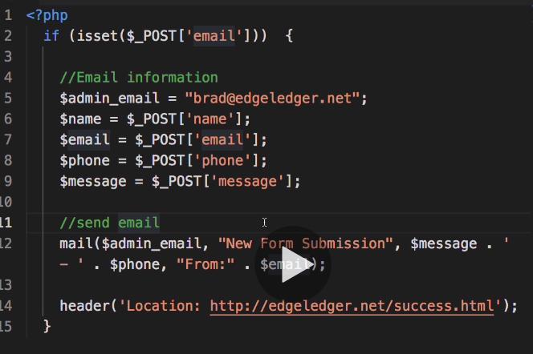
mail () address title body

targeted selectors
Direct child
/* Direct child */
div > p {
background: #ddd;
}

NTH-CHILD PSEUDO SELECTOR
Before and After pseudo selectors let us to insert content before or after the elements
Example:
Form with fileds which are required

<label class="is-required" for="name">Name</label>
<input type="text" />
.is-required:after {
content: '*'
}

No asterisk in the markup
Create an overlay for background image
- there will be opacity but we wont the text not to be fading away.

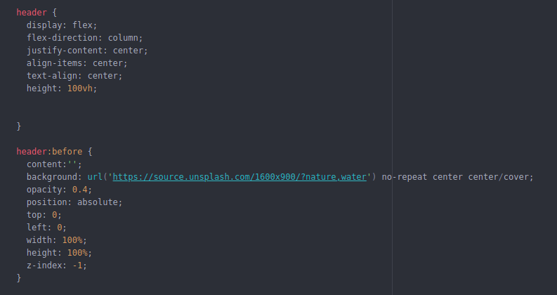
Box shadow property
CSS variables – custom properties
1) define scope for the variables
--light-color: #f4f4f4;
background: var(--light-color);
define all variables in the same place

:root {
--light-color: #f4f4f4;
}

primary colors,
secondary color,
gray,
width f the page
width of the boxes

ANIMATIONS IN CSS
propery which can be animated opacity, width, color
- go from 0 to 600 px
- fading
1) keyframe animation
- define the animation-name and animation-duration
- define @keyframes. In there we will have two properties from and to:
@keyframes animate1 {
from {
width: 200px;
}

to {
width: 600px;
}
}
As the width is precised earlier we can ommit from.
Repeated animation: anomation-iteration-count (number or infinite)
After the animation is done the object is returning to its base shape.
To prevent that use
animation-fill-mode: forwards; (it is going to stay where it is)
delaying animation: animation-delay: 2s;
animation-direction: alternate-reverse: going back
TIMING:
animaion-timing-function: (motion)
- ease-in/ease-out: starts fast then slows down
ease-in-out slows down on the beginning and end

Animate colors:
to {
background-color: red;
(it will go through the whole color system to red

By adding position: relative we can precize top, left ect.

There is a shortcut e can use: one line animation

Keyframes is not just from and to we can add more:
- percentages
0% is the start

TRANSITIONS
happen on events, ex. Hover
1) Specify the transition properties: can be all or we can specifying On the element
.box {
background: white;
width: 100px;
height: 100px;

transition-property: background;
transition-duration: 2s;
}
2) specify the duration
change the property:
.box:hover {
background: red;
It will give soother efect

Many properties:
transition: background, border-radius 2s ease-in-out;
or
transition: all 2s ease-in-out;

Transform
WEBSITE DEPLOYMENT
Netlify
static website and front applications
secure submiion of the forms
Free to sign up
Git – version control system
Inicialize the git repository
1) git init creates a hidden folder called .git
git add .
Private got available!!!
Deploy repository to netlify
Go to netlify and choose your repository.
Choose the branch (ex master)
Build command
publish directory

make the form work
method=”post” data-netlify=”true”
nput name should be given
namecheap
IN THE HOST RECORDS
Arecord ip addresses
cname www your domain from netlify

SASS
Syntactically Awesome StyleSheets.
CSS Preprocessor/Prcompiler
- Enchances te functionality of CSS
-OtherPreprocessorsinclude: Less and Stylus
- Sass uses .scss (prefered) or sass fileextentions
- thebrowser does not read Sass it must be compiled
- Sass files are compiled to noral CSS files
- There are may different types of Sass compilers (cli & gui)
- NODE sass
- vs code extentions

What does sass offer?
1) Variables
css variables are new.
2) Nesting
Main reason. Nest styles. Inside the curly braces structure css
3) Partials/Imports
With regular css you can import other css files but it makes the separate request to the server to get each file sass is build on the top instead of requiring all css serving a single css file to the server
Build on top on the
4) Functions & Mixins
Predifined styling. Dont repeat yourself
5) Conditionals
6) Inheritance
DRY
7) Operators and Calculations
8) Color Functions
Lightening and darkening

Difference between SASS and SCSS files:
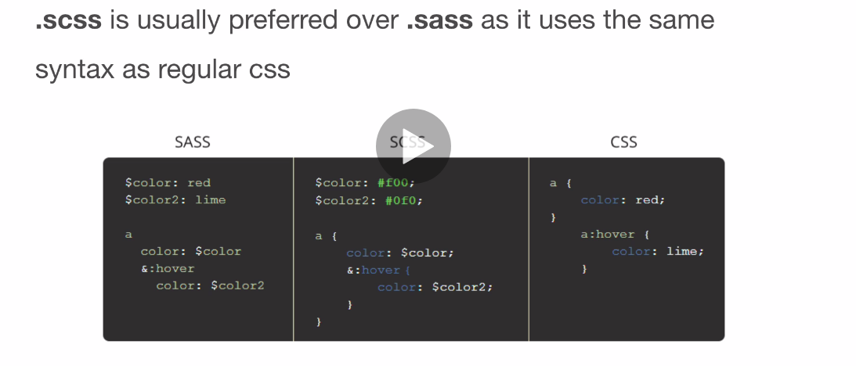
preferred scss
ENVIRONMENT SETUP WITH NODE-SASS
1) Go to the folder
2) Make sure there is npm installed.
3) we will ceate a package.json file
npm init

{
"name": "sass_sandbox",
"version": "1.0.0",
"description": "training",
"main": "index.js",
"scripts": {
"test": "echo \"Error: no test specified\" && exit 1"
},
"author": "",
"license": "ISC"
}

4) Installing sass
npm install node-sass
it will be our dependency

5) Creating an npm script which will allow us to use npm-sass
"scripts": {
"sass": "node-sass -w scss/ -o dist/css/"
},
- w set a watch flag
watching folder scss
-o output
dist/css (deloyed)
6) Create watch nd output folders
7) call the script: npm run sass
When change made and save it will be compiled

The dist is the actual proyect to deploy the rest will be the development

Using underscores on the file names:
- partial
NESTING:
header {
background: $dark-color;
color: $light-color;
padding: 1rem;

h1 {
text-align: center;
}
}

.section {
padding: 3rem;

h3 {
font-size: 2rem;
}

&-a{
& -whaever is parent selector
}
}

SUDO selectors:
a {
color: #333;
&:hover {
color: coral;
}
}

FUNCTION AND MIXING
1) Function will return sth (retun keyword is needed)
2) Mixing Set of styles to include

