**What is Google Colab?**

Google Colab is a free cloud service and now it supports free GPU! You can:

* improve your **Python**programming language coding skills.
* develop deep learning applications using popular libraries such as **Keras**,  
  **TensorFlow**, **PyTorch**, and **OpenCV**.

The most important feature that distinguishes Colab from other free cloud services is: **Colab**provides GPU and is totally free. Detailed information about the service can be found on the [faq](https://research.google.com/colaboratory/faq.html" \t "_blank) page.

**Getting Google Colab Ready to Use**

**Creating Folder on Google Drive**

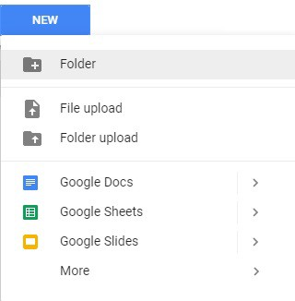

Since **Colab** is working on your own **Google Drive**, we first need to specify the folder we’ll work. I created a folder named “**app**” on my **Google Drive**. Of course, you can use a different name or choose the default **Colab Notebooks**folder instead of **app folder**.

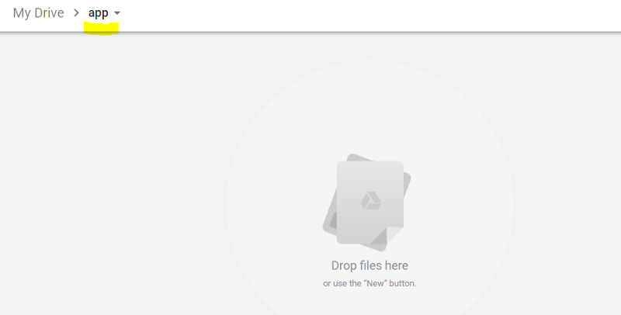  
**I created an empty “app” folder**

**Creating New Colab Notebook**

Create a new notebook via **Right click > More > Colaboratory**

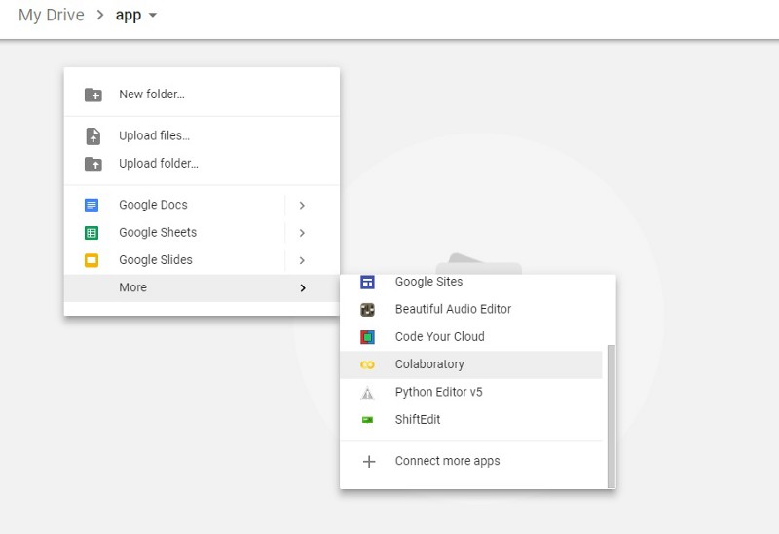  
**Right click > More > Colaboratory**

**Rename**notebook by means of clicking the file name.

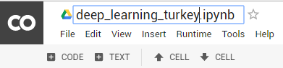

**Setting Free GPU**

It is so simple to alter default hardware **(CPU to GPU or vice versa)**; just follow **Edit > Notebook settings** or **Runtime>Change runtime type**and **select GPU**as **Hardware accelerator**.

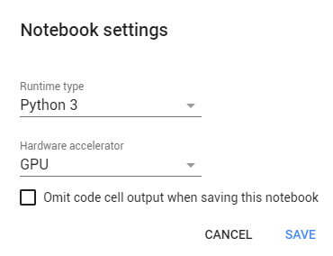

**Running Basic Python Codes with Google Colab**

Now we can start using **Google Colab**.

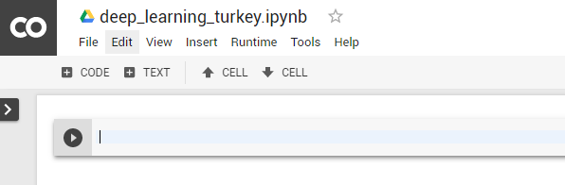

I will run some **Basic Data Types** codes from [Python Numpy Tutorial](http://cs231n.github.io/python-numpy-tutorial/).

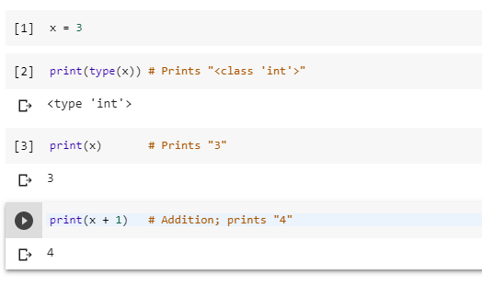

It works as expected :) If you do not know **Python**which is the **most popular programming language for AI**, I would recommend this simple and clean tutorial.