**For this lab you will need to open the lab notebook in Colab:**

<https://colab.research.google.com/github/ophir91/Iplab_5/blob/master/Lab5.ipynb>

and save the file in your Drive (**File -->** **'save a copy in Drive'**).

Then make sure you are using GPU as describe above.

Now you will need to upload your image and the pretrained neural network (net.pth) from the lab folder:

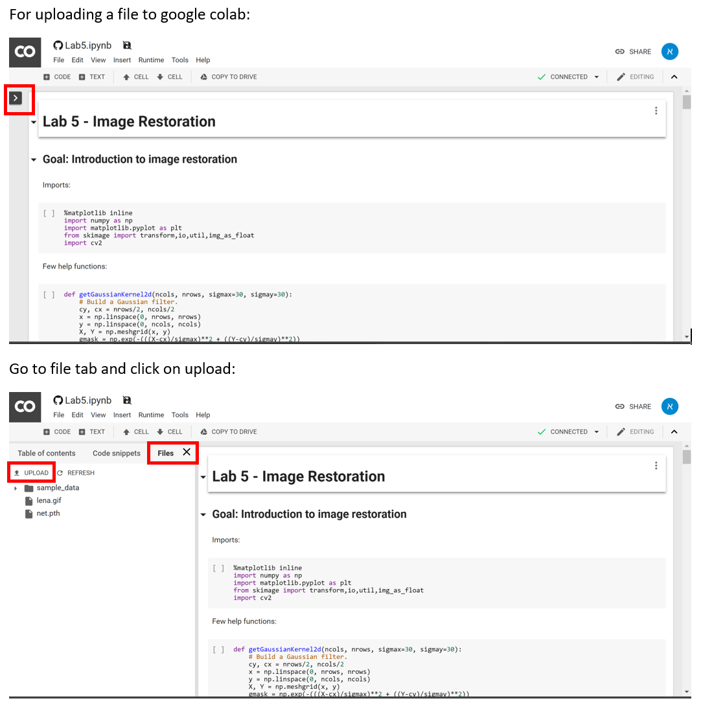

**And now you are ready to start the lab**