# **Release 2**

Delivery date: 25/10/2016 Total Story Points: 29

The goal of this release is to have a functional website. The overall goal is to have account management working as well as a functioning calculator.

## **Account Management - Sprint 3**

This will provide account information for employee and managers to access.

|  |  |  |
| --- | --- | --- |
| Story ID | Story Title | Story Points |
| S21 | View / Manage Customer Accounts | 5 |
| S33 | Employee Accounts | 3 |
| S22 | View / Manage Employee Accounts | 5 |
| S23 | New Order Notifications | 5 |
|  | Story Point Sub-Total: | 18 |

## **Finishing Touches - Sprint 4**

This is where the package is organized and prepared to be delivered, the schedules and calculations of costs are made.

|  |  |  |
| --- | --- | --- |
| Story ID | Story Title | Story Points |
| S20 | Order Status | 5 |
| S09 | Estimated Cost Calculator | 3 |
| S28 | Printable Files for Manager | 3 |
|  | Story Point Sub-Total: | 11 |

# **Release 2 Burndown Chart**

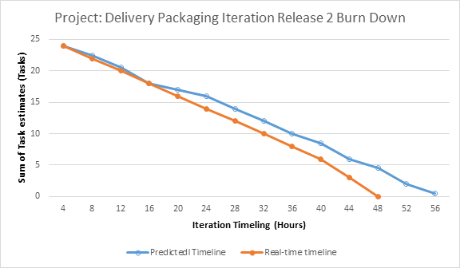

# **Sprint 3**

Total Story Points: 28 Story Points Estimated Total Hours: 42 Hrs

Total Hours: 37 Hrs

## Current Velocity: 23

## **Story ID: View / Manage customer accounts**

|  |  |  |  |
| --- | --- | --- | --- |
| Task ID | Task Description | Estimate | Taken |
| T39 | Pull list of customer accounts | 2 | 1 |
| T40 | Create link to each customer's information + orders | 3 | 2 |
| T41 | Pull history of individual users orders | 4 | 3 |
| T42 | Display relevant information in a organised manner | 3 | 2 |
|  | Story Points: 5 Total Hours: | 12 | 8 |

## **Story ID: Employee Accounts**

|  |  |  |  |
| --- | --- | --- | --- |
| Task ID | Task Description | Estimate | Taken |
| T43 | Generate employee accounts | 2 | 1 |
| T44 | Prompt employee to change password on first login | 1 | 1 |
| T45 | ‘Track’ statistics | 5 | 4 |
|  | Story Points: 3 Total Hours: | 8 | 6 |

## **Story ID: View / Manage employee accounts**

|  |  |  |  |
| --- | --- | --- | --- |
| Task ID | Task Description | Estimate | Taken |
| T46 | Pull employee list | 1 | 2 |
| T47 | Pull individual employees information, including delivery history | 3 | 3 |
| T48 | Enable editing of applicable information | 3 | 2 |
|  | Story Points: 5 Total Hours: | 7 | 7 |

## **Story ID: New Order Notifications**

|  |  |  |  |
| --- | --- | --- | --- |
| Task ID | Task Description | Estimate | Taken |
| T49 | Create notification icon | 1 | 2 |
| T50 | Implement notification check | 2 | 2 |
| T51 | Create notification page | 5 | 5 |
| T52 | Implement dynamic notification | 2 | 2 |
|  | Story Points: 5 Total Hours: | 10 | 11 |

## 

Sprint 3 Burndown Chart

Below is the Sprint 3 Burndown chart

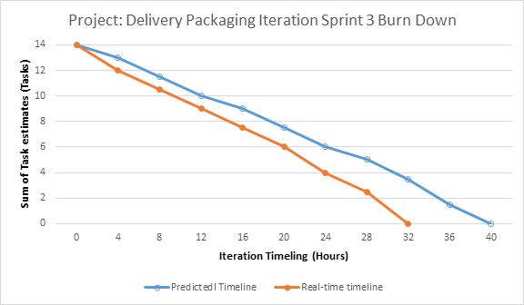

## 

## **Sprint 3 - Testing**

## **Story ID: View / Manage customer accounts**

|  |  |  |  |  |  |
| --- | --- | --- | --- | --- | --- |
| **Task ID** | **Testing - Functionality** | **How  was it Tested** | **Does  it Work** | **What is the Function** | **Can it be Fixed** |
| **T39** | Pull list of customer accounts | Pulled the list of customers | Yes it does | To gather all the customer information | Doesn’t need fixing |
| **T40** | Create link to each customer's information + orders | Made sure link was connected to information and orders. | Yes it does | To correlate the correct information for orders to customers | Doesn’t need fixing |
| **T41** | Pull history of individual users orders | Pulled history of individual customer orders. | Yes it does | To find what they’ve ordered in the past | Doesn’t need fixing |
| **T42** | Display relevant information in an organised manner | Visually checked that the manner of display was organised. | Yes it does | To see if the layout is easy to understand and relate to | Doesn’t need fixing/can be modified to suit |

## **Story ID: Employee Accounts**

|  |  |  |  |  |  |
| --- | --- | --- | --- | --- | --- |
| **Task ID** | **Testing - Functionality** | **How  was it Tested** | **Does  it Work** | **What is the Function** | **Can it be Fixed** |
| **T43** | Generate employee accounts | Tried to make a new employee account | Yes it does | To create a new employee account | Doesn’t need fixing |
| **T44** | Prompt employee to change password on first login | Check email for message prompt. | Yes it does | So the employee has a personalised password to suit them. | Doesn’t need fixing |
| **T45** | ‘Track’ statistics | Check to see if amount of deliveries is updated | No | To see how many deliveries each employee has completed | Difficult to implement without practical experiments |

## **Story ID: View / Manage employee accounts**

|  |  |  |  |  |  |
| --- | --- | --- | --- | --- | --- |
| **Task ID** | **Testing - Functionality** | **How  was it Tested** | **Does  it Work** | **What is the Function** | **Can it be Fixed** |
| **T46** | Pull employee list | Pulled employee list | Yes it does | To gather a list of employee accounts | Doesn’t need fixing |
| **T47** | Pull individual employees information, including delivery history | Check employee profile for information. | Yes it does | To gather all of an employee's history and details | Doesn’t need fixing |
| **T48** | Enable editing of applicable information | Checked if able to edit applicable information. | Yes it does | To be able to update employee information after initial creation of account | Doesn’t need fixing |

## **Story ID: New Order Notifications**

|  |  |  |  |  |  |
| --- | --- | --- | --- | --- | --- |
| **Task ID** | **Testing - Functionality** | **How  was it Tested** | **Does  it Work** | **What is the Function** | **Can it be Fixed** |
| **T49** | Create notification icon | Moved to Sprint 5 | - | Icon to be displayed when a notification is received | Moved to Sprint 5 |
| **T50** | Implement notification check | Moved to Sprint 5 | - | Ability to trigger the icon so that the user can see it | Moved to Sprint 5 |
| **T51** | Create notification page | Moved to Sprint 5 | - | The purpose of this page is to see a larger list of notifications. (history) | Moved to Sprint 5 |
| **T52** | Implement dynamic notification | Moved to Sprint 5 | - | Icon to be triggered and displayed automatically when a notification is received | Moved to Sprint 5 |

# **Sprint 4**

Total Story Points: 13 Estimated Total Hours: 17 Hrs

Total Hours: 14 Hrs

## Current Velocity: 18

## **Story ID: Order status**

|  |  |  |  |
| --- | --- | --- | --- |
| Task ID | Task Description | Estimate | Taken |
| T36 | Pull list of orders | 2 | 1 |
| T37 | Separate list into past / current | 1 | 1 |
| T38 | Create display, organised by order number | 2 | 2 |
|  | Story Points: 5 Total Hours: | 5 | 4 |

## **Story ID: Estimated Costing Calculator - Moved to Release 3**

|  |  |  |  |
| --- | --- | --- | --- |
| Task ID | Task Description | Estimate | Taken |
| T17 | Create system for delivery prices based on weight & distance | 2 | 2 |
| T18 | Calculate weight and size | 2 | 2 |
| T19 | Add package to the delivery list | 3 | 2 |
| T20 | Calculate time and distance travelled for cost | 2 | 2 |
|  | Story Points: 3 Total Hours: | 9 | 8 |

## **Story ID:** Printable Files for Manager

|  |  |  |  |
| --- | --- | --- | --- |
| Task ID | Task Description | Estimate | Taken |
| T53 | Create a print function | 1 | 0.5 |
| T54 | Convert data sheets into a printable format | 1 | 0.5 |
|  | Story Points: 3 Total Hours: | 2 | 1 |

**Requested Changes by Client**

|  |  |  |  |
| --- | --- | --- | --- |
| Task ID | Task Description | Estimate | Taken |
| - | Change background image from a rocket to a vehicle | 0.5 | 1 |
| - | Remove front page information about cloud storage | 0.5 | 0.5 |
| - | Twitter and facebook buttons to be removed unless implemented | 0.5 | 0.5 |
| Total |  | 1.5 | 2 |

## **Sprint 4 Burndown Chart**

Below is the Sprint 4 Burndown Chart

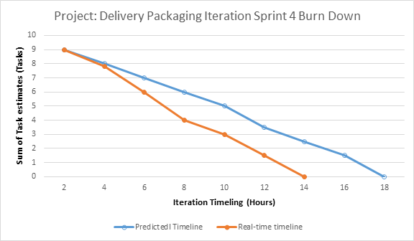

## **Story ID: Order Status**

|  |  |  |  |  |  |
| --- | --- | --- | --- | --- | --- |
| **Task ID** | **Testing - Functionality** | **How  was it Tested** | **Does  it Work** | **What is the Function** | **Can it be Fixed** |
| **T36** | Pull list of orders | Pulled the list of orders | Yes it does | Get the list of orders. | Doesn’t need fixing |
| **T37** | Separate list into past / current | Made sure that past orders weren’t visible in current order list and vise versa. | Yes it does | List of current orders to be separate from past orders so that user can see what orders are still active | Doesn’t need fixing |
| **T38** | Create display, organised by order number | Made sure the orders weren’t randomly displayed and that they were visible | Yes it does | To have an easily-readable presentation of all the orders | Doesn’t need fixing |

## **Story ID: Estimated Cost Calculator - Moved from Sprint 1**

|  |  |  |  |  |  |
| --- | --- | --- | --- | --- | --- |
| **Task ID** | **Testing - Functionality** | **How  was it Tested** | **Does  it Work** | **What is the Function** | **Can it be Fixed** |
| **T17** | Create system for delivery prices based on weight & distance | This was done by selecting a weight when creating a delivery | Yes it does | To have the option for inputting the weight of the package | Doesn't need fixing |
| **T18** | Calculate weight and size | This was tested by making the system calculate multiple different deliveries | Yes it does | To calculate the correct price depending on the weight and size of the package | Doesn't need fixing |
| **T19** | Add package to the delivery list | Tested adding test packages to the delivery list for drivers | Yes it does | Package list for Delivery Drivers | Doesn't need fixing |
| **T20** | Calculate time and distance travelled for cost | Standard delivery plans were put in place for this measure | Yes it does | Standard delivery plans for packages / orders | Doesn't need fixing |

## **Story ID: Printable Files for Manager**

|  |  |  |  |  |  |
| --- | --- | --- | --- | --- | --- |
| **Task ID** | **Testing - Functionality** | **How  was it Tested** | **Does  it Work** | **What is the Function** | **Can it be Fixed** |
| **T57** | Create a print function | Testing whether the function was implemented properly. | Yes it does | To give the option to print out a data sheet | Doesn’t need fixing |
| **T58** | Convert data sheets into a printable format | Testing if a data sheet can be printed. | Yes it does | A paper version is able to be printed | Doesn’t need fixing |