Data Mining and Machine Learning Report: Focus on Outliers

By: Ashiat Adeogun

Table of Contents
1.
Title Page 1
2. Contents……..……..………………………………………………………………………………………………………..………..2
3. Introduction 3
4. Task 1: Visualizing and Detecting Outliers 3
- 1.1 Visualizing Outliers…………………………………………………………………………………………………..3
- 1.2 Detecting Outliers…………………………………………………………………………………………………….4
- 1.3 Handling Outliers…………………………………………………………………………………………………..5-8
5. Task 2: Analysis of a Different Dataset 8
- 2.1 Univariate Analysis……………………………………………………………………………………………………8
- 2.2 Bivariate Analysis…………………………………………………………………………………………………….8
- 2.3 Multivariate Analysis……………………………………………………………………………………………….9
6. Task 3: Exploring Categorical Variable.. 10-14
7. Conclusion 14

Introduction
This report presents an analysis of outlier detection and handling techniques, along with an exploration of categorical variables using data mining and machine learning methods.

Task 1: Visualizing and Detecting Outliers
1.1 Visualizing Outliers
The box plot revealed two outliers at values 135 and 168 as shown in figure 1. The scatterplot exhibited potential outliers as some points lie far away from the main cluster, which makes them potential outliers. Analyzing the relationship between ozone levels and wind, we can observe that there are a few data points that stand out as shown in Figure 2. However, the histogram of ozone levels showed no outliers, with data distributed evenly across distinct bars as shown in Figure 3. Similarly, the density plot indicated a continuous distribution of ozone levels without visible outliers as shown in Figure4. These findings highlight the variability in outlier presence across different visualization methods and emphasize the importance of thorough data exploration.
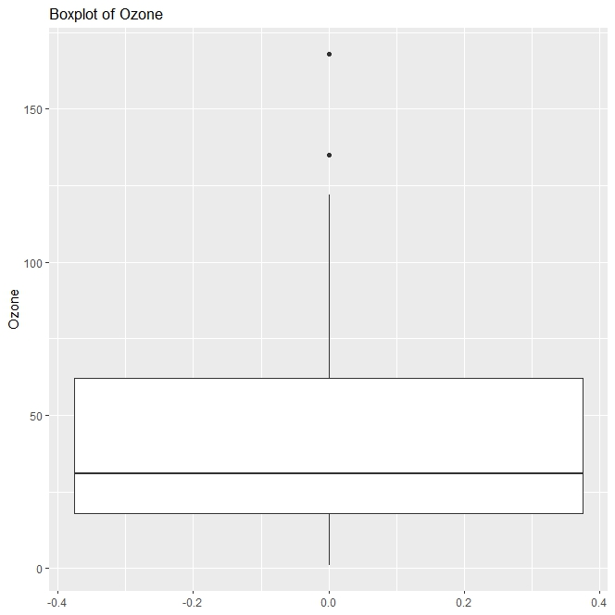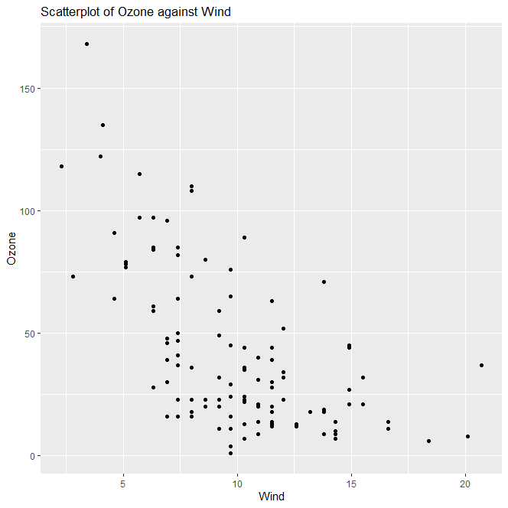
Figure 1: The Box plot Figure 2: The Scatterplot
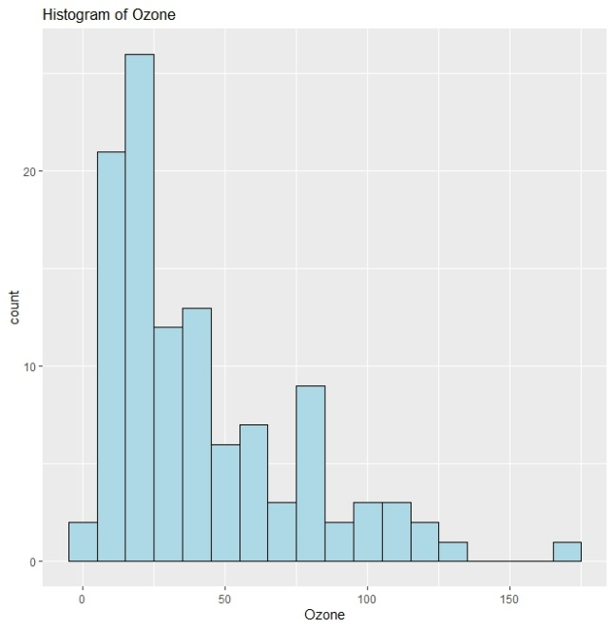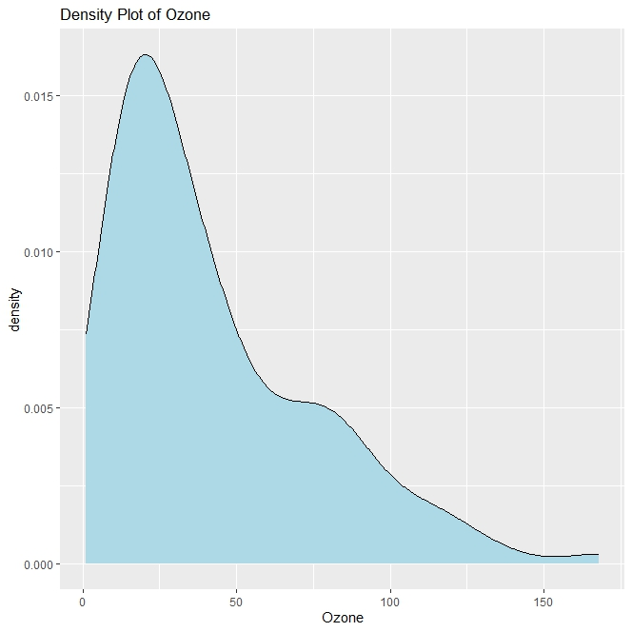
Figure 3: The Histogram Graph Figure 4: The Density Plot
1.2: Detecting outliers
The Z-score method identified six outliers with values exceeding 2 standard deviations from the mean for the "Ozone" variable. Both the IQR method and Tukey's fences method detected the same two outliers with values of 135 and 168. These results show consistency across the methods in identifying outliers in the "Ozone" data as shown in figure5. However, Grubbs' test did not identify any outliers for the "Ozone" variable in the dataset. Overall, these methods provide insights into outlier detection and the variability of "Ozone" values in the dataset.
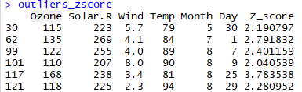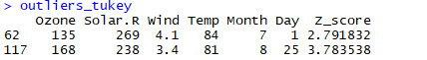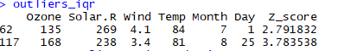
Figure 5: The result of different techniques of outliers
1.3: Handling Outliers
Handling outliers is an essential step in data preprocessing. A synthetic dataset was generated to observe how to handle outliers. We explored techniques like Winsorisation, Trimming, Mean Imputation, and Logarithmic Transformation to address outliers effectively. Each technique has its advantages and limitations, influencing how outliers are managed and their impact on subsequent analysis as shown in Figure 6.
 | Pros | Cons
Winsorisation | - Preserves the overall data range by replacing extreme values with less extreme values based on percentiles.  - Maintains the integrity of the dataset while reducing the impact of outliers. | - May not completely remove outliers, as they are replaced with less extreme values rather than being eliminated.  - Can distort the distribution of the data if there are many outliers.
Trimming | - Removes outliers from the dataset entirely, ensuring they do not influence statistical analyses.  - Preserves the original distribution of the data within the trimmed range. | - Can lead to loss of information, especially if the outliers contain meaningful insights.  - The choice of trimming percentage (e.g., top and bottom 5%) can affect the results and may not be optimal for all datasets.
Mean Imputation | - Replaces outliers with a representative value (mean), maintaining the overall central tendency of the data.  - Preserves the dataset size and structure without removing data points. | - May introduce bias if the outliers are not truly representative of the overall dataset.  - Can distort statistical analyses that rely heavily on mean values.
Logarithmic Transformation | - Stabilizes variance and improves the distribution of the data, especially for skewed datasets.  - Reduces the impact of extreme values by compressing the data range. | - May not eliminate outliers but rather mitigate their influence on statistical analyses.  - Requires careful interpretation, as transformed data may not be directly comparable to the original
Figure 6: Shown the pros and cons of different techniques.

Task 2: Analysis of a Different Dataset
Based on the analysis of the Obesity dataset obtained from the UCI Machine Learning Repository, the following are the key findings after data cleaning, preprocessing, and conducting univariate, bivariate, and multivariate analyses with outlier detection and handling.
2.1 Univariate Analysis
The univariate analysis of the Obesity dataset unveiled important details about various variables like Gender, Age, Height, Weight, family history of overweight, dietary habits, physical activity frequency, and alcohol consumption. For instance, the dataset spans ages from 14 to 61 years, weights ranging from 39 to 173 kilograms, and diverse lifestyle factors such as vegetable consumption frequency and high-calorie food habits. These insights provide a comprehensive understanding of individual characteristics and behaviors related to obesity status, contributing to informed decision-making in public health and healthcare interventions.

2.2 Bivariate Analysis
The bivariate analysis of the Obesity dataset revealed interesting correlations among Age, Height, Weight, Consumption of Water (CH2O), Physical Activity Frequency (FAF), and Time of Usage of Technology Devices (TUE). There were weak to moderate positive correlations between Weight and Height, CH2O and Height, as well as FAF and Height. Conversely, Age showed weak negative correlations with Height, CH2O, FAF, and a moderate negative correlation with TUE. These insights provide valuable information about how different variables interact within the dataset, which can inform further investigations into factors influencing obesity and health-related behaviors.

2.3 Multivariate Analysis
The multivariate analysis of the Obesity dataset identified three distinct clusters characterized by age, height, and weight. Cluster 1 comprised younger individuals with taller heights and higher weights, while Cluster 2 encompassed a broad age range with shorter heights. Cluster 3 included older individuals with varying weights. Although outliers were detected in the age variable, they fell within the same range and were addressed through winsorization to preserve data integrity. Winsorization had minimal impact on these outliers since they remained within specified percentiles, ensuring the robustness of the analysis.
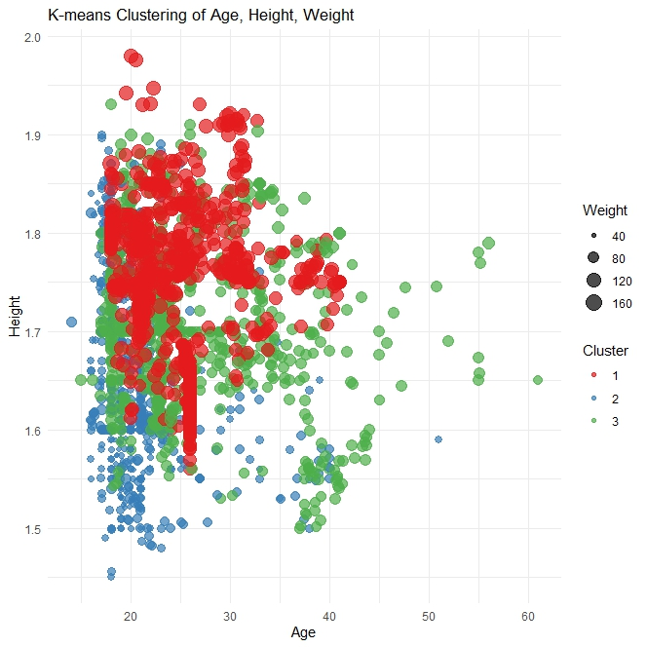
Figure 6: The Multivariate Analysis.

Task3: Exploring Categorical Variable
The sleep_health_and_lifestyle dataset was sourced from Kaggle.com and underwent data cleaning and preprocessing. Various visualizations were performed, including bar plots, stacked bar plots, and mosaic plots.
The bar plot illustrating BMI category distribution revealed that the Normal and Overweight categories had the highest counts of 190 and 148, respectively. In Figure 8 depicts most factors dominated by None parameters, except for Nurses with sleep apnea and Salespersons and Teachers having the highest insomnia rates in sleep disorders.
In the gender vs. sleep disorders graph (Figure 9), females exhibited the highest sleep apnea rates, while males predominantly had no sleep disorders.
Customized Visualization:
A modified box plot of Heart Rate and BMI category is shown in Figure 4. Figure 11 indicates that females experience a stress level of 8 and sleep duration ranging from 4 to 6.2 hours, with None being the dominant sleep disorder.
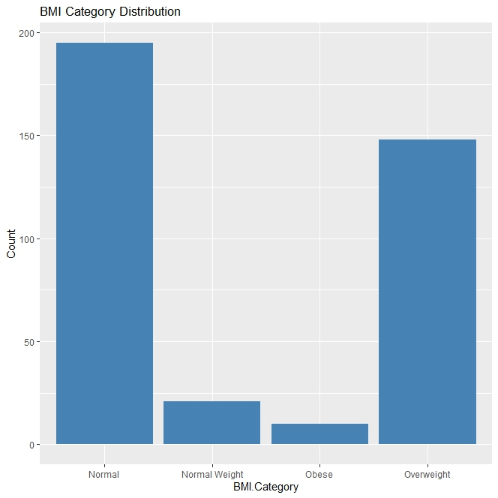
Figure 7: The BMI Category Distribution
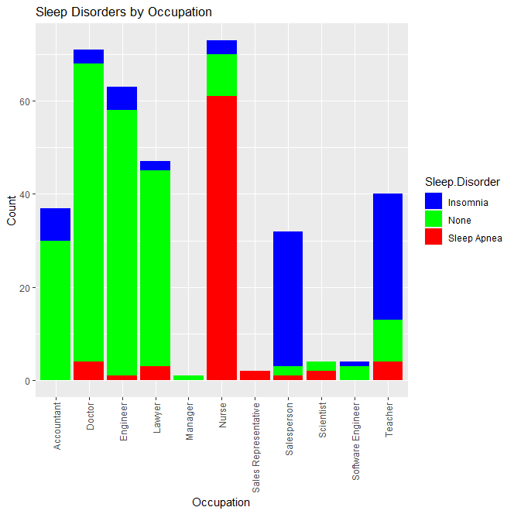
Figure 8: The Sleep Disorders by Occupation Graph
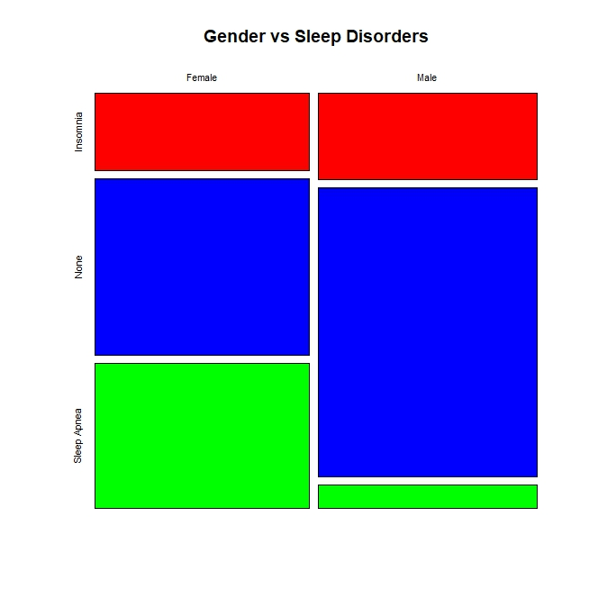
Figure 9: The gender vs sleep disorders chat.
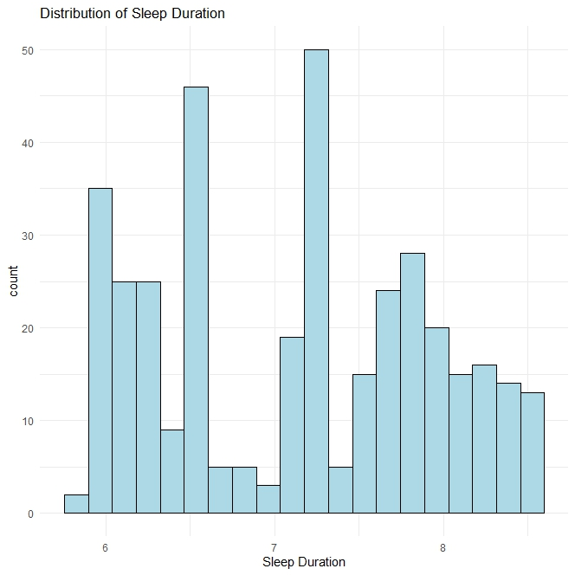
Figure 10: The distribution of sleep disorders
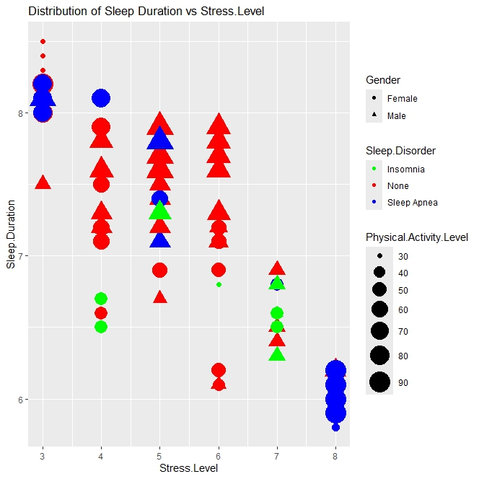
Figure 11: The distribution of sleep duration vs stress level
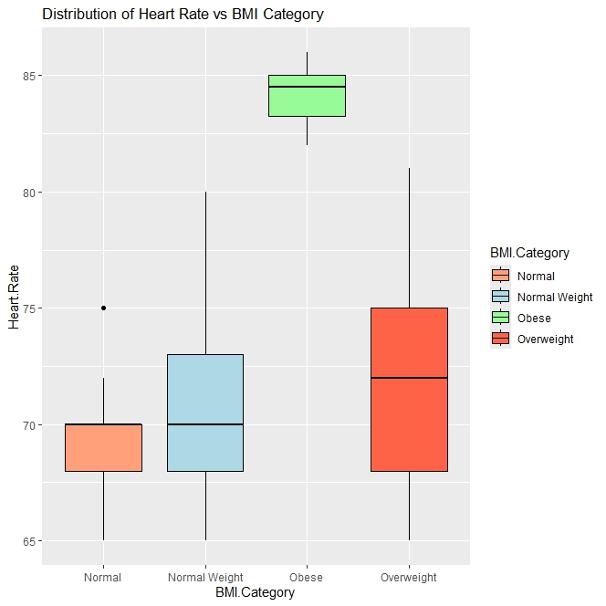
Figure 12: The distribution of heart rate vs BMI Category.
4. Conclusions
In conclusion, the analysis delved into outlier detection techniques such as Z-score, IQR, Tukey's methods, and Winsorisation, ensuring consistent identification of outliers in the "Ozone" variable. It also explored correlation analysis, clustering, and categorical variable exploration in datasets related to health and lifestyle. In the Obesity dataset, correlations and distinct clusters based on age, height, and weight were revealed, shedding light on potential relationships between these variables. Additionally, categorical variable exploration in the sleep_health_and_lifestyle dataset highlighted patterns in BMI, sleep disorders, and gender differences, offering valuable insights into the interplay of these factors in health and lifestyle outcomes. Overall, the analysis employed a range of techniques to extract meaningful information from the data, contributing to a deeper understanding of health-related variables and their associations.

