Program for Doctor Patient Web Application

1. Software's Used:

A. Net beans(IDE):

* Download from https://netbeans.org/downloads/6.7.1/
* From the website select ,

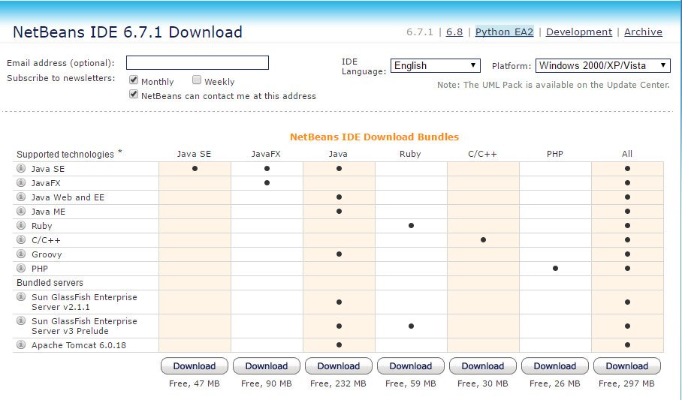

the all option in the last.

* Once downloaded run the .exe file and follow the steps to complete the setup.

B. MySQL(Database)

* Download from , https://dev.mysql.com/downloads/workbench/
* in that website scroll down and find

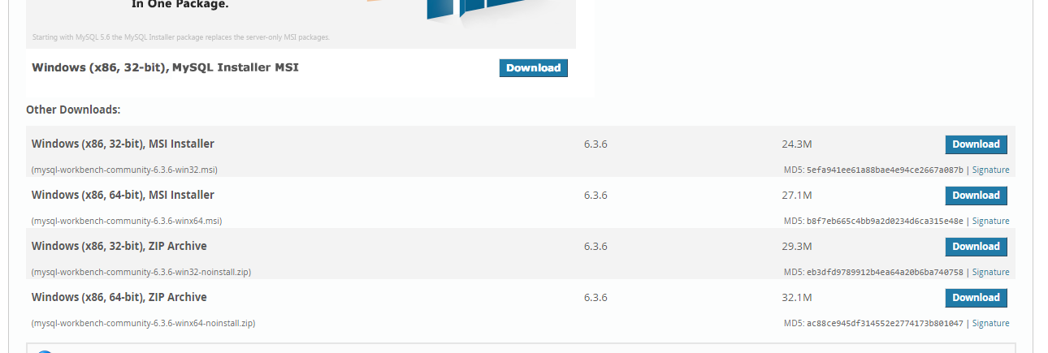

* download the msi file and follow the steps to download the database.

2. Overall setup and working of project,

A. MySQL database,

* open MySQL workbench,

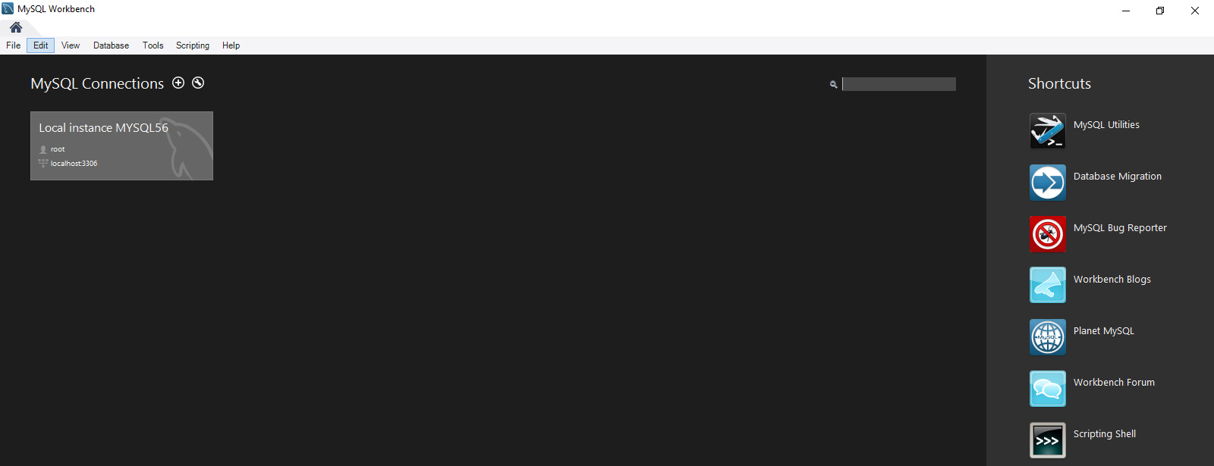

* create user with username root and password root.
* copy the contents of the sql file and paste on the console,

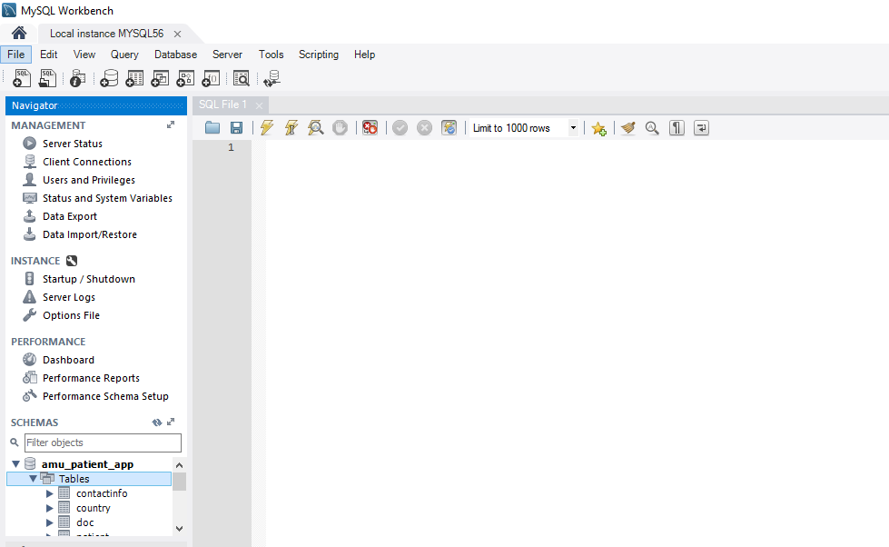

* run the script
* check to see if all the tables are populated

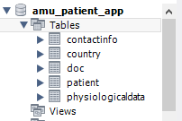

B. Netbeans IDE setup,

* open Netbeans IDE
* goto file and select New Project

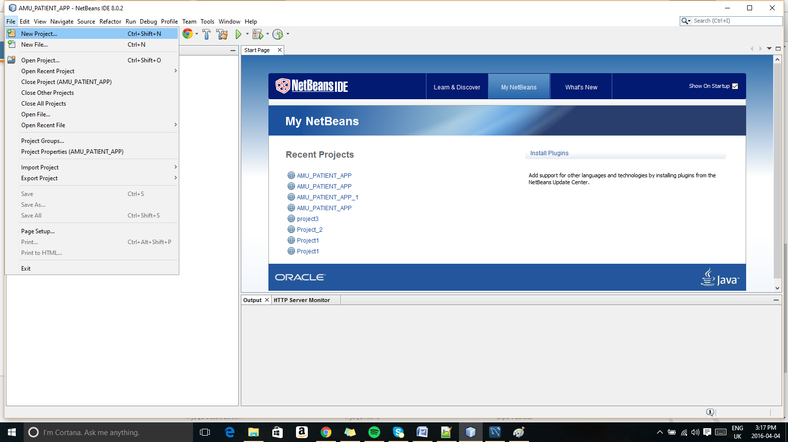

* now select Java Web as an option

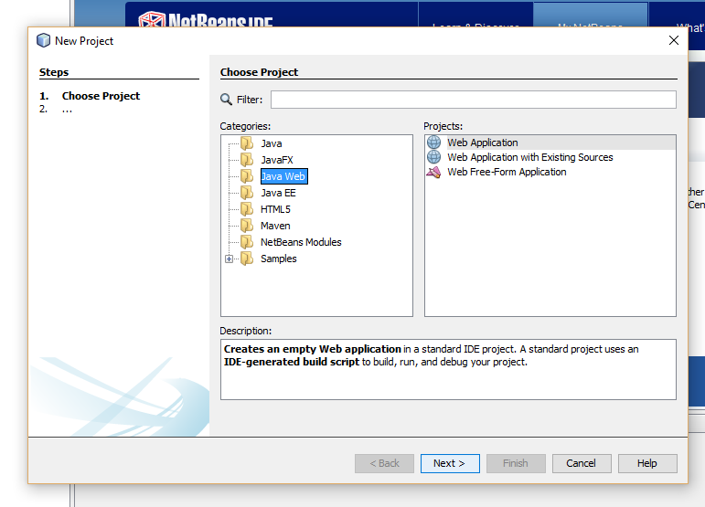

* select web application with existing sources

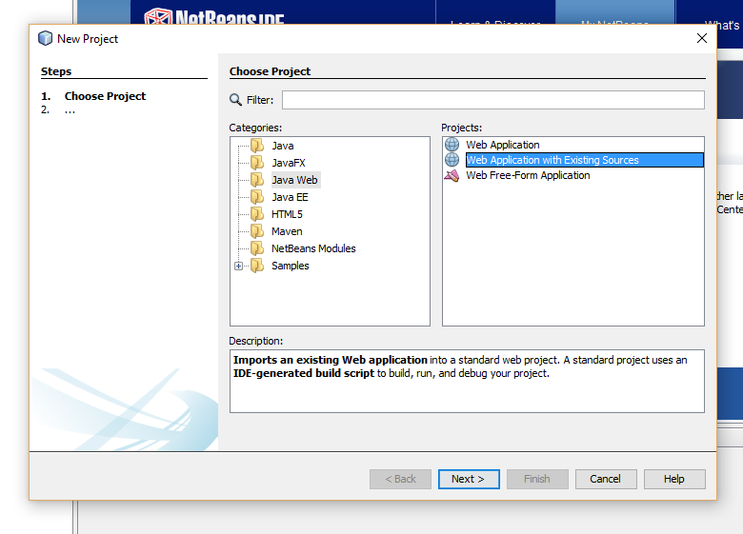

* select the location where the project is downloaded

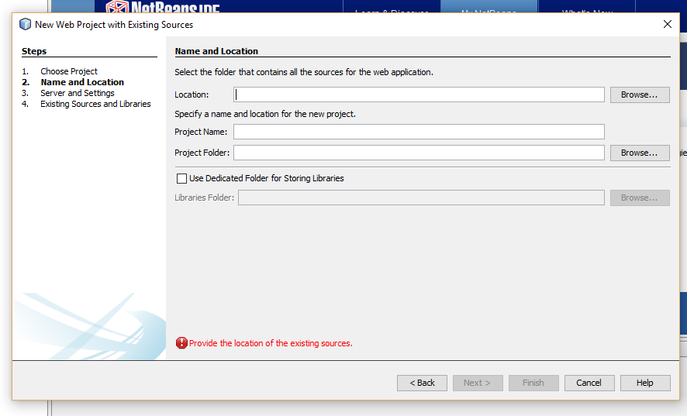

* this can be done by clicking on browse,

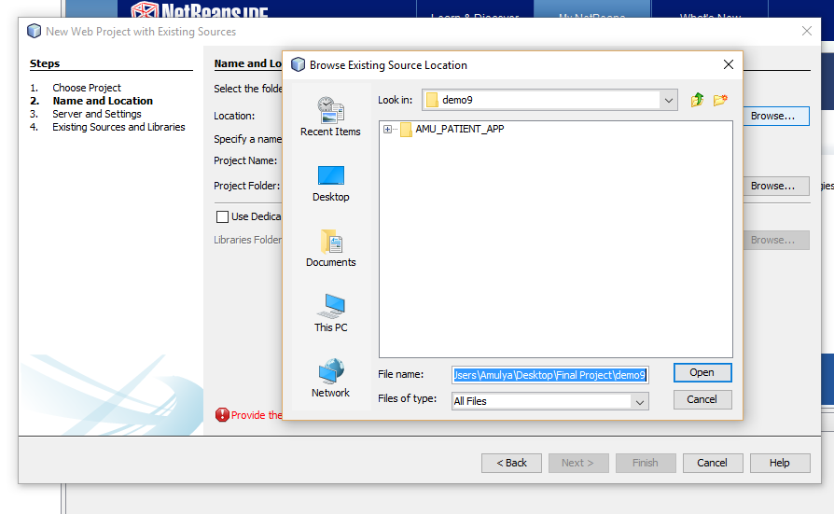

* select the file location,

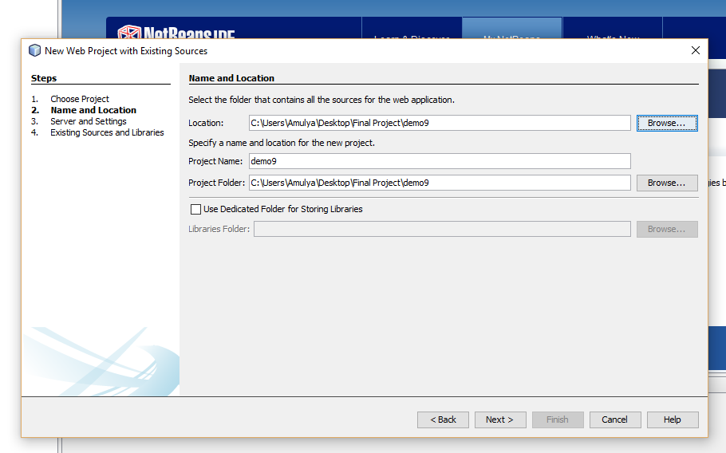

* click on next and select the server as tomcat,

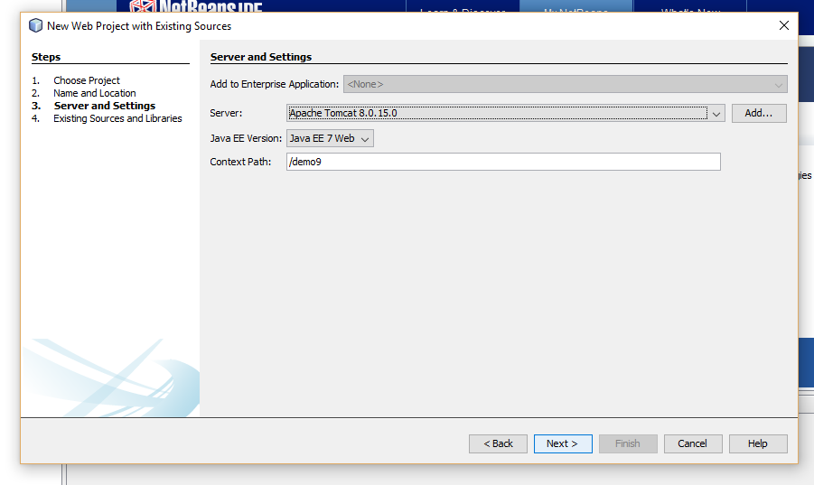

* click on finish after all the steps are done,

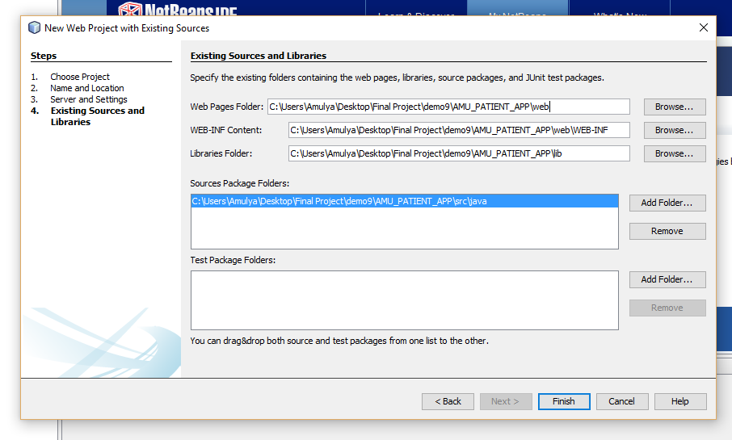

* check if the project is present on the left hand side with no errors,

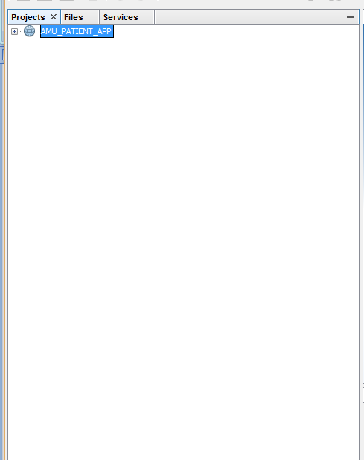

* click on the plus mark on the left and expand ,

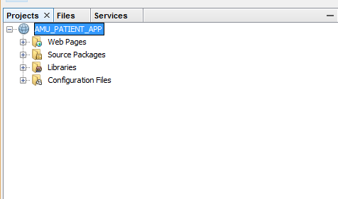

* right click on the project run it.