UNIVERSITY OF GHANA
School of Engineering Sciences
Department of Computer Engineering

FINAL PROJECT REPORT
From Blueprint to Behemoth: Building Your Own CPU
First Semester 2025/2026 Academic Year
Submission Date: 3rd April 2026
Asiedu Nana Yaw — 22025934
Effah-Asare Kofi — 22012574
Instructor: Prof. Robert A. Sowah | TA: Raphael Kuayi

Abstract
This report documents the design and implementation of a CPU across two levels of abstraction. In Part A, a 16-bit CPU was constructed using Logisim Evolution, encompassing an Arithmetic Logic Unit (ALU), register file, datapath, program counter, RAM interfacing, and a micro-architected control unit. The CPU was constructed in a sequential, step-by-step manner starting from the ALU, progressing through the register file and datapath, and culminating in a fully functional CPU integrated with a Control Unit. The processor supports four instructions (LoadA, LoadB, Arithmetic, and Store), and was verified through manual clock-cycle simulations. The simulation confirmed correct data flow, with Register A loading the value 10, Register B loading 15, the Output Register computing the sum 25, and the result being stored back into RAM. In Part B, a 32-bit single-cycle MIPS processor was implemented in VHDL, targeting the GHDL simulator. Six key components were designed and verified: Data Memory, ALU, ALU Control Unit, Register File, Instruction Memory, and CPU Control Unit, each accompanied by a comprehensive testbench.

1. Introduction
The design of a Central Processing Unit (CPU) is one of the most fundamental exercises in computer engineering. By building a CPU from individual logic components, students gain a hands-on understanding of how hardware and software interact at the lowest level of abstraction.
This project involved the implementation of a 16-bit CPU in Logisim Evolution and a 32-bit MIPS processor in VHDL. The 16-bit CPU was designed to execute a minimal instruction set comprising four instructions: LoadA, LoadB, an Arithmetic operation, and Store. The project covers all major components of a CPU including the ALU, registers, datapath, program counter, RAM interface, and a microarchitecture-based Control Unit generated using Logisim's Combinational Analysis feature. The 32-bit VHDL processor extends these concepts to a standard MIPS-compatible single-cycle architecture.
The objectives of this report are to present the architecture, implementation details, simulation results, and challenges encountered during both the Logisim and VHDL design processes.

2. Architecture Design

2.1 Part A — 16-bit CPU Architecture (Logisim)
The 16-bit CPU is built around a classic von Neumann architecture with a shared internal data bus connecting all major components. The architecture consists of the following components:
- Arithmetic Logic Unit (ALU) — performs 14 arithmetic and 6 relational operations on 16-bit inputs A and B
- Register A and Register B — 16-bit general-purpose registers that hold the ALU operands
- Instruction Register (IR) — 16-bit register that stores the currently fetched instruction
- Output Register — 16-bit register that holds the result of the ALU operation
- Memory Address Register (MAR) — 8-bit register that holds the memory address for RAM access
- Memory Buffer Register (MBR) — 16-bit register that acts as a buffer between the CPU and RAM
- Program Counter (PC) — 4-bit counter that cycles through instruction addresses 0000 to 0011
- RAM — 256 x 16-bit memory with first 8 addresses reserved for instructions, last 8 for data
- Control Unit (CU) — microarchitecture-based combinational circuit generating 16 control signals based on opcode and step counter

2.1.1 Instruction Set
Opcode | Instruction | Operation
00000000 | LoadA | Load RAM[addr] into Register A
00000001 | LoadB | Load RAM[addr] into Register B
00000010 | Arithmetic | Perform ALU operation on A and B
00000011 | Store | Write Output Register to RAM[addr]

2.1.2 ALU Operations
AUSel | Arithmetic Operation | RUSel | Relational Operation
0 | A + B | 0 | A > B
1 | A & B (AND) | 1 | A == B
2 | A | B (OR) | 2 | A >= B
3 | A ^ B (XOR) | 3 | A < B
4 | A / B | 4 | A <= B
5 | A % B (Mod) | 5 | A != B
6 | A * B
7 | A - B
8 | A << 2 (Shift Left A)
9 | B << 2 (Shift Left B)
10 | A >> 2 (Shift Right A)
11 | B >> 2 (Shift Right B)
12 | 2's Complement of A (-A)
13 | 2's Complement of B (-B)

2.2 Part B — 32-bit MIPS Processor Architecture (VHDL)
The 32-bit processor follows a single-cycle MIPS architecture where each instruction completes in one clock cycle. It supports R-type, I-type, and J-type instruction formats.
Format | Fields | Usage
R-type | op|rs|rt|rd|funct | Arithmetic: add, sub, and, or, slt, jr
I-type | op|rs|rt|imm | Memory and branch: lw, sw, beq, addi, slti
J-type | op|target | Jumps: j, jal

3. Implementation Details

3.1 Part A — Logisim Evolution Implementation

3.1.1 ALU (project_alu)
The ALU is implemented as a top-level sub-circuit named project_alu, which instantiates two sub-circuits: project_ao (arithmetic operations) and project_ro (relational operations). The ALU accepts two 16-bit inputs (A and B), a 4-bit arithmetic selector (AUSel), and a 3-bit relational selector (RUSel). It outputs a 16-bit arithmetic result (AUResult), a copy of the result (AUDout), and a 1-bit relational result (RUResult). All operations are computed in parallel and a multiplexer selects the final output.
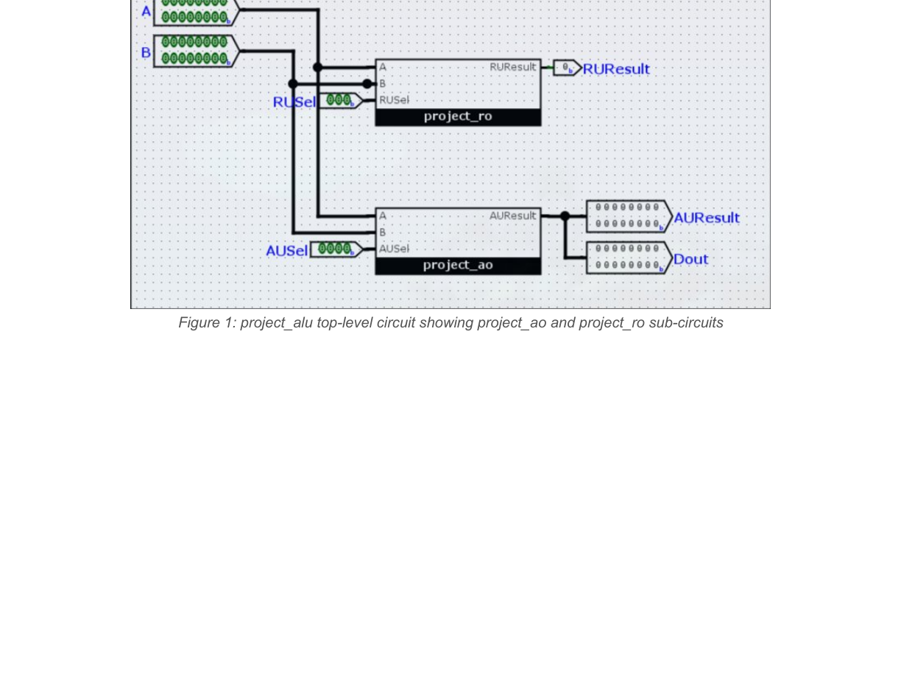
Figure 1: project_alu top-level circuit showing project_ao and project_ro sub-circuits
The arithmetic unit (project_ao) implements 14 operations. All operation blocks receive inputs A and B simultaneously. A 16-input, 16-bit MUX driven by AUSel selects the result. The relational unit (project_ro) implements six comparison operations using Logisim's built-in Comparator block with a MUX controlled by RUSel.
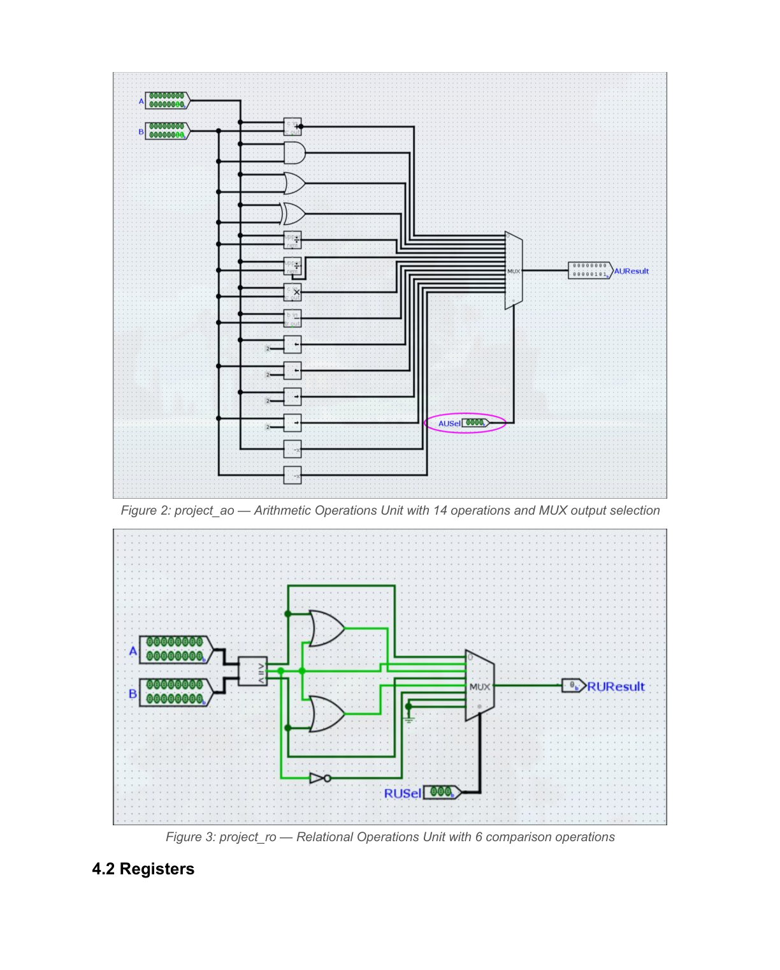
Figure 2 & 3: project_ao arithmetic unit (top) and project_ro relational unit (bottom)

3.1.2 Registers
All registers were implemented using Logisim's built-in Register component from the Memory folder. Register A and B are 16-bit wide, the IR and Output Register are 16-bit, the MAR is 8-bit, and the MBR is 16-bit. Each register exposes a Write Enable (WE) input and an Output Enable (OE) input to control data flow on the internal bus.
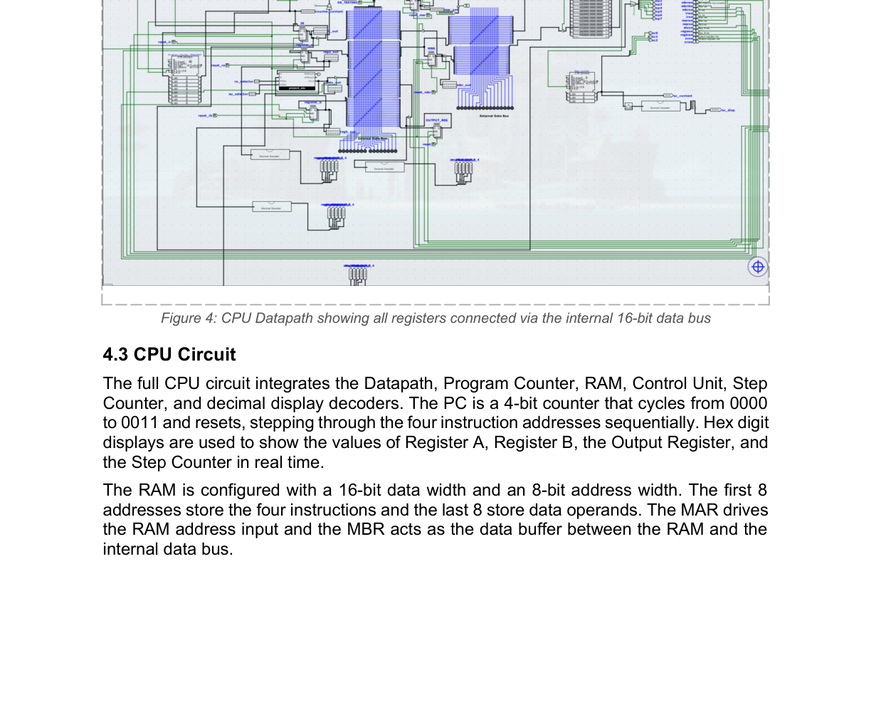
Figure 4: CPU Datapath showing all registers connected via the internal 16-bit data bus

3.1.3 CPU Circuit
The full CPU circuit integrates the Datapath, Program Counter, RAM, Control Unit, Step Counter, and decimal display decoders. The PC is a 4-bit counter cycling 0000→0011→0000. Hex digit displays show Register A, Register B, the Output Register, and Step Counter values in real time. The RAM has a 16-bit data width and 8-bit address width, with the MAR driving the RAM address input and MBR acting as the data buffer.
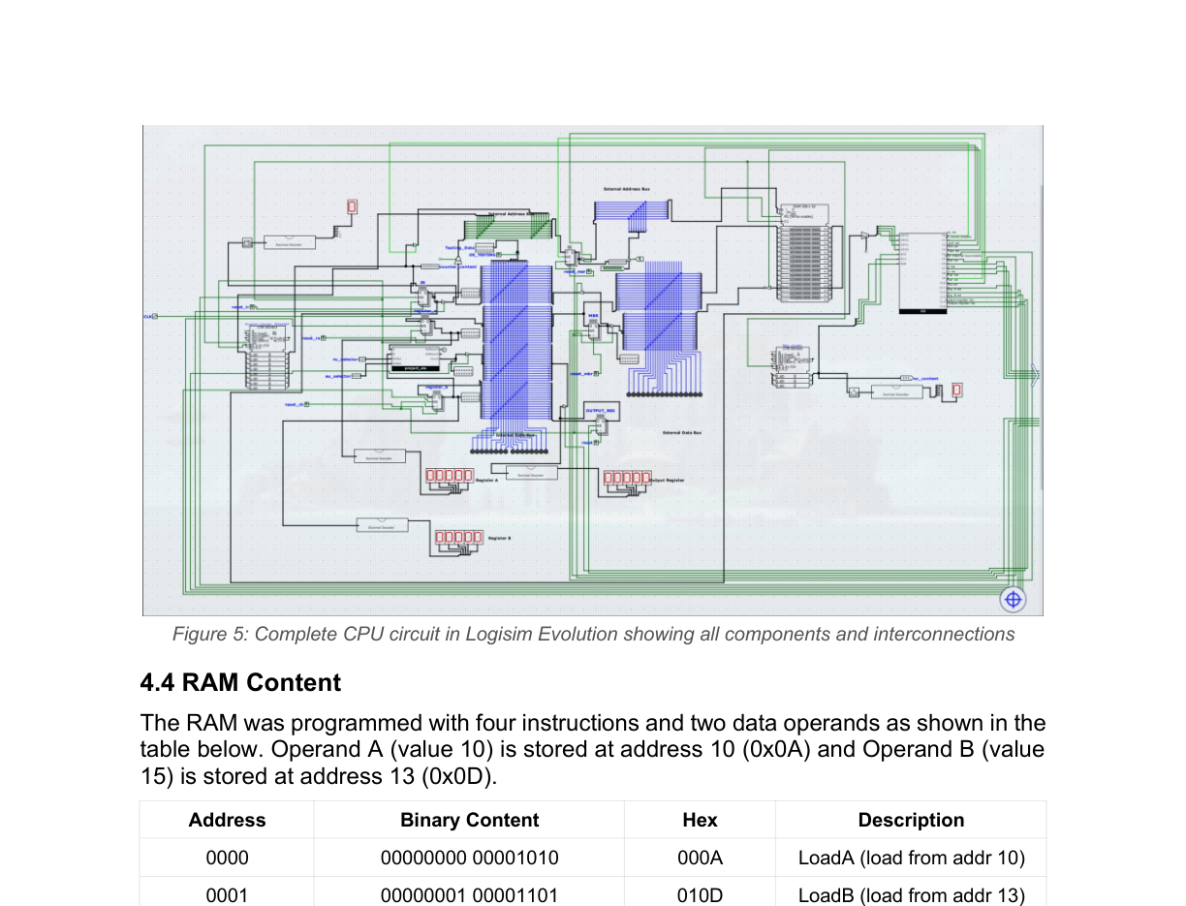
Figure 5: Complete CPU circuit in Logisim Evolution showing all components and interconnections

3.1.4 RAM Content
The RAM was programmed with four instructions and two data operands:
Address | Binary Content | Hex | Description
0000 | 00000000 00001010 | 000A | LoadA — load from addr 10
0001 | 00000001 00001101 | 010D | LoadB — load from addr 13
0010 | 00000010 00000000 | 0200 | Arithmetic operation
0011 | 00000011 00001010 | 030A | Store result to addr 10
0100–1001 | 00000000 00000000 | 0000 | Empty (reserved)
1010 | 00000000 00001010 | 000A | Operand A = 10
1011–1100 | 00000000 00000000 | 0000 | Empty
1101 | 00000000 00001111 | 000F | Operand B = 15
1110–1111 | 00000000 00000000 | 0000 | Empty

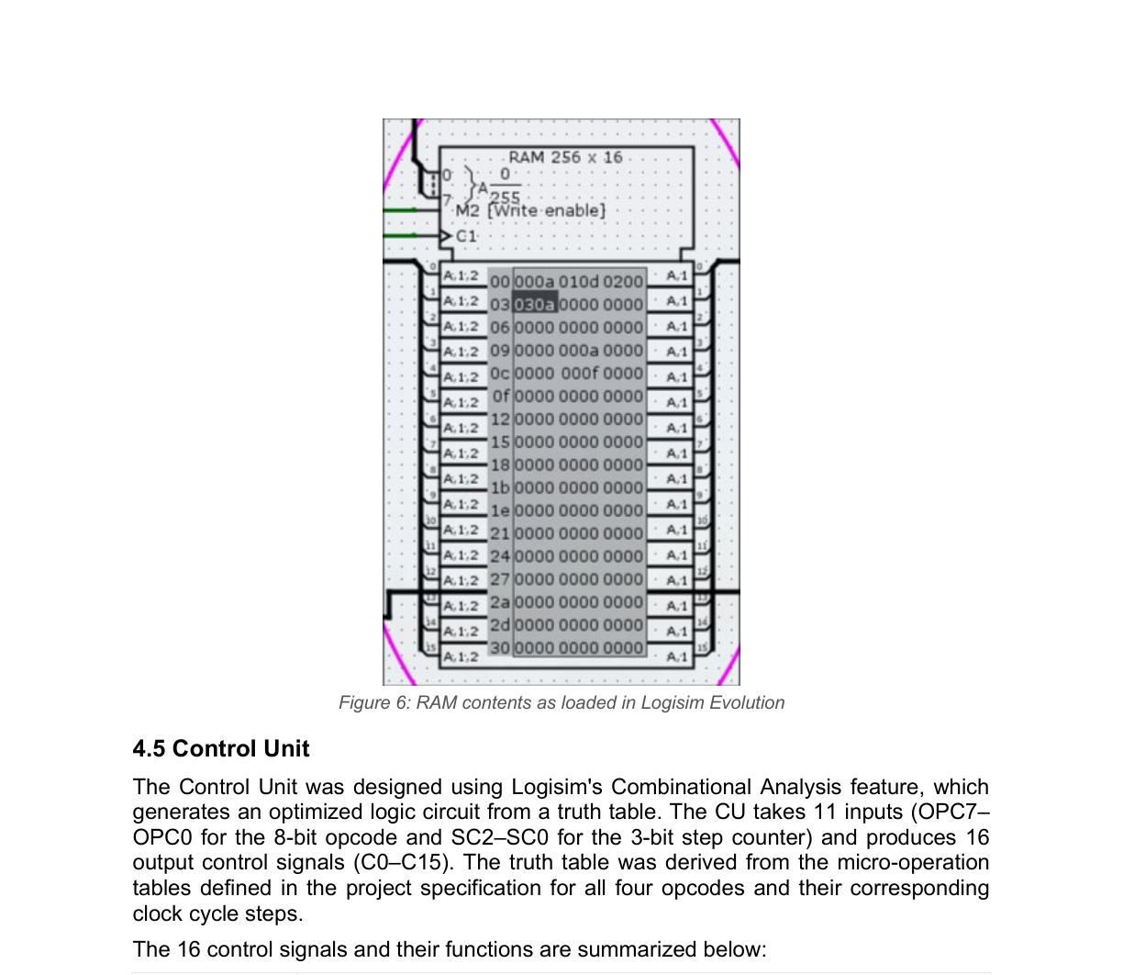
Figure 6: RAM contents as loaded in Logisim Evolution

3.1.5 Control Unit
The Control Unit was designed using Logisim's Combinational Analysis feature, which generates an optimized logic circuit from a truth table. The CU takes 11 inputs (OPC7–OPC0 for the 8-bit opcode and SC2–SC0 for the 3-bit step counter) and produces 16 output control signals (C0–C15). The truth table was derived from the micro-operation tables in the project specification for all four opcodes and their clock cycle steps.
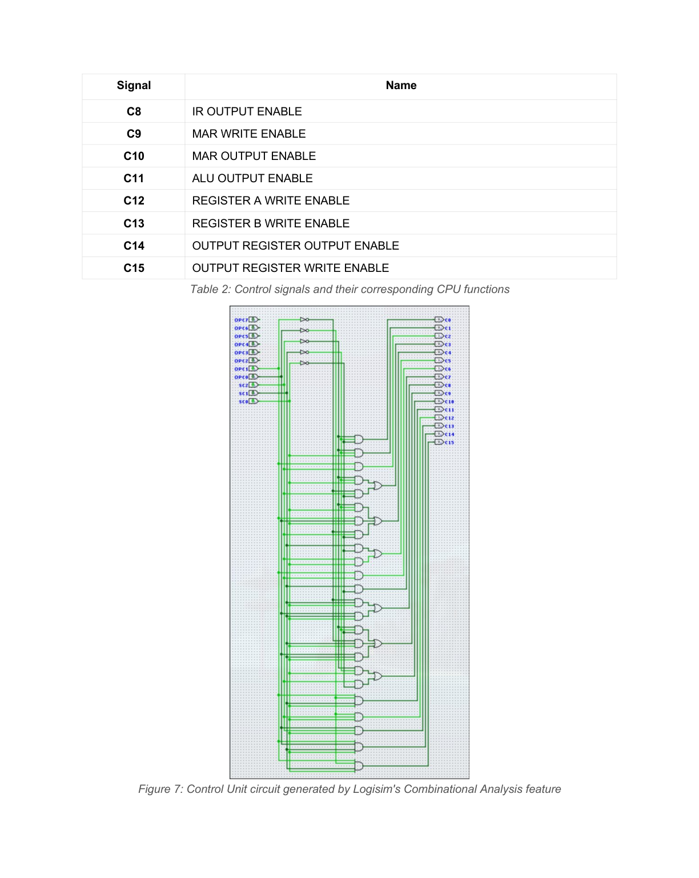
Figure 7: Control Unit circuit generated by Logisim's Combinational Analysis feature

3.2 Part B — VHDL Implementation
All components were written in VHDL-2008 and compiled using GHDL with --std=08. Waveforms were captured using GTKWave (.ghw format).

3.2.1 Data Memory
Synchronous-write, asynchronous-read RAM with 256 × 32-bit storage.
Entity: Data_Memory
Ports: clk, mem_access_addr(31:0), mem_write_data(31:0), mem_write_en, mem_read, mem_read_data(31:0)
Internal: RAM array [0..255] of STD_LOGIC_VECTOR(31 downto 0), initialized to all zeros

3.2.2 ALU
Combinational 32-bit ALU with zero flag. Five operations selected by 3-bit alu_control:
ALU Control | Operation | Instruction Usage
000 | ADD: a + b | addi, lw, sw
001 | SUB: a - b | beq, sub
010 | AND: a and b | R-type and
011 | OR: a or b | R-type or
100 | SLT: 1 if a < b | slt, slti

3.2.3 ALU Control Unit
ALUOp | Funct | ALUControl | Instruction
11 | xxxx | 000 (ADD) | addi, lw, sw
01 | xxxx | 001 (SUB) | beq
00 | 0000 | 000 (ADD) | R-type: add
00 | 0001 | 001 (SUB) | R-type: sub
00 | 0010 | 010 (AND) | R-type: and
00 | 0011 | 011 (OR) | R-type: or
00 | 0100 | 100 (SLT) | R-type: slt
10 | xxxx | 100 (SLT) | slti

3.2.4 Register File
8 registers (R0–R7), 32 bits wide. On reset, registers are pre-loaded with 0x00000001–0x00000008. Register 0 always reads as 0x00000000. Synchronous write, asynchronous dual-port read.

3.2.5 Instruction Memory
Read-only ROM indexed by lower 4 bits of the 32-bit PC. Outputs 0x00000000 when PC > 0x00000020.
PC Addr | Instruction | 32-bit Encoding
0 | add $t0,$t1,$t2 | 000000 00011 00101 00001 00000 100000
2 | sub $t2,$t2,$t3 | 000000 00101 00111 00101 00000 100010
4 | and $t1,$t2,$t0 | 000000 00101 00001 00011 00000 100100
6 | or $t2,$t3,$t1 | 000000 00111 00011 00101 00000 100101

3.2.6 CPU Control Unit
Decodes 3-bit opcode, generates all datapath control signals. Combinational, sensitive to reset and opcode.
Instr | RegDst | ALUSrc | MemtoReg | RegWr | MemRd | MemWr | Branch | ALUOp | Jump
R-type | 1 | 0 | 0 | 1 | 0 | 0 | 0 | 00 | 0
lw | 0 | 1 | 1 | 1 | 1 | 0 | 0 | 11 | 0
sw | 0 | 1 | 0 | 0 | 0 | 1 | 0 | 11 | 0
addi | 0 | 1 | 0 | 1 | 0 | 0 | 0 | 11 | 0
beq | 0 | 0 | 0 | 0 | 0 | 0 | 1 | 01 | 0
j | 0 | 0 | 0 | 0 | 0 | 0 | 0 | 00 | 1
jal | 2 | 0 | 2 | 1 | 0 | 0 | 0 | 00 | 1
slti | 0 | 1 | 0 | 1 | 0 | 0 | 0 | 10 | 0

4. Results and Discussion

4.1 Part A — Logisim Simulation Results

4.1.1 Manual Simulation
Manual simulation was performed by stepping through each clock cycle for all four instructions with auto-tick disabled. The control signals were activated and deactivated manually in the order specified by the project micro-operation tables:
- LoadA (cycles 0–5): Instruction at address 0 fetched into IR. Value 10 loaded from RAM address 10 into Register A.
- LoadB (cycles 0–5): Instruction at address 1 fetched. Value 15 loaded from RAM address 13 into Register B.
- Arithmetic (cycles 0–3): Instruction at address 2 fetched. ALU computed 10 + 15 = 25, stored in Output Register.
- Store (cycles 0–4): Instruction at address 3 fetched. Value 25 written back to RAM address 10.

4.1.2 Full Simulation Result
After interfacing the Control Unit with the CPU and enabling auto-tick, the CPU executed all four instructions autonomously. Register A displayed 10, Register B displayed 15, and the Output Register displayed 25 — the correct sum of the two operands.
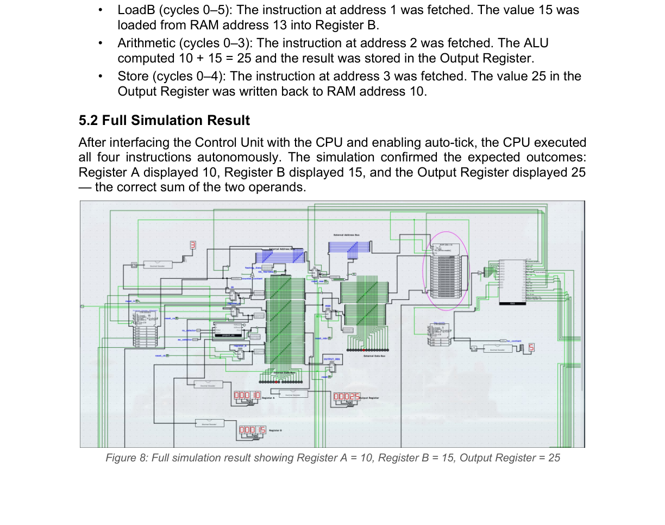
Figure 8: Full simulation result showing Register A = 10, Register B = 15, Output Register = 25

4.2 Part B — VHDL Simulation Results (Expected)

Task 1 — Data Memory
Operation | Address | Data Written | Expected Read
Write then Read | 2 | 1024 (0x00000400) | 1024
Write then Read | 4 | 429496 (0x00068DF8) | 429496

Task 2 — ALU
A | B | Control | Expected Result | Zero
2500 | 25000 | 000 (ADD) | 27500 | 0
540250 | 37800 | 001 (SUB) | 502450 | 0
53957 | 30000 | 010 (AND) | 20512 | 0
746353 | 846465 | 011 (OR) | 1044081 | 0
58847537 | 72464383 | 100 (SLT) | 1 (a < b) | 0

Task 3 — Register File
Register | Value Written | Hex Encoding | Expected Read
R1 | 1934858 | 0x001D890A | 0x001D890A
R3 | 8558447 | 0x008290AF | 0x008290AF
R5 | 203848544 | 0x0C28FB60 | 0x0C28FB60
R7 | 20670420 | 0x013B41D4 | 0x013B41D4

Task 4 — Instruction Memory
PC Addr | Instruction | Expected 32-bit Output
0 | add $t0,$t1,$t2 | 0x00A30820
2 | sub $t2,$t2,$t3 | 0x00A72822
4 | and $t1,$t2,$t0 | 0x00A11824
6 | or $t2,$t3,$t1 | 0x00E32825

Task 5 — Control Unit Signal Verification
Instr | RegDst | ALUSrc | MemtoReg | RegWr | MemRd | MemWr | Branch | ALUOp | Jump
add | 1 | 0 | 0 | 1 | 0 | 0 | 0 | 00 | 0
slti | 0 | 1 | 0 | 1 | 0 | 0 | 0 | 10 | 0
j | 0 | 0 | 0 | 0 | 0 | 0 | 0 | 00 | 1
jal | 2 | 0 | 2 | 1 | 0 | 0 | 0 | 00 | 1
lw | 0 | 1 | 1 | 1 | 1 | 0 | 0 | 11 | 0
sw | 0 | 1 | 0 | 0 | 0 | 1 | 0 | 11 | 0
beq | 0 | 0 | 0 | 0 | 0 | 0 | 1 | 01 | 0
addi | 0 | 1 | 0 | 1 | 0 | 0 | 0 | 11 | 0

5. Challenges and Solutions

7-Segment Display Complexity
Implementing a full decimal decoder using ROMs for 16-bit values proved complex due to Logisim's 32-bit maximum ROM data width. This was resolved by adopting hex digit displays, which directly accept 4-bit inputs and eliminate the need for a ROM-based lookup table.

Bit Width Mismatches in Logisim
Connecting components with different bit widths (e.g., the 4-bit PC to the 16-bit decimal decoder input) required bit extenders configured to zero-extend the narrower signals to the required width.

Control Unit Truth Table Entry
Entering the complete truth table for all four opcodes and six step counter values into Logisim's Combinational Analysis tool was tedious but ensured the CU generated the correct control signals for every micro-operation.

Wire Conflicts in the Datapath
Conflicting output enables caused error conditions (red wires) and floating bus conditions (blue wires). These were resolved by carefully sequencing OE and WE signals to ensure only one component drives the bus at a time.

GHDL Multiplication Width Errors
Multiplying two 32-bit UNSIGNED values in VHDL produces a 64-bit result. Assigning directly to a 33-bit signal caused a bound check failure. An intermediate UNSIGNED(63 downto 0) variable was used to capture the product before slicing to 32 bits.

Duplicate Signal Drivers in VHDL
A copy-paste error resulted in parity_check and PARITY_FLAG being driven by duplicate concurrent assignments. GHDL correctly identified this as a multiple-driver error, which was resolved by removing the duplicate assignments.

Infinite Simulation Hang in GHDL
The testbench clock process ran indefinitely with no exit condition. std.env.stop was added at the end of the stimulus process to terminate the simulation cleanly.

6. Conclusion and Future Work
This project successfully demonstrated the design and implementation of a functional 16-bit CPU in Logisim Evolution and a 32-bit MIPS-compatible processor in VHDL. Starting from a 16-bit ALU with 20 operations, the Logisim design progressively incorporated registers, a datapath, a program counter, RAM interfacing, and a microarchitecture-based Control Unit. The completed CPU correctly executed a LoadA, LoadB, Arithmetic, and Store instruction sequence, producing the expected result of 10 + 15 = 25.
The VHDL implementation extended these concepts to a 32-bit single-cycle MIPS architecture, with all six components verified through GHDL testbenches. The exercise provided valuable practical insight into the fetch-decode-execute cycle, micro-operation sequencing, and the role of control signals in coordinating CPU components.
Potential future improvements include:
- Expanding the instruction set to support branching and jump instructions in the Logisim design
- Pipelining the 32-bit MIPS processor with hazard detection and forwarding units
- Adding floating-point operation support to the ALU
- Synthesizing the VHDL design to an FPGA target using Vivado or Quartus
- Implementing a cache memory hierarchy between the CPU and main memory

7. References
Prof. Robert A. Sowah, CPEN 315 Final Project Specification, University of Ghana, School of Engineering Sciences, 2026.
Patterson, D. A., & Hennessy, J. L. (2013). Computer Organization and Design: The Hardware/Software Interface (5th ed.). Morgan Kaufmann.
Pedroni, V. A. (2020). Circuit Design with VHDL (3rd ed.). MIT Press.
Logisim Evolution Documentation. Available at: https://github.com/logisim-evolution/logisim-evolution
GHDL Documentation. Available at: https://ghdl.github.io/ghdl/

