* Deployment, Management and Automation
* Compute
* Storage
* Messaging
* Email
* Networking
* Security
* Operating System & Data Transfer
* Development Languages and Runtime Support

|  |  |  |  |
| --- | --- | --- | --- |
| Point | What | Amazon | Azure |
| Deployment, Management, Automation | Visual Studio Integration | Amazon SDK | Built in |
|  | Command line | Many languages are supported | Many languages are supported |
|  | API | X | X |
|  | Configuration | Json templates for different environments | Publishing profiles for different web environments |
|  | Supported by CI | X | X |
|  | Fully automatable | X | X |
|  | Web management | Pretty good | Pretty good |
| Storage | Data stream processing | Kinesis | Event Hubs |
|  | Complex Event Processing | Elastic Map Reduce | StreamInsight |
|  | SSD | X | X |
|  | Blob | Simple Storage Service (S3) | Azure Blob Storage |
|  | Tables | SimpleDB | Table storage |
|  | Queues | SQS |  |
|  | Files | Simple Storage Service (S3) | Azure File Storage (SMB connector to cloud), mounted drive in explorer on vm in cloud, API for on prem |
|  | Durable Disk |  | Azure Disks |
|  | Local network to cloud storage | Storage Gateway | Site to Site VPN |
|  | Search |  | Azure Search (Elastic Search implementation) |
|  | Nosql |  | DocumentDB |
|  | Long term storage | Glacier |  |
|  | Block storage | Elastic Book Store | Azure Drive |
| Networking | Active Directory as a service |  | X |
|  | VPN | AWS Direct Connect | Site to Site VPN |
|  | On Prem |  | Azure Pack |
| Compute | Large scale | EC2 | HPC (high performance compute) |
|  | Large scale on prem story? |  | X |
|  | Flexible pricing story? | X (instance types: On-Demand, reserved, spot) |  |
|  | Elasticity | Elastic Beanstalk |  |
| Messaging | Queue | Simple Queue Service | Queues |
|  | Service Bus |  | Service Bus |
|  | Large scale injection | Kinesis | Event Hubs |
|  | Notifications | Simple Notification service |  |
| Email |  |  |  |

# Pricing

Narrative around “But pricing isn’t just the fixed cost of a running service. You need to ask yourself how it fits into the day to day activities of the applications you are creating. Does the infrastructure story blend well with the dev ops story and the development story. Can you do some testing locally on your hardware and not pay for the cloud cost? Etc…”

<https://cloudvertical.com/cloud-costs#cloud_costs/index>

VMs

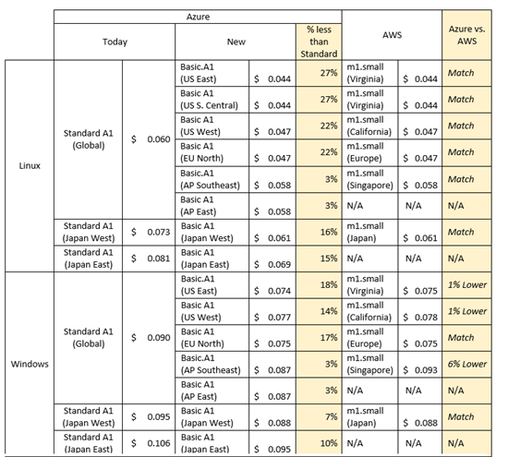

Memory Intensive

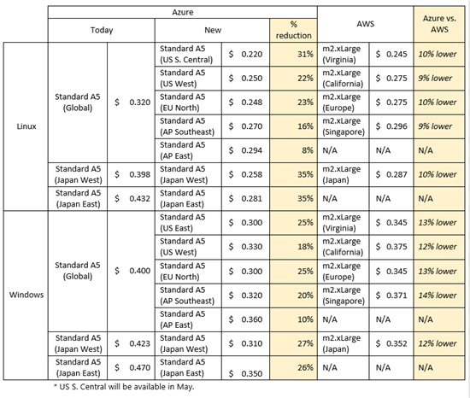

Storage (blobs)

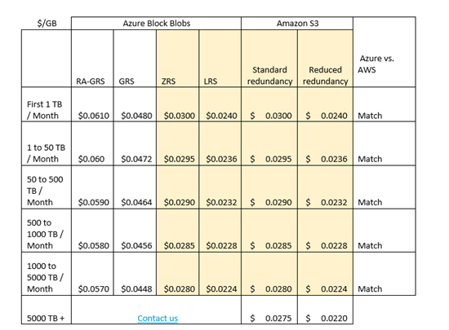

<http://azure.microsoft.com/blog/2014/03/31/microsoft-azure-innovation-quality-and-price/>

# CEM

Data stream processing, Complex Event Processing (CEP)

**Log and Event Data Collection**

Collect log and event data from numerous sources to be processed generating metrics, or powering large dashboard style applications to allow for near real time decision making.

**Application and Service Alerting**

Collect high volume log data from applications and services to be processed for alert generation.

**Real time analytics**

Analyze data from click stream metrics collected from various web properties to optimize the user experience in near real time.

**Data capture from an Internet of Things**

Collect data from thousands of devices in real time to monitor equipment in the field or trucks on the road to see when service is required before it gets expensive.

**Buffer yourself from a social fire hose**

Reliably take in a large stream of data from social networks and process it to learn about your brand in real time.

# CEM Research

<http://www.slideshare.net/AmazonWebServices/realtime-streaming-and-querying-with-amazon-kinesis-and-amazon-elastic-mapreduce-36852319>

# Network Research

<file:///C:/Users/Andy/Downloads/Windows_Azure_Pack_Datasheet.pdf>

