## Description of the Project

In this project the user will have 3 games to choose from.

* Egunean Behin – A trivia game
* Paper Scissors Stone
* Hangman

The user will be prompt to choose a game and the program will run that game.

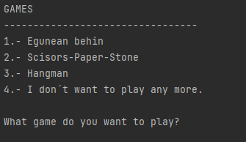

### Egunean behin

* Collaborator Asier Ferrero
* The game will ask questions with 3 answer options.
  + Each correct answer will give you 10 points.
  + Incorrect answer deducts 4 point.
  + Speed gives extra points:
    - <50sec +30points
    - Between 51 and 60 27 points
    - Etc…
* At the end of the game it gives the user the points they got.

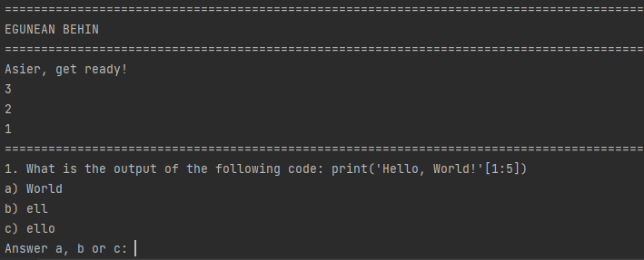

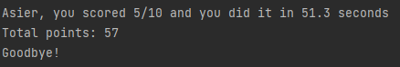

### Paper Scissors Stone

* Collaborator Alberto Cáceres
* The game is to the best of 5.
* The user will put a number from 0 to 2 to chose Scissors, paper or stone.
* The programme will randomly choose an option and draw the pic of the option.
* The two hands will be compared and it will tell if it´s a draw or who wan.
* At the end of the game, the programme will tell the user who the winner was and the final score.

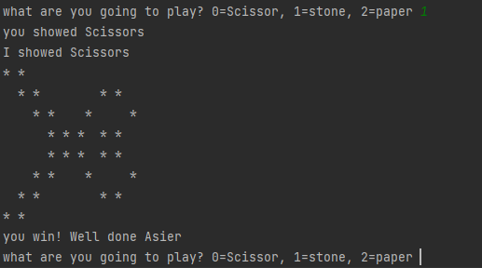

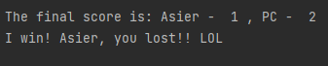

### Hangman

* Collaborator Iker Palomares
* The game will chose a name from a list and the user will have to try and guess it by imputing letters.
* If the letter is in the word, the programme will show where it is located in the word.
* If the letter is not in the word, it will draw the next part of the hang-man.
* The user will have wrong guesses before he loses.

