**Sequence Diagram**

There are total 12 diagram in our sequence diagram-

* Customer search and address
* Create new category
* Create new item
* Adding item to cart
* Editing cart item to cart
* Customer order
* Restaurant order
* Rider order
* Admin order
* Customer feedback
* Promo

Some module were parted into multiple sequence diagram for the convenience of drawing the diagrams.

**Customer Search and Address**

This diagram shows sequence diagram needed for customer operations and search operations.

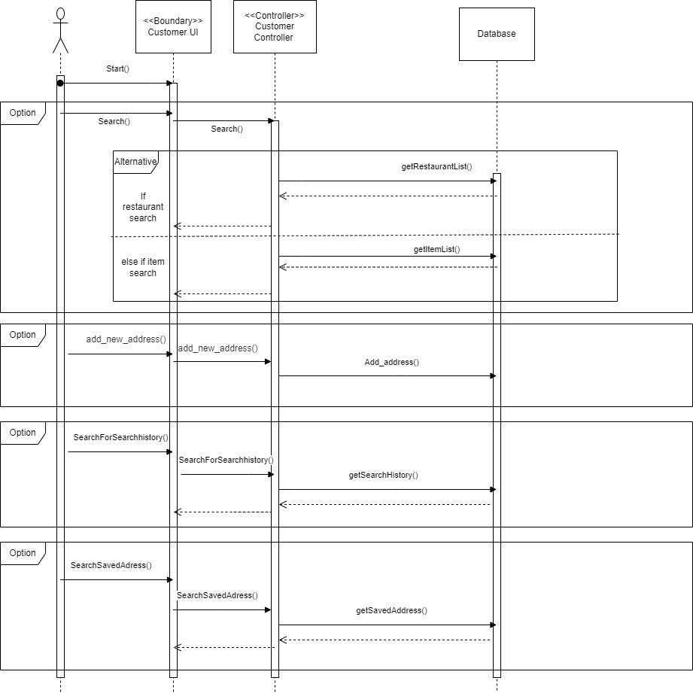

**Create New Category**

This diagram shows sequence diagram related to creating new category in Customer end.

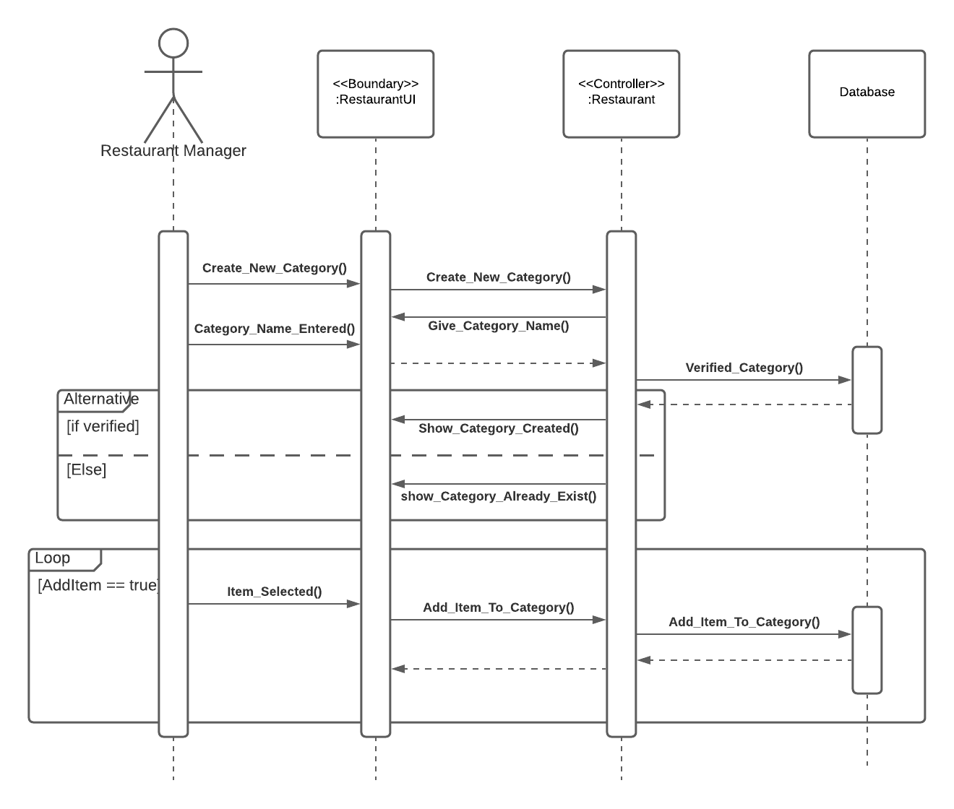

**Create New Item**

This diagram shows the sequence diagram need to create a new item in restaurant end.

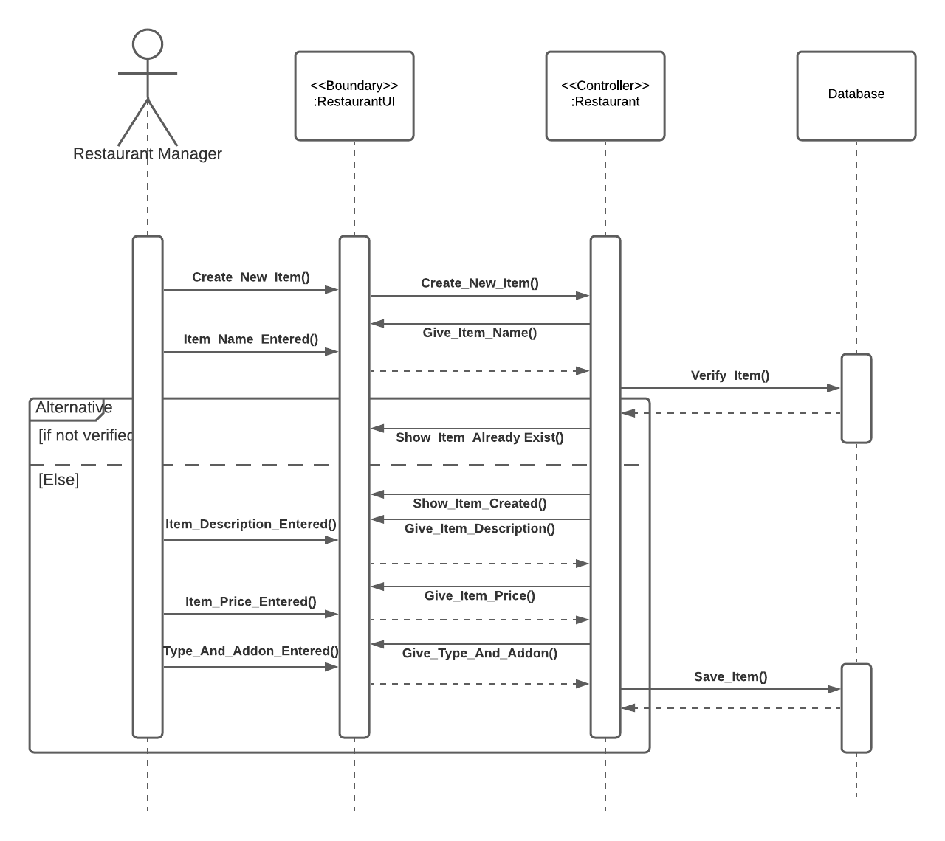

**Adding item to Cart**

This diagram shows sequence diagram related to building up order Cart in customer end.

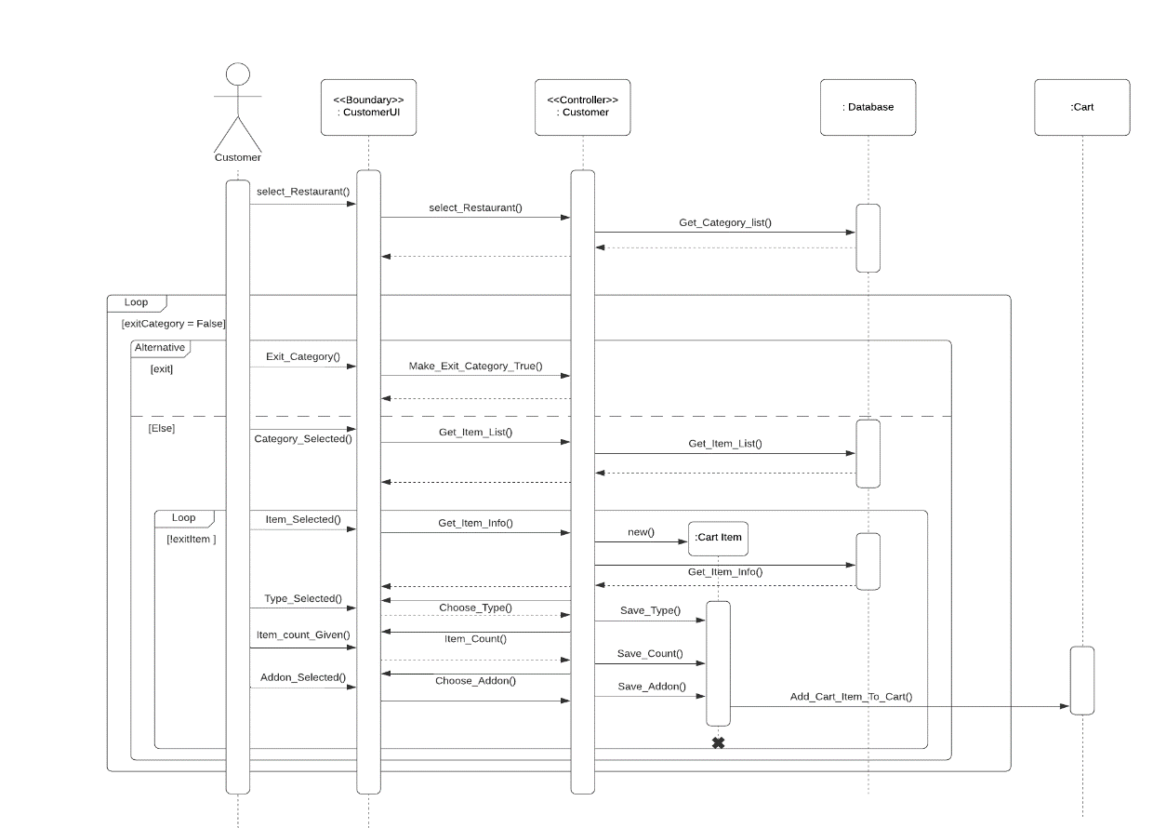

**Editing Cart-item to Cart**

This diagram shows sequence diagram related to editing cart for making an order.

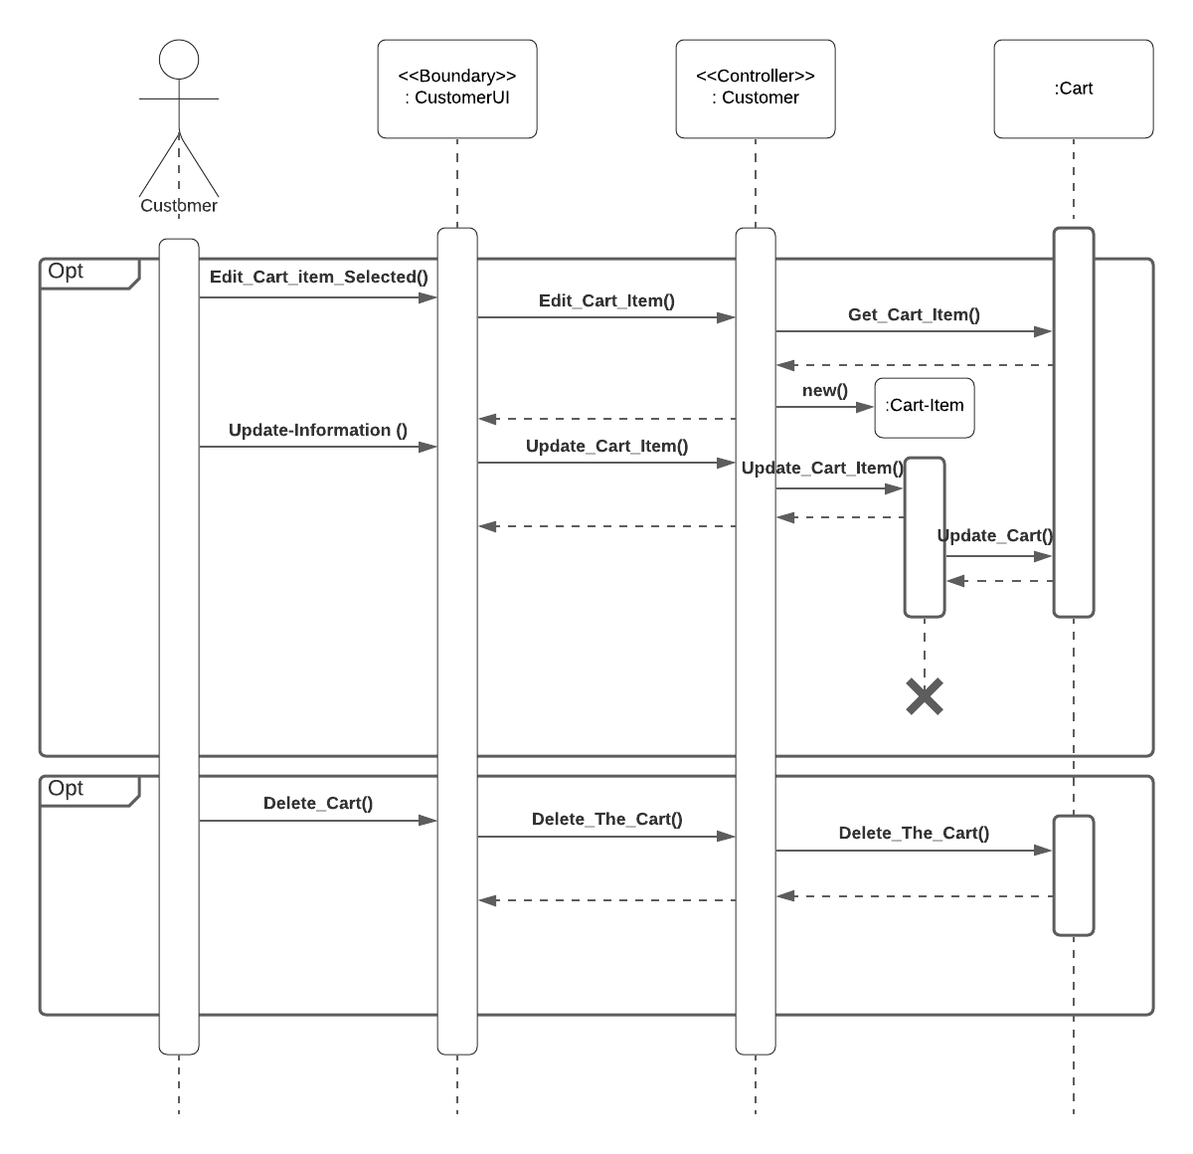

**Customer Order**

This diagram shows sequence diagram of making an order from customer end.

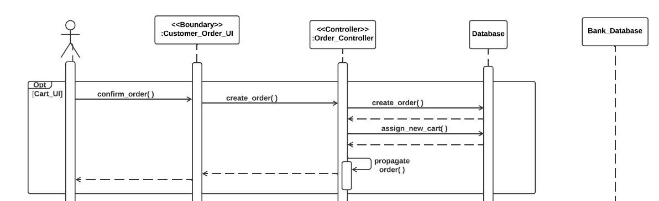

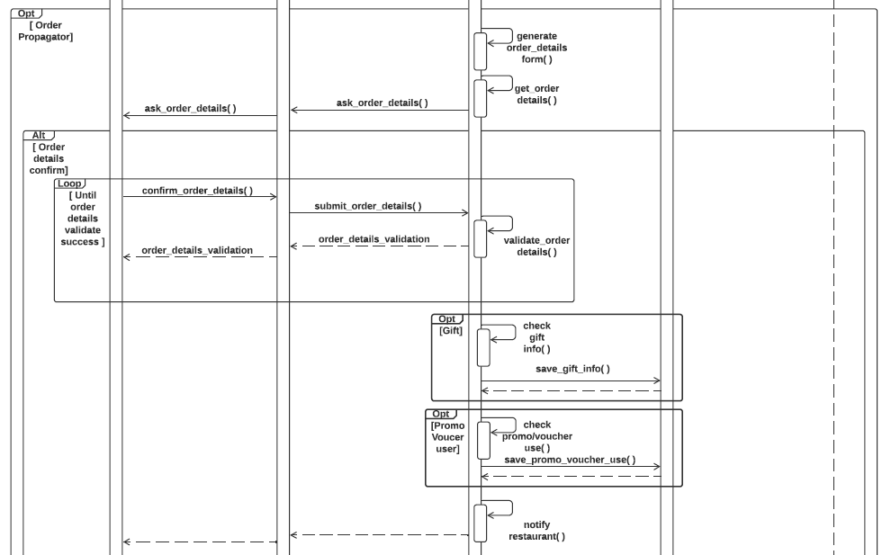

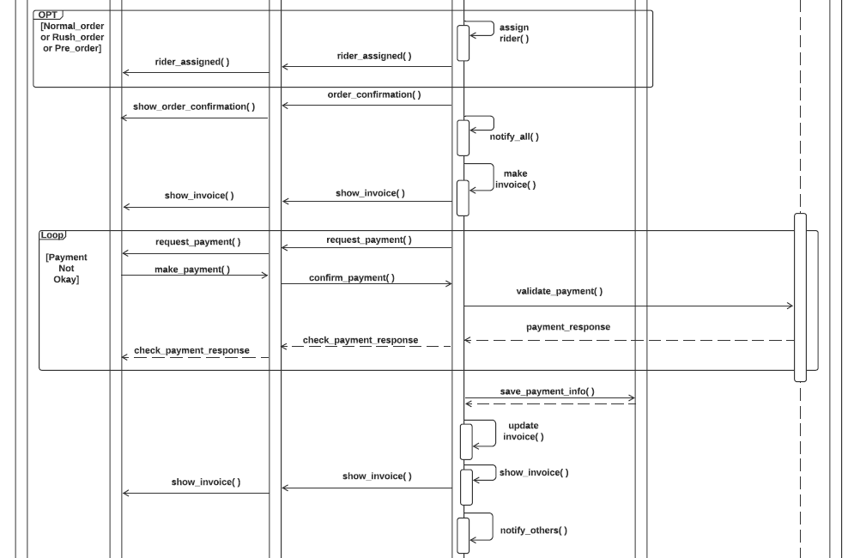

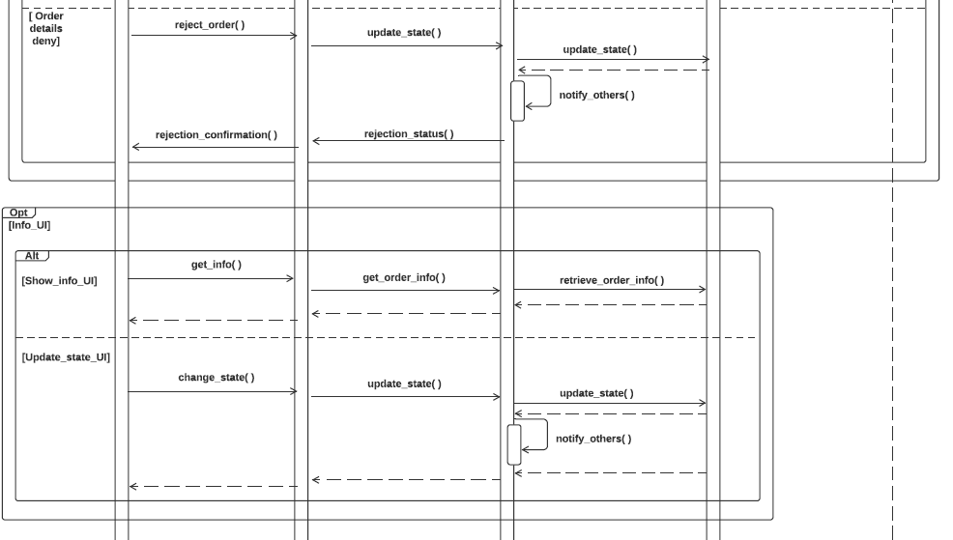

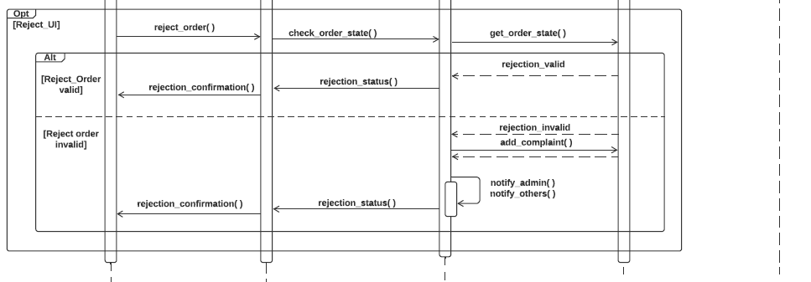

**Restaurant Order**

This diagram shows sequence diagram related to operations of an order in restaurant end. This is part of Order module.

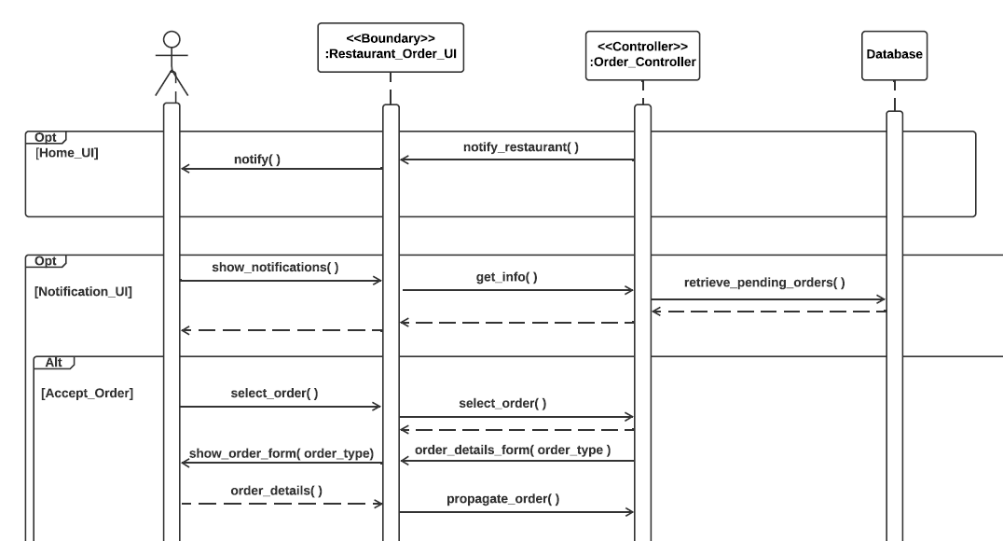

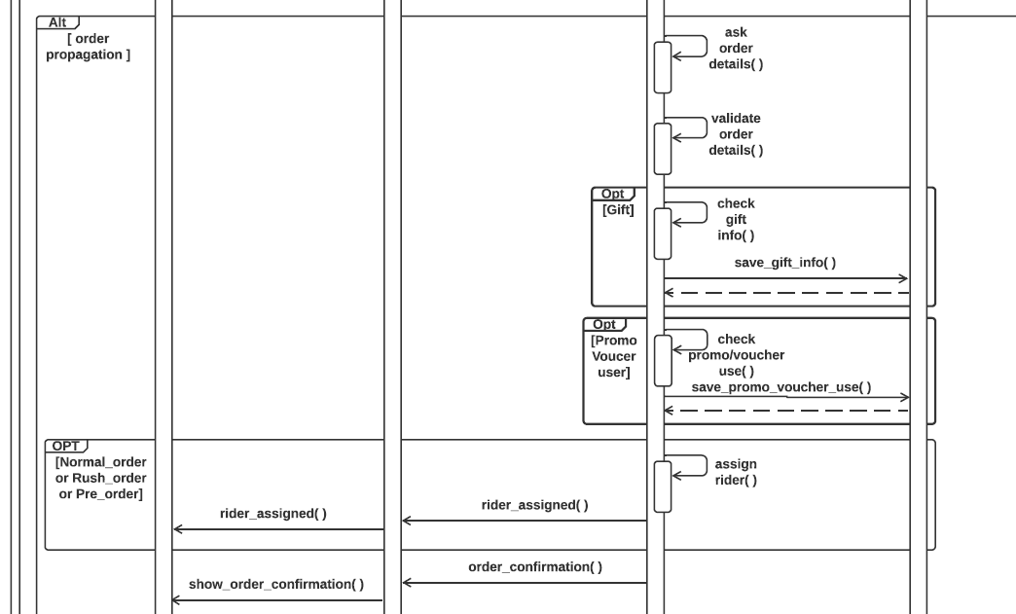

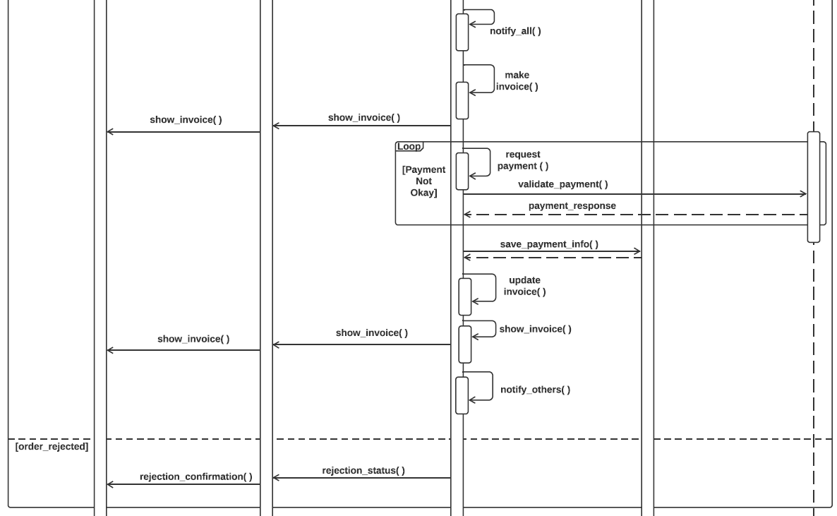

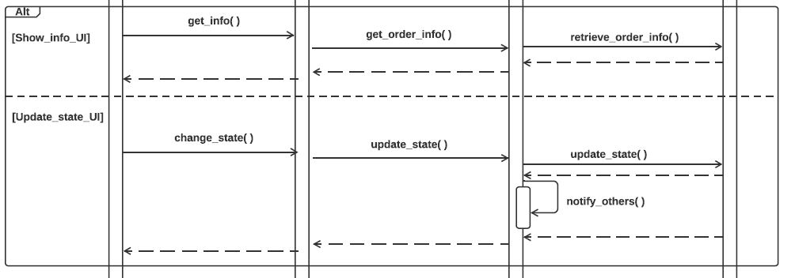

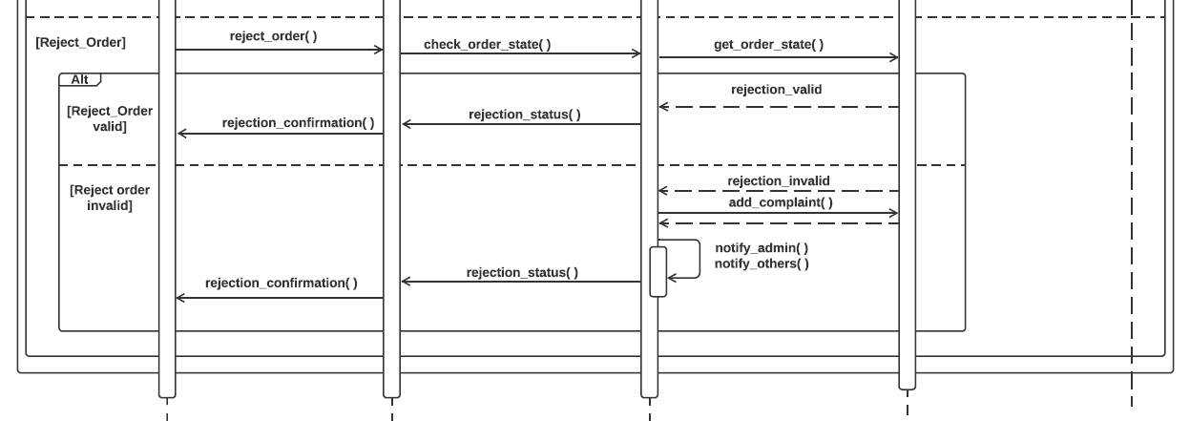

**Rider Order**

This diagram shows sequence diagram related to operations of an order in rider end. This is part of Order module.

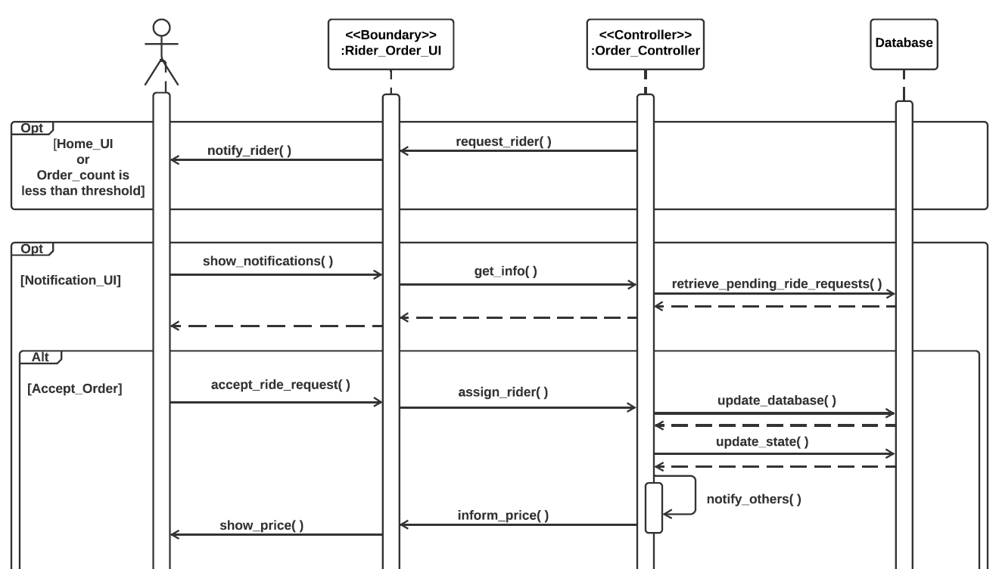

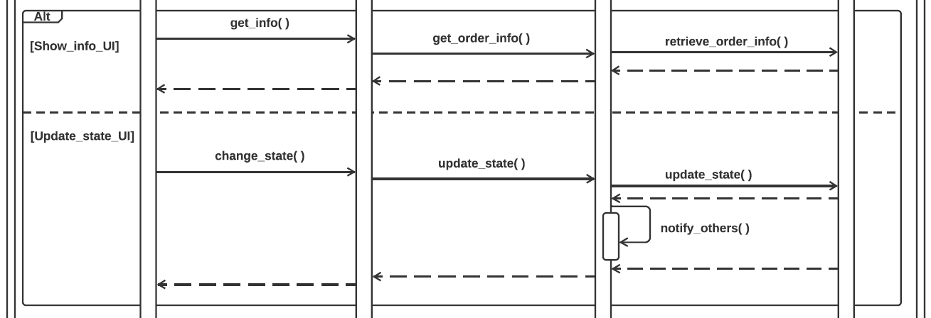

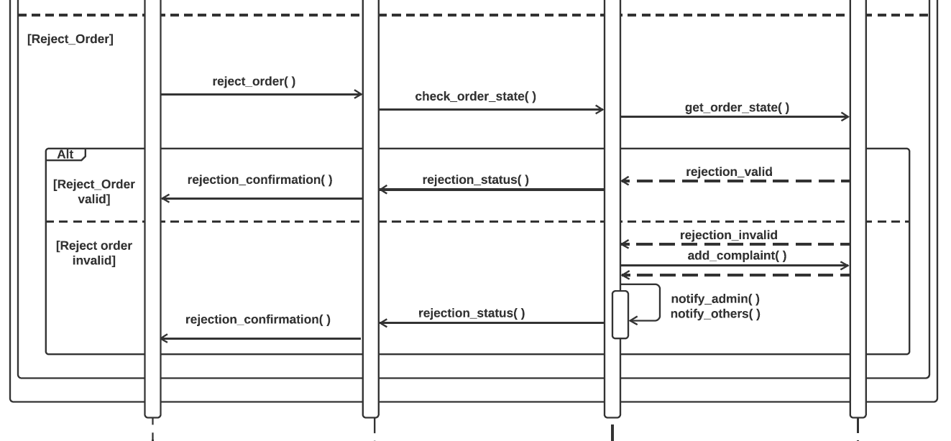

**Admin Order**

This diagram shows sequence diagram related to operations of an order in admin end. This is part of Order module.

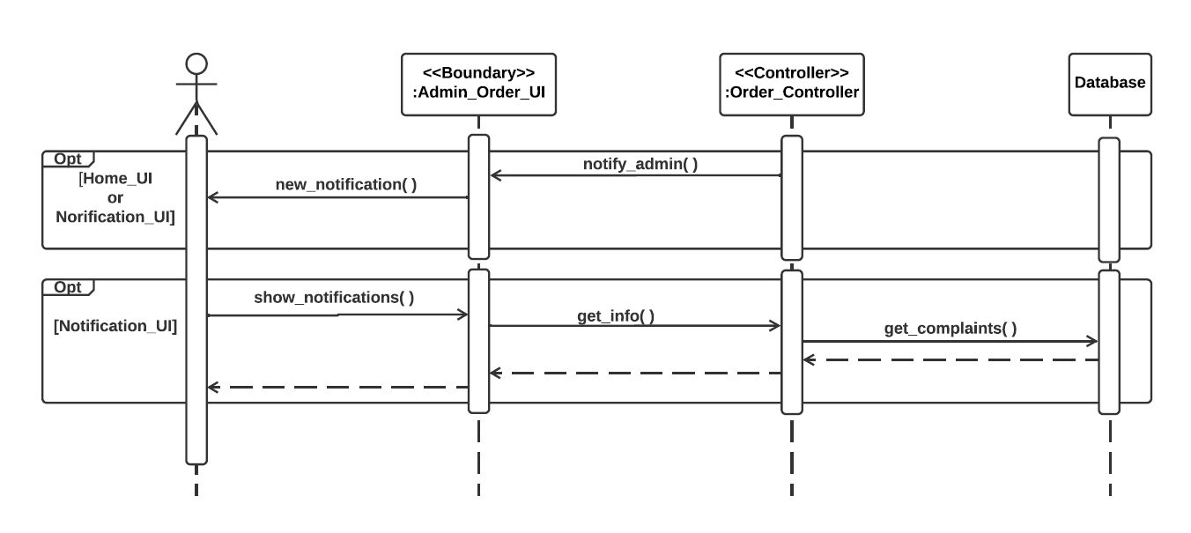

**Customer Feedback**

This diagram shows sequence diagram related to making review on an order in customer end.

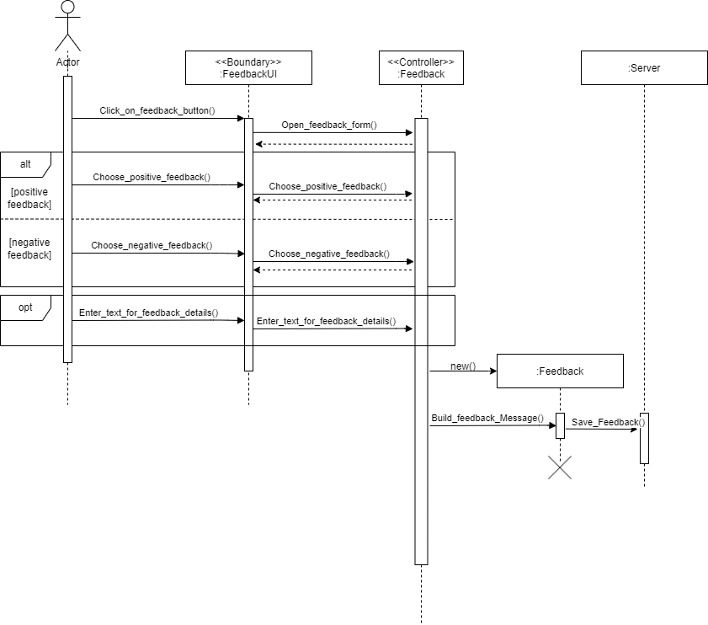

**Promo**

This diagram shows sequence diagram related to promos.

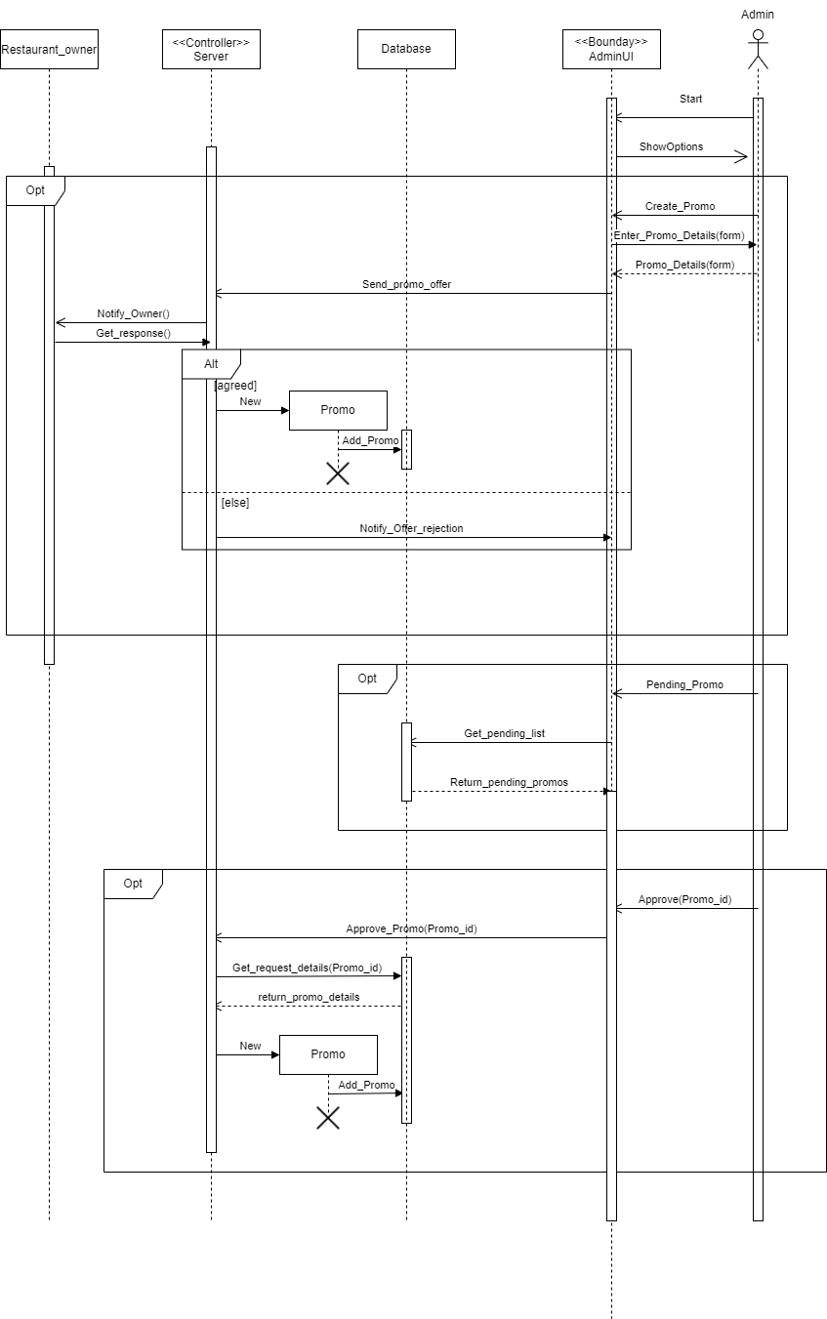

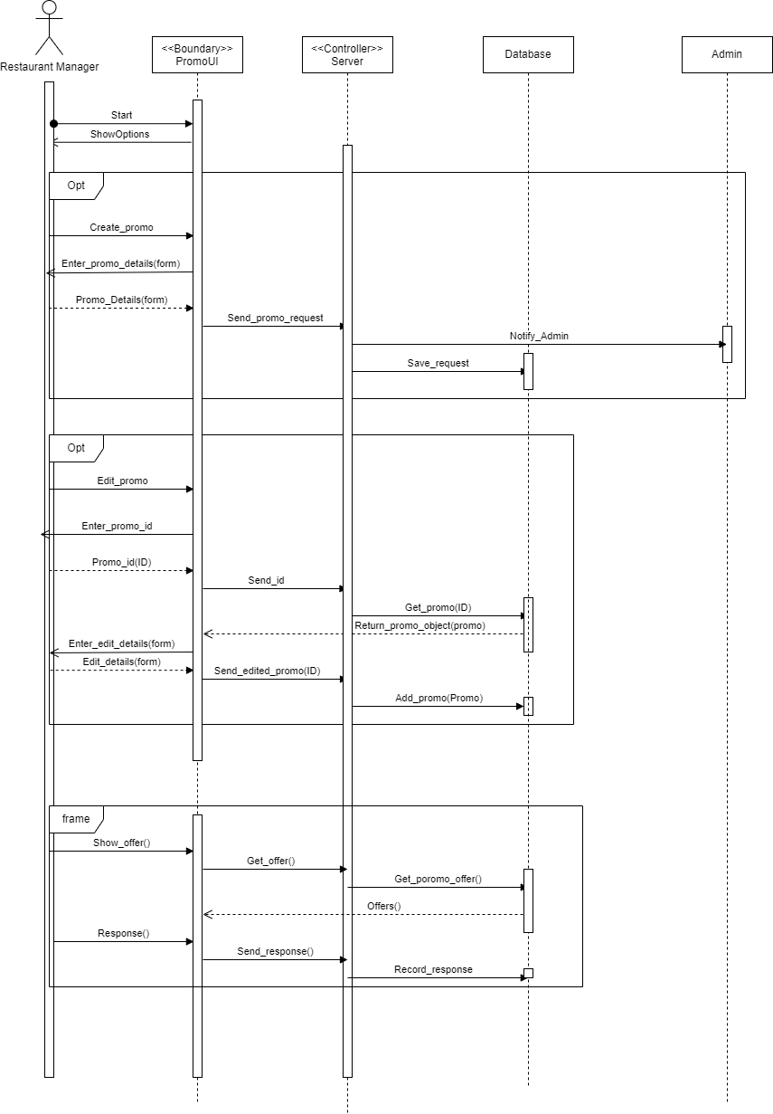

**The feedback provided in the class:**

1. We were advised to prefer assignment of rider from restaurant end. This was later edited while implementing a significant module of our project.