Web Portal User Manual

When you enter the web portal, you will see the home screen like the image below.

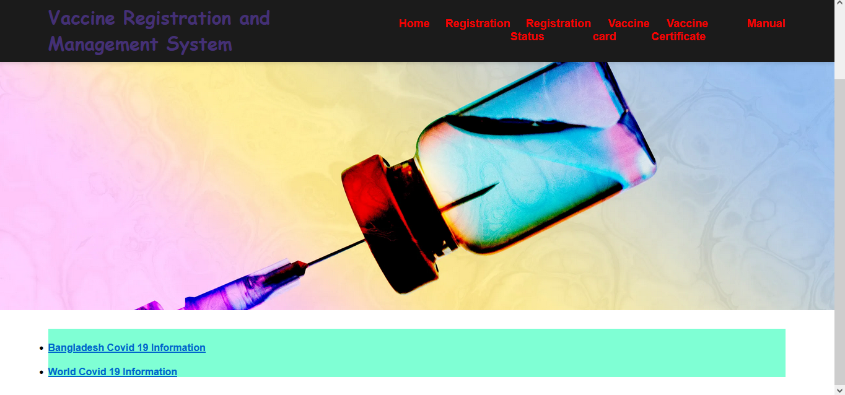

The description of the five steps mentioned in the figure is given below-

**STEP-1:**

You can return to the first page from any other page by clicking the “Home” button.

**STEP-2:**

Clicking on the “Registration” button will open the page like the image below-

Fill in the fields shown in the picture and press the “Register” button.

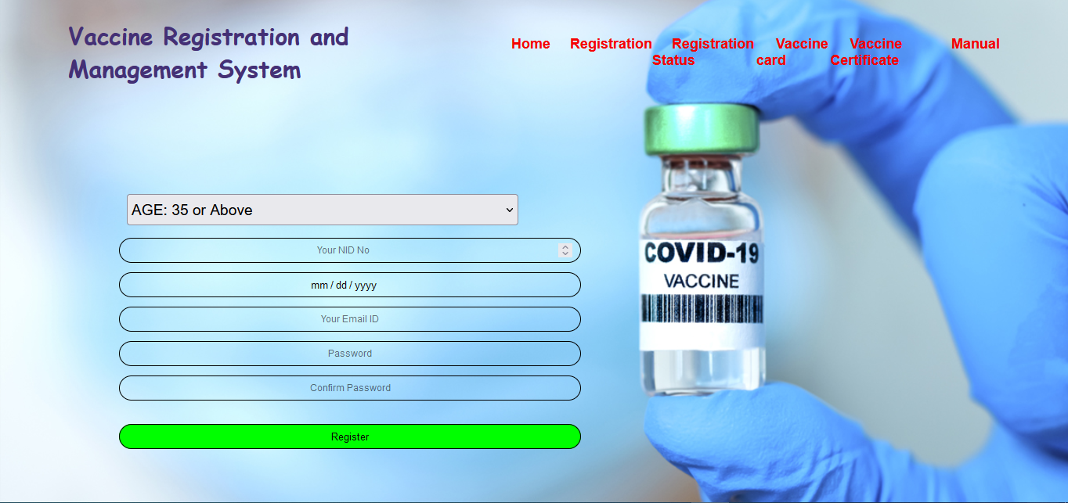

**STEP-3:**

Clicking on the “Registration Status” button will open a page like the image below-

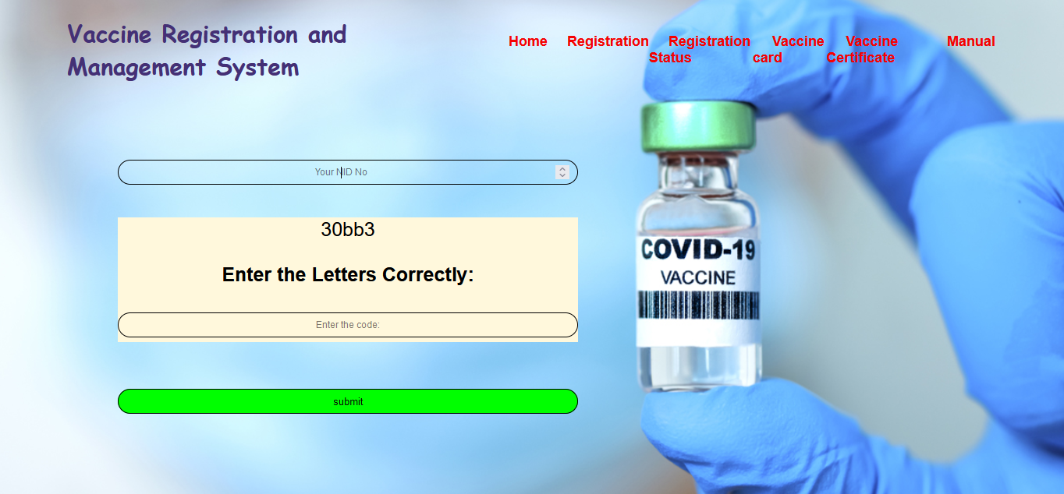



Here you have to enter the correct information in the blanks above and click on the “Click” button. If the information matches to the information given at the time of registration, then you will check the registration status.

**STEP-4:**

Once the registration is completed, the vaccine card can be downloaded going to the vaccine card option.

**STEP-5:**

After completing two doses of Covid-19 vaccine, the certificate can be collected from the web portal by going to the “Vaccine Certificate” option.

