CLUBSPHERE: SMART CLUB MEMBERSHIP, FINANCE & EVENT ANALYTICS SYSTEM
MINI PROJECT REPORT
24MNC201 ESSENTIALS OF OFFICE AUTOMATION
Submitted
By
Asif Hussain, AJC25CS058
In partial fulfillment for the award of the degree
of
BACHELOR OF TECHNOLOGY
IN
COMPUTER SCIENCE AND ENGINEERING

DEPARTMENT OF COMPUTER SCIENCE AND ENGINEERING
AMAL JYOTHI COLLEGE OF ENGINEERING (AUTONOMOUS),
KANJIRAPALLY 686 518
OCTOBER 2026
AMAL JYOTHI COLLEGE OF ENGINEERING
(AUTONOMOUS), KANJIRAPALLY
DEPARTMENT OF COMPUTER SCIENCE AND ENGINEERING
BONA FIDE CERTIFICATE
This is to certify that the Mini Project Report entitled “CLUBSPHERE: SMART CLUB MEMBERSHIP, FINANCE & EVENT ANALYTICS SYSTEM” submitted by Asif Hussain (AJC25CS058), in partial fulfillment of the requirement for the award of the Bachelor of Technology in Computer Science and Engineering is a bona fide record of the work carried out at AMAL JYOTHI COLLEGE OF ENGINEERING (AUTONOMOUS), under our guidance and supervision.

INTERNAL EXAMINER  Lis Jose  Assistant Professor  Department of Computer Science and Engineering | HEAD OF THE DEPARTMENT  Dr Juby Mathew  Professor  Department of Computer Science and Engineering

ACKNOWLEDGEMENT
I thank God Almighty for the blessings that helped me to complete this mini project successfully.
I thank my parents for the sacrifices they have made in their lives to give me the best education and to help me become a promising professional of tomorrow.
I express my sincere gratitude to the Principal and to the Head of the Department of Computer Science and Engineering of Amal Jyothi College of Engineering (Autonomous), Kanjirapally, for providing the facilities and encouragement needed for this work.
I am deeply thankful to Lis Jose, Assistant Professor, Department of Computer Science and Engineering, for the guidance, valuable suggestions and support given during the course 24MNC201 Essentials of Office Automation.
I also thank my friends and classmates for their motivation and feedback while I developed and tested the project.
Asif Hussain
ABSTRACT
College clubs must manage member records, fee collection, events and attendance, but these tasks are often handled in separate lists that are slow to update and easy to get wrong. This mini project presents ClubSphere, a Smart Club Membership, Finance and Event Analytics System built entirely in Microsoft Excel without macros or programming. The workbook links member, fee, event and attendance records through unique Member IDs and Event IDs, and formulas such as EDATE, IF, COUNTIFS, SUMIFS and INDEX with MATCH calculate renewal dates, membership status, fee balances and attendance percentages automatically. Data validation, dropdown lists and conditional formatting reduce entry errors and highlight overdue or expiring records. A Member Profile sheet, a Reports sheet and a Dashboard with key indicators, alerts, charts and leaderboards present the results and update whenever a record changes. Testing with fictional data of 40 members, 52 fee records and 7 events showed that all calculations responded correctly to changes. An extension module built with Microsoft Word mail merge uses the same data to produce 40 membership confirmation letters, 17 renewal reminders, 16 fee notices and 40 ID cards without retyping. The merged documents were checked against the data source and saved as Word and PDF files. Together the two parts show that built-in office tools alone can deliver a practical administration and communication system for a small organisation.
Keywords: Microsoft Excel, Microsoft Word, Mail Merge, Office Automation, Club Management, Dashboard, Data Validation
LIST OF FIGURES
Figure No Figure Title Page No
Figure 1.1 Overview of the ClubSphere system 1
Figure 3.1 ClubSphere Dashboard 6
Figure 3.2 Member Register sheet 7
Figure 3.3 Fee Tracker sheet 7
Figure 3.4 Event Manager sheet 7
Figure 3.5 Attendance sheet 8
Figure 3.6 Member Profile sheet 9
Figure 3.7 Reports sheet 10
Figure 4.1 Relationship between the sheets of ClubSphere 12
Figure 4.2 Lists sheet with dropdown values and settings 14
Figure 4.3 Formulas in the Member Register (formula view) 14
Figure 4.4 Formulas in the Fee Tracker (formula view) 15
Figure 4.5 Formulas in the Event Manager (formula view) 15
Figure 4.6 Read Me sheet of the workbook 15
Figure 5.1 Test 1: Fee Tracker before and after paying FEE005 17
Figure 5.2 Test 1: Dashboard totals before and after the payment 17
Figure 5.3 Test 2: new member CS041 added to the Member Register 18
Figure 5.4 Test 3: Member Profile for Member ID CS012 18
Figure 5.5 Test 4: Dashboard counts for two different report dates 19
Figure 6.1 Data source worksheet Members_All (selected columns) 22
Figure 6.2 Membership confirmation letter: main document and merged output 24
Figure 6.3 Renewal reminder: main document and merged output 24
Figure 6.4 Fee payment notice: main document and merged output 25
Figure 6.5 Membership ID card sheet: main document and merged output (top half of page) 25
Figure 6.6 Mail merge workflow in Microsoft Word 26
LIST OF TABLES
Table No Table Title Page No
Table 2.1 Comparison of manual records and ClubSphere 4
Table 4.1 Sheets of the ClubSphere workbook 11
Table 4.2 Key formulas used in ClubSphere 13
Table 4.3 Validation rules and conditional formatting 14
Table 5.1 Test cases and results 16
Table 5.2 Key indicators on the dashboard 19
Table 5.3 Department-wise summary 20
Table 5.4 Payment status summary 20
Table 5.5 Event performance 20
Table 6.1 Main merge fields in the data source 23
Table 6.2 Test cases for the mail merge 26
Table 6.3 Merged outputs produced 27
LIST OF SYMBOLS AND ABBREVIATIONS
Abbreviation | Meaning
KPI | Key Performance Indicator
UI | User Interface
ID | Identifier
VBA | Visual Basic for Applications
Rs. | Indian Rupee
CSE, ECE, EEE, ME, CE, MCA | Computer Science, Electronics and Communication, Electrical and Electronics, Mechanical, Civil Engineering, Master of Computer Applications

TABLE OF CONTENTS
CHAPTER NO. TITLE PAGE NO.
ACKNOWLEDGEMENT i
ABSTRACT ii
LIST OF FIGURES iii
LIST OF TABLES iv
LIST OF SYMBOLS AND ABBREVIATIONS v
1 INTRODUCTION 1
1.1 Background 1
1.2 Motivation 1
1.3 Scope of the Project 1
1.4 Organisation of the Report 2
2 LITERATURE REVIEW 3
2.1 Spreadsheets for Record Keeping 3
2.2 Dashboard Design 3
2.3 Problem Statement 3
2.4 Gap Identification 3
2.5 Design Objectives 4
2.6 Design Constraints 4
3 UI DESIGN OVERVIEW 6
3.1 Design Principles 6
3.2 Dashboard 6
3.3 Member Register 7
3.4 Fee Tracker 7
3.5 Event Manager 7
3.6 Attendance 8
3.7 Member Profile 8
3.8 Reports 9
4 IMPLEMENTATION 11
4.1 Workbook Structure 11
4.2 Data Design and Relationships 11
4.3 Steps Followed to Develop the Project 12
4.4 Key Formulas 13
4.5 Data Validation and Conditional Formatting 14
4.6 Development Screenshots 14
5 TESTING AND RESULTS 16
5.1 Testing 16
5.2 Results 19
5.3 Observations 21
6 EXTENSION: WORD MAIL MERGE 22
6.1 Introduction and Objectives 22
6.2 Data Source 22
6.3 Main Documents and Merged Output 23
6.4 Steps Followed 25
6.5 Testing and Results 26
6.6 Observations 27
7 CONCLUSION AND FUTURE SCOPE 28
7.1 Conclusion 28
7.2 Limitations 28
7.3 Future Scope 28
REFERENCES 29

Chapter 1
Introduction
1.1 Background
A college club is a small organisation with many connected activities. It registers members, collects membership and event fees, renews memberships every year, conducts events and records who attended them. When each of these activities is kept in a separate list or paper register, a coordinator needs a lot of time to answer simple questions such as who has paid, whose membership has expired, or how many members attended an event.
Office automation software offers a practical way to organise such records. Spreadsheets in particular are widely available and allow data to be arranged in tables, calculated with formulas and summarised with charts (Alexander, Kusleika and Walkenbach, 2018). This mini project uses Microsoft Excel to build ClubSphere, a Smart Club Membership, Finance and Event Analytics System, which links the records of a club and shows the results on one dashboard. Figure 1.1 gives an overview of the idea.
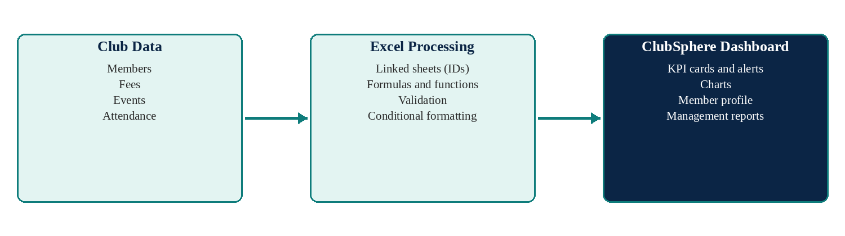
Figure 1.1: Overview of the ClubSphere system
1.2 Motivation
Manual record keeping has three common problems: the same information is typed more than once, updates in one list are not reflected in the others, and reports take a long time to prepare. These problems grow as the number of members and events increases. A connected workbook in which a change in one place automatically updates every dependent result removes much of this effort and reduces mistakes.
The project was also chosen to demonstrate practical office automation skills: structured tables, lookup and summary functions, data validation, conditional formatting, charts and page layout, all without macros or programming.
1.3 Scope of the Project
ClubSphere is a single Excel workbook for one club. It manages members, fees, events and attendance, calculates statuses and totals, and presents analytics. It is built for up to 100 members, 150 fee records, 20 events and 300 attendance records and is demonstrated with fictional sample data. Automatic emails, a web portal, login systems and database integration are outside the scope because they need programming or external services. As an extension, the same membership data is used with Microsoft Word mail merge to produce personalised letters and ID cards (Chapter 6).
1.4 Organisation of the Report
Chapter 2 reviews the background and defines the problem, gap, objectives and constraints. Chapter 3 describes the user interface with screenshots. Chapter 4 explains the implementation, formulas and validation rules. Chapter 5 presents testing and results, Chapter 6 describes the Word mail merge extension, and Chapter 7 gives the conclusion and future scope.
Chapter 2
Literature Review
2.1 Spreadsheets for Record Keeping
When every row of a sheet represents one record and every record has a unique identifier, a spreadsheet can behave like a simple database. Lookup functions retrieve related data using the identifier, and conditional counting and summing functions produce totals for any category (Alexander, Kusleika and Walkenbach, 2018). For example, the SUMIFS function adds the values that meet more than one condition, such as the fees of one department that are still unpaid (Microsoft, n.d.a).
Excel also provides data validation, which restricts what can be typed into a cell, and conditional formatting, which changes the appearance of a cell according to its value. Together they help keep data consistent and make important cases visible without reading every row.
2.2 Dashboard Design
Few (2006) explains that a dashboard should gather the most important information on a single screen so that it can be monitored at a glance. Clear labels, restrained colour and simple chart types help the reader understand the figures quickly, while decoration that does not carry information distracts from them. These ideas guided the layout of the ClubSphere dashboard: key numbers appear as cards at the top, alerts follow, and charts are kept simple and consistently coloured.
2.3 Problem Statement
The coordinator of a college club needs quick answers to the following questions: How many members are active, expired or about to expire? Who has paid the fee, who owes money and which payments are overdue? Which events were well attended and which departments take part most? How much money has been collected, and can the details of any member be found instantly? When records are scattered in unrelated lists, these answers require repeated manual work and are prone to error.
2.4 Gap Identification
In the author's observation, small clubs usually keep either a plain member list or several unconnected sheets. A plain list stores data but does not calculate anything, while separate sheets must be compared by hand. Dedicated membership software could solve this but may be costly or complex for a small student club. Table 2.1 compares the manual approach with the proposed workbook.
Table 2.1: Comparison of manual records and ClubSphere
Aspect | Manual / separate lists | ClubSphere workbook
Membership status | Checked by reading dates | Calculated automatically as Active or Expired
Fee balance | Calculated by hand | Amount due minus amount paid, with Paid / Overdue status
Attendance | Counted manually per event | Counted by formula for each event and member
Member details | Searched in several lists | One-page profile from a Member ID
Reports | Prepared separately | Formula-driven tables and charts that update
Errors | Typing mistakes go unnoticed | Dropdowns, validation rules and colour alerts

The gap addressed by this project is therefore a low-cost, no-code tool that connects membership, fee, event and attendance records and reports on them automatically.
2.5 Design Objectives
• Maintain a central member register with automatic renewal date and membership status.
• Track fees with automatic balance, payment status and days overdue.
• Record events and attendance and calculate attendance and seat-fill percentages.
• Provide a one-page Member Profile lookup using a Member ID.
• Generate department, fee, monthly and event reports using formulas and charts.
• Present key figures, alerts and charts on a single dashboard that updates automatically.
• Reduce data-entry errors using dropdown lists, validation rules and colour-coded statuses.
2.6 Design Constraints
• The project must be completed individually using Microsoft Excel (or Word) as required by the course.
• No macros, VBA or other programming may be used; only built-in features.
• The workbook must work offline on a single computer and use fictional sample data.
• Formulas should work in common Excel versions, so INDEX with MATCH is used instead of newer lookup functions.
• The workbook is sized for up to 100 members, 150 fee records, 20 events and 300 attendance records.
Chapter 3
UI Design Overview
3.1 Design Principles
The interface uses a navy and teal colour scheme with the Times-style simplicity of a business report: one font family, consistent alignment and gridlines hidden on presentation sheets. Input cells use blue text and formula cells use black text so that users know where to type. Status values are colour coded: green for good states (Active, Paid, Present), amber for warnings (Expiring Soon, Partial), red for problems (Expired, Overdue, Absent) and blue for pending states (Pending, Upcoming, Registered). Every data sheet has frozen headers, filters and dropdown lists.
3.2 Dashboard
The Dashboard is the first sheet. It shows eight key performance indicator cards (total, active, expired and expiring members, fees collected, outstanding dues, collection rate and average attendance rate), three automatically written alerts, six charts and two leaderboards listing the five most engaged members and the five largest pending dues (Figure 3.1).
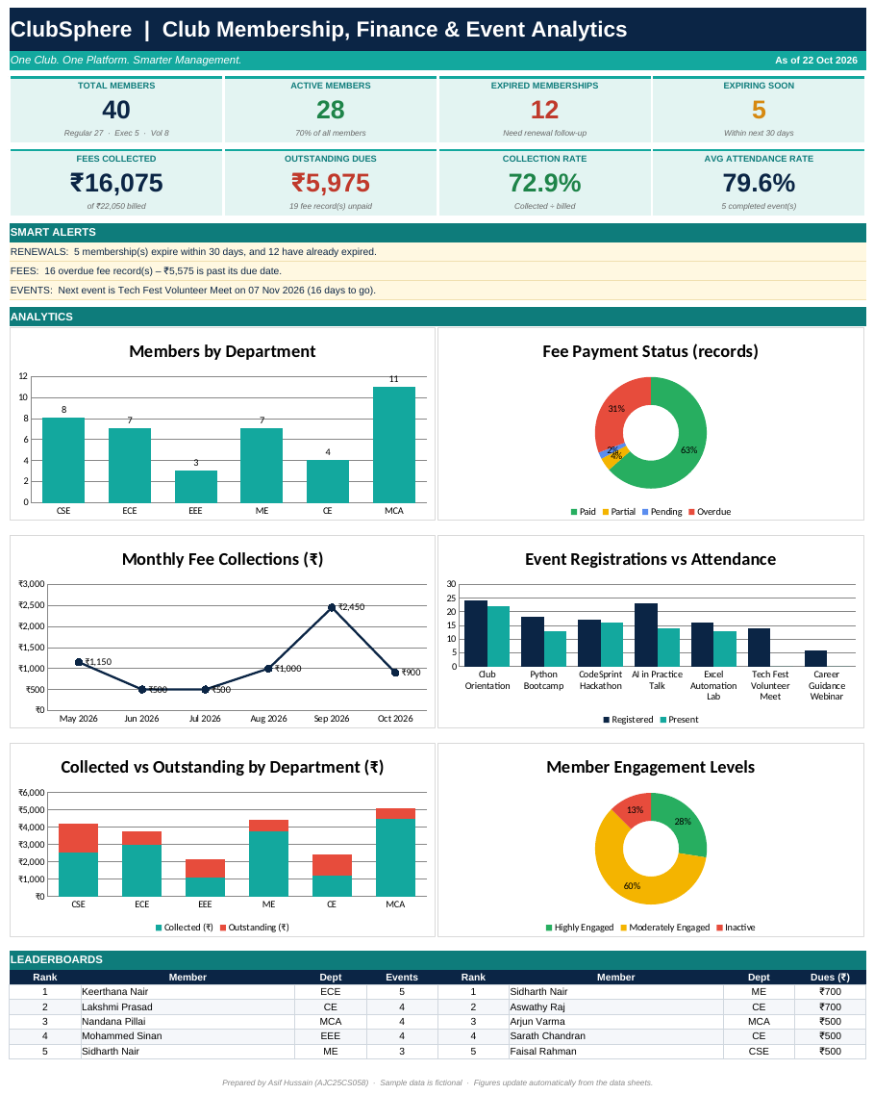
Figure 3.1: ClubSphere Dashboard
3.3 Member Register
The Member Register is the master record of the club. Blue columns are typed by the user, while the renewal date, membership status, days to renewal, renewal alert, events attended and fees outstanding are calculated. Expired and expiring memberships are highlighted, and a data bar shows the outstanding amount (Figure 3.2).
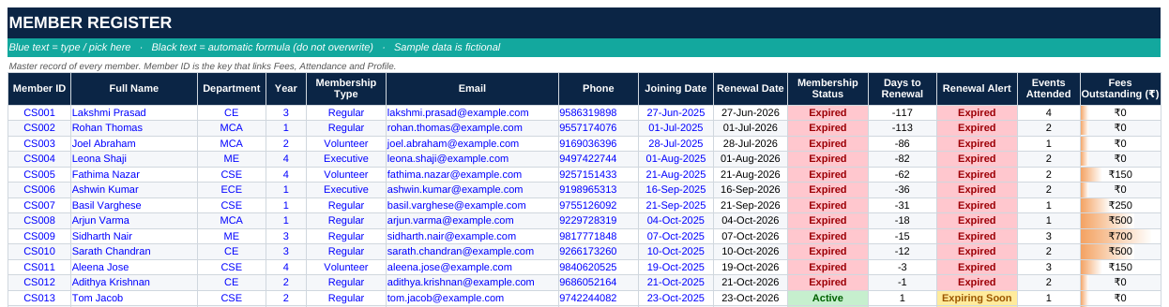
Figure 3.2: Member Register sheet
3.4 Fee Tracker
The Fee Tracker keeps one row for each fee. The member name, department and membership type are retrieved from the Member ID. The balance, payment status and days overdue are calculated, and the status cell turns green, amber, red or blue (Figure 3.3).
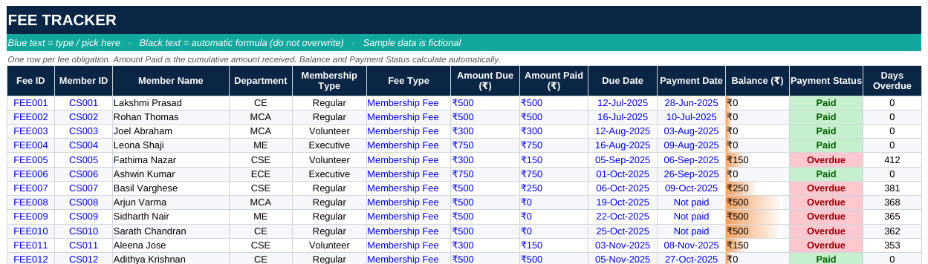
Figure 3.3: Fee Tracker sheet
3.5 Event Manager
The Event Manager lists each event with its category, date, venue and capacity. Registered, present and absent counts, attendance percentage, seats filled percentage and event status are calculated from the Attendance sheet (Figure 3.4).
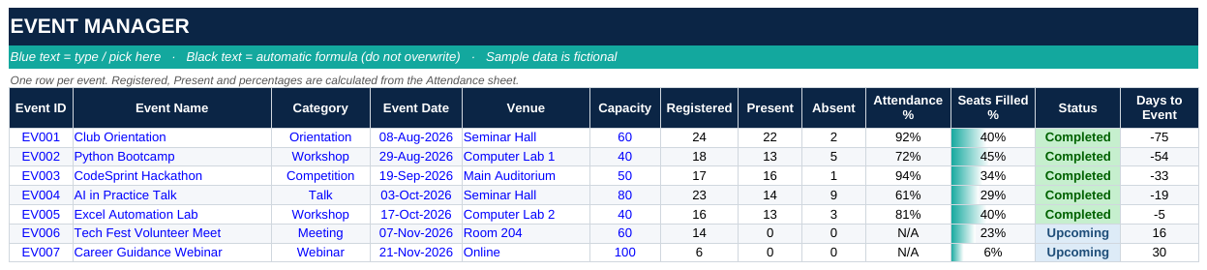
Figure 3.4: Event Manager sheet
3.6 Attendance
The Attendance sheet contains one row for every member-event registration. The user selects the Event ID and Member ID from dropdown lists and sets the status to Present, Absent or Registered. The member name, department and event name are filled automatically (Figure 3.5).
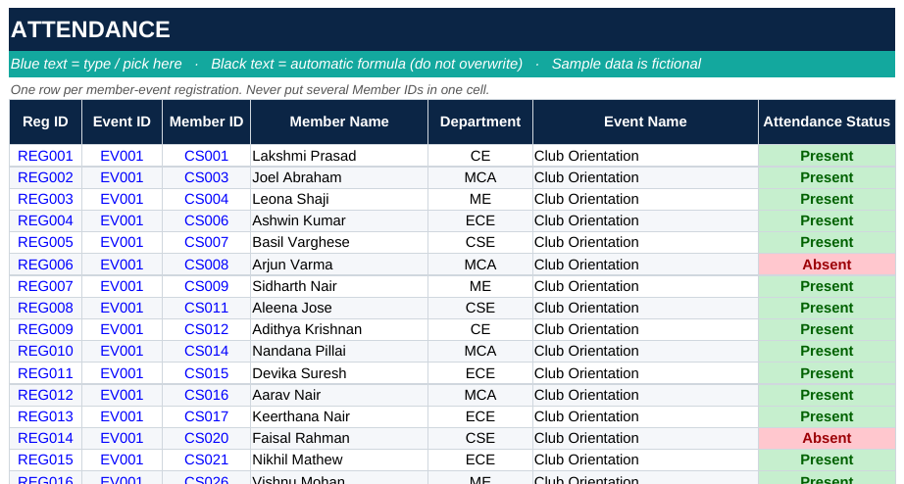
Figure 3.5: Attendance sheet
3.7 Member Profile
The Member Profile sheet has a yellow selector cell. When a Member ID is chosen, the page displays personal details, membership status, fee summary, event participation, an engagement level and a one-line summary sentence. It can be printed as a one-page member summary (Figure 3.6).
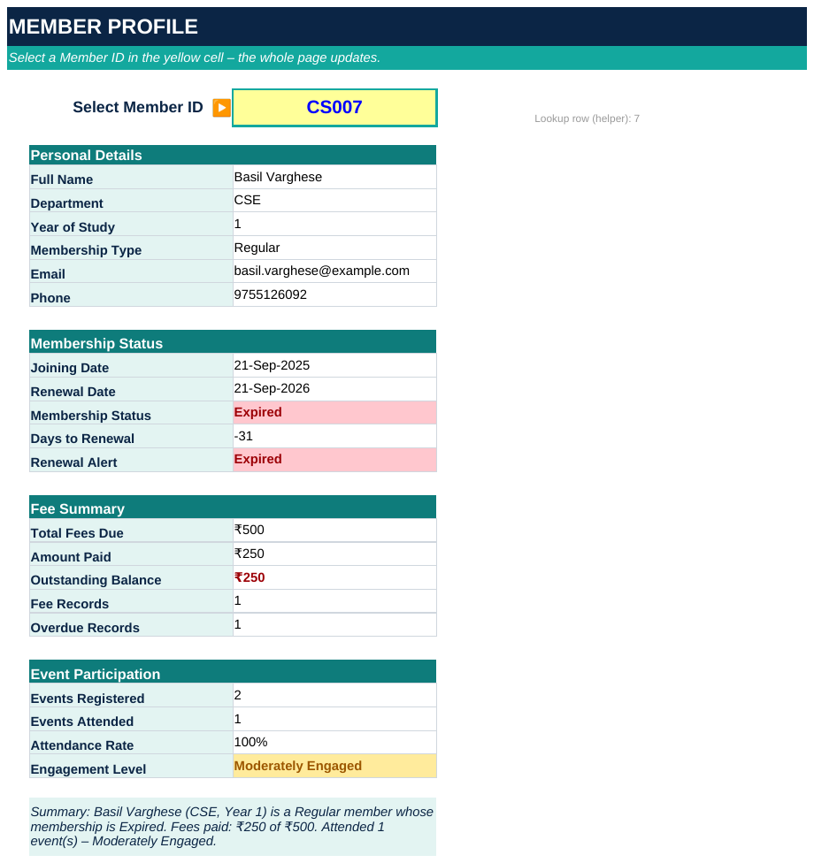
Figure 3.6: Member Profile sheet
3.8 Reports
The Reports sheet contains six formula-driven tables: department-wise summary, membership-type summary, payment-status summary, monthly collections for the last six months, event performance and member engagement levels. The charts on the dashboard read their data from these tables (Figure 3.7).
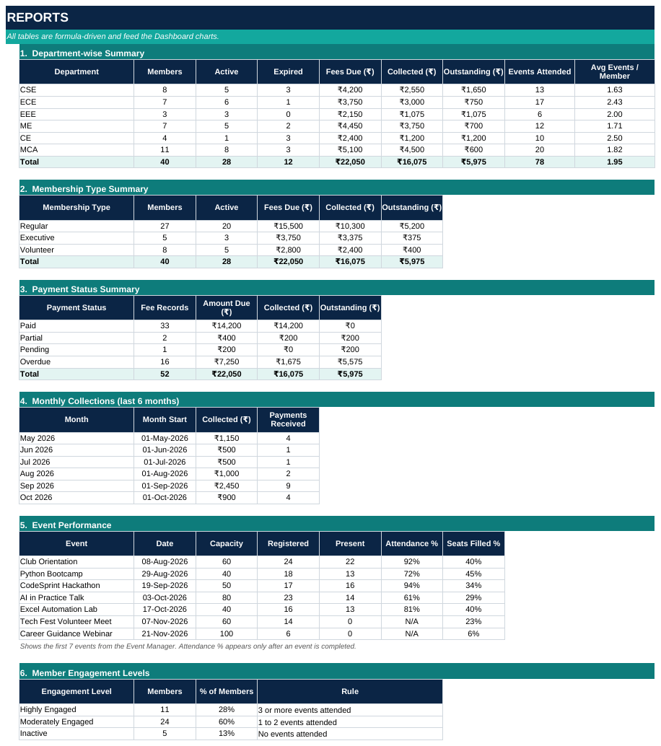
Figure 3.7: Reports sheet
Chapter 4
Implementation
4.1 Workbook Structure
The workbook ClubSphere_Working_Prototype.xlsx contains nine sheets, listed in Table 4.1. The sample data consists of 40 members from six departments (CSE, ECE, EEE, ME, CE and MCA), 52 fee records, 7 events and 118 attendance records. All names, contact details, amounts and dates are fictional. Unused spare rows and helper columns are hidden so that the sheets show only complete records; the hidden rows can be unhidden to add new members, fees, events or attendance.
Table 4.1: Sheets of the ClubSphere workbook
Sheet | Purpose
Dashboard | KPI cards, smart alerts, six charts and Top 5 leaderboards
Member Register | Master member record with calculated renewal date, status, alert, events attended and dues
Fee Tracker | Fee records with calculated balance, payment status and days overdue
Event Manager | Event details with calculated registrations, attendance % and status
Attendance | Member-event registrations with Present / Absent / Registered status
Member Profile | Dropdown-driven one-page lookup of a selected member
Reports | Six summary tables that feed the dashboard charts
Read Me | Usage guide, colour code, formulas and assumptions
Lists | Dropdown lists and settings (report date, alert window, validity)

4.2 Data Design and Relationships
Each record has a unique identifier. Member ID links the Member Register, Fee Tracker and Attendance sheets, and Event ID links the Event Manager and Attendance sheets. Names and departments are never typed twice; they are retrieved with INDEX and MATCH. The Reports sheet summarises the four data sheets and the Dashboard reads from both (Figure 4.1).
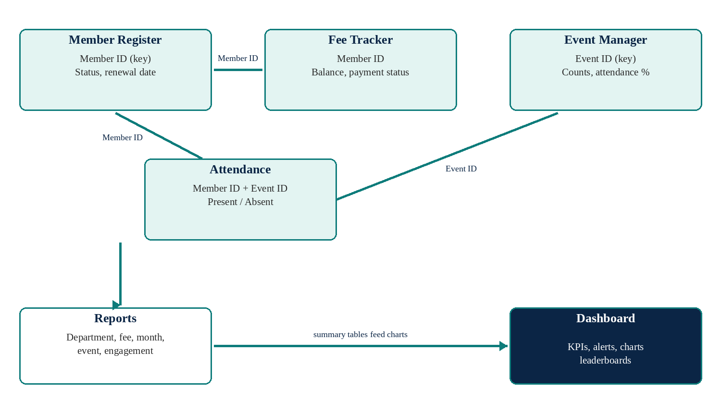
Figure 4.1: Relationship between the sheets of ClubSphere
Three settings on the Lists sheet control the date logic: the Report Date (fixed at 22 October 2026 so that results match this report; =TODAY() can be typed there for live alerts), the Renewal Alert Window (30 days) and the Membership Validity (12 months).
4.3 Steps Followed to Develop the Project
Step 1 – Create the workbook. The nine sheets were created and named, a navy and teal colour theme was chosen and sheet tabs were coloured.
Step 2 – Lists and settings. The dropdown values for departments, membership types, attendance statuses, fee types, years and event categories were entered on the Lists sheet together with the three settings. They were named ReportDate, AlertDays and ValidMonths.
Step 3 – Master data sheets. Headers were placed in row 4 and data from row 5 on the four data sheets. Fictional records were entered, and frozen panes, filters, borders and number formats were applied (dates as dd-mmm-yyyy, amounts in rupees).
Step 4 – Connect the records. Member ID and Event ID were used consistently, and INDEX with MATCH was used to retrieve names, departments and event names.
Step 5 – Add formulas. Formulas were added for renewal date, membership status, balance, payment status, event counts and percentages (Table 4.2).
Step 6 – Validation and alerts. Dropdown lists, unique-ID, date and amount rules and conditional formatting were configured (Table 4.3).
Step 7 – Reports. The six summary tables were built with COUNTIFS and SUMIFS, including a six-month collection table that moves with the report date.
Step 8 – Dashboard. Eight KPI cards, three alert sentences, six charts and two leaderboards (LARGE with MATCH) were created and linked to the report tables.
Step 9 – Testing and documentation. The workbook was tested with changed data, screenshots were captured and the report and video were prepared.
4.4 Key Formulas
Table 4.2 lists the main formulas for the first data row of each sheet; they are copied down for all rows. In the workbook the ranges are fixed ranges such as 'Member Register'!$A$5:$A$104; readable names are shown here for clarity.
Table 4.2: Key formulas used in ClubSphere
Result | Formula | Sheet
Renewal Date | =IF(H5="","",EDATE(H5,ValidMonths)) | Member Register
Membership Status | =IF(I5<ReportDate,"Expired","Active") (with blank and Not Set checks) | Member Register
Renewal Alert | =IF(K5<0,"Expired",IF(K5<=AlertDays,"Expiring Soon","OK")) | Member Register
Events Attended | =COUNTIFS(AttMemberID,$A5,AttStatus,"Present") | Member Register
Name lookup | =IFERROR(INDEX(MemberNames,MATCH($B5,MemberIDs,0)),"ID not found") | Fee Tracker
Balance | =G5-H5 | Fee Tracker
Payment Status | =IF(K5<=0,"Paid",IF(I5<ReportDate,"Overdue",IF(H5>0,"Partial","Pending"))) | Fee Tracker
Registered | =COUNTIFS(AttEventID,$A5) | Event Manager
Attendance % | =IF(L5<>"Completed","",H5/G5) | Event Manager
Department fees | =SUMIFS(AmountPaid,FeeDepartment,B5) | Reports
Monthly collection | =SUMIFS(AmountPaid,PaymentDate,">="&C30,PaymentDate,"<"&EDATE(C30,1)) | Reports
Top 5 engaged | =INDEX(Names,MATCH(LARGE(EngagementKey,k),EngagementKey,0)) | Dashboard

4.5 Data Validation and Conditional Formatting
Table 4.3: Validation rules and conditional formatting
Sheet / field | Rule | Purpose
Member ID (Register) | Must be unique: COUNTIF($A$5:$A$104,A5)=1 | Prevent duplicate members
Department, Type, Year | Dropdown from the Lists sheet | Consistent categories
Joining Date, Event Date | Date after 01-Jan-2020 | Reject invalid dates
Member ID (Fees, Attendance, Profile) | Dropdown from the Member Register | Prevent wrong IDs
Amount Paid | Decimal, not more than Amount Due | Prevent over-payment entries
Attendance Status | Dropdown: Present, Absent, Registered | Consistent statuses
Status columns | Green / amber / red / blue fills | Show problems at a glance
Outstanding amounts | Orange data bars | Compare dues visually

4.6 Development Screenshots
The following screenshots show the working parts of the workbook. Figure 4.2 shows the Lists sheet, which holds the dropdown values and the three workbook settings together with the student name and roll number used in the Dashboard footer. Figures 4.3 to 4.5 show the formulas used in the first data row of the Member Register, Fee Tracker and Event Manager, displayed as text. Figure 4.6 shows the Read Me sheet that explains the workbook to a new user.
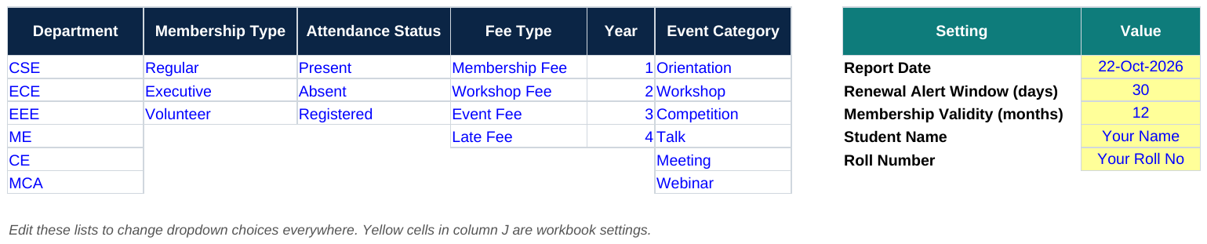
Figure 4.2: Lists sheet with dropdown values and settings
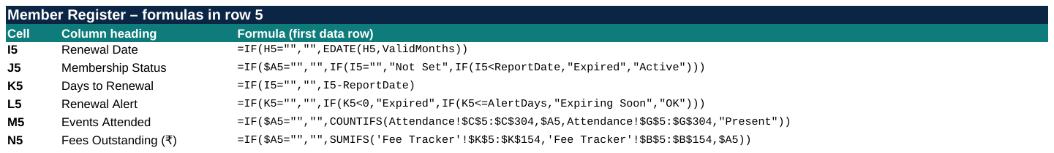
Figure 4.3: Formulas in the Member Register (formula view)
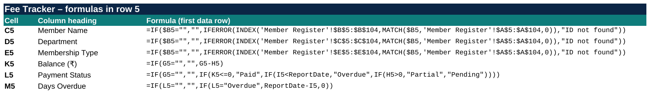
Figure 4.4: Formulas in the Fee Tracker (formula view)
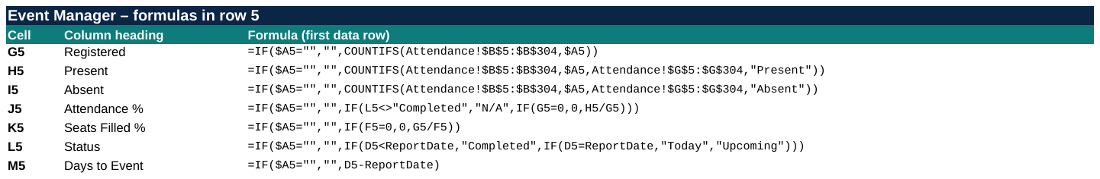
Figure 4.5: Formulas in the Event Manager (formula view)
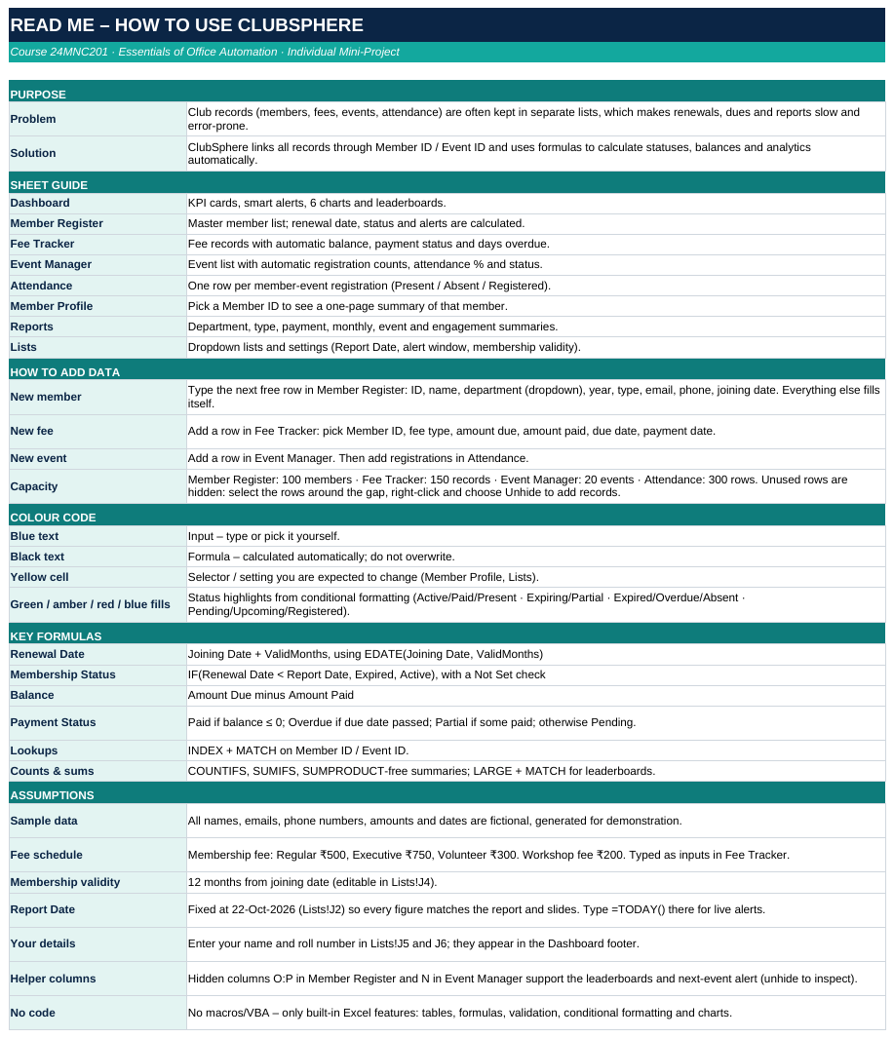
Figure 4.6: Read Me sheet of the workbook
Chapter 5
Testing and Results
5.1 Testing
The workbook was tested by changing data in a copy, recalculating and comparing the output with the original. Each test behaved as expected (Table 5.1).
Table 5.1: Test cases and results
No. | Test action | Expected result | Actual result | Status
1 | Change Amount Paid of fee FEE005 (member CS005) from Rs. 150 to Rs. 300 | Status becomes Paid; collected rises and outstanding falls by Rs. 150 | Collected Rs. 16,075 to Rs. 16,225; outstanding Rs. 5,975 to Rs. 5,825 | Pass
2 | Add new member CS041 (CSE, Regular, joined 20-Oct-2026) | Renewal date 20-Oct-2027, status Active; total and active members increase by 1 | Renewal 20-Oct-2027, Active; total 40 to 41; active 28 to 29 | Pass
3 | Select Member ID CS012 on Member Profile | Profile shows details of CS012 | Adithya Krishnan, CE, Expired, Rs. 700 paid, 2 events, outstanding Rs. 0 | Pass
4 | Change Report Date from 22-Oct-2026 to 01-Dec-2026 | More memberships expire | Expired 12 to 18; active 28 to 22; expiring soon 5 to 1 | Pass

The screenshots below were captured from the workbook before and after each change. In Test 1 the Amount Paid of fee FEE005 was changed from Rs. 150 to Rs. 300; the Fee Tracker row changed from Overdue to Paid (Figure 5.1) and the Dashboard totals changed accordingly (Figure 5.2).
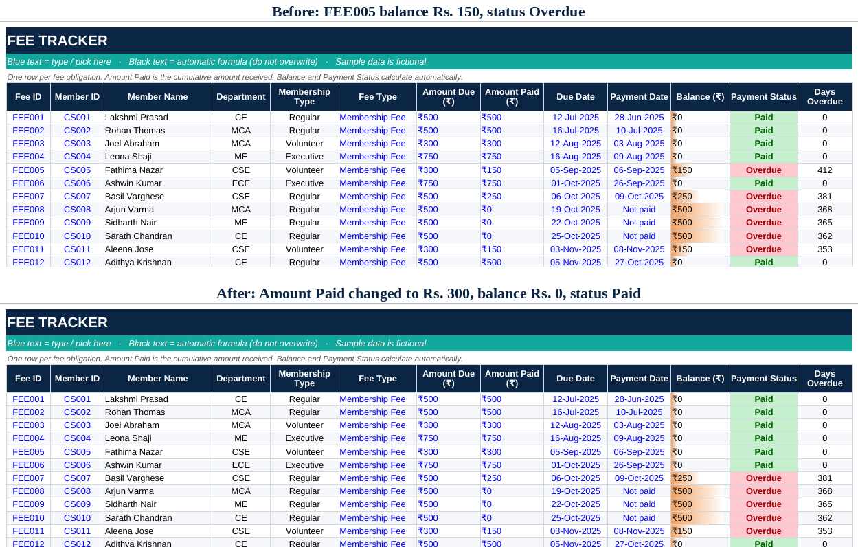
Figure 5.1: Test 1: Fee Tracker before and after paying FEE005
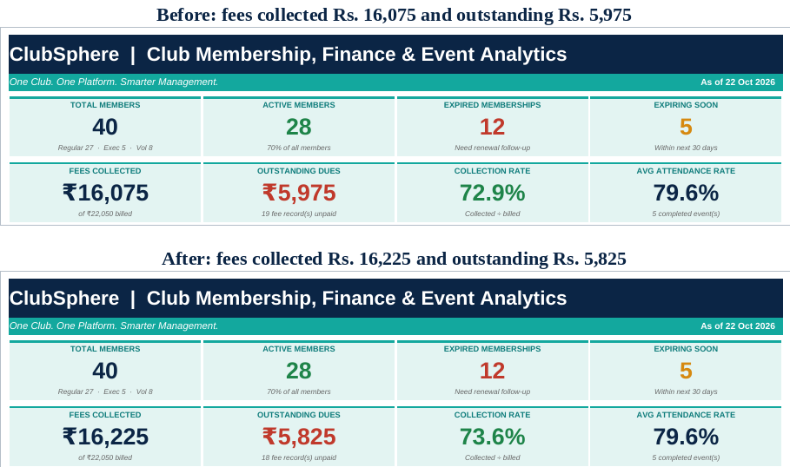
Figure 5.2: Test 1: Dashboard totals before and after the payment
In Test 2 a new member CS041 was typed into the next row of the Member Register. The renewal date, status and days to renewal were filled in automatically (Figure 5.3).
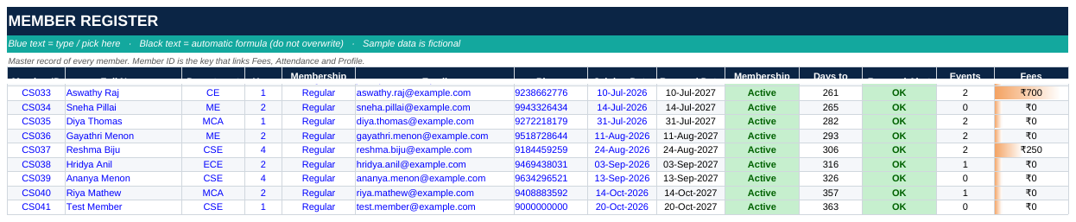
Figure 5.3: Test 2: new member CS041 added to the Member Register
In Test 3 the Member ID CS012 was selected on the Member Profile sheet, and the whole page changed to show that member (Figure 5.4).
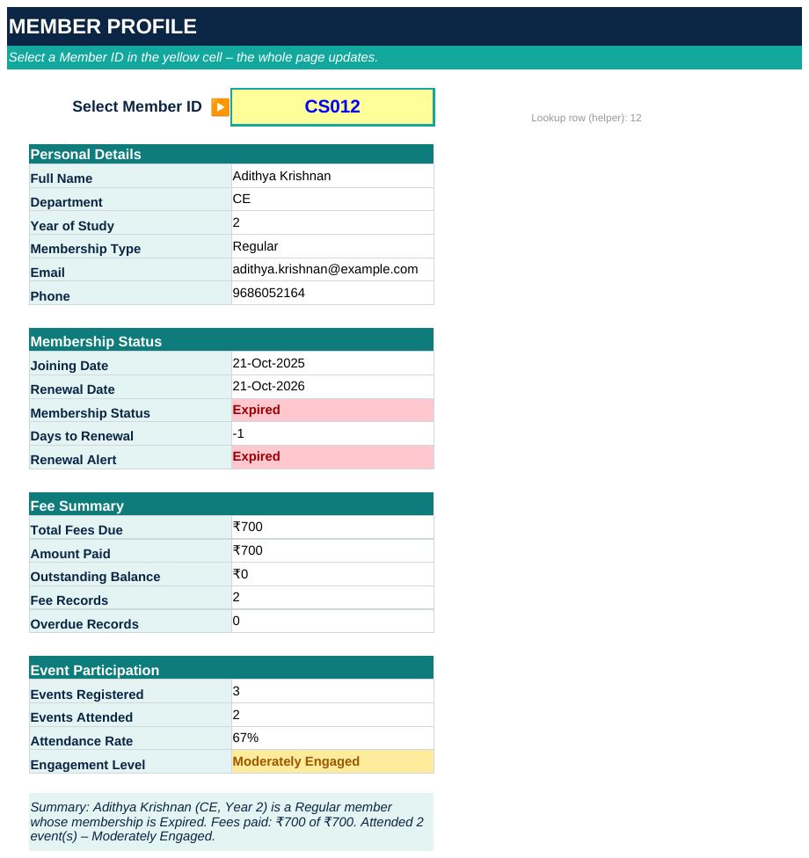
Figure 5.4: Test 3: Member Profile for Member ID CS012
In Test 4 the report date in the Lists sheet was changed from 22 October 2026 to 1 December 2026, and the membership counts on the Dashboard moved from active to expired (Figure 5.5).
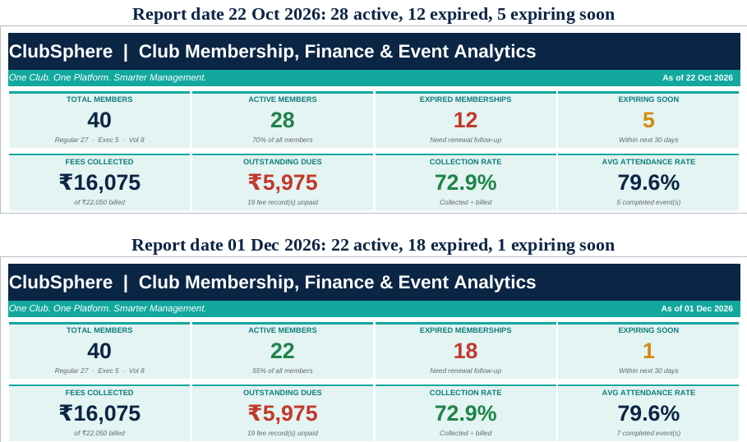
Figure 5.5: Test 4: Dashboard counts for two different report dates
5.2 Results
With the sample data and a report date of 22 October 2026, ClubSphere produced the indicators in Table 5.2.
Table 5.2: Key indicators on the dashboard
Indicator | Result
Total members | 40
Active members | 28 (70%)
Expired memberships | 12
Expiring within 30 days | 5
Fees billed | Rs. 22,050
Fees collected | Rs. 16,075
Outstanding dues | Rs. 5,975
Collection rate | 72.9%
Average event attendance rate | 79.6%

Table 5.3: Department-wise summary
Dept | Members | Active | Expired | Fees Due | Collected | Outstanding | Events Attended
CSE | 8 | 5 | 3 | Rs. 4,200 | Rs. 2,550 | Rs. 1,650 | 13
ECE | 7 | 6 | 1 | Rs. 3,750 | Rs. 3,000 | Rs. 750 | 17
EEE | 3 | 3 | 0 | Rs. 2,150 | Rs. 1,075 | Rs. 1,075 | 6
ME | 7 | 5 | 2 | Rs. 4,450 | Rs. 3,750 | Rs. 700 | 12
CE | 4 | 1 | 3 | Rs. 2,400 | Rs. 1,200 | Rs. 1,200 | 10
MCA | 11 | 8 | 3 | Rs. 5,100 | Rs. 4,500 | Rs. 600 | 20
Total | 40 | 28 | 12 | Rs. 22,050 | Rs. 16,075 | Rs. 5,975 | 78

Table 5.4: Payment status summary
Status | Records | Amount Due | Collected | Outstanding
Paid | 33 | Rs. 14,200 | Rs. 14,200 | Rs. 0
Partial | 2 | Rs. 400 | Rs. 200 | Rs. 200
Pending | 1 | Rs. 200 | Rs. 0 | Rs. 200
Overdue | 16 | Rs. 7,250 | Rs. 1,675 | Rs. 5,575
Total | 52 | Rs. 22,050 | Rs. 16,075 | Rs. 5,975

Table 5.5: Event performance
Event | Date | Capacity | Registered | Present | Attendance | Seats Filled
Club Orientation | Aug 2026 | 60 | 24 | 22 | 91.7% | 40.0%
Python Bootcamp | Aug 2026 | 40 | 18 | 13 | 72.2% | 45.0%
CodeSprint Hackathon | Sep 2026 | 50 | 17 | 16 | 94.1% | 34.0%
AI in Practice Talk | Oct 2026 | 80 | 23 | 14 | 60.9% | 28.7%
Excel Automation Lab | Oct 2026 | 40 | 16 | 13 | 81.3% | 40.0%
Tech Fest Volunteer Meet | Nov 2026 | 60 | 14 | 0 | Upcoming | 23.3%
Career Guidance Webinar | Nov 2026 | 100 | 6 | 0 | Upcoming | 6.0%

5.3 Observations
• MCA has the most members (11) and the highest collection (Rs. 4,500); ECE has the highest average attendance per member (2.4).
• CE and CSE each have three expired memberships, and CE has only one active member out of four, so they need renewal follow-up.
• Overdue fees account for Rs. 5,575 of the Rs. 5,975 outstanding, so reminders should target overdue records first.
• The Hackathon and the Orientation had the best attendance (94% and 92%) and the AI in Practice Talk the lowest (61%).
• Eleven members (27.5%) are highly engaged, 24 (60%) are moderately engaged and 5 (12.5%) have attended no event.
These observations apply to the fictional sample data and show the type of insight the workbook produces.
Chapter 6
Extension: Word Mail Merge
6.1 Introduction and Objectives
The Excel workbook stores and analyses the club's records, but the coordinator must also communicate with members. Microsoft Word mail merge combines a main document that contains the fixed text and merge fields with a data source that supplies one record for each recipient, and Word then produces a personalised document for every record (Microsoft, n.d.b). Bucki (2018) describes the same steps of choosing the document type, selecting recipients, inserting fields, previewing and finishing the merge. This extension, named ClubSphere Connect, uses the ClubSphere membership data as the data source.
The objectives of the extension are to prepare a clean data source from the workbook, to design Word main documents with merge fields for a confirmation letter, a renewal reminder and a fee payment notice, to design an ID card sheet with eight cards per page, to merge the documents and save the results as Word and PDF files, and to check that every record produces exactly one correct document.
6.2 Data Source
An Excel worksheet is the most convenient data source for mail merge. The first row must contain unique column headings that become the field names, and each following row must be one record (Alexander, Kusleika and Walkenbach, 2018). The data was therefore copied from the Member Register and Fee Tracker into a separate file, ClubSphere_MailMerge_Data.xlsx, with three worksheets: Members_All (40 records), Renewal_Due (17 records) and Fee_Due (16 records). Dates were stored as text in the form 27 June 2025 and amounts with the rupee sign so that Word shows them correctly, and helper fields such as FirstName, RenewalNote and FeeNote were added (Figure 6.1, Table 6.1).
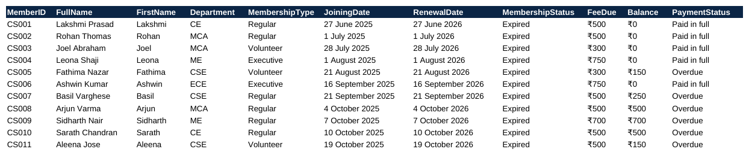
Figure 6.1: Data source worksheet Members_All (selected columns)
Table 6.1: Main merge fields in the data source
Field name | Meaning | Example
MemberID | Unique member identifier | CS001
FullName | Full name of the member | Lakshmi Prasad
FirstName | First name used in the greeting | Lakshmi
Department | Department of the member | CE
MembershipType | Regular, Executive or Volunteer | Regular
JoiningDate | Date of joining | 27 June 2025
RenewalDate | Membership valid until | 27 June 2026
RenewalNote | Sentence about expiry | expired on 27 June 2026 (117 days ago)
Balance | Fees still to pay | ₹150
FeeNote | Remark about the dues | 1 overdue fee record(s); the oldest was due on 5 September 2025

6.3 Main Documents and Merged Output
Four main documents were designed in Word with the same letterhead: the club name, the tagline and the college name above a teal rule, followed by a date, the address block, the subject line, the body text and a member details table. Merge fields appear inside « » symbols in the main document and are replaced by real values in the merged output. The letter date is a DATE field in the main documents and is fixed at 22 October 2026 in the merged output to match the report date of the data.
The membership confirmation letter is merged with all 40 members, the renewal reminder only with the 17 members whose membership has expired or will expire within 30 days, and the fee payment notice only with the 16 members who have a balance (Figures 6.2 to 6.4).
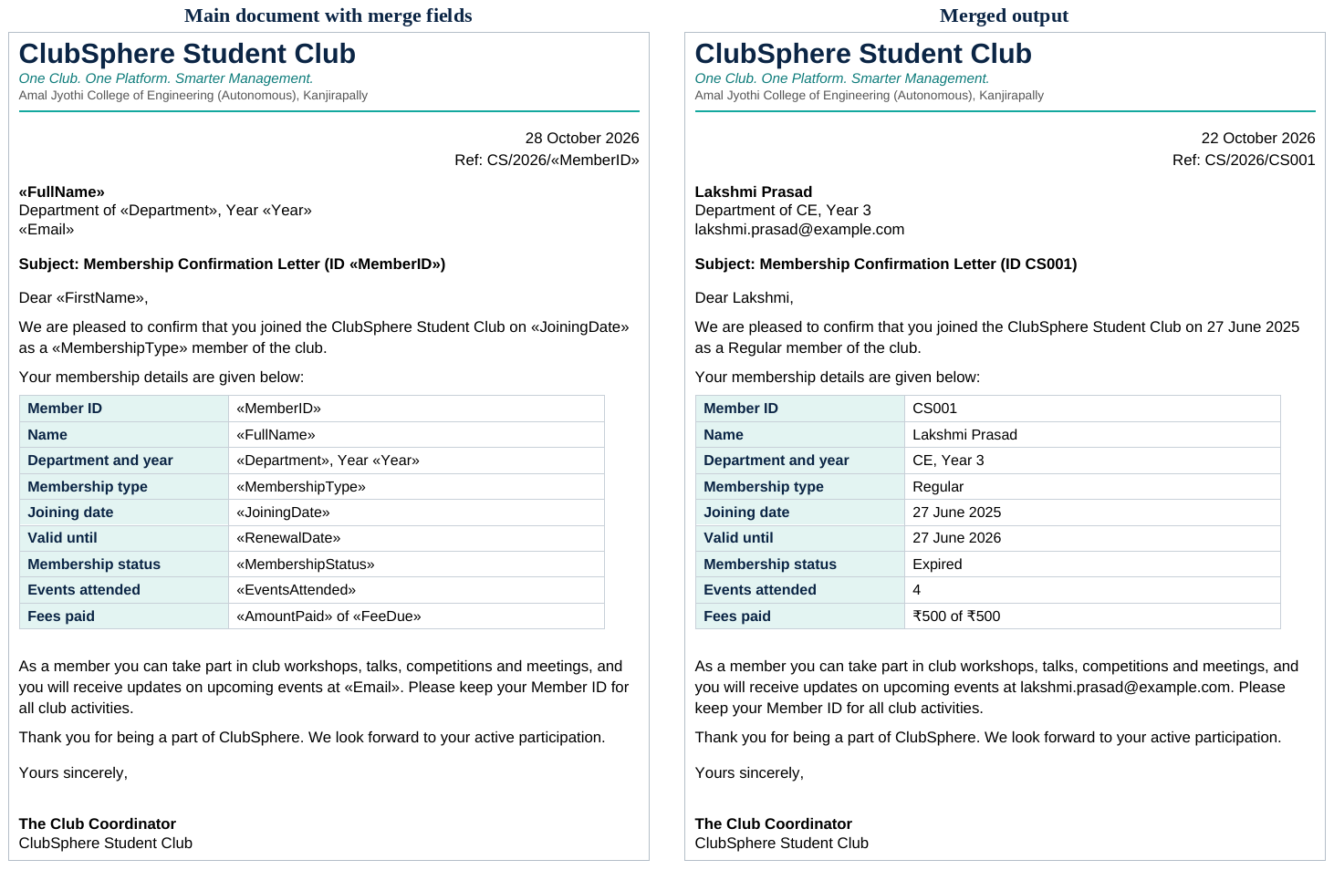
Figure 6.2: Membership confirmation letter: main document and merged output
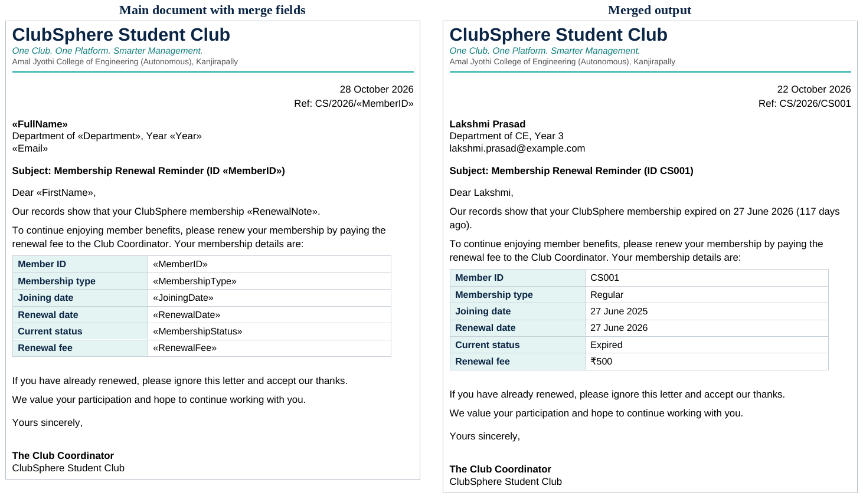
Figure 6.3: Renewal reminder: main document and merged output
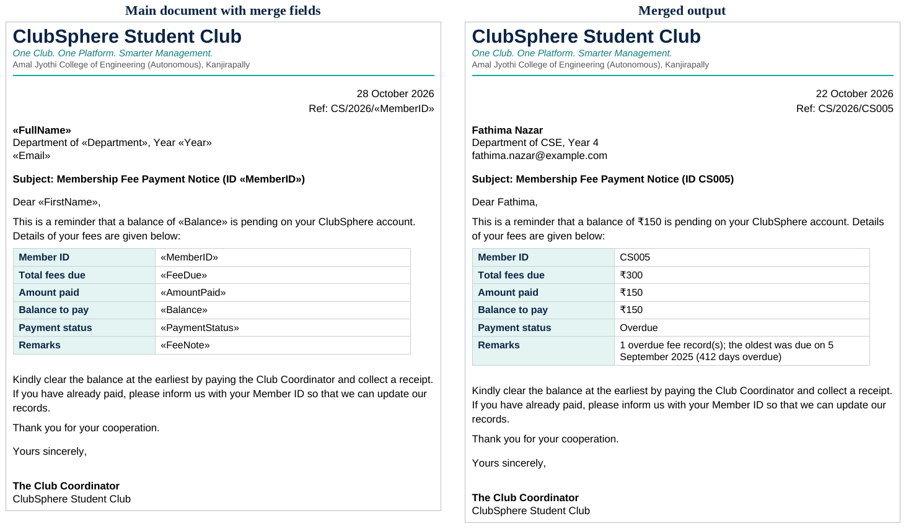
Figure 6.4: Fee payment notice: main document and merged output
The ID card sheet is a table of eight cards per page. The first card holds the merge fields and every other card begins with a Next Record field, so that eight different members appear on each page. The 40 members fill five pages (Figure 6.5).
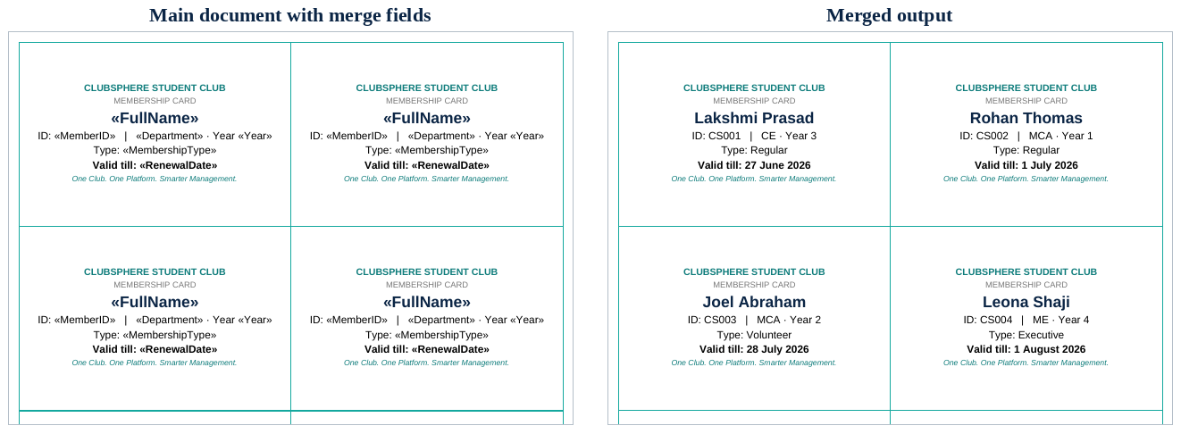
Figure 6.5: Membership ID card sheet: main document and merged output (top half of page)
6.4 Steps Followed
The merge follows the five stages shown in Figure 6.6: start the merge by choosing Letters, select the Excel file and the correct worksheet as recipients, insert the merge fields, preview the results to check a few records, and finish by merging to a new document that is saved as a Word file and as a PDF.
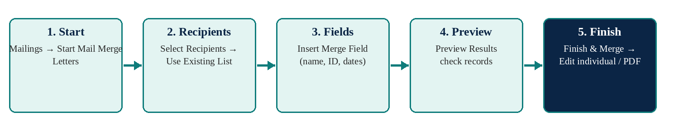
Figure 6.6: Mail merge workflow in Microsoft Word
The Word features used were merge fields, the DATE and NEXT fields, tables for the details block and the ID cards, paragraph borders and fonts for the letterhead, A4 page layout with page breaks between letters, and Save as PDF for sharing.
6.5 Testing and Results
The merged documents were checked against the data source (Table 6.2). Table 6.3 summarises the outputs.
Table 6.2: Test cases for the mail merge
No. | Test | Expected result | Actual result | Status
1 | Confirmation letters for the 40 members in Members_All | 40 letters, one per page | 40 letters on 40 pages | Pass
2 | Renewal reminders from Renewal_Due | 17 reminders (12 expired and 5 expiring soon) | 17 reminders on 17 pages | Pass
3 | Fee notices from Fee_Due | 16 notices, one per member with a balance | 16 notices on 16 pages | Pass
4 | Every member name appears in the merged output | All names present | No name missing in any file | Pass
5 | No unreplaced field codes remain | No « » or field text in the output | None found | Pass
6 | ID card layout | 8 cards per page, 40 cards on 5 pages | 5 pages with 8 cards each | Pass

Table 6.3: Merged outputs produced
Merged document | Data worksheet | Records | Pages | Formats
Membership confirmation letters | Members_All | 40 | 40 | Word, PDF
Renewal reminders | Renewal_Due | 17 | 17 | Word, PDF
Fee payment notices | Fee_Due | 16 | 16 | Word, PDF
Membership ID cards | Members_All | 40 | 5 | Word, PDF
Total |  | 113 | 78

6.6 Observations
• Four templates and one data file replaced 113 separately typed documents.
• Separate recipient lists meant that only the members who needed a renewal reminder or a fee notice received one.
• No names, dates or amounts had to be retyped, because every value came from the data source.
• Updating the data and merging again produces new documents in a few minutes.
Chapter 7
Conclusion and Future Scope
7.1 Conclusion
ClubSphere shows that Microsoft Excel can work as a small management system when records are linked through identifiers and formulas perform the calculations. Membership status, fee balances, attendance percentages, reports and dashboard figures update automatically when a record changes, and validation rules and colour coding reduce mistakes and make problems visible. The project met its objectives and demonstrates practical use of tables, formulas, functions, charts, formatting and page layout without any programming. The Word mail merge extension in Chapter 6 shows how the same data can also produce confirmation letters, renewal reminders, fee notices and ID cards without retyping. It can save a coordinator's time, give instant answers about members, dues and events, and be adapted by other clubs and societies.
7.2 Limitations
The workbook is sized for up to 100 members, 150 fee records, 20 events and 300 attendance rows, uses sample data and works for one user at a time. It does not send reminders or emails automatically.
7.3 Future Scope
• Add PivotTables and slicers for interactive analysis.
• Add an expense tracker and event budget analysis.
• Add a printable membership card or fee receipt for every member.
• Move the workbook to a shared online location so that several coordinators can update it.
REFERENCES
Alexander, M., Kusleika, R. and Walkenbach, J. (2018) Excel 2019 Bible. Indianapolis: Wiley.
Bucki, L.A. (2018) Word 2019 Bible. Hoboken: Wiley.
Few, S. (2006) Information Dashboard Design: The Effective Visual Communication of Data. Sebastopol: O'Reilly Media.
Microsoft (n.d.a) SUMIFS function. Available at: https://support.microsoft.com/en-us/excel/sumifs-function (Accessed: 23 October 2026).
Microsoft (n.d.b) Use mail merge for bulk email, letters, labels, and envelopes. Available at: https://support.microsoft.com/en-us/office/use-mail-merge-for-bulk-email-letters-labels-and-envelopes-f488ed5b-b849-4c11-9cff-932c49474705 (Accessed: 28 October 2026).

