Final Project Report

THE SHOE SHOP



Project Supervisor

SYED AUN ALI BUKHARI

Submitted By

F22028CEDA

AYESHA SOHAIL F22028CEDA

Software Projects & Research Section,
Department of Computer Sciences,
Virtual University of Pakistan


CERTIFICATE

This is to certify that AYESHA SOHAIL (F22028CEDA) has worked on and completed her Software Project at Software & Research Projects Section, Department of Computer Sciences, Virtual University of Pakistan in partial fulfillment of the requirement for the degree of MCS in Computer Sciences under my guidance and supervision.

In our opinion, it is satisfactory and up to the mark and therefore fulfills the requirements of MCS in Computer Sciences.

Supervisor / Internal Examiner

SYED AUN BUKHARI
Supervisor,
Software Projects & Research Section,
Department of Computer Sciences
Virtual University of Pakistan

___________________
(Signature)

External Examiner/Subject Specialist
<<External Supervisor Name>>

___________________
(Signature)

Accepted By:

(For office use)

EXORDIUM

In the name of Allah, the Compassionate, the Merciful.

Praise be to Allah, Lord of Creation,
The Compassionate, the Merciful,
King of Judgment-day!

You alone we worship, and to You alone we pray for help,
Guide us to the straight path

The path of those who You have favored,

Not of those who have incurred Your wrath,
Nor of those who have gone astray.

DEDICATION

Dedicated to
The greatest
Designer,
Creator,
Implementer,
Developer
And his prophet
Muhammad (pbuh)
And our beloved parents and Respectable Teacher.

ACKNOWLEDGEMENT

First of all, we are grateful to Allah Almighty most beneficent compassionate, most merciful and his prophet (PBUH) whose gracious favor and blessings enable us to complete our Project successfully.

A very special thanks and appreciation goes to our parents and other family members for always encouraging us. They really deserve us for enduring our problems with great patience and love and whom endless prayers are a source of determination for us.

We would like to express special thanks to our project supervisor Mr. SYED AUN ALI BUKHARI
for his kind guidance, valuable suggestion, cooperation and keen supervision needed throughout the project.

Submitted by:-

AYESHA SOHAIL

PREFACE

This report has been written in June 2023 in a two semester’s project at the Virtual University of Pakistan under the supervision of Mr. SYED AUN ALI BUKHARI.

During the project, we have developed a web based application to facilitate our users to place order for the goods online without physically visiting the shopping centers.

The main objective of this report is to express the systematic flow of the work in the form of software
TABLE OF CONTENTS

CHAPTER NO. 1
gathering & Analyzing info 9

1.1 Introduction

1.2 purpose

1.3 scope

1.4 definitions, acronyms and abbreviations

1.5 Project requirements

1.5.1 Functional Requirements

1.5.2 Non-Functional Requirements

1.6 use cases and usage scenarios

1.6.1 Use Case Diagrams

1.6.2 Usage Scenarios

1.7 Development Methodology

1.7.1 Chosen Methodology

1.7.2 Reasons for Chosen Methodology
1.7.2 Work Plan (Gantt Chart)
1.7.2 Project Schedule (Submission Calendar)

CHAPTER NO. 2
designing the project 41

2.1 Introduction

2.2 purpose

2.3 scope

2.4 definitions, acronyms and abbreviations

2.5 Architectural Representation (Architecture Diagram)

2.6 Dynamic Model: Sequence Diagrams

2.7 Object Model/Logical Model: Class Diagram

2.8 Database Model (Database Diagram)

2.9 Graphical User Interfaces

Chapter no.3
DEvelopment 58
3.1 Development plan (Architecture Diagram)

CHAPTER 1
Gathering & Analyzing Info

  - Introduction:
We are going to build web based application named the shoe shop. By using this website Customer will be able to buy shoes in each categories , women, men , Kids Casual and Party wear shoes online without physically visiting the market. This website facilitates its customers to get every type of shoes at their doorstep.

1.2 purpose:
In this age of busyness, it is difficult for everyone to take time out of their tight schedule and go to the market for daily shopping. The project the shoe shop aims to develop a website that will serve its registered users (customers/clients) to buy shoes of different varieties. This website eliminates the need of physically visiting the Bazaar which is hectic. It is also the need of time.

1.3 scope:

As internet Customers are increasing day by day and with the easy access to internet it is now possible to do online shopping anywhere from the world.
Ordering shoes online through the proposed website will eliminate the need to physically visit the market for this purpose.

1.4 definitions, acronyms and abbreviations
- HTML (Hyper Text Markup Language)
- CSS (Cascading Style Sheet)
- PHP (PHP Hyper Text Markup Language)
- DBMS Database Management System)
- SQL (Structure Query Language)

1.5 Project requirements

1.5.1 Functional Requirements:

- Navigation through the pages should be easy.
- Secured payment methods.
- Admin can add delete or modify the website according to the available products.
- Admin can also keep the record of sale products, in order to watch their total income or loss.
- Admin can generate sales report (daily, monthly and yearly).
- Shoes should be categorized as men, women and kids. In men there should be two categories of shoes (formal and casual). In women there should be two categories (Casual and party). In kids there should be two categories (girls and boys).
- Each category of shoes must have different sizes like 37, 38, 39, 40 and so on.
- Main page must have all three categories and description of all shoes. There should be a different page for each category. Each categories must have at least 10 products displayed on the page.
- Customer can only view the available and upcoming items.
- Customer can place order and make payment online or cash on delivery.
- Customer must register before any order placement.
- Database should be relational.

1.5.2 Non Functional Requirements:

- Performance:
Application should be designed and developed in such a way that it should not utilize too many resources.

- Usability:
Usability defines how well the application meets the requirements of the user and consumer by being intuitive, easy to localize and globalize, providing good access for disabled users, and resulting in a good overall user experience.

- Secure:
Login system should be safe and secure.

4. Reliability:
This app is reliable to use with more than 500 users at same time without any problem.

5 .Back and Recovery
System login must be generated and maintained by application about the daily tasks of its user for efficiently backup and recovery of the applications.

1.6 use cases and usage scenarios

1.6.1 Use Case Diagrams

Use Case Diagrams:

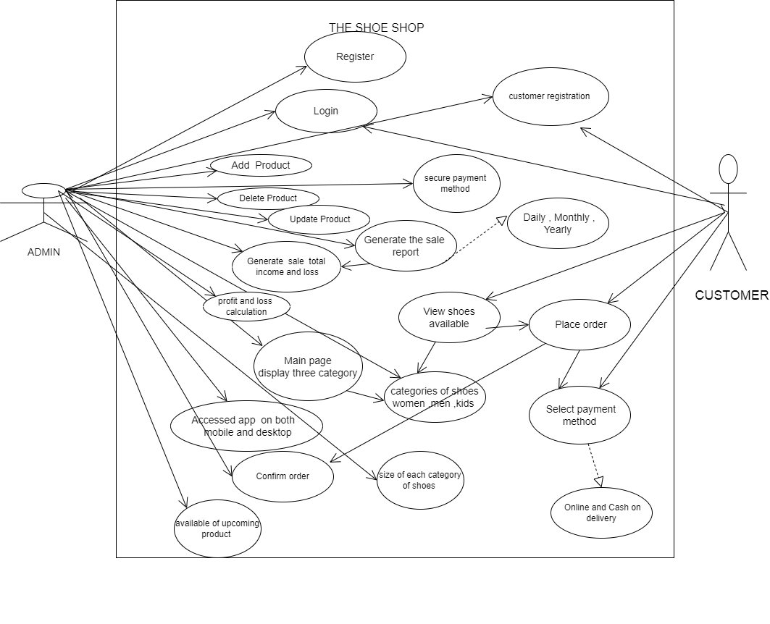
Figure no 1

Usage Scenarios:

Usage Scenario 1:
 | Use case related to registration of customer
Use case title |  | Customer Registration
Abbreviated title |  | CR
Use case ID |  | UC-01
Actors |  | Customer
Description |  | This use case provides registration form by this form customer register on web application
Pre conditions |  | Internet connection should be available.
Task sequence |  |  |  | Exceptions
- Use case starts when customer click on register to create account on the system  - System is shown the all features  - Customer initiates the register of user command.  - A small questionnaire given to the customer, which is related to personal & contact details.  - The user answers the questionnaire and finishes the registration.  - System should be validate information by  Customer. |  |  |  | 1. Customer has entered the invalid mobile phone number.  2. customer has entered a incorrect password  3. customer does not verified then customer does not register
Post  condition |  |  | Customer has registered successfully and saved detail in database.
Author |  |  | Mc210400906

Usage Scenario 2:
 | Use case related to login customer
Use case title |  | Login
Abbreviated title |  | L
Use case ID |  | UC-02
Actors |  | CUSTOMER
Description |  | This use case provides facility to customer to Login on website.
Pre conditions |  | Customer have to request login by clicking on login ; system will access to the web by the login
Task sequence |  |  |  | Exceptions
- Use case starts when click on login.  - The system respond click on login button.  - System provide the interface to enter name or password.  - Customer Enter his/her the user name and Enter password  5. System will check the provide user name or password.  6. System forwards these details to admin.  7. Admin will approve the login details. |  |  |  | - Customer has entered the incorrect user name.  - Customer has entered a incorrect password.
Post  condition |  |  | Customer successfully login.
Author |  |  | Mc210400906

Usage Scenario 3:
 | Use case related to Add product
Use case title |  | Add Product
Abbreviated title |  | AP
Use case ID |  | UC-3
Actors |  | ADMIN
Description |  | This use case provide facility to admin that add new product on website.
Pre conditions |  | Any new shoe product available to add on website
Task sequence |  |  |  | Exceptions
- This use case starts when admin click on add product.  - After clicking on add product button the form is appeared and admin added a new product  - After clicking on add product button then new shoe product added on website successfully |  |  |  | 1. if the admin is not logged in then cannot added a new product
Post  condition |  |  | Admin has added a new variety successfully.
Author |  |  | Mc210400906

Usage Scenario 4:
 | Use case related to Delete product
Use case title |  | Delete Product
Abbreviated title |  | DP
Use case ID |  | UC-4
Actors |  | ADMIN
Description |  | This use case provides facility to admin that delete a product on website.
Pre conditions |  | There is no shoe product available to sale then delete
Task sequence |  |  |  | Exceptions
- This use case starts when admin click on delete product.  - After clicking on delete product button the form is appeared and admin delete old product  - After clicking on delete product button then old shoe product deleted on website successfully |  |  |  | 1. If the admin is not logged in then cannot added a new product
Post  condition |  |  | Admin has deleted product Successfully.
Author |  |  | Mc210400906

Usage Scenario 5:
 | Use case related to update product
Use case title |  | Update Product
Abbreviated title |  | UP
Use case ID |  | UC-5
Actors |  | ADMIN
Description |  | This use case provides facility to admin that update product on website.
Pre conditions |  | If any shoe product available to update.
Task sequence |  |  |  | Exceptions
1. This use case starts when admin click on update product.  2 After clicking on update product button the form is appeared  and admin update product.  3. After clicking on update product button then shoe product updated on website successfully. |  |  |  | 1. if the admin not logged in then cannot update the product.
Post  condition |  |  | Admin has updated product successfully.
Author |  |  | Mc210400906

Usage Scenario 6:
 | Use case related to generate the sale report by admin
Use case title |  | Generate the sale report
Abbreviated title |  | GTSR
Use case ID |  | UC-6
Actors |  | ADMIN
Description |  | This use case provide facility to admin that generate a sale report daily , monthly and yearly.
Pre conditions |  | Admin should be registered on system.
Task sequence |  |  |  | Exceptions
- This use case starts when the admin click on generate sale report.  - After clicking on generate sale report the a form is appeared and show option daily , monthly , and yearly.  - If Admin wants to generate daily sale report then click on daily sale report.  - After clicking on daily sale report then admin generate a daily sale report. |  |  |  | 1. If admin not register to system then they cannot generate a sale report .
Post  condition |  |  | Admin has generated a daily sale report successfully.
Author |  |  | Mc210400906

Usage Scenario 7:
 | Use case related to generate the total income and loss
Use case title |  | Generate the sale total income and loss
Abbreviated title |  | GTSTIAL
Use case ID |  | UC-7
Actors |  | ADMIN
Description |  | This use case provides facility to admin that generate the sale total income and loss.
Pre conditions |  | Admin should be registered in system.
Task sequence |  |  |  | Exceptions
- This use case starts when admin click on generate the sale total income.  - After click on this button a form is appeared to calculate a total sale income.  - After the Calculation, admin generate a sale a total sale income.  - And when admin want to generate the loss then click on loss button  - After click on this button form appeared to calculate the loss  - After calculation, admin  Generate the loss |  |  |  | 1. If admin not register in system then they cannot generate a total income and loss.
Post  condition |  |  | Admin has generated a total income and loss successfully.
Author |  |  | Mc210400906

Usage Scenario 8:
 | Use case related to view shoes available
Use case title |  | View shoes available
Abbreviated title |  | VSA
Use case ID |  | UC-8
Actors |  | CUSTOMER
Description |  | This use case provides facility to user to view shoes categories on website.
Pre conditions |  | Customer should be login.
Task sequence |  |  |  | Exceptions
- This use case starts when customer click on view shoes categories.  - After the click on view shoes categories then all available categories show on website.  - Then Customer choose the shoes. |  |  |  | 1. If customer is not login on this website then they cannot view shoes categories  2. Customer internet connection is not available.
Post  condition |  |  | Customer has viewed shoes available successfully.
Author |  |  | Mc210400906

Usage Scenario 9:
 | Use case related to place order
Use case title |  | Place order
Abbreviated title |  | PO
Use case ID |  | UC-9
Actors |  | CUSTOMER
Description |  | This use case provides facility to customer to place order.
Pre conditions |  | Customer should be login.
Task sequence |  |  |  | Exceptions
- This use case starts when customer click on place order.  - After click on place order then all categories of shoes for selection is open.  - Then customer select the shoes for place order  - After selection, customers provide address and contact number. |  |  |  | 1. If customer not login on this website.  2 customer internet connections is not available.
Post  condition |  |  | Customer has place ordered successfully.
Author |  |  | Mc210400906

Usage Scenario 10:

 | Use case related to login admin
Use case title |  | Login
Abbreviated title |  | L
Use case ID |  | UC-10
Actors |  | ADMIN
Description |  | This use case provides facility to admin to Login on website.
Pre conditions |  | Admin have to request login by clicking on login ; system will access to the web by the login
Task sequence |  |  |  | Exceptions
1.Use case starts when click on login.  - The system respond click on login button.  - System provide the interface to enter name or password.  - admin Enter his/her the user name and Enter password  - System will check the provide user name or password. |  |  |  | 1. admin has entered the incorrect user name.  2 . admin has entered a incorrect password.
Post  condition |  |  | Admin has successfully login.
Author |  |  | Mc210400906

Usage Scenario 11:
 | Use case related to select payment method
Use case title |  | Select payment method
Abbreviated title |  | SPM
Use case ID |  | UC-11
Actors |  | CUSTOMER
Description |  | This use case provides facility to customer to select the method of payment.
Pre conditions |  | Customer should be place order.
Task sequence |  |  |  | Exceptions
- This use case starts when customer click on select payment method.  - Then form appeared and show two options cash on delivery and online.  - If customer wants to cash on delivery then select cash on delivery.  - If customer wants to pay online then select online.  - After selection of payment then order confirm. |  |  |  | 1. If customer not login then they cannot select payment method  2. If customer have a internet issue.
Post  condition |  |  | Customer has selected payment method
Author |  |  | Mc210400906

Usage Scenario 12:
 | Use case related to main page display three categories
Use case title |  | Main page display three categories
Abbreviated title |  | MPDTC
Use case ID |  | UC-11
Actors |  | ADMIN
Description |  | This use case provides facility to admin that display three categories on main page.
Pre conditions |  | Admin should be registered in system.
Task sequence |  |  |  | Exceptions
- This use case starts when admin click on main page.  - After click on main page admin display three categories. .  - There are three categories men, women and kids.  - This categories available with description like sizes ,  And color. |  |  |  | 1. If admin not register in system then they cannot display a all three categories on main page.
Post  condition |  |  | Admin has display three categories on main page successfully.
Author |  |  | Mc210400906

Usage Scenario 13:
 | Use case related to accessed app both on mobile and desktop
Use case title |  | Accessed app both mobile and desktop
Abbreviated title |  | AABMD
Use case ID |  | UC-13
Actors |  | ADMIN
Description |  | This use case provides facility to admin they accessed app on mobile and desktop.
Pre conditions |  | Admin should be registered in system
Task sequence |  |  |  | Exceptions
- This use case starts when customer open this app on mobile.  - Then admin allow to customer to open this app on mobile easily.  - If customer open this app on desktop then admin allow to opening this app on desktop. |  |  |  | 1. If admin not register in system
Post  condition |  |  | Admin has accessed app on both mobile and desktop successfully.
Author |  |  | Mc210400906

Usage Scenario 14:
 | Use case related to confirm order
Use case title |  | Confirm order
Abbreviated title |  | CO
Use case ID |  | UC-14
Actors |  | ADMIN
Description |  | This use case provides facility to admin that confirm order from customer.
Pre conditions |  | Admin should be registered in system and place the order.
Task sequence |  |  |  | Exceptions
- This use case starts when customer click on confirm order.  - If shoes not available then admin cancel the order and show out of stock.  - If shoes is available then admin confirm order and show message order is confirmed successfully. |  |  |  | 1. If admin not register in system then they cannot confirm order  2. Products are out of stock.
Post  condition |  |  | Admin has confirmed order successfully.
Author |  |  | Mc210400906

Usage Scenario 15:
 | Use case related to profit and loss calculation
Use case title |  | Profit and loss calculation
Abbreviated title |  | PLC
Use case ID |  | UC-15
Actors |  | ADMIN
Description |  | This use case provide facility to admin that calculate profit and loss calculation
Pre conditions |  | Admin should be login on system.
Task sequence |  |  |  | Exceptions
- This use case starts when the admin click on calculation .  - After clicking on calculation a form is appeared and show profit and loss  - If Admin wants to calculate profit daily sale report then click on profit sale report.  - After clicking on profit sale report then admin calculate profit of sale report. |  |  |  | 1. If admin not register to system then they cannot calculate the profit and loss calculation report .
Post  condition |  |  | Admin has calculated profit and loss sale report successfully.
Author |  |  | Mc210400906

Usage Scenario 16:
 | Use case related to secure payment method
Use case title |  | Secure payment method
Abbreviated title |  | SPM
Use case ID |  | UC-16
Actors |  | ADMIN
Description |  | This use case provides facility to customer Secure method of payment.
Pre conditions |  | Customer should be place order.
Task sequence |  |  | Exceptions
- This use case starts when customer click on secure payment method.  - Then form appeared and show two options cash on delivery and online.  - If customer wants to cash on delivery then select cash on delivery.  - If customer wants to pay online then select online.  - After selection of payment then order confirm. |  |  | 1. If Amin not login then they cannot secure payment method

Post Condition | Admin has secured payment method successfully .
Author | Mc210400906

Usage Scenario 17:
 | Use case related to categories of shoes men , women ,and kids
Use case title |  | Categories of shoes men,women ,and kids
Abbreviated title |  | CSMWKS
Use case ID |  | UC-17
Actors |  | ADMIN
Description |  | This use case provides facility to admin that show shoes categories.
Pre conditions |  | Admin should be registered in system.
Task sequence |  |  |  | Exceptions
- This use case starts when admin click on shoes categories.  - After clicking on shoes categories then all shoes categories show on website.  - There are different shoes categories men ,  Women and kids shoes with different variety.  - When admin click on men shoes.  - After clicking on men shoes the both categories available formal and casual.  - When admin click on women shoes then show both categories available casual and party.  - When admin click on kids shoes then show both categories available girls and boys |  |  |  | 1. If admin not register in system then they cannot categorized the shoes.
Post  condition |  |  | Admin has Categorized the shoes successfully.
Author |  |  | Mc210400906

Usage Scenario 18:
 | Use case related to size of each categories of shoes
Use case title |  | Size of each Categories of shoes
Abbreviated title |  | SCOS
Use case ID |  | UC-18
Actors |  | ADMIN
Description |  | This use case provides facility to admin that show size of shoes categories.
Pre conditions |  | Admin should be registered in system.
Task sequence |  |  |  | Exceptions
- This use case starts when admin click on size shoes categories.  - After clicking on shoes size then all shoes size categories show on website.  - There are different shoes size categories .  - Customer select size of shoes . |  |  |  | 1. If admin not register in system then they cannot categorized the size of shoes.
Post  condition |  |  | Admin has Categorized the size of shoes successfully.
Author |  |  | Mc210400906

Usage Scenario 19:
 | Use case related to available upcoming product
Use case title |  | Available upcoming product
Abbreviated title |  | AUP
Use case ID |  | UC-19
Actors |  | ADMIN
Description |  | This use case provides facility to admin that available upcoming product on website.
Pre conditions |  | If any shoe product available to upcoming.
Task sequence |  |  |  | Exceptions
- 1. This use case starts when admin click on upcoming product  - After clicking on update product button the form is appeared  and admin update upcoming product product.  - After clicking on update product button then shoe upcoming product updated on website successfully. |  |  |  | 1. if the admin not logged in then cannot show upcoming product .
Post  condition |  |  | Admin has updated upcoming product successfully.
Author |  |  | Mc210400906

1.7 Software Development Methodologies

Software development methodologies are also known as system development methodologies. Actually this is system development life cycle, or it can be called System Development Process. Software development methodologies are frames that are used to structure, control and plan the process of developing system.

There are several models for such processes each describing approach to different variety of tasks, or activities that take place during the process. The names of the some of the methodologies are as follows:

- Agile software Development
- Incremental model
- Crystal Methods
- Extreme programming
- Waterfall model
- Spiral model

My adopted methodology is combination of these two given methodologies as follows:

Waterfall methodology

The first published model of the software development process was derived from other engineering processes. Because of the cascade from one phase to another, this model is known as the waterfall model. This model is also known as linear sequential model.
The waterfall model is a documentation-driven model. It therefore generates complete and comprehensive documentation and hence makes the maintenance task much easier. I t however suffers from facts that the client feedback is received when the product is finally delivered and hence any errors in the requirement specifications are not discovered until the product is sent to the client after completion. This therefore has major time and cost related consequences.

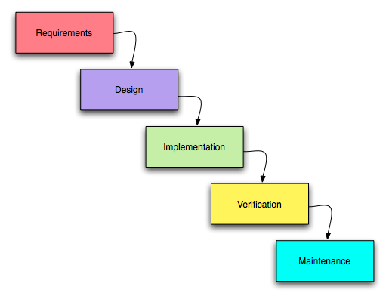

Figure 2 Waterfall Methodology

Spiral Methodology

This model was developed by Barry Boehm. The main idea of this model is to avert risk as there is always an element of risk in development of software. For example key personnel may resign at a critical juncture, the manufacturer of the software development may go bankrupt, etc.
In its simplified form, the Spiral model is Waterfall model plus risk analysis. In this case each stage is preceded by identification of alternatives and risk analysis and is then followed by evaluation and planning for the next phase. If risks cannot be resolved, project immediately terminated.
The main strength of the Spiral Model comes from the fact that it is very sensitive to the risk. Because of the spiral nature of development it is easy to judge how much to test and there is no distinction between development and maintenance.

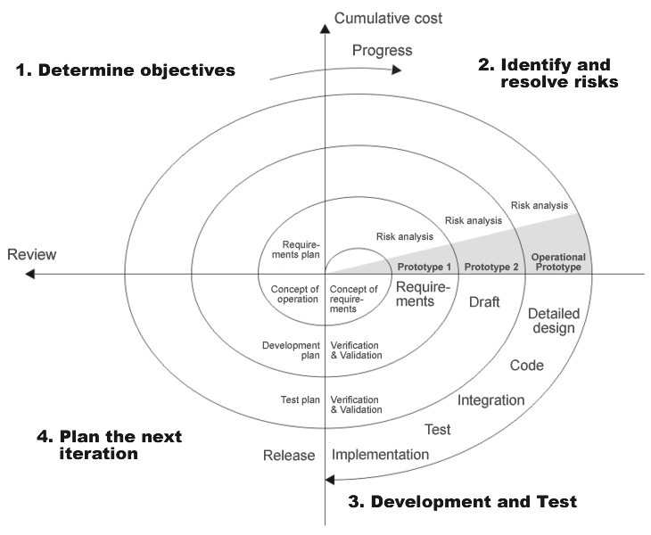
Figure 3 Spiral Methodology

1.7.1 Adopted Methodology

The below is VU process model which is combination of waterfall and spiral models.
It has seven phases.

1. System Requirement Specification (SRS)
2. Design phase
3. Test phase 1
4. Test Phase 2
5. Development
6. Final report
7. Presentation and viva

In the requirement phase system goals services and constraints are established after discussion with users.

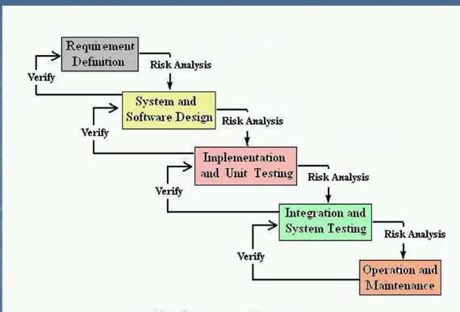

Figure 4 Vu model process

Why we use this methodology? Reason :

- We use this methodology because virtual university of Pakistan guides to that you must select vu process model .
- This model is used when cost and risk evaluation is important.
- This methodology is also used when users are unsure of their requirement.

Benefits of using this methodology

- This is sequenced model.
- This model is easy to understand.
- This model is easy to use.
- Each phase has specific deliverable.
- In this model phases are completed and processed one at a time.
- Avoidance of risk is enhanced.
- Additional functionality can be added later.
- It is also used when significant changes are expected.

Team structure

This project consist one supervisor and one developer.

Supervisor

Developer

Figure 5 team structure

1.7.2 Work Plan

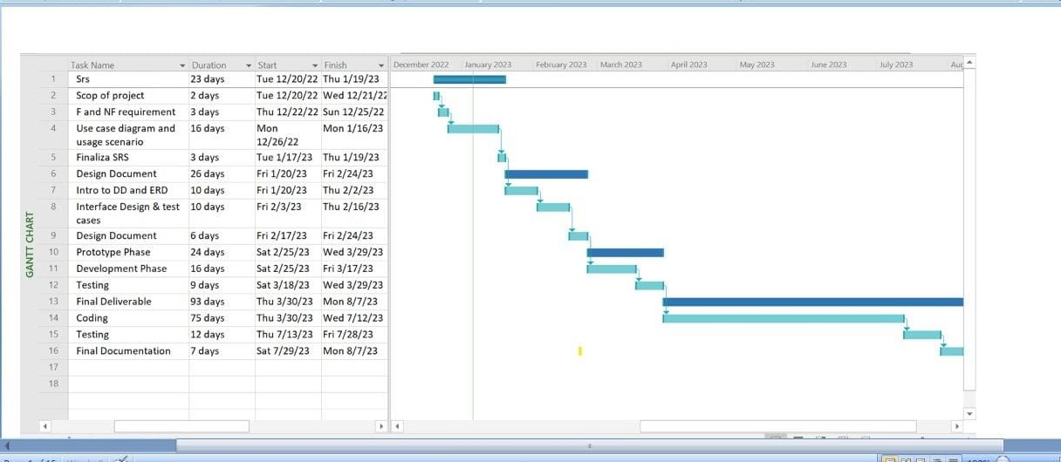

Figure 6 Gantt chart

Time line

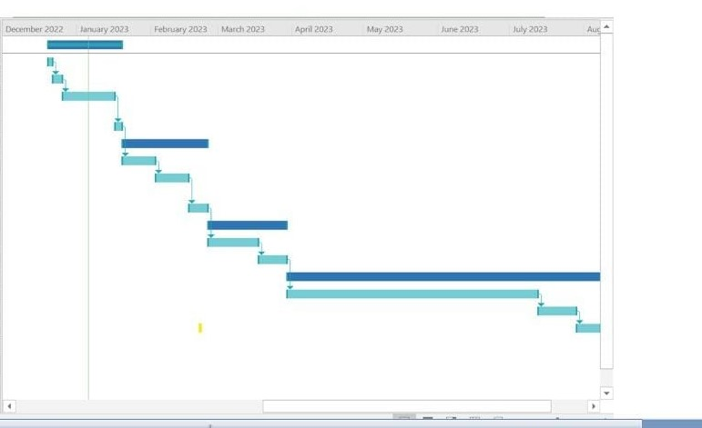

Figure 7 timeline

The project schedule is one of the most important parts of the Project development plan.

The plan includes:
• Scheduling of development activities and
• Scheduling of project resources, particularly people

The project development plan describes in detail:
• How the project manager plans to develop the project
• What resources will be required and
• How these resources will be applied
A schedule is a list of:
- Activities and
- Anticipated time of implementation of these activities
0
There are many ways of representing a schedule:
- Lists of activities,
- Diagrams,
- Graphs etc

The most common methods of schedule representation are:
- Diagrams,
- Gantt charts and
- Lists of milestones

The goal of a software project schedule is to determine the
Duration of the software project and the phases within the project. A software project schedule enables you to distribute the estimated effort to be spent in performing the critical activities.

The description of the project schedule plan is given below:

Sr.# | phases | Deliverable | description | Submission date
1 | Gathering & analyzing requirement | SRS document | Scope, Function and Non- functional requirement, Use cases, Usage scenarios, Methodology, Work plan. | Thu 19 Jan, 2023
2 | Planning and design phase | Design document | Entity relationship diagram, Sequence diagram, Architecture diagram, Class diagram, Database design diagram ,Test cases | Fri 24Feb,2023
3 | Test phase | Test phase task | Test phase task was to learn about the basic working method of project at initial level. | Wed 29  Mar,2023
4 | Development, project final report | Final project report | Design, Methodologies, Testing Implementation or coding, Maintenance, Documentation | Mon 7 Aug  ,2023
 | Pre and Final viva | Pre-final and final viva | Compilation and submission of project then viva’s will be schedule. | To be Schedule

CHAPTER 2
Designing the Project

2.1 Introduction

In design phase we focus on ‘HOW’ to do. It means how the problem will be solved and which tools and techniques will be used. Much care is taken during the design phase because any mistake in this phase could be very expensive to solve in he later stage of the software development. The purpose of design phase is to plan out a system that meets the requirement defined in the analysis phase. This phase surround:

- Entity Relationship Diagram (ERD)
- Sequence Diagrams
- Architecture Design Diagram
- Class Diagram
- Database Design
- Interface Design
- Test Cases

- Entity Relationship Diagram:

Entity Relationship Diagram is a data model for describing a database in an abstract model. It contains entities and their relationships. An entity may be defined as a thing which is recognized as being capable of an independent existence and which can be uniquely identified.

- Sequence Diagram

Sequence Diagram is an interaction diagram that shows how processes operate with each other. It shows the messages exchanges between entities.

- Architecture Design Diagram:

Architecture Design Diagram used to represent data in the form of layers. It contains three layers’ data link layer, application layer and business layer.

- Class Diagram:
In Class diagram, we will describe the structure of Intelligent Lecture Scheduling System by showing the system's classes, show their attributes, operations or methods and relationships between classes or objects. In a class, diagram classes represent both the main objects and interactions.

- Database Design:
Database Design is a process of producing a detailed data model of a database. It can be taken as the logical design of the base data structures to store the data

- Interface Design:
Interface Design is a GUI view of main software. It shows how our Software Application will look like and how we interference with the System.

- Test cases:
In the test cases for the Intelligent Lecture Scheduling System are also given. A test case in software engineering is a set of conditions or variables under which a tester will determine whether an application or software system is working correctly or not.

2.2 purpose

This document is, written to give a complete description, while maintaining a high-level view of the software so that documentation will reduce abstraction effectively and gradually.

2.3 scope

In analysis and design phase of a project we create a design document that is an illustrative explanation of a software product. A software designer designs this document in order to give a software development team an overall picture and guidance of the architecture of the software project. It usually accompanies an architecture diagram and has pointers to the detailed feature specifications of smaller pieces of the design. A design document is practically required to coordinate a large team under a single vision. Design document allowed team members to mutually communicate with each other and to take early design decision about the product to be developed.

2.4 definitions, acronyms and abbreviations
- HTML (Hyper Text Markup Language)
- CSS (Cascading Style Sheet)
- PHP (PHP Hyper Text Markup Language)
- DBMS Database Management System)
- SQL (Structure Query Language)

2.5 Architectural Representation (Architecture Diagram)

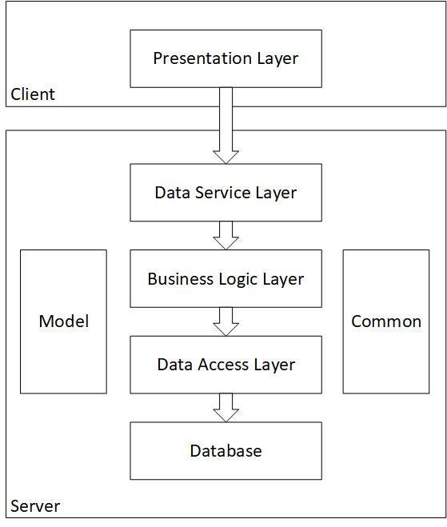 figure no 8

2.6 Dynamic Model: Sequence Diagrams

- Sequence Diagrams
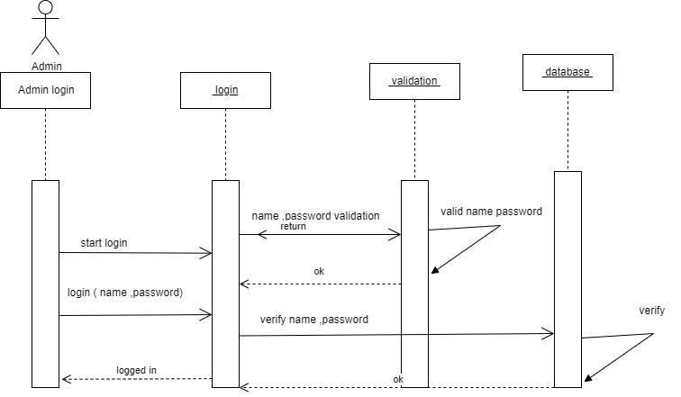
Figure 9 Admin login
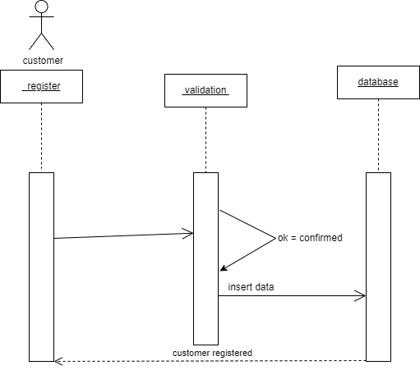
Figure 10 customer register
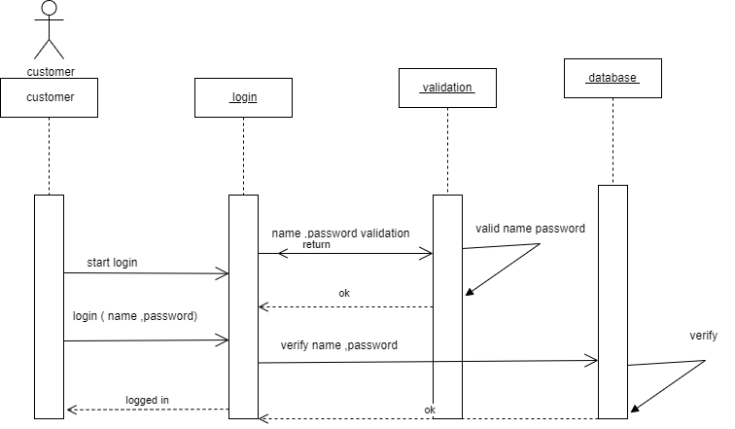
Figure 11 Customer login

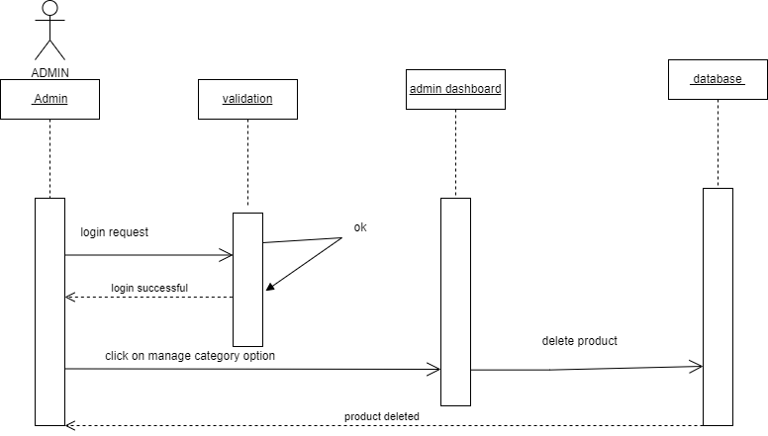
Figure 12 Delete product
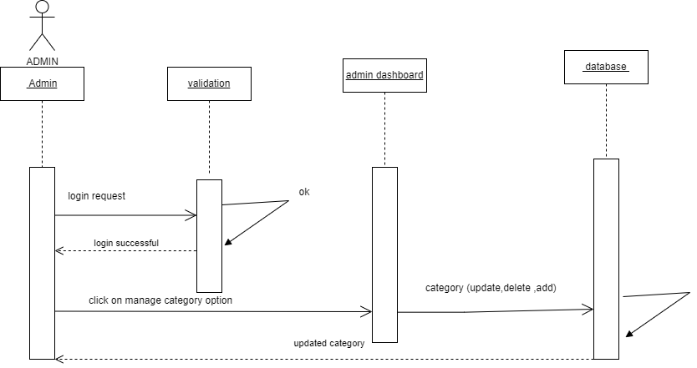
Figure 13 Updated category

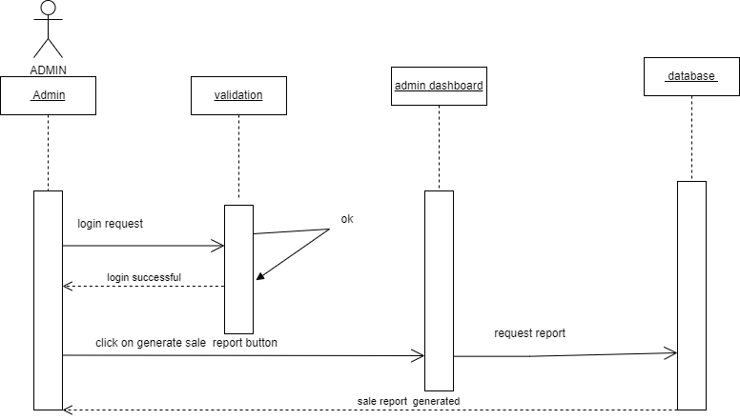
Figure 14 Generate sale report

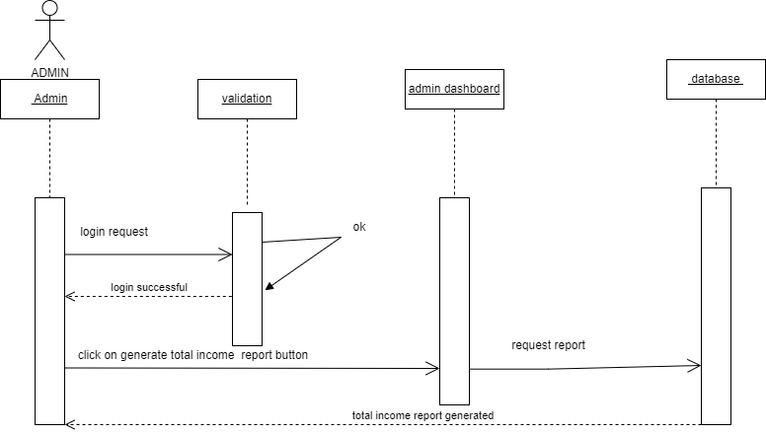
Figure 15 total income report
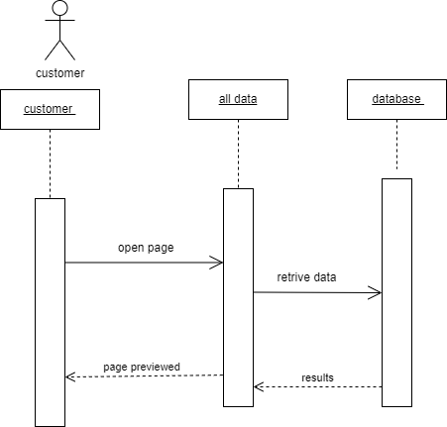
Figure 16 page preview

2.7 Object Model/Logical Model: Class Diagram

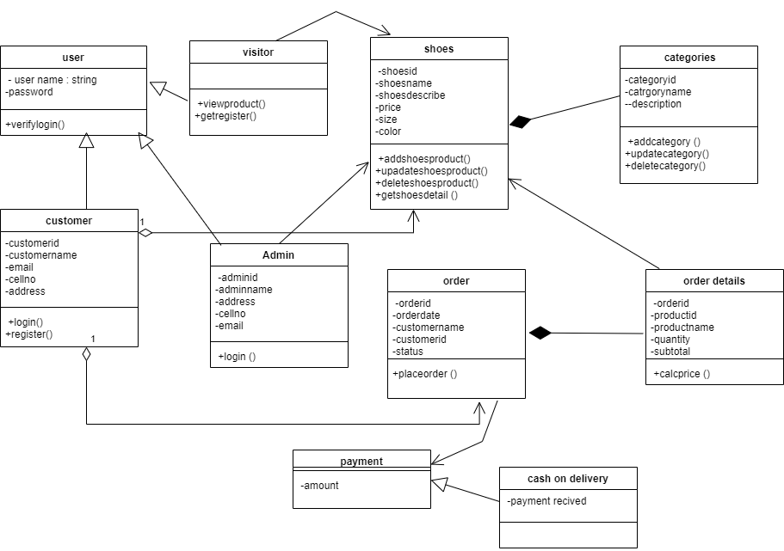

Figure 17 Class Diagram

2.8 Database Model (Database Diagram)

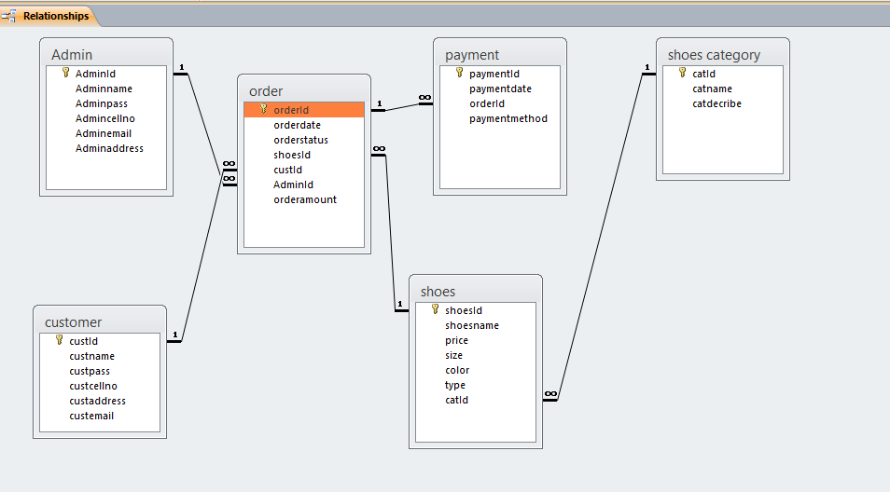

Figure 18 Database Design

2.9 Graphical User Interfaces

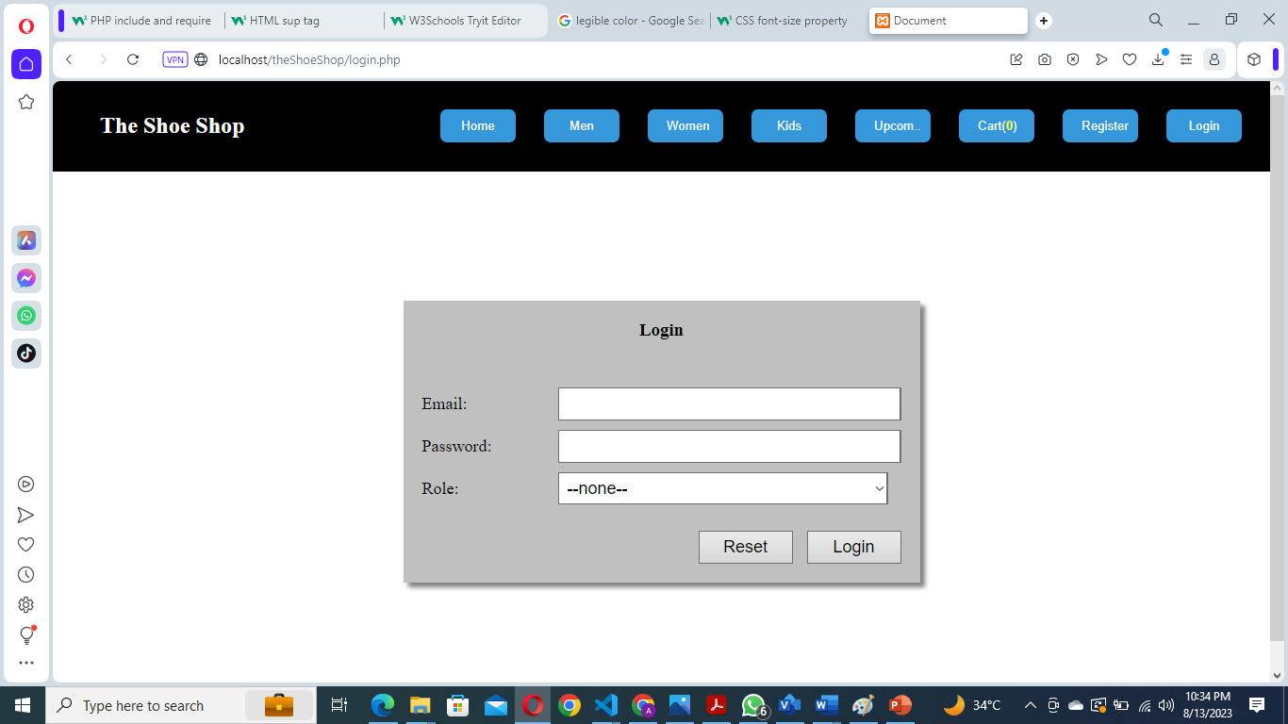

Figure 19 Login form
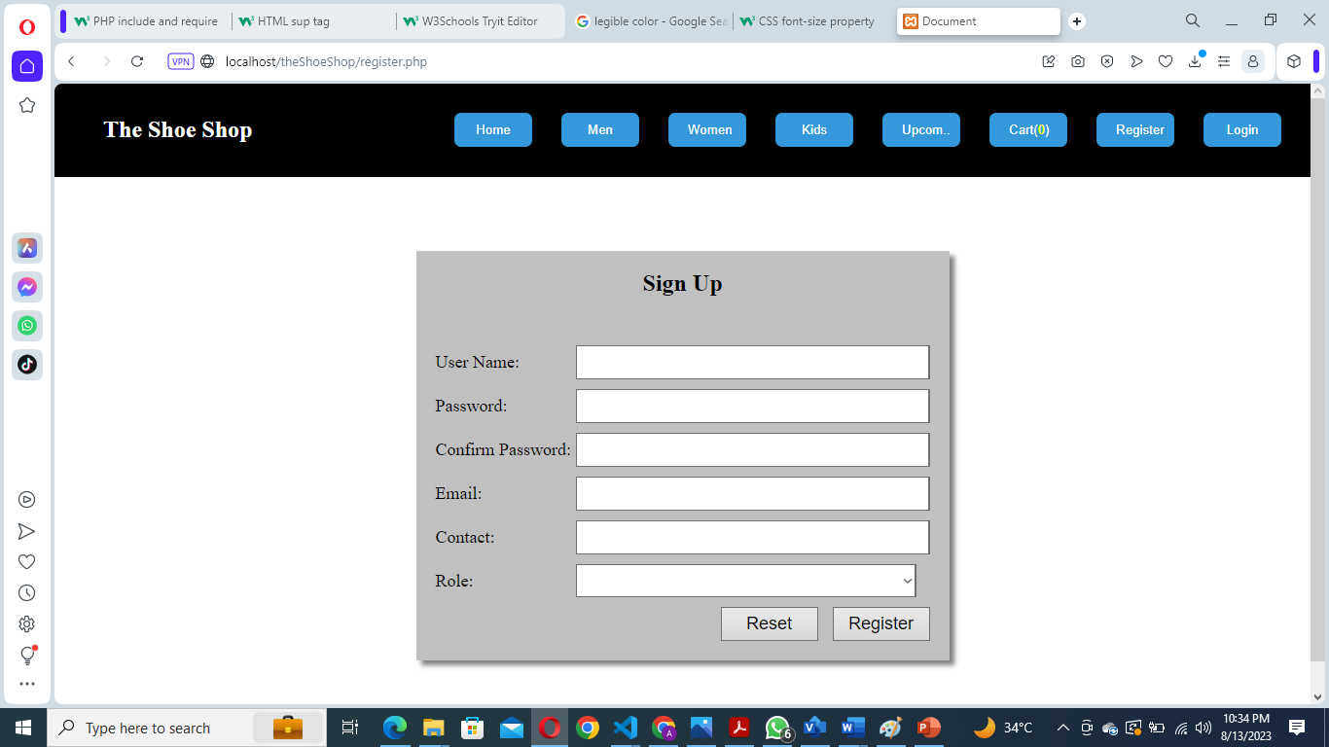
Figure 20 Registration form
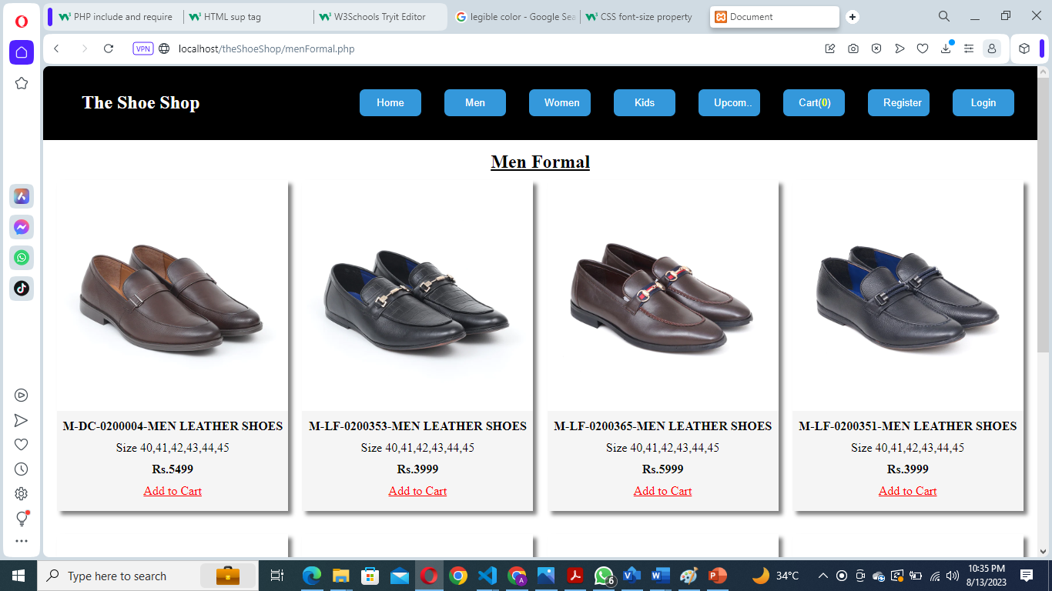

Figure 21 Men shoes category
s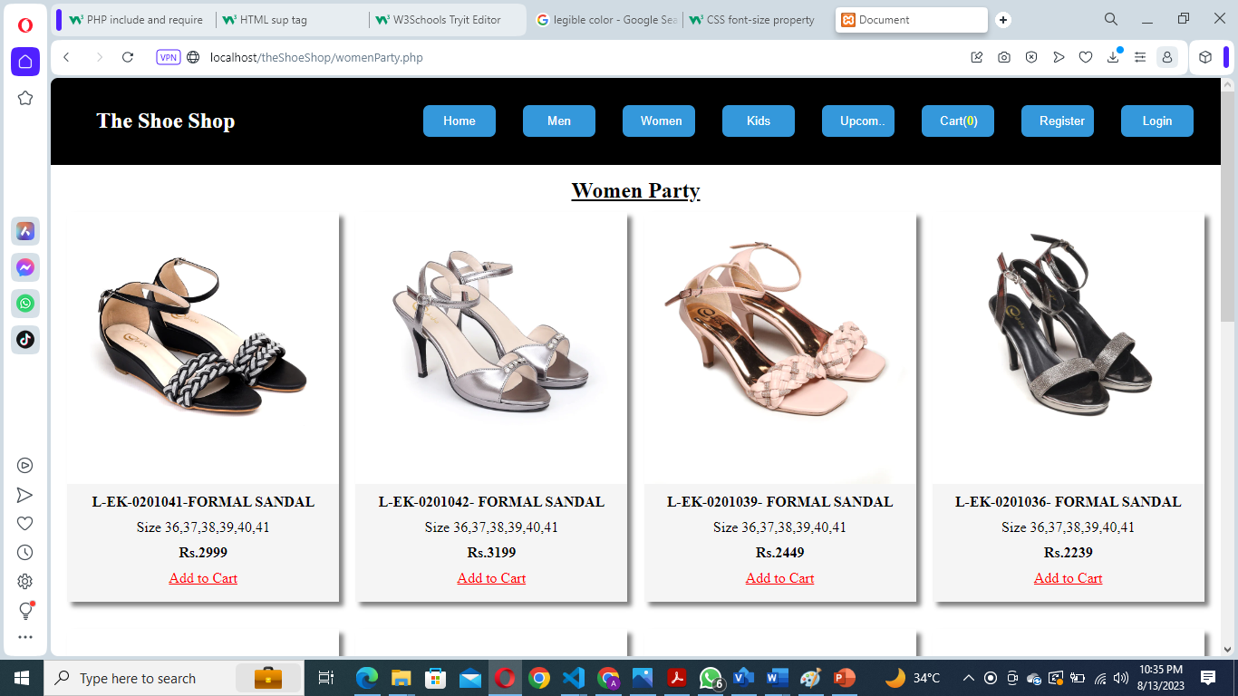
Figure 22 Women shoes category

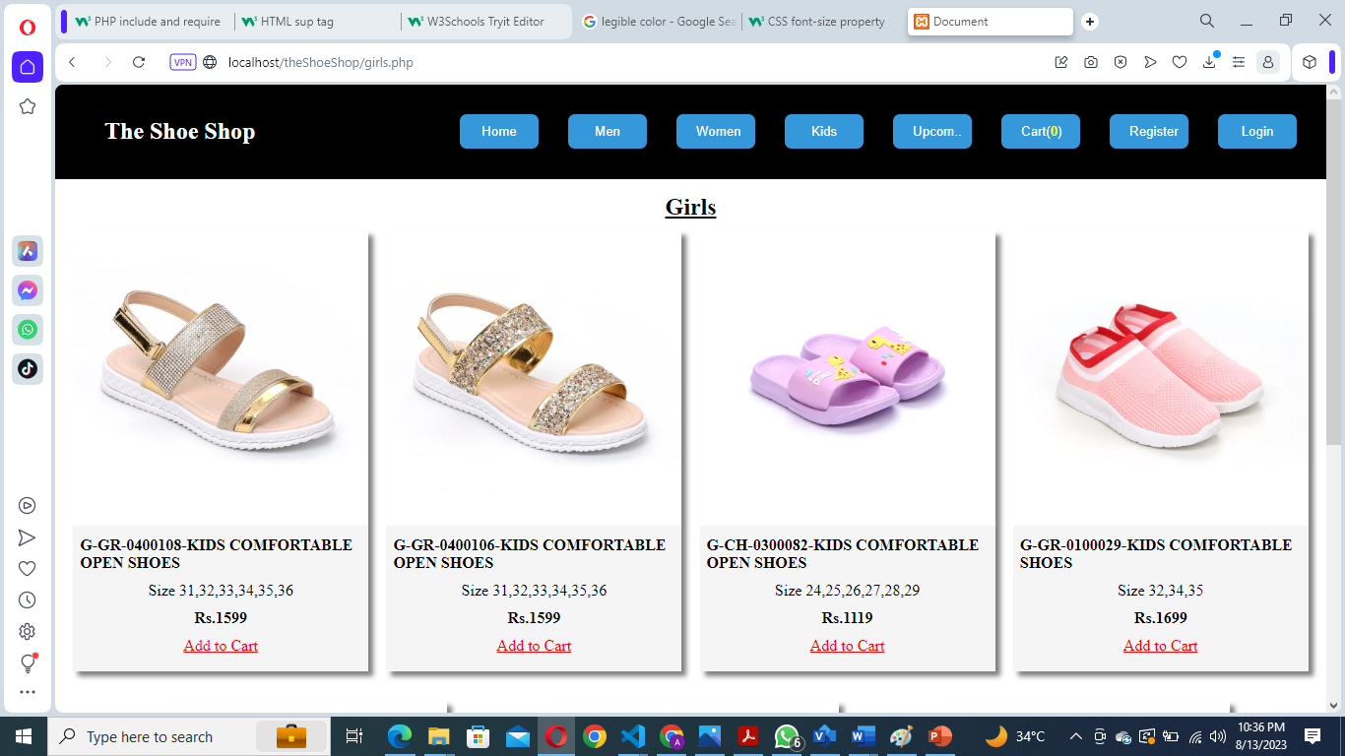
Figure 23 Kids shoes category
s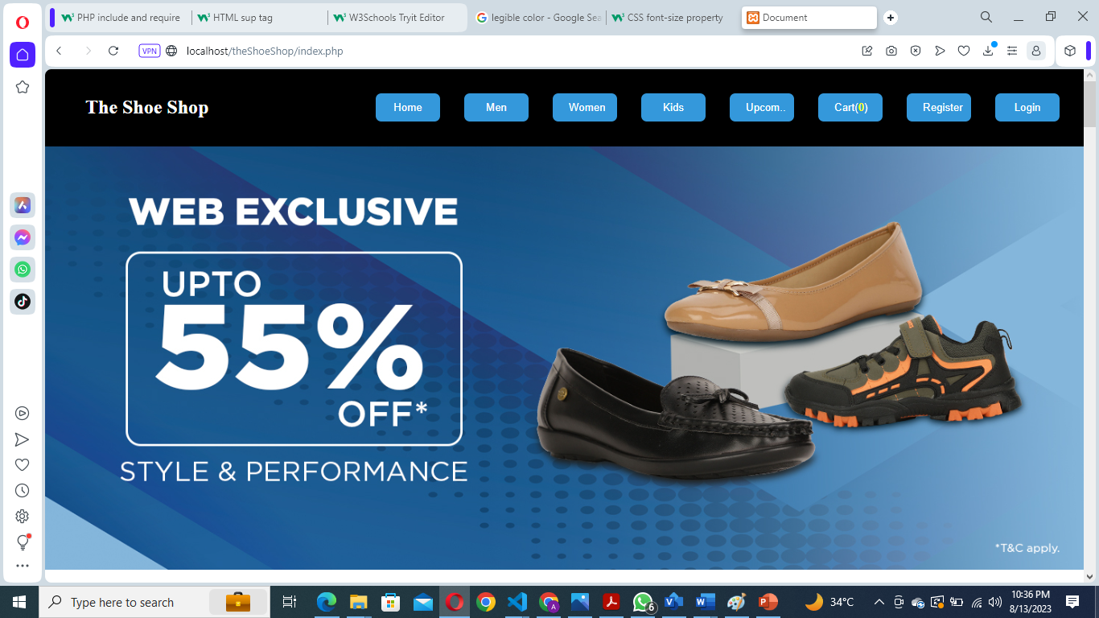
Figure 24 View all category

CHAPTER 3
Development

3.1 DEVELOPMENT PLAN (ARCHITECTURE DIAGRAM)

Presentation layer
The presentation layer is also called the Translation layer. The data from the application layer is extracted here and manipulated as per the required format transmit over the network.

Logical layer

The logical layer determines the logical transmission paths between sources and destinations. The physical layer is responsible for sending packets from one end to the other end of the logical link.

Data layer

Data link layer performs the most reliable node to node delivery of data. It forms frames from the packets that are received from network layer and gives it to physical layer. It also synchronizes the information which is to be transmitted over the data.

3.1 Development plan (Architecture Diagram)

Figure 25

REFERENCES

Handout CS504 – Software Engineering - 1
Handout CS605 – Software Engineering - 2
Handout CS403 – DBMS
also by
W3schools.com website
Getbootsrapt.com
Google, YouTube and from my instructor.

APPENDIX

What is Bootstrap?

Bootstrap is a free front-end framework for faster and easier web development.
Bootstrap includes HTML and CSS based design templates for typography, forms, buttons, and tables, navigation, modals, image carousels and many other, as well as optional JavaScript plug-in.
Bootstrap also gives you the ability to easily create responsive designs.

What is PHP?

PHP is an acronym for "PHP: Hypertext Pre-processor"
PHP is a widely-used, open source scripting language
PHP supports many databases (MySQL, Informix, Oracle, Sybase, Solid, PostgreSQL, Generic ODBC, etc.) .
PHP scripts are executed on the server
PHP is free to download and use

What is a PHP File?

PHP files may contain text, HTML tags and scripts.
PHP files are returned to the browser as plain HTML.
PHP files have a file extension of ".php", ".php3", or ".phtml".

What is MySQL?
MySQL is a database server.
MySQL is ideal for both small and large applications.
MySQL supports standard SQL.
MySQL compiles on a number of platforms.
MySQL is free to download and use.
PHP combined with MySQL are cross-platform (means that you can develop in Windows and serve on a UNIX platform).

What do you need?

This tutorial will not explain how to install PHP, MySQL, or Apache Server.
If your server supports PHP - you don't need to do anything! You do not need to compile anything or install any extra tools - just create some .php files in your web directory - and the server will parse them for you. Most web hosts offer PHP support.
However, if your server does not support PHP, you must install PHP. Below is a link to a good tutorial from PHP.net on how to install PHP:

http://www.php.net/manual/en/install.php
Download PHP
Download PHP for free here: http://www.php.net/downloads.php
Download Xampp server for free: https://www.apachefriends.org/download.html

Basic PHP Syntax:

A PHP scripting block always starts with <?php and ends with ?>. A PHP scripting block can be placed anywhere in the document.
On servers with shorthand support enabled we can start a scripting block with <? And end with ?>.
However, for maximum compatibility, it is recommended that you use the standard form (<?php) rather than the shorthand form.

Comments in PHP :

In PHP, we use // to make a single-line comment or /* and */ to make a large comment block.

Variables in PHP:

Variables are used for storing values, like text strings, numbers or arrays.
When a variable is set it can be used over and over again in your script All variables in PHP start with a $ sign symbol.

The Concatenation Operator:
There is only one string operator in PHP.
The concatenation operator (.) is used to put two string values together.

Conditional Statements:
Very often when you write code, you want to perform different actions for different decisions.You can use conditional statements in your code to do this.

if...else statement:
use this statement if you want to execute a set of code when a condition is true and another if the condition is not true.

else if statement:
is used with the if...else statement to execute a set of code if one of several condition are true.

Looping:

Very often when you write code, you want the same block of code to run a number of times. You can use looping statements in your code to perform this.

In PHP we have the following looping statements:

- while - loops through a block of code if and as long as a specified condition is true.
- do...while - loops through a block of code once, and then repeats the loop as long as a special condition is true.
- for - loops through a block of code a specified number of times.
- foreach - loops through a block of code for each element in an array.
PHP Functions
In this tutorial we will show you how to create your own functions.
Create a PHP Function
A function is a block of code that can be executed whenever we need it.
Creating PHP functions:

- All functions start with the word "function()"
- Name the function - It should be possible to understand what the function does by its name. The name can start with a letter or underscore (not a number)
- Add a "{" - The function code starts after the opening curly brace
- Insert the function code
- Add a "}" - The function is finished by a closing curly brace
PHP Functions - Adding parameters
Our first function (writeMyName()) is a very simple function. It only writes a static string.
To add more functionality to a function, we can add parameters. A parameter is just like a variable.
You may have noticed the parentheses after the function name, like: writeMyName(). The parameters are specified inside the parentheses.

functionwriteMyName($fname)
{
echo $fname;
}
Why use $_GET?
Note: When using the $_GET variable all variable names and values are displayed in the URL. So this method should not be used when sending passwords or other sensitive information! However, because the variables are displayed in the URL, it is possible to bookmark the page. This can be useful in some cases.

Note:

The HTTP GET method is not suitable on large variable values; the value cannot exceed 100 characters.
The $_POST Variable:
The $_POST variable is an array of variable names and values sent by the HTTP POST method The $_POST variable is used to collect values from a form with method="post". Information sent the POST method is invisible to others and has no limits on the amount of information to send.

Why use $_POST?

- Variables sent with HTTP POST are not shown in the URL
- Variables have no length limit

However, because the variables are not displayed in the URL, it is not possible to bookmark that variables.

The $_REQUEST Variable :
The PHP $_REQUEST variable contains the contents of both $_GET, $_POST, and $_COOKIE.

