📝 Operating Manual: Honorarium Bill Submission
This manual outlines the steps required to access the Honorarium Bill Submission, obtain login credentials, apply for the bill, and download the application form.

1. Get Access to the Dashboard
If you do not have your Registration No. & Password, you need to complete a quick process to obtain them.
- Navigate to the home page of the Honorarium Bill Submission.
- Scroll to the bottom of the home page.
- Click the "Go" Button of “Ready to get started?”
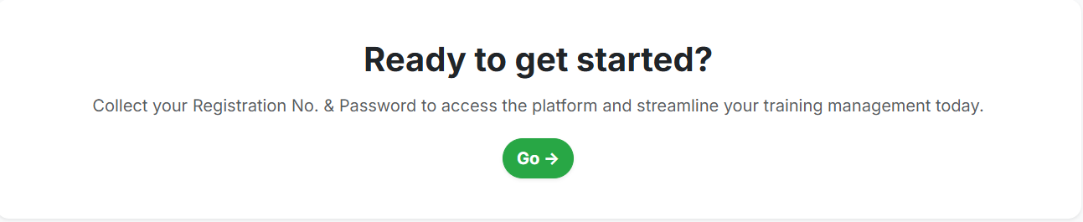

2. Obtain Access Credentials
After clicking "Go," you will be directed to a form to retrieve your access credentials.
- Enter Pen No: This is the Registration No. found on your FCPS Part-I Congratulation Letter (e.g., A-0000-0-00-0000).
- Enter Mobile No: Use the mobile number that was provided during your FCPS Part-I registration.
- Enter Email: Use the email address that was provided during your FCPS Part-I registration.
- Select Preferred Delivery Method: Choose how you wish to receive your credentials (SMS / Email / Both).
- Follow the remaining steps of the application procedure to successfully obtain your dashboard access credentials (Registration No. and Password).
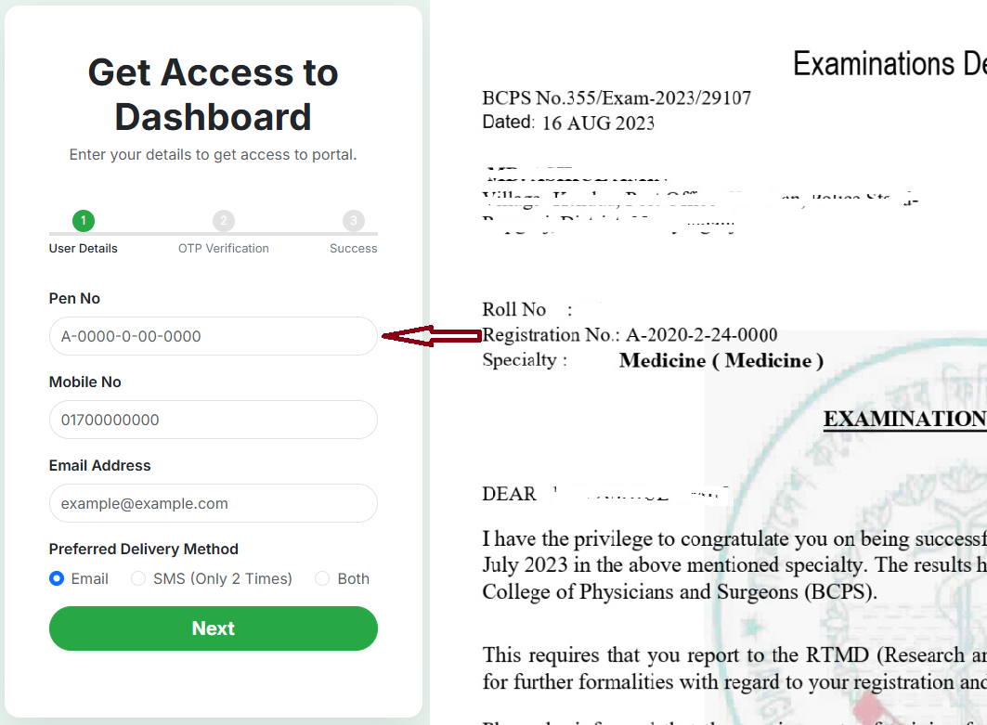

3. Login to the System
Once you have your credentials, you can log in to the system.
- Go back to the main login page.
- Enter your newly obtained Registration No. and Password.
- Click the Login button to access the dashboard.
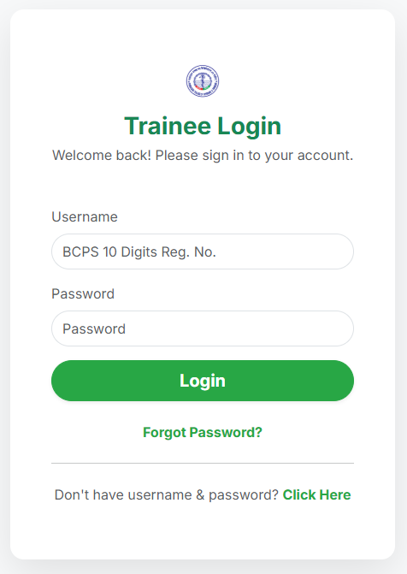

4. Apply for the Bill (Non-Governmental Trainees Allowances)
To submit an application for the allowance:
- From the main dashboard, look at the left menu.
- Click on the menu item named "Honorarium Bill Application".
- Carefully fill up the necessary information in the application form.
- Attach the required files as specified.
- Preview the application to ensure all details are correct.
- Finally, submit the form.
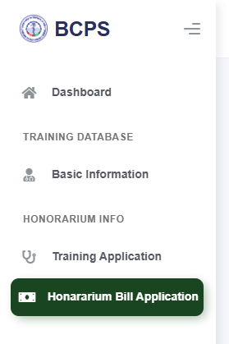

5. Download the Bill Application Form
After a successful submission, you can download a copy of your application form.
- Go back to the left menu of the dashboard.
- Click on the "Honorarium Bill Application" menu item again.
- Follow the instructions on the resulting page to download the submitted bill application form.
