**Project Overview**

This is a simple AI chatbot project developed using **Python** and **Flask**. The chatbot can answer user messages like greetings, jokes, motivational quotes, study tips, and more. It uses a predefined JSON file (intents.json) to understand and respond to user queries.

**Project Structure**

Below are the main files in this project:

* **app.py** – Main Flask application (used to run the chatbot in the browser)
* **chatbot.py** – Optional terminal-based chatbot
* **chatbot_logic.py** – Logic to select responses from the JSON data
* **intents.json** – Stores all user inputs (patterns) and bot replies (responses)
* **script.js** – JavaScript for handling frontend user input
* **style.css** – Styles for chatbot UI
* **templates/index.html** – HTML page for chatbot (make sure it's present)

**How to Run This Project**

**Step 1: Clone the Project**

If you uploaded this to GitHub, copy your repository link and run the following in your terminal:

git clone https://github.com/your-username/your-repo-name.git

cd your-repo-name

(Or just extract the files if using a ZIP)

**Step 2: Install Flask**

Make sure Python is installed on your system.

Then open terminal or command prompt and type:

pip install flask

**Step 3: Run the Flask App**

Now start the app:

python app.py

If successful, you'll see:

Running on http://127.0.0.1:5000/

**Step 4: Open in Browser**

Open your browser and go to

http://127.0.0.1:5000/

You will now see the chatbot interface.

**How the Chatbot Works**

* The bot reads messages and replies from **intents.json**.
* The function get_response() in **chatbot_logic.py** matches the user’s message with a known pattern.
* **app.py** connects frontend and backend using Flask.
* **JavaScript (script.js)** sends user input to the Flask server and shows the bot’s reply.
* **CSS (style.css)** makes the chatbot look good.

**Technologies Used**

* Python 3
* Flask
* HTML, CSS, JavaScript
* JSON

**Developed By**

**Mr. Asif**  
(Basic chatbot with Dialogue Management project using Python + Flask)

**Screenshots**

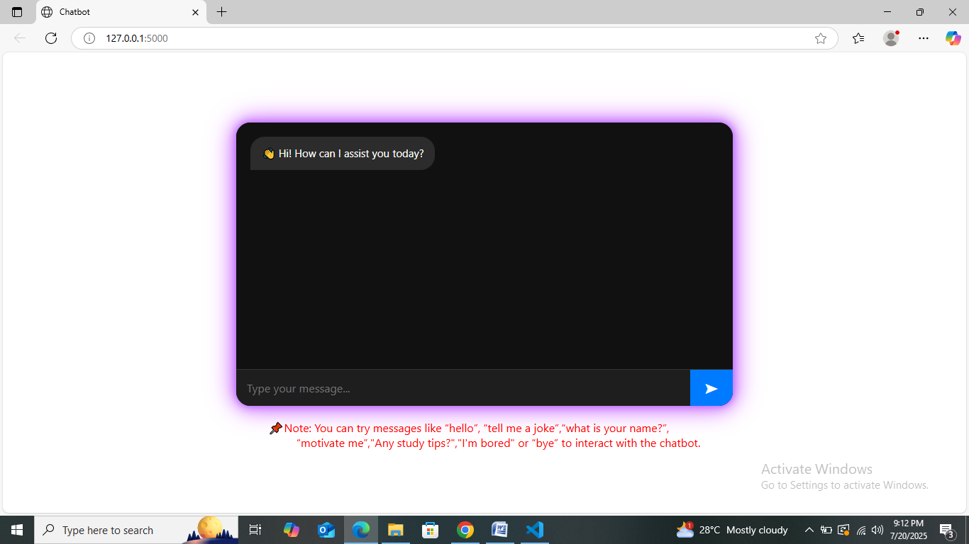

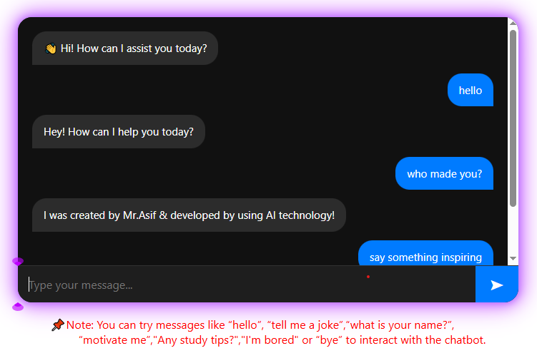

**Important Note**

* **GitHub doesn’t support Flask hosting directly.**
* Run it locally using the instructions above.
* If you want to host online, use platforms like:
  + **Render**
  + **Replit**
  + **PythonAnywhere**