Document Template
- Heading 1
Normal Text. You can find all the appropriate styles located under the “custom styles” category. Access the styles by hitting F11. Then switch the view over to custom styles. (See Figure 1.1)
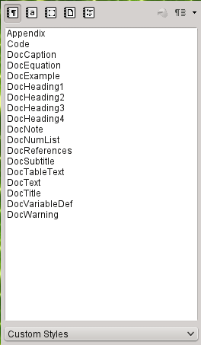
Figure 1.1: Custom Styles
  - Heading 2
More example text.
Here is an example of note text. Use this to call special attention to a subtle point. Something that user really needs to understand.

This is an example of an equation. Notice the equation reference at the end. And how any new variables should be defined immediately after the equation.

Equation 1.1
Where:
x = 1
    - Heading 3
Here is an example of warning text. Use this to alert the user when something may produce incorrect output.
      - Heading 4
And now there are a few examples. Use the “DocExample” style to show examples of program operation.
This is how you type the word “Hello”: H – e – l – l – o

And here is an example of program code. Use this specifically for program code.
Here is an example of program code.
For (int i = 0, i < 2, i++)
{
i = i + 1;
}

Finally, you can insert tables. There is already a table auto-format setup for you. Saves a lot of time. Use the auto-format style of “OpenSEA”
Table 1.1: Example Table
 | 1
There is a “DocTableText” format for tables. | 1

