Global Coordinate System
The global coordinate system defined all environmental conditions and the positions of all bodies within the same environment. The global coordinate system was a right-handed, cartesian coordinate system. The curvature of the earth is not included. oFreq assumes all analysis happens on a small enough scale that curvature of the Earth is not a concern.
- Origin
The origin of the coordinate system lies horizontal, on the undisturbed water surface.
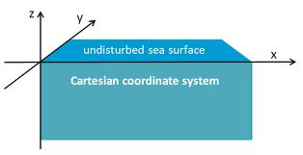
Figure 1.1: Global Coordinate System

- Translation Coordinates
The origin of the coordinate system is the reference point for all other items.
- X-axis is horizontal to the water surface, positive towards True North on the compass rose.
- Y-axis is horizontal to the water surface, positive towards True West on the compass rose.
- Z-axis is positive vertically up, out of the water.
All translation coordinates are measured in units of meters. See the page on [units].
- Rotation Coordinates
All rotation coordinates follow the right hand rule.
- Rotation about X-axis is positive rotating from the positive Y-axis to the positive Z-axis.
- Rotation about Y-axis is positive rotating from the positive Z-axis to the positive X-axis.
- Rotation about Z-axis is positive rotating from the positive X-axis to the positive Y-axis.
- Heading Coordinates
Heading measures angle of direction on the water surface, relative to the compass rose. Heading is treated just like rotation about the Z-axis.
- Heading rotation is measured in units of radians [dimensional units][units].
- A heading of 0 rad points directly to True North.
- Heading rotates positive counter-clockwise.
- This means that increasing heading goes from True North to True West.
  - True North = heading of 0 rad.
  - West = heading of π/2 (1.57 rad).
  - South = heading of π (3.14 rad).
  - East = heading of 3π /2 (4.71 rad).

