**CRAMER’S RULE**

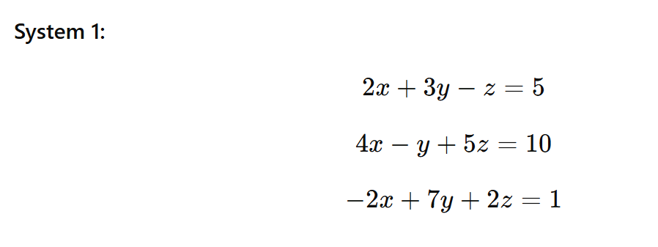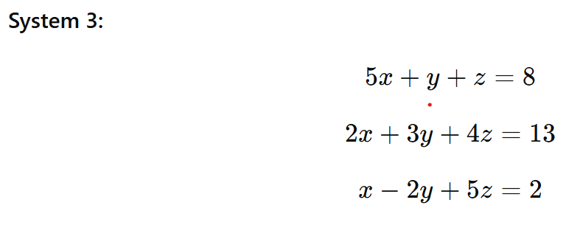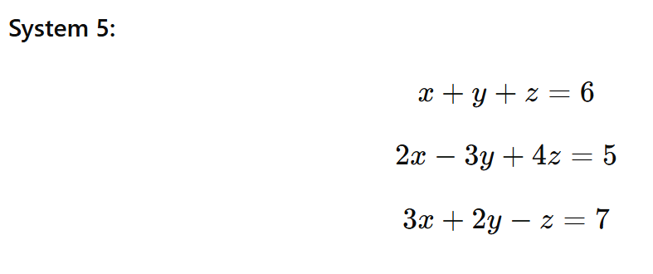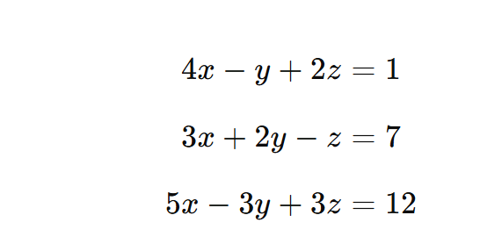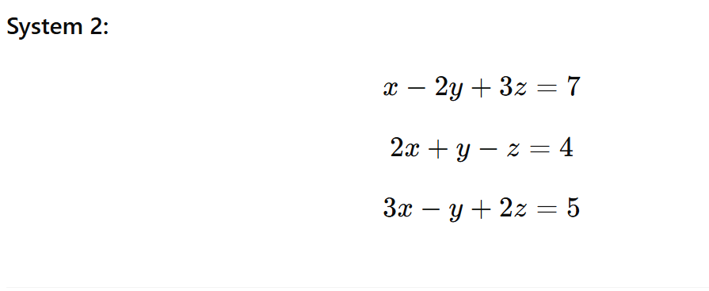

**MATRIX ADDITION, SUBSTRACTION AND MULTIPLICATION PROBLEMS**

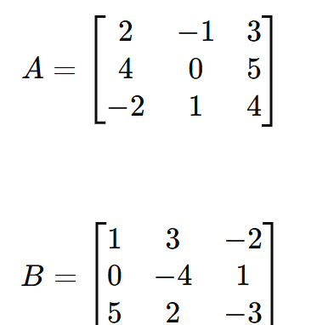

**Find 1) 2A -B**

**2)2A+B**

**3) A+3B**

**4) AB**

**5) BA**

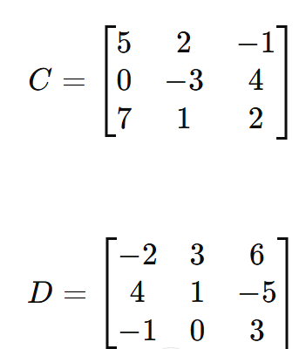

**Show that AB $≠BA$**