SE331 | SOFTWARE ENGINEERING CAPSTONE PROJECT

PROJECT PROPOSAL

RoadGuard AI
Intelligent Road Damage Detection, Localization,
Severity Assessment & Community Reporting Platform
An AI-supported platform for reporting, reviewing, and mapping road damage

Course: Software Engineering Capstone Project (SE331)
Department: Department of Software Engineering
Institution: Daffodil International University
Team Member | Student ID | Primary Responsibility
Md Asif Hossen | 232-35-307 | AI/ML, dataset preparation, model training and evaluation
Tahsin Jubayer | 232-35-370 | Application development, database, map and admin workflow
Tasfia Tasnim Nidi | 232-35-474 | Requirements, UI/UX support, testing and documentation review

Contents
- 1. Introduction
- 1.1 Background Overview
- 1.2 Problem Statement
- 1.3 Objectives
- 1.4 Scope
- 1.5 Stakeholders
- 1.6 Proposed Solution
- 1.7 AI Features
- 2. System Requirements
- 2.1 Functional Requirements
- 2.2 AI and Non-Functional Requirements
- 3. Tools and Technologies
- 4. Project Timeline and Work Plan
- 4.1 Team Responsibility Summary
- 5. System Architecture
- 6. Ethical, Legal, and Social Considerations
- 7. Risks and Limitations
- 8. Future Work
- 9. Conclusion
- References
- Pre-Submission Checklist

1. Introduction
Road damage, including potholes, cracks, and surface deterioration, can make travel uncomfortable and may contribute to vehicle damage or unsafe road conditions. Reporting a damaged road often depends on a person noticing the problem, taking a photograph, describing the location, and contacting a responsible organization. When reports arrive through disconnected channels, they may be incomplete, duplicated, difficult to categorize, or hard to track.
RoadGuard AI is a proposed web-based prototype that combines community reporting with computer vision. A user submits a road image and location; an AI model predicts a supported damage category and may identify the approximate damaged region if the chosen dataset supports localization. Reports are stored on a shared platform, displayed on a map, and reviewed by an administrator. The system is designed to support human review, not replace road engineers or make official repair decisions.

1.1 Background Overview
The project belongs to smart infrastructure monitoring and community-based road maintenance. Road conditions are commonly documented through inspections, complaint forms, photographs, and maintenance records. These methods can be useful, but manual review and inconsistent report formats can make it difficult to compare reports at scale. Computer-vision research uses image classification and object detection to identify visible road defects, although results depend on image quality, lighting, camera angle, surface type, and training data.
RoadGuard AI will use a public road-damage dataset only after checking its source, licence, categories, and annotation format. The final AI capabilities will be limited to what the selected data can reasonably support. The proposal does not assume that a model trained on one dataset will work equally well in every local setting.

1.2 Problem Statement
The main problem is the lack of a single, structured workflow in which community members can submit road-damage evidence and reviewers can categorize, verify, map, and track each report. Manual visual inspection of every submitted image can require time, and different users may describe similar damage in different ways. Reports about the same location may also be submitted more than once.
Road users, moderators, and potential road-maintenance stakeholders are affected by incomplete or inconsistent information. A shared software platform can organize images, coordinates, report status, and review history. AI can assist with the manual first step of examining an image and suggesting a damage category; a detection model may mark the approximate region of visible damage. Because predictions can be wrong, administrators remain responsible for verification.
The project will not claim to estimate pothole depth accurately from a single ordinary image, predict accidents, automatically dispatch repair teams, or guarantee that a report is genuine. These tasks require additional data, sensors, external authorization, or engineering assessment beyond the planned prototype.

1.3 Objectives

General Objective
To develop a web-based prototype for AI-assisted road-damage image analysis, community reporting, map visualization, administrator verification, and report-status tracking.

AI Objective
To train or adapt a computer-vision model that classifies uploaded road images into supported damage categories and evaluates its performance on held-out data. Damage localization and severity classification will be included only if suitable annotations and reliable labels are available.

Specific Objectives
- Allow users to submit an image, location, and optional description.
- Predict a supported road-damage class and show a confidence score.
- Show a detected region on the image if a suitable object-detection model is implemented.
- Display submitted reports in a list and location-based map.
- Allow administrators to verify, reject, reclassify, and update report status.
- Flag possible duplicate reports using geographic proximity and image similarity.
- Provide basic analytics by category, location, and status.
- Evaluate the AI model and document its errors and limitations.

1.4 Scope

In-Scope
- Image upload, file validation, optional description, and location selection.
- AI classification for categories supported by the selected dataset.
- Optional damage localization if bounding-box annotations are available.
- Optional AI severity classification only if reliable severity-labelled data is available; otherwise severity can be manually assessed or omitted.
- Unique report ID, timestamp, location, image reference, AI prediction, and report status.
- Map/list views, administrator verification, status history, duplicate-candidate flags, and basic dashboard analytics.
- In-app report-status display; email/SMS notifications only if time and service access permit.

Out-of-Scope
- Automatic repair, contractor dispatch, or unapproved integration with government systems.
- Guaranteed detection of all damage types or every road in Bangladesh.
- Engineering-grade depth measurement or official safety assessment from a single photo.
- Automatic accident prediction or final repair-priority decisions.
- Continuous CCTV monitoring or a separate native mobile app in the first prototype.
- Automatic approval or rejection of a report based only on AI output.

1.5 Stakeholders
Stakeholder | Role and Interest
Community members / road users | Submit images and locations, and check the progress of their reports.
System administrator / moderator | Review reports, correct labels, check possible duplicates, and update statuses.
Road-maintenance authority (potential) | May use verified reports as supporting information for inspection; no formal partnership is assumed.
Project team | Builds the AI model and application, evaluates results, tests the workflow, and documents limitations.
Supervisor / evaluator | Reviews feasibility, requirements, implementation evidence, and evaluation.

1.6 Proposed Solution
A user uploads a road image and provides a location or selects a point on a map. The application validates the file and sends it to the computer-vision model. The model returns a supported class and confidence score; if localization is implemented, it also returns a marked region. The system stores the prediction with the report and assigns the status Pending Review. A duplicate-check module may flag reports with nearby coordinates and similar images. An administrator reviews the report, verifies or corrects its details, and updates its status. The map and analytics dashboard summarize the collected reports.

System Overview Diagram
AI Road Damage Detection, Localization & Community Reporting Platform
COMMUNITY USER
↓
WEB APPLICATION / INPUT VALIDATION
Road image • GPS / selected location • Optional description
↓
AI COMPONENT: COMPUTER-VISION MODEL
Damage class | Confidence score | Optional damage localization (bounding box)
↓
REPORT SERVICE
↓
DATABASE /  IMAGE STORAGE | POSSIBLE DUPLICATE  FLAG | REPORT MAP &  ANALYTICS DASHBOARD
↘ ↓ ↙
ADMINISTRATOR REVIEW / STATUS UPDATE
↓
REPORT STATUS / USER NOTIFICATION
.

1.7 AI Features

Existing AI Features and Limitations
Road-damage research uses computer-vision models for image classification and object detection. Public datasets can support experiments, but models may be affected by weather, shadows, image resolution, camera angle, road materials, and regional differences. A model trained on one dataset may not generalize to another area, and severity prediction requires clear, consistent severity labels. The team will inspect the selected dataset and cite the actual source used.

Proposed AI Features
AI Feature | Input | Output | Manual Work Assisted
Damage classification (core) | Uploaded road image | Supported damage class and confidence score | Initial visual categorization of images.
Damage localization (conditional) | Image and detection model | Bounding box / marked damage region | Finding the approximate visible defect area.
Severity classification (conditional) | Image plus reliable severity labels | Defined severity class | Preliminary grouping only; not an engineering assessment.
Duplicate candidate detection | New report image/location and existing reports | Possible duplicate flag and candidate list | Finding reports that may refer to the same location or defect.

AI Techniques
- Transfer learning with a pretrained CNN for image classification.
- A suitable YOLO object-detection implementation if bounding-box annotations and computing resources are available.
- Visual image embeddings or perceptual similarity combined with geographic-distance rules to flag possible duplicates.
- Held-out testing with precision, recall, F1-score, confusion matrix, and suitable detection metrics if object detection is included.

Why AI Is Essential
The main intelligent task is automated road-image analysis to suggest a damage category. Without the trained computer-vision model, the system would only collect manually labelled reports and would not perform its central automated image-analysis function. Mapping and administration support the workflow, while human verification is retained to manage prediction errors.

2. System Requirements
Each requirement below is presented in a separate bordered box. FR denotes a functional requirement, AI denotes an AI-specific requirement, and NFR denotes a non-functional requirement.

2.1 Functional Requirements
FR-01 | User Registration and Role-Based Login
Description: | The system shall allow authorized users to sign in and shall restrict administrator functions to authorized administrator accounts.
Stakeholders: | Community User, Administrator

FR-02 | Submit Road-Damage Report
Description: | The system shall allow a user to submit a road image, location coordinates or a map-selected location, and an optional description.
Stakeholders: | Community User

FR-03 | Validate Uploaded Image
Description: | The system shall validate supported file types and configured size limits and shall display an error message for invalid files.
Stakeholders: | Community User, Administrator

FR-04 | Generate AI Damage Prediction
Description: | For a valid image, the system shall return a predicted class from the model's supported categories and display the model confidence score when available.
Stakeholders: | Community User, Project Developer

FR-05 | Localize Visible Damage
Description: | If a trained detection model and suitable annotations are available, the system shall display the predicted damage region on the submitted image.
Stakeholders: | Community User, Administrator

FR-06 | Create and Store Report Record
Description: | The system shall assign a unique report ID and store the image reference, location, timestamp, AI result, and current status.
Stakeholders: | Community User, Administrator

FR-07 | Display Reports on Map and List
Description: | The system shall display reports in a searchable list and show a map marker when valid location coordinates are available.
Stakeholders: | Community User, Administrator

FR-08 | Verify and Update Report
Description: | The system shall allow an authorized administrator to verify, reject, reclassify, and update the status of a submitted report.
Stakeholders: | Administrator, Road-Maintenance Stakeholder

FR-09 | Flag Possible Duplicate Reports
Description: | The system shall flag candidate duplicates using configured location-proximity and image-similarity rules; it shall not automatically delete or reject them.
Stakeholders: | Administrator, Community User

FR-10 | Classify Damage Severity (Conditional)
Description: | If reliable severity labels and a validated model are available, the system shall display a defined severity class; otherwise severity shall remain a human-reviewed field or be omitted.
Stakeholders: | Administrator, Project Developer

FR-11 | Track Report Status
Description: | The system shall display the current status of a report, such as Pending Review, Verified, Rejected, or Resolved.
Stakeholders: | Community User, Administrator

FR-12 | Display Analytics Dashboard
Description: | The system shall show counts grouped by report status and supported damage category, with filters where feasible.
Stakeholders: | Administrator, Project Team

FR-13 | Maintain Status History
Description: | The system shall record status changes and the responsible administrator account for basic accountability.
Stakeholders: | Administrator, Educational Institution

FR-14 | Show AI Disclaimer
Description: | The system shall inform users that AI predictions are estimates and require human review before being treated as verified results.
Stakeholders: | Community User, Administrator

2.2 AI and Non-Functional Requirements

AI-01 | Evaluate at Least One Baseline Model
Description: | The team shall train or fine-tune a baseline image classifier and evaluate it on held-out data not used for training.
Stakeholders: | Project Developer, Research Team

AI-02 | Report Comprehensive Evaluation Metrics
Description: | The evaluation shall report precision, recall, F1-score, a confusion matrix, and accuracy where appropriate; class imbalance shall be considered.
Stakeholders: | Project Developer, Supervisor

AI-03 | Prevent Data Leakage
Description: | The team shall separate training, validation, and test data before model selection and shall fit preprocessing steps using training data only.
Stakeholders: | Project Developer, Research Team

AI-04 | Provide Responsible Prediction Explanations
Description: | The system shall show the predicted class and confidence score and shall describe outputs as model estimates, not causal proof or engineering conclusions.
Stakeholders: | Community User, Administrator

AI-05 | Document Model and Dataset Limits
Description: | The team shall document dataset source, licence, supported classes, data-splitting approach, model version where practical, and known limitations.
Stakeholders: | Project Developer, Supervisor

NFR-01 | Input Validation and Error Messages
Description: | The prototype shall show understandable messages for missing locations, unsupported images, oversized files, and failed model inference.
Stakeholders: | Community User, Administrator

NFR-02 | Access Control
Description: | Administrator-only pages and status-changing actions shall require authentication.
Stakeholders: | Administrator, Educational Institution

NFR-03 | Privacy and Data Minimization
Description: | The public interface shall not expose unnecessary personal information; location access shall be permission-based or manually selectable.
Stakeholders: | Community User, Administrator

NFR-04 | Usability
Description: | A first-time user shall be able to find the report form, submit a valid report, and view the report status using clearly labelled controls.
Stakeholders: | Community User

NFR-05 | Maintainability
Description: | The project shall separate UI, report handling, model inference, and data-storage logic into understandable modules where practical.
Stakeholders: | Project Team, Future Maintainer

NFR-06 | Performance Measurement
Description: | The team shall measure model inference time and test the main reporting workflow in the available development environment; results shall be reported rather than assumed.
Stakeholders: | Project Developer, Supervisor

NFR-07 | Reliability and Error Handling
Description: | A failed prediction shall not silently discard the report; the application shall show an error or preserve the report for manual review where feasible.
Stakeholders: | Community User, Administrator

NFR-08 | Reproducibility
Description: | The team shall record key package versions, model configuration, and evaluation procedure so that experiments can be repeated.
Stakeholders: | Project Team, Supervisor

Use Case Diagram:

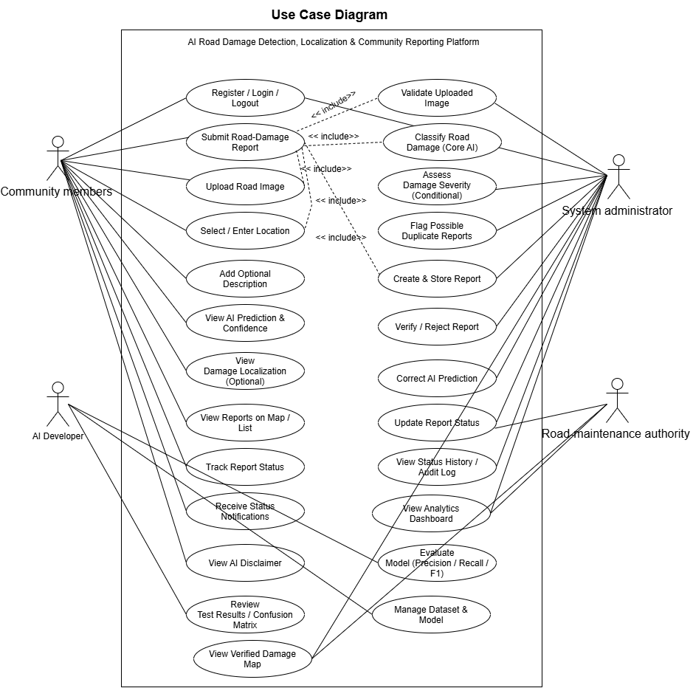

3. Tools and Technologies

Area | Proposed Technology | Purpose
Programming language | Python | Application logic, dataset preparation, model training and evaluation.
Web interface | Streamlit for a feasible prototype | Report submission, report list, administrator pages, and dashboard.
Deep learning | PyTorch or TensorFlow/Keras (choose one) | Train or fine-tune the image classifier.
Image processing | OpenCV and Pillow | Image validation, resizing, preprocessing, and visualization.
Data analysis | pandas, NumPy, scikit-learn | Dataset inspection, data splitting, and evaluation metrics.
Object detection (optional) | A suitable YOLO implementation | Damage localization if annotations and licence permit.
Database | SQLite for prototype | Store report metadata, predictions, and status history.
Map | Folium/Leaflet or equivalent | Display report locations.
Charts | Plotly or Matplotlib | Show report statistics and model evaluation charts.
Version control | Git and GitHub | Collaborative development and change tracking.

The team should select one main deep-learning framework and confirm the dataset and model licences before implementation. The core prototype should not depend on a paid AI API.

4. Project Timeline and Work Plan
The following is a 12-week sample plan. The team should adjust dates to the actual course calendar and update the progress column during development.
Milestone / Weeks | Work Packages | Lead / Support | Deliverable / Acceptance Evidence | Status
M1 — Week 1  Requirements | Confirm problem, scope, user roles, requirements, and feasible AI features. | All members; Nidi coordinates requirement review. | Approved scope and requirement checklist. | Planned
M2 — Weeks 2–3  Dataset preparation | Find dataset; verify licence and labels; inspect class balance; split train/validation/test data. | Asif leads; Nidi documents data checks. | Dataset card, split files, and preprocessing notes. | Planned
M3 — Weeks 4–5  AI baseline | Train a baseline classifier; compare a second approach if time permits; record experiments. | Asif leads; Tahsin supports integration planning. | Saved baseline model and experiment log. | Planned
M4 — Week 6  Model evaluation | Calculate metrics, inspect errors, and decide whether localization/severity are feasible. | Asif leads; all review results. | Evaluation table, confusion matrix, and final AI scope. | Planned
M5 — Weeks 7–8  Core application | Implement report form, input validation, unique report ID, database, and report list. | Tahsin leads; Nidi tests usability. | A user can submit and retrieve a report. | Planned
M6 — Week 9  Map and admin | Add map markers, administrator login, verification, and status updates. | Tahsin leads; Nidi prepares test cases. | A report can be reviewed and its status updated. | Planned
M7 — Week 10  AI integration | Connect model inference; show class/confidence; add duplicate-candidate check if feasible. | Asif + Tahsin; Nidi validates output wording. | Uploaded image returns an AI result stored with the report. | Planned
M8 — Week 11  Testing | Run functional tests, model evaluation checks, error handling, privacy review, and fix defects. | Nidi coordinates tests; all members fix issues. | Test report, bug list, and evidence screenshots. | Planned
M9 — Week 12  Final demo | Complete documentation, prepare demonstration, review limitations, and rehearse presentation. | All members. | Working prototype, final proposal/report, and demo slides. | Planned

4.1 Team Responsibility Summary
Member | Main Responsibilities | Expected Evidence
Md Asif Hossen  232-35-307 | Dataset preparation, image preprocessing, model training, evaluation metrics, and AI limitation analysis. | Dataset notes, trained model, metric tables, confusion matrix.
Tahsin Jubayer  232-35-370 | Web interface, report submission workflow, database, map/list view, admin pages, and AI integration support. | Working application, database schema, integration evidence.
Tasfia Tasnim Nidi  232-35-474 | Requirements review, UI/UX feedback, functional test cases, testing coordination, documentation review, and presentation preparation. | Requirement checklist, test cases/results, reviewed document and slides.
All members | Scope decisions, integration, debugging, ethical review, final report, and demonstration. | Integrated prototype and final presentation.

5. System Architecture

5.1 Main Components
- Presentation layer: community report form, report list/map, and administrator dashboard.
- Application layer: input validation, report creation, inference request, duplicate-candidate check, and status workflow.
- AI layer: trained image classifier and optional object detector.
- Data layer: report metadata, image references, prediction, model version where practical, and status history.
- Evaluation layer: held-out test data, metrics, error analysis, and functional test cases.

5.2 Prediction Workflow
- The user submits a supported image and selects or enters a location.
- The application validates and preprocesses the image using the training-time preprocessing steps.
- The model returns a supported damage category and confidence score; an optional detector returns a marked region.
- The system saves the report with status Pending Review.
- The duplicate module may flag nearby reports with similar images for human review.
- An administrator verifies or corrects the information and updates the status.

6. Ethical, Legal, and Social Considerations
- Use datasets in accordance with their licence and attribution requirements.
- Collect only necessary personal information and avoid displaying reporter contact details publicly.
- Request permission before accessing device location and provide manual location selection.
- Keep AI predictions separate from administrator-verified results.
- Check for data bias caused by under-represented road types, lighting, weather, or geographic regions.
- Do not present AI outputs as proof of legal responsibility, road safety, or official repair priority.

7. Risks and Limitations

Risk | Impact | Mitigation
Dataset differs from local images | Model may be less reliable in local conditions. | Document the source; test local examples if permitted; report limitations.
Insufficient bounding-box labels | Localization may not be feasible. | Prioritize classification and make localization conditional.
No reliable severity labels | Severity predictions may be misleading. | Use administrator-assessed severity or omit AI severity.
Low-quality image / missing location | Report may be difficult to review or map. | Validate inputs and allow re-upload or manual location selection.
False duplicate flag | Different defects may be incorrectly grouped. | Only flag candidates; require administrator confirmation.
Limited time or compute | Optional features may remain incomplete. | Prioritize core classification, report workflow, and evaluation.

8. Future Work
- Build a permission-based local road-image dataset and evaluate the model under local conditions.
- Improve localization and severity assessment with consistent expert-labelled data.
- Develop a mobile-friendly or offline-capable reporting workflow.
- Explore hotspot analysis when sufficient verified reports have been collected over time.
- Explore authorized integration with road-maintenance organizations if formal access becomes available.

9. Conclusion
RoadGuard AI proposes a practical prototype that combines community road-damage reporting with AI-assisted image analysis. The core AI feature classifies supported damage categories from uploaded images, while localization and severity assessment depend on suitable annotations and feasible development resources. Maps, duplicate-candidate flags, administrator verification, status tracking, and analytics make reports easier to organize. The project emphasizes a working implementation, transparent evaluation, and clearly stated limitations rather than unsupported promises of automatic repair or engineering decisions.

References
Complete this section with sources actually consulted by the team. Verify dataset licence, model documentation, and publication details before submission; do not leave placeholder references in the final copy.
- [1] Selected road-damage dataset: add official title, authors/organization, URL, licence, and access date.
- [2] Selected computer-vision model or architecture: add the paper or official documentation used.
- [3] PyTorch or TensorFlow/Keras official documentation for the chosen framework.
- [4] OpenCV/Pillow documentation for the image-processing tools used.
- [5] Mapping library documentation for the selected map implementation.

