**Pre-Requisites**

* Oracle Java JDK 6 and above should be installed on your machine.
* Test by typing “Java –version” on the command line from your shell prompt. There should be output something similar to this.

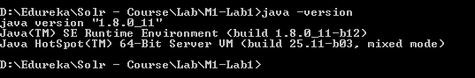

**Step 1: Creating New Index**

Execute the following command to create new index from the lucene source files for searching & should see something similar output after executing the command.

$> cd M1-Lab1

$> java -cp "Apache-Lucene-1.0.jar;lib/*" m1_lab1.IndexFiles -index ./index -docs ./lucene-4.10.1/core/src

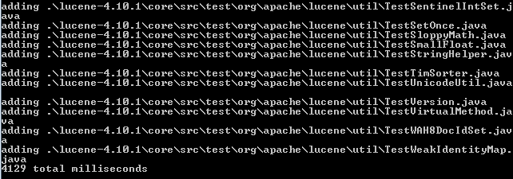

**Step 2: Updating the Index**

Execute the following command to update already created index with new / deleted / edit documents.

$> java -cp "Apache-Lucene-1.0.jar;lib/*" m1_lab1.IndexFiles -index ./index -docs ./lucene-4.10.1/core/src -update

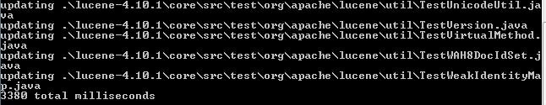

**Step 3: Searching the Index**

Execute the following command to search terms or words from the index.

It would prompt you enter term or word to search from the matching files in the index.

$> java -cp "Apache-Lucene-1.0.jar;lib/*" m1_lab1.SearchFiles



**Example-1**

**Enter the term or phrase:** “timelimitingcollector” & should return following search results from the index.

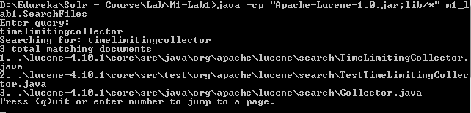

**You can quit by typing (q) or enter next page number to navigate search results.**

**Example-2**

**Enter the term or phrase:** “fuzzy” & should return following search results from the index.

