# **StopAnalyzer**

StopAnalyzer restricts words from indexing and searching.

**Step 1 Creating & Searching the Index: (SimpleAnalyzer)**

Execute the following command to create new index from the lucene source files for searching & should see something similar output after executing the command.

$> cd M2-Lab2

$> Delete the index folder if exists

$> java -cp "Apache-Lucene-1.0.jar;lib/*" m2_lab1.IndexFiles -index ./index -docs ./documents

$> java -cp "Apache-Lucene-1.0.jar;lib/*" m2_lab1.SearchFiles

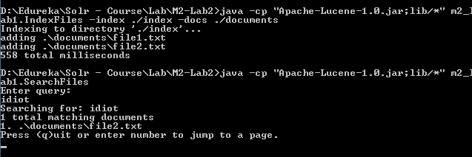

**Step 2: Creating & Searching Index (StopAnalyzer)**

$> Delete the index folder if exists

$> java -cp "Apache-Lucene-1.0.jar;lib/*" m2_lab2.IndexFiles -index ./index -docs ./documents

$> java -cp "Apache-Lucene-1.0.jar;lib/*" m2_lab2.SearchFiles

**Test-1**

**Enter the term or phrase:** “idiot” & “rascal” should return following search results from the index.

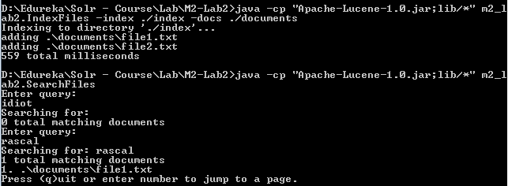

**Test-2**

**Add “rascal” word to the stopwords.txt file and again search.**

