# **Stemming**

**Step 1 Creating & Searching the Index: (ProterStemFilter)**

Execute the following command to create new index from the lucene source files for searching & should see something similar output after executing the command.

Delete the index folder if exists

Create a new document “file3.txt” in “documents” folder with following content.

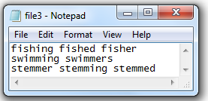

$> cd M2-Lab3

$> java -cp "Apache-Lucene-1.0.jar;lib/*" m2_lab3.IndexFiles -index ./index -docs ./documents

$> java -cp "Apache-Lucene-1.0.jar;lib/*" m2_lab3.SearchFiles

