# **M2-Lab4 - Synonyms**

**Creating & Searching the Index: (MySynonymAnalyzer)**

Execute the following command to create new index from the lucene source files for searching & should see something similar output after executing the command.

**Step 1** Delete the index folder if exists

**Step 2** Create a new document “file4.txt” in “documents” folder with following content.

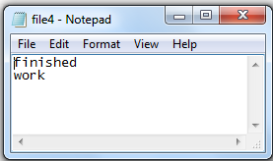

Synonyms for the following terms has been added in the code & searching with alternate synonyms should match the above document & return.

finished -> completed, over, ended

work -> job, labor, effort

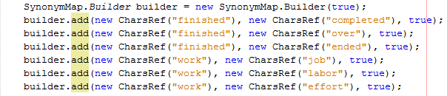

**Step 3** $> cd M2-Lab4

**Step 4** $> java -cp "Apache-Lucene-1.0.jar;lib/*" m2_lab4.IndexFiles -index ./index -docs ./documents

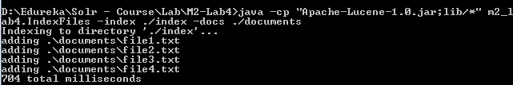

**Step 5** $> java -cp "Apache-Lucene-1.0.jar;lib/*" m2_lab4.SearchFiles

