**All Queries can be done in 2 ways.**

* Using the Query API
* Using the Lucene Query Parser & Syntax.

# **M2-Lab5 – Term Querying**

**Using API’s Approach**

**Test-1**

$> java -cp "Apache-Lucene-1.0.jar;lib/*" m2_lab5.LuceneTermQueryDemo "apples"



Check the file content & validate the output.

**Test-2**

$> java -cp "Apache-Lucene-1.0.jar;lib/*" m2_lab5.LuceneTermQueryDemo "apple"



Check the file content & validate the output.

**Test-3**

$> java -cp "Apache-Lucene-1.0.jar;lib/*" m2_lab5.LuceneTermQueryDemo "2012"



Check the file content & validate the output.

**Test-4**

$> java -cp "Apache-Lucene-1.0.jar;lib/*" m2_lab5.LuceneTermQueryDemo "french fries"



Check the file content & validate the output.

**Test-5**

$> java -cp "Apache-Lucene-1.0.jar;lib/*" m2_lab5.LuceneTermQueryDemo "french"



Check the file content & validate the output.

**Using Query Parser Approach**

$> java -cp "Apache-Lucene-1.0.jar;lib/*" m2_lab5.QueryParserDemo "contents: apples"

$> java -cp "Apache-Lucene-1.0.jar;lib/*" m2_lab5.QueryParserDemo "contents: apple"

$> java -cp "Apache-Lucene-1.0.jar;lib/*" m2_lab5.QueryParserDemo "contents: 2012"

$> java -cp "Apache-Lucene-1.0.jar;lib/*" m2_lab5.QueryParserDemo "contents: french fries"

$> java -cp "Apache-Lucene-1.0.jar;lib/*" m2_lab5.QueryParserDemo "contents: french"

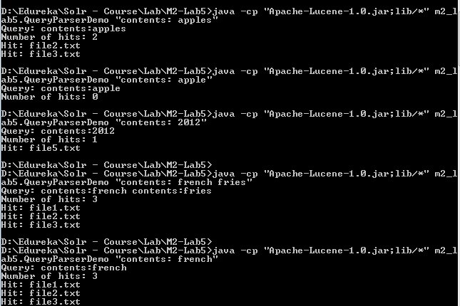

Check the file content & validate the output.

# **M2-Lab5 – Boolean Querying**

**Creating & Searching the Index using Boolean Queries**

**Using API’s Approach**

Occur.MUST -> Signifies the term should occur

Occur.SHOULD -> Signifies the term is optional.

Occur.MUST_NOT -> Signifies the term should not occur.

Execute the following command to create new index from the lucene source files for searching & should see something similar output after executing the command.

**Step 1** cd M2-Lab5

**Step 2** java -cp "Apache-Lucene-1.0.jar;lib/*" m2_lab5.LuceneBooleanQueryDemo

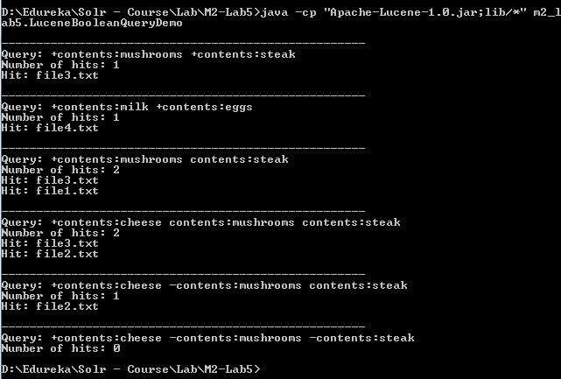

**Using Query Parser Approach**

|  |  |  |
| --- | --- | --- |
| **API** | **Query Parser Syntax** | **Description** |
| Occur.MUST | **+** | Signifies the term should occur. |
| Occur.MUST_NOT | **-** | Signifies the term should not occur. |
| Occur.SHOULD |  | Signifies the term is optional. |

**Test-1**

$> java -cp "Apache-Lucene-1.0.jar;lib/*" m2_lab5.QueryParserDemo "+contents:mushrooms +contents:steak"

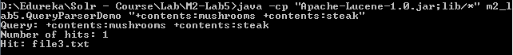

**Test-2**

$> java -cp "Apache-Lucene-1.0.jar;lib/*" m2_lab5.QueryParserDemo "+contents:milk +contents:eggs"

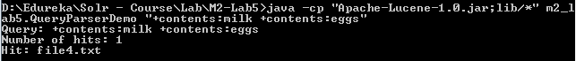

**Test-3**

$> java -cp "Apache-Lucene-1.0.jar;lib/*" m2_lab5.QueryParserDemo "+contents:mushrooms contents:steak"

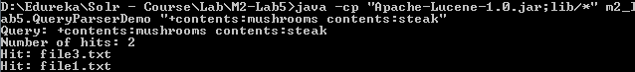

**Test-4**

$> java -cp "Apache-Lucene-1.0.jar;lib/*" m2_lab5.QueryParserDemo "+contents:cheese contents:mushrooms contents:steak"

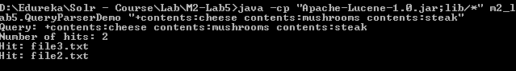

**Test-5**

$> java -cp "Apache-Lucene-1.0.jar;lib/*" m2_lab5.QueryParserDemo "+contents:cheese -contents:mushrooms contents:steak"

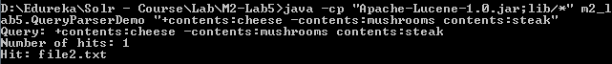

**Test-6**

$> java -cp "Apache-Lucene-1.0.jar;lib/*" m2_lab5.QueryParserDemo "+contents:cheese -contents:mushrooms -contents:steak"

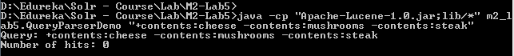

# **M2-Lab5 – Phrase Querying**

**Using API’s Approach**

**$>** cd M2-Lab5

**Test-1**

$> java -cp "Apache-Lucene-1.0.jar;lib/*" m2_lab5.LucenePhraseQueryDemo "french fries" 0

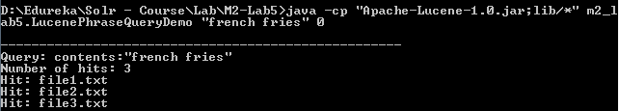

Check the file content & validate the output.

**Test-2**

$> java -cp "Apache-Lucene-1.0.jar;lib/*" m2_lab5.LucenePhraseQueryDemo "milk eggs" 0

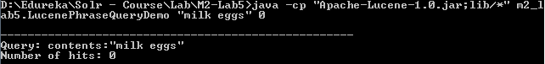

Check the file content & validate the output.

**Test-3**

$> java -cp "Apache-Lucene-1.0.jar;lib/*" m2_lab5.LucenePhraseQueryDemo "milk eggs" 1

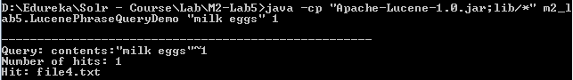

Check the file content & validate the output.

**Test-4**

$> java -cp "Apache-Lucene-1.0.jar;lib/*" m2_lab5.LucenePhraseQueryDemo "hamburger apples" 5

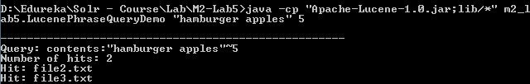

Check the file content & validate the output.

**Using Query Parser Approach**

**Test-1**

$> java -cp "Apache-Lucene-1.0.jar;lib/*" m2_lab5.QueryParserDemo "\"french fries\"~0"



Check the file content & validate the output.

**Test-2**

$> java -cp "Apache-Lucene-1.0.jar;lib/*" m2_lab5.QueryParserDemo "\"milk eggs\"~0"



Check the file content & validate the output.

**Test-3**

$> java -cp "Apache-Lucene-1.0.jar;lib/*" m2_lab5.QueryParserDemo "\"milk eggs\"~1"



Check the file content & validate the output.

**Test-4**

$> java -cp "Apache-Lucene-1.0.jar;lib/*" m2_lab5.QueryParserDemo "\"hamburger apples\"~5"



Check the file content & validate the output.

# **M2-Lab5 – Prefix Querying**

**Using API’s Approach**

**$>** cd M2-Lab5

**Test-1**

$> java -cp "Apache-Lucene-1.0.jar;lib/*" m2_lab5.LucenePrefixQueryDemo "app"

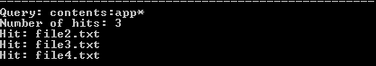

Check the file content & validate the output.

**Test-2**

$> java -cp "Apache-Lucene-1.0.jar;lib/*" m2_lab5.LucenePrefixQueryDemo "a"

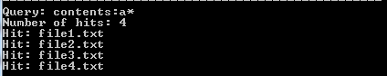

Check the file content & validate the output.

**Test-3**

$> java -cp "Apache-Lucene-1.0.jar;lib/*" m2_lab5.LucenePrefixQueryDemo "sa"

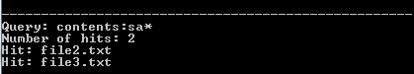

Check the file content & validate the output.

**Test-4**

$> java -cp "Apache-Lucene-1.0.jar;lib/*" m2_lab5.LucenePrefixQueryDemo "st"

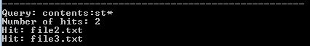

Check the file content & validate the output.

**Using Query Parser Approach**

**Test-1**

$> java -cp "Apache-Lucene-1.0.jar;lib/*" m2_lab5.QueryParserDemo "app*"



Check the file content & validate the output.

**Test-2**

$> java -cp "Apache-Lucene-1.0.jar;lib/*" m2_lab5.QueryParserDemo "a*"



Check the file content & validate the output.

**Test-3**

$> java -cp "Apache-Lucene-1.0.jar;lib/*" m2_lab5.QueryParserDemo "sa*"



Check the file content & validate the output.

**Test-4**

$> java -cp "Apache-Lucene-1.0.jar;lib/*" m2_lab5.QueryParserDemo "st*"



Check the file content & validate the output.

# **M2-Lab5 – Range Querying**

**Using API’s Approach**

* Range queries can be done on both numeric and character based terms.
* Range queries are searched based on the byte stream lexical order.

**$>** cd M2-Lab5

**Test-1**

$> java -cp "Apache-Lucene-1.0.jar;lib/*" m2_lab5.LuceneRangeQueryDemo

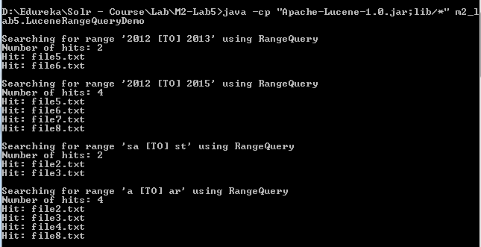

Check the file content & validate the output.

**Using Query Parser Approach**

**Test-1**

$> java -cp "Apache-Lucene-1.0.jar;lib/*" m2_lab5.QueryParserDemo "contents: [2012 TO 2013]"

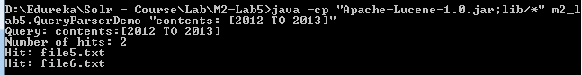

Check the file content & validate the output.

**Test-2**

$> java -cp "Apache-Lucene-1.0.jar;lib/*" m2_lab5.QueryParserDemo "contents: [2012 TO 2015]"

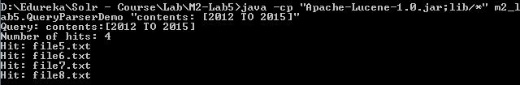

Check the file content & validate the output.

**Test-3**

$> java -cp "Apache-Lucene-1.0.jar;lib/*" m2_lab5.QueryParserDemo "contents: [sa TO st]"

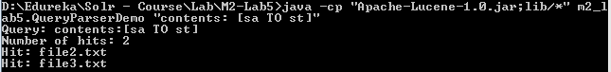

Check the file content & validate the output.

**Test-4**

$> java -cp "Apache-Lucene-1.0.jar;lib/*" m2_lab5.QueryParserDemo "contents: [a TO ar]"

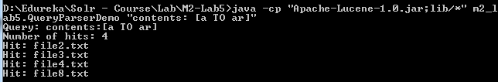

Check the file content & validate the output.

# **M2-Lab5 – Wild Card Querying**

**Using API’s Approach**

Execute the following commands.

$> cd m2-lab5

$> java -cp "Apache-Lucene-1.0.jar;lib/*" m2_lab5.LuceneWildcardQueryDemo "s*"

$> java -cp "Apache-Lucene-1.0.jar;lib/*" m2_lab5.LuceneWildcardQueryDemo "*s"

$> java -cp "Apache-Lucene-1.0.jar;lib/*" m2_lab5.LuceneWildcardQueryDemo "f*s"

$> java -cp "Apache-Lucene-1.0.jar;lib/*" m2_lab5.LuceneWildcardQueryDemo "fr??s"

$> java -cp "Apache-Lucene-1.0.jar;lib/*" m2_lab5.LuceneWildcardQueryDemo "fr?s"

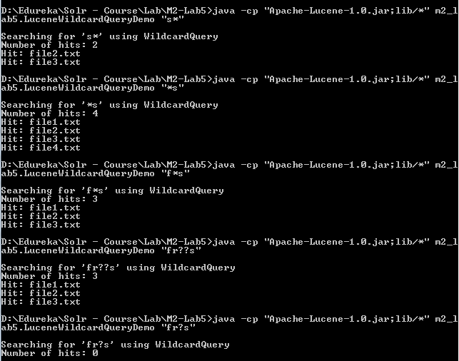

Check the file content & validate the output.

**Using Query Parser Approach**

Execute the following commands & validate the file and output.

$> java -cp "Apache-Lucene-1.0.jar;lib/*" m2_lab5.QueryParserDemo "s*"

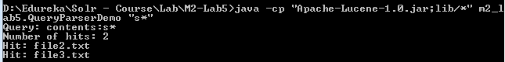

Lead wild cards are not allowed & would through exception.

$> java -cp "Apache-Lucene-1.0.jar;lib/*" m2_lab5.QueryParserDemo "*s"

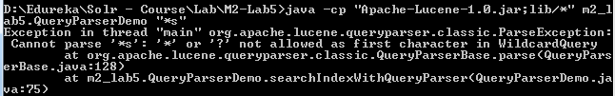

$> java -cp "Apache-Lucene-1.0.jar;lib/*" m2_lab5.QueryParserDemo "f*s"

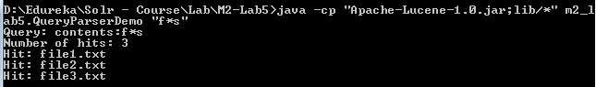

$> java -cp "Apache-Lucene-1.0.jar;lib/*" m2_lab5.QueryParserDemo "fr??s"

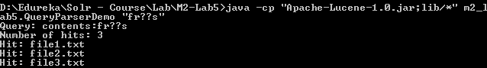

$> java -cp "Apache-Lucene-1.0.jar;lib/*" m2_lab5.QueryParserDemo "fr?s"

