# **M2-Lab6 – Boosting**

$> cd M2-Lab6

**Index Time Boosting**

Create index of car’s/suv’s from different countries, If anyone searching SUV then Indian suv’s should come first in the results.

$> java -cp "Apache-Lucene-1.0.jar;lib/*" m2_lab6.BoostExamples index false

$> java -cp "Apache-Lucene-1.0.jar;lib/*" m2_lab6.BoostExamples index true

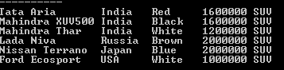

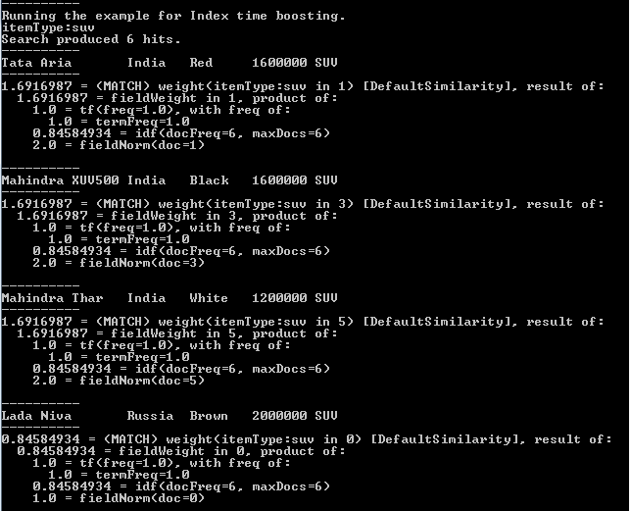

**Query Time Boosting**

Create index of car’s/suv’s from different countries & colours, if anyone searching SUV then “white” colour suv’s should come first in the results.

$> java -cp "Apache-Lucene-1.0.jar;lib/*" m2_lab6.BoostExamples index false

$> java -cp "Apache-Lucene-1.0.jar;lib/*" m2_lab6.BoostExamples index true

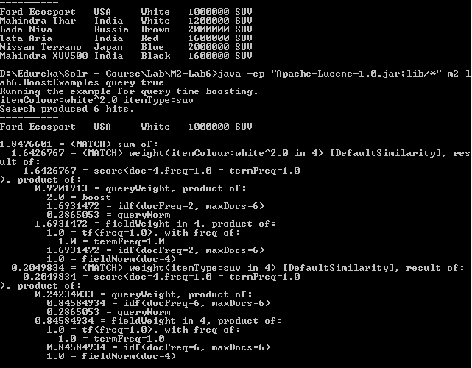

**Index & Query Time Boosting**

$> java -cp "Apache-Lucene-1.0.jar;lib/*" m2_lab6.BoostExamples index false

