# **M2-Lab8 – Facets**

$> cd M2-Lab8

Delete index & taxonomy folder if exists.

$> java -cp "Apache-Lucene-1.0.jar;lib/*" m2_lab8.FacetLuceneIndexer index taxonomy ./documents/books.json

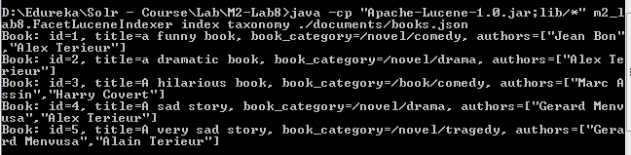

$> java -cp "Apache-Lucene-1.0.jar;lib/*" m2_lab8.FacetLuceneSearcher index taxonomy story

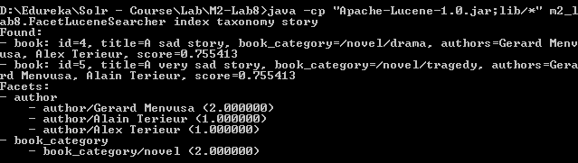

$> java -cp "Apache-Lucene-1.0.jar;lib/*" m2_lab8.FacetLuceneAdvancedSearcher index taxonomy book book_category novel

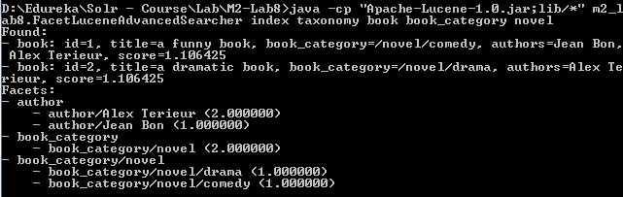

$> java -cp "Apache-Lucene-1.0.jar;lib/*" m2_lab8.FacetLuceneAdvancedSearcher index taxonomy book book_category novel/comedy

