Project Analysis Document

Version <#>

<Project Name>

Team <#>

|  |  |
| --- | --- |
| Member Name | Roll number |
|  |  |
|  |  |
|  |  |
|  |  |

**Table of Contents**

**1.** **Introduction** 1

**1.1** **Project Overview** 1

**1.2** **User Classes and Characteristics** 1

**2.** **Functionality Points** 1

**Appendix A: Glossary** 2

Revision History

|  |  |  |  |
| --- | --- | --- | --- |
| **Name(s)** | **Date** | **Reason(s) For Change(s)** | **Version** |
|  |  |  |  |
|  |  |  |  |

# **Introduction**

3-4 Lines of introduction about project description.

Sample:  
The document briefly explains all important features the project Live8 has. Live8 is a kind of sister project implemented at undergraduate level that is almost similar to popular social networking website “FaceBook” in functionalities and lay out. The document explains the purpose of creating this document, the kind of people the document is intended for and the structure and functionalities of the project Live8.

## **Project Overview**

5-6 Lines of brief description about project overview, purpose of project, which technology you are opting for development?

Sample:  
Live8 is a look alike to “FaceBook”, the popular social networking website. It has almost all the features of FaceBook except, of course, its networking implementation. In Live8, a person can have his personal account where he can share his biographical information, upload photos, add new friends and post comments over other people wall. Live8 is implemented using Database Systems Entity-Relationship model concepts.

## **User Classes and Characteristics**

Identify the various user classes that you anticipate will use this product. User classes may be differentiated based on frequency of use, subset of product functions used, technical expertise, security or privilege levels, educational level, or experience. Describe the pertinent characteristics of each user class. Certain requirements may pertain only to certain user classes. Distinguish the favored user classes from those who are less important to satisfy

Sample :

1. Account holder User
2. Non-Account Holder User
3. Administrator

# **Functionality Points**

State all main functionalities you are looking forward to achieve in this project. And the user of that functionality.

Sample:

1. **Functionality 1 : Signup**

|  |  |
| --- | --- |
| **SignUp** | |
| **User** | Non Account Holder User |
| **Steps** | |
| a) | A user can sign up for this website by providing username, password, First name, last name and contact number on signup.aspx page. |
| b). | If this user name is already taken a message is shown "sorry, this user name already exists. Try another" |
| c). | In case the user name is available, a new account is created and the new user Is redirected to his/her Home.aspx page. |
| **Assumptions** | username, password, First name, last name will be not null, Contact number can be null |

1. **Functionality 2 : Login**

|  |  |
| --- | --- |
| **Login** | |
| **User** | Account Holder User |
| **Steps** | |
| a) | A user can login to the website by providing username and password on login.aspx page. |
| b). | In case incorrect user name or password is provided following message is shown "Incorrect user name or password" |
| c). | In case of correct username and password user will be redirected to his/her Home.aspx page. |
| **Assumptions** | - |

1. **Functionality 2 : Login**

|  |  |
| --- | --- |
| **Login** | |
| **User** | Admin |
| **Steps** | |
| a) | Admin can login to the website by providing username and password on Adminlogin.aspx page. |
| b). | In case incorrect user name or password is provided following message is shown "Incorrect user name or password" |
| c). | In case of correct username and password user will be redirected to his/her AdminHome.aspx page. |
| **Assumptions** | - |

1. **Functionality 2 : Search Products**

|  |  |
| --- | --- |
| **Login** | |
| **User** | Account Holder |
| **Steps** | |
| a) | Account holder User can search for product by using Search Box. This Search box will be on top of every page. |
| b). | User will have to type the product name, and all the products with that name will be in form of list. |
| c). | User can click on these items and view details of the clicked product |
| **Assumptions** | - |

1. **Functionality 2 : Add New Product**

|  |  |
| --- | --- |
| **Login** | |
| **User** | Admin |
| **Steps** | |
| a) | Admin can add a new product from AddnewProduct.aspx page, by providing following information of the New item   * Name * Category * Quantity * Picture |
| **Assumptions** | Name, category and Quantity cannot be null, picture is not mandatory  The Newly added products will be readily available for users to view/purchase |

# **Database Diagram**

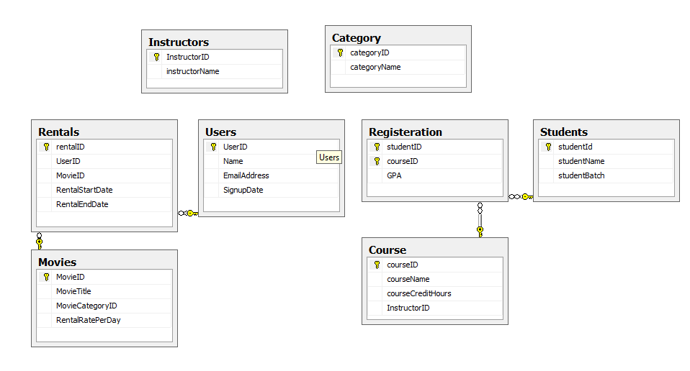

# **Appendix A: Glossary**

<Define all the terms necessary to properly interpret the SRS, including acronyms and abbreviations. You may wish to build a separate glossary that spans multiple projects or the entire organization, and just include terms specific to a single project in each SRS.>