IBA CAREER CENTRE

INSTITUTE OF BUSINESS ADMINISTRATION

UNIVERSITY OF DHAKA

**INTERNSHIP (Session: Jan-Mar.)2023**

**FACULTY ADVISOR SELECTION FORM**

Program: MBA/BBA

Name of Student: Md Golam Muktadir Asif

Registration No:

Roll # 026 Batch # 026 Major Area # Marketing

Name of Organization: Ha-Meen Group

Name of Faculty Advisor: Fatematuz Zahra Saqui

Designation: Lecturer

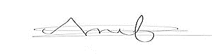Signature of Advisor :

Date :14th January 2023 Signature of Intern:

Mobile No: 01751634503 E-mail: muhammad2111.asif@gmail.com