PROGRESS REPORT

TOPIC: Physics-Informed Regime Discovery and Local Symbolic Law Learning in Semi-batch Polymerization Reactors

BY
S ASIFA

CORE IDEA:
A nonlinear chemical reactor should not be modelled using only one global equation, because different operating regions behave differently. So, we discover hidden regimes first, then learn separate symbolic laws inside each regime.
This research is valid because polymerization reactors are highly nonlinear. Their behavior changes due to heat-up, monomer feed, reaction heat, cooling, viscosity increase, fouling, product differences, seasonal changes, and disturbances.

Module 1:
Dataset Generation
The dataset is based on the Chylla-Haase semibatch polymerization benchmark. This benchmark is commonly used for polymerization reactor control studies because it includes nonlinear heat generation, jacket cooling/heating, fouling, multiple products, seasonal operation, and semibatch feeding.
Baseline values considered: (taken from papers shared by Prof Laksh)

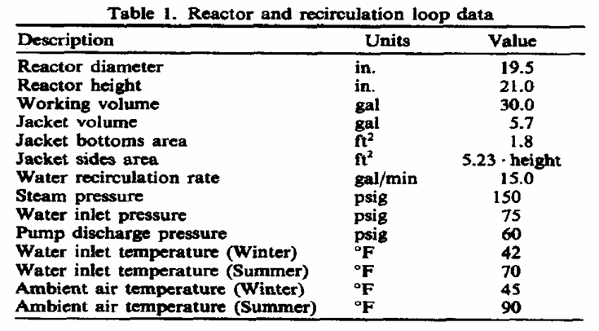
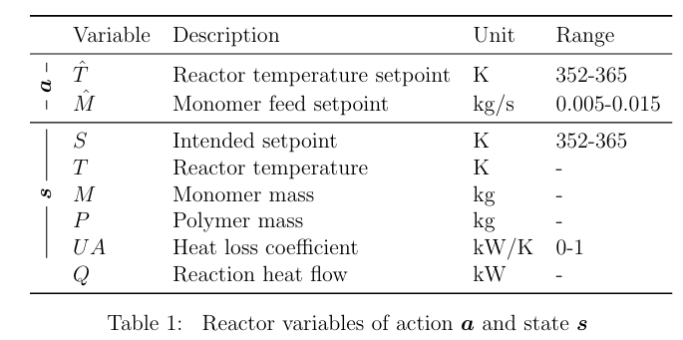
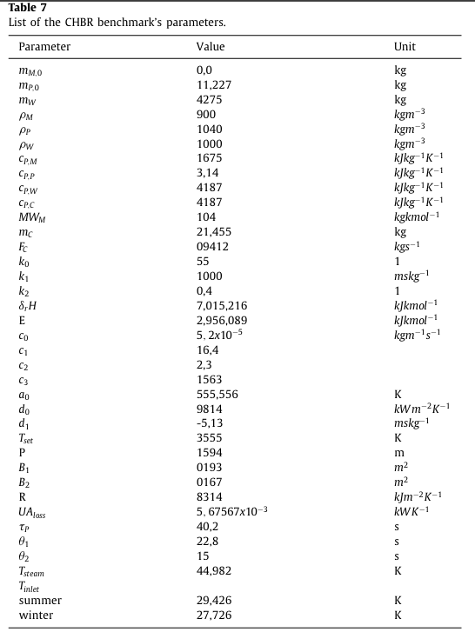
The dataset is generated by a semibatch polymerization reactor simulator. Each trajectory represents one polymerization batch.

PROCESS FOLLOWED:
initial reactor state
↓
heat-up stage
↓
monomer feed stage
↓
hold stage
↓
final batch trajectory
For every time step, the simulator calculates:
- reaction rate
- reaction heat
- feed heat
- jacket heat
- ambient heat loss
- temperature change
- monomer mass
- polymer mass
- viscosity
- heat-transfer coefficient U
- valve movement
- feed-rate movement

Temperature is generated from energy balance:

dT/dt = (Q_feed + Q_reaction + Q_jacket + Q_loss) / C_total

Initially temperature was directly generated and went out of bounds because of random generation, then corrected that issue by looking into other factors.
- controller controls valve
- valve affects jacket heat
- jacket heat affects energy balance
- energy balance affects temperature
As commented by Prof Laksh, Valve dynamics were taken into consideration, means the valve cannot jump unrealistically.

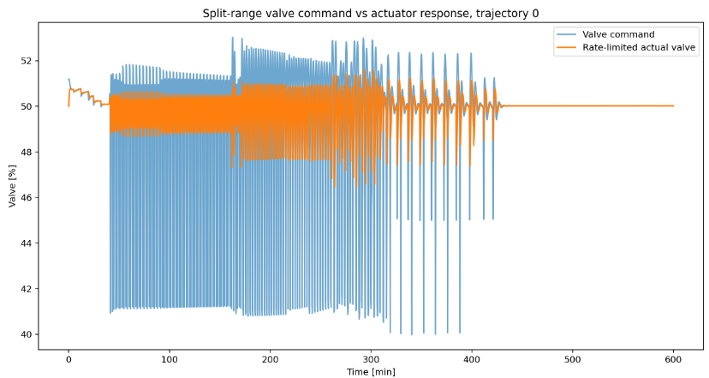
The blue line, valve command, changes rapidly.
The orange line, actual valve, is smoother and rate-limited.
This means the simulator did not allow the actuator to jump unrealistically. That is important because real valves cannot instantly move from one position to another, it would also lead to valve damage.

-----------------------------------------------------------------------------------------------------------------------------------
Why this data isn’t manipulated:
- temperature is generated from energy balance
- mass variables follow mass balance
- reaction heat follows reaction rate
- U decreases with viscosity
- valve motion is rate-limited
- feed motion is rate-limited
- residuals are near numerical zero

GRAPHS:
- reactor temperature trajectories across different dataset splits
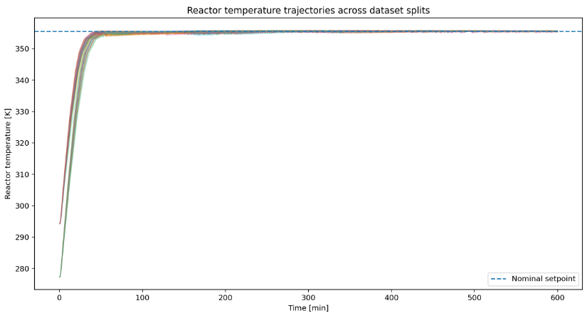
Setpoint temp
Heatup stage
Controlled operation- controller keeps temperature near setpoint to avoid thermal runaway or product quality issues

1. The reactor starts from realistic initial temperatures.
2. The reactor heats up smoothly.
3. The reactor reaches the nominal setpoint.
4. The reactor remains controlled near the setpoint.
5. Different trajectories show variation but still follow the same physical recipe.
6. There is no artificial random temperature behavior.
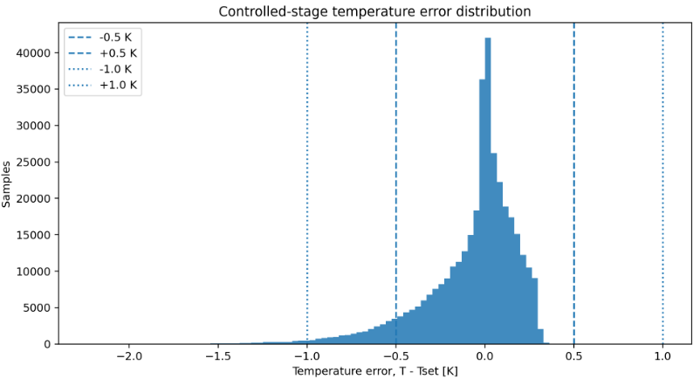
LEFT SKEW- mostly temperature is lesser than set point dataset has realistic temperature-control behavior: the reactor does not randomly drift or overheat

Actual temp- setpoint temp =0
Meaning it follows setpoint temperature, tallest bars are 0 kelvin.

temperature error = actual reactor temperature - target setpoint temperature
So negative error means the reactor is slightly colder than the target. Positive error means the reactor is slightly hotter than the target.
Y axis- how many time points in the dataset had that particular temperature error.
The tallest bars are near 0 K, meaning most reactor samples are very close to the setpoint. This is good because polymerization reactors must be tightly temperature-controlled.
The graph is slightly left-skewed, meaning the reactor is more often a little below the setpoint than above it. This is acceptable and even safer for an exothermic polymerization reactor because overheating is more dangerous than slight underheating.
- dataset has realistic temperature-control behavior, the reactor does not randomly drift or overheat
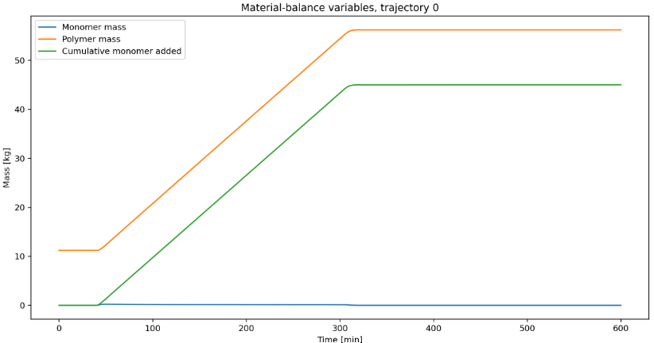
feed stops after the target amount is reached

Monomer being fed, monomer mass increases
No monomer fed

Polymer increases as monomer converts to polymer

U never goes below about 0.2
That is intentional.
Your simulator contains a minimum heat-transfer coefficient.
Physically,
even a very thick polymer still transfers some heat.
It never becomes
U = 0
because that would mean
no heat could leave the reactor,
which is impossible.
So the simulator correctly places a lower limit.
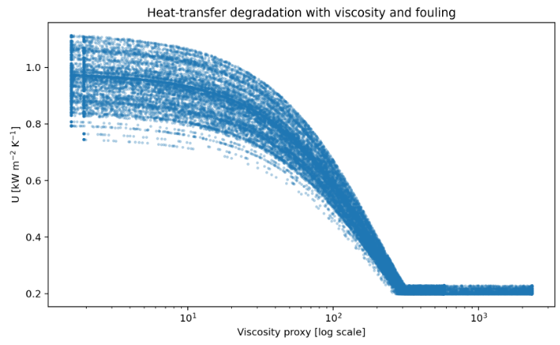
viscosity increases as the reaction proceeds
overall heat-transfer coefficient
Larger U- easy heat transfer, cooling is efficient.
Smaller U- heat cannot be easily transferred, cooling is difficult

U never goes below about 0.2. That is intentional.
Your simulator contains a minimum heat-transfer coefficient. Physically, even a very thick polymer still transfers some heat. It never becomes U = 0 because that would mean no heat could leave the reactor, which is impossible. So, the simulator correctly places a lower limit.

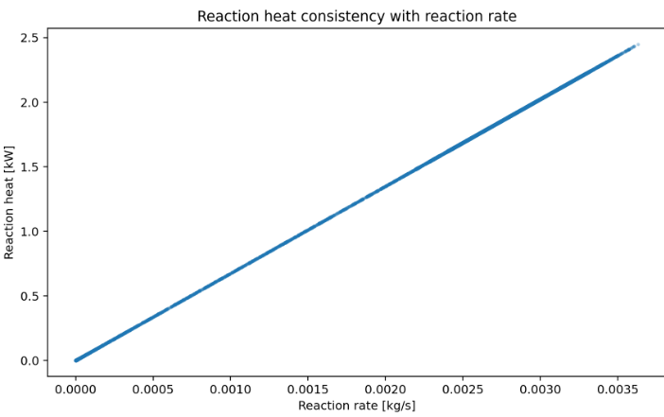
reaction rate increases → reaction heat increases

how fast monomer is being converted into polymer
how much heat is being produced by the polymerization reaction
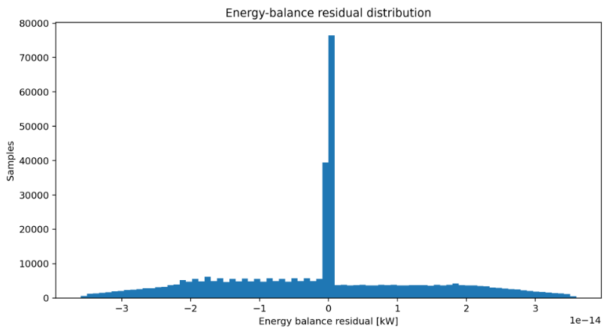
Total heat effect = reaction heat + jacket heat + feed heat + heat loss

means most samples have almost no heat-balance error.

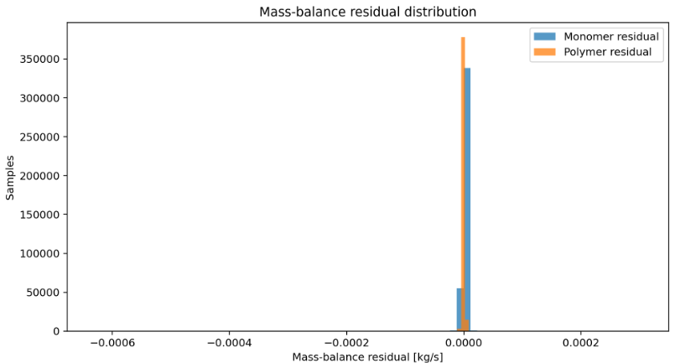

MODULE 2:
Module 2 converted reactor time-series data into 64-step windows, learned physics-informed temporal embeddings using PI-MambaRegime, clustered the embeddings using GMM, and discovered eight physically meaningful hidden reactor regimes.
We used the frozen Module 1 dataset:
CH-Regime-220-v1
From that dataset, Module 2 used important physics features:
- T_K
- Tj_in_K
- Tj_out_K
- valve_actual_pct
- feed_rate_kg_s
- mM_kg
- mP_kg
- mM_added_kg
- conversion_proxy
- solids_fraction
- viscosity_proxy
- U_kW_m2_K
- reaction_rate_kg_s
- Q_feed_kW
- Q_reaction_kW
- Q_jacket_kW
- Q_loss_kW
- dTdt_K_min

PIPELINE FOLLOWED:
Validated Module 1 dataset
↓
Select 18 physics features
↓
Create 64-step sliding windows
↓
Train PI-MambaRegime
↓
Extract 24-dimensional embeddings
↓
Cluster embeddings using GMM
↓
Discover regimes R0–R7
↓
Validate using Regime Reality Test
↓
PASS

After selecting the important physics features for the model, we use the sliding window concept to analyse the time series dataset, here we use 64 step window, this helps to analyse the behavior over time.
Physics Informed MAMBA model
These windows are given to the model now.
Mamba is a time series deep learning model which is used here to understand the hidden reactor behavior.
The model is not given with any pre-defined regime labels since there isn’t proper awareness of the hidden regimes yet.
Model tries to learn by performing 3 tasks:
- Reconstruction loss
Model tries to compress the reactor window and tries to reconstruct useful reactor information
- Future prediction loss
The model uses the current 64-step window to predict what happens next.
- Physics-informed loss
The model is encouraged to respect physics.

Extract 24-dimensional embeddings
Embeddings compress each 64-step reactor window into a compact behavior summary so similar physical dynamics can be clustered together meaningfully.

64-step reactor window
↓
PI-MambaRegime encoder
↓
24-dimensional embedding

Clustering embeddings using GMM (GUASSIAN MIXTURE MODEL)
Similar embeddings should represent similar reactor behavior. So we use clustering.
After clustering each group becomes a regime. We had identified 8 groups so 8 regimes.
Regime Reality Test
Regime Reality Test is how you confirm that R0–R7 are valid regimes
A valid regime should satisfy these conditions:
1. It should have enough samples.
2. It should appear in many trajectories.
3. It should persist over time.
4. It should be different from other regimes physically.
5. It should not be just copied from recipe_stage.
6. It should not be just Product A/Product B.
7. It should not be caused by train/test split leakage.
8. It should be useful for the next module.

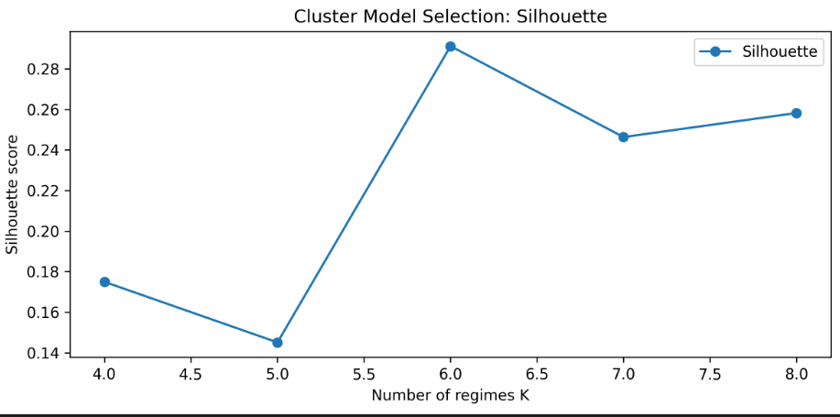
Although K=6 achieved the highest silhouette score and K=7 produced the lowest Davies-Bouldin score, K=8 was selected because it provided richer physically interpretable regimes and passed all Regime Reality Test acceptance criteria.
Metrics used:
- silhouette score
- Davies-Bouldin score
- BIC
- physics interpretability
- Regime Reality Test

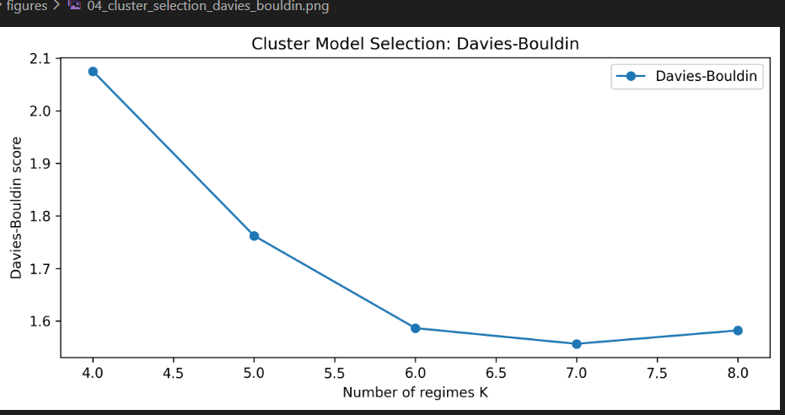

Lower Davies-Bouldin score = better clustering
The Davies-Bouldin score decreases from K=4 to K=7, indicating improved cluster compactness and separation. Although K=7 gives the minimum score, K=8 remains close and was selected based on combined clustering quality, physical interpretability, and regime validation.

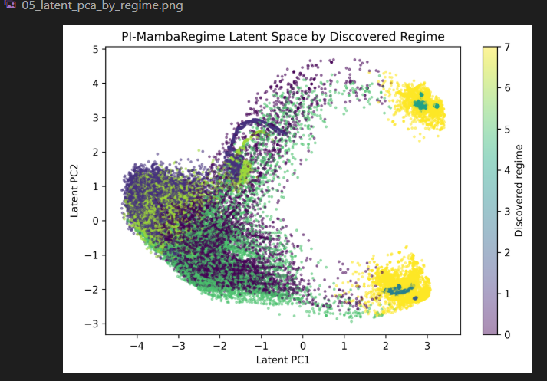
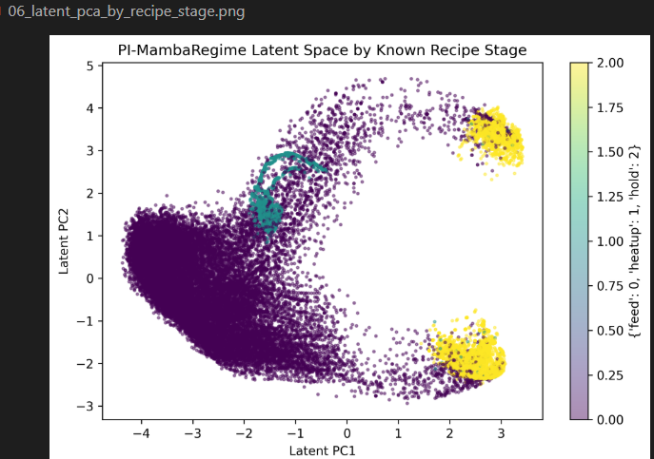
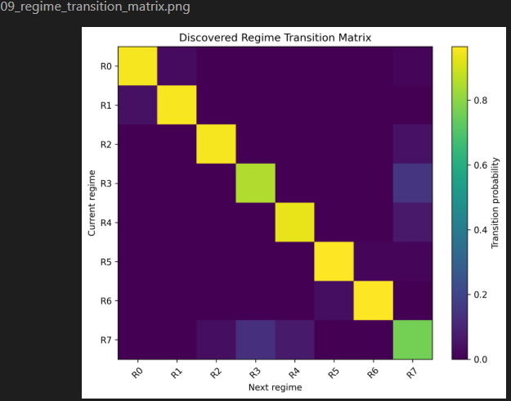
Rows = current regime
Columns = next regime

The regimes are not random.
The reactor does not jump randomly between R0–R7.
Each regime stays for some time.
Then it moves to another regime in a structured way.

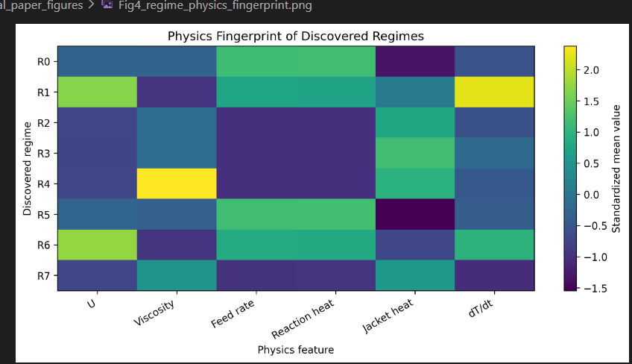

Regimes identified via MAMBA model
The model first discovers regimes from time-series embeddings. Then we interpret and validate those regimes using physics features.

MODULE 3

Module 2 regime assignments
↓
Use reactor physics features
↓
Fit one global symbolic law
↓
Fit one symbolic law per regime R0–R7
↓
Compare global vs regime-conditioned prediction
↓
Apply safety gate
↓
Evaluate on train/val/test/OOD/baseline
↓
PASS

OUTPUT:
GLOBAL LAW
------------------------------------------------------------------------
dTdt_K_min = 0.0382078 + 0.0945202*z(Q_reaction_kW) + 0.170078*z(Q_jacket_kW) + 0.0900033*z(Q_total_kW) - 0.0177227*z(heating_load_kW) + 0.0542428*z(inv_viscosity) - 0.0485583*z(U_over_viscosity) + 0.130937*z(Q_total_times_U) + 0.0277323*z(Q_jacket_kW^2)

REGIME-SPECIFIC LAWS
------------------------------------------------------------------------
R0: dTdt_K_min = 0.000659002 + 0.00775571*z(Q_jacket_kW) + 0.257699*z(Q_total_kW) + 0.000883143*z(jacket_times_U) + 0.0497743*z(Q_total_times_U)
R1: dTdt_K_min = 0.181273 + 0.263004*z(Q_jacket_kW) + 0.130545*z(Q_total_kW) + 0.0564622*z(inv_viscosity) - 0.0563356*z(U_over_viscosity) - 0.221784*z(jacket_times_U) + 0.455967*z(Q_total_times_U) - 0.0588368*z(Q_total_kW^2) + 0.0459766*z(Q_jacket_kW^2)
R2: dTdt_K_min = 0.000658289 + 4.3871e-05*z(Q_reaction_kW) + 0.00594718*z(Q_jacket_kW) + 8.01603e-05*z(Q_loss_kW) - 3.02102e-05*z(conversion_proxy) + 7.54431e-05*z(Q_total_kW) + 9.42295e-06*z(Q_total_times_U) - 6.41153e-07*z(feed_rate_kg_s^2)
R3: dTdt_K_min = 0.0278193 + 0.0811584*z(Q_jacket_kW) + 0.000100268*z(Q_loss_kW) - 0.000435665*z(conversion_proxy) + 5.95308e-06*z(Q_total_kW) + 4.63599e-06*z(heating_load_kW) + 8.49495e-06*z(reaction_times_feed) + 6.77528e-06*z(Q_reaction_kW^2) - 5.15624e-05*z(feed_rate_kg_s^2)
R4: dTdt_K_min = 0.0138072 + 3.82292e-05*z(Q_reaction_kW) + 0.051183*z(Q_jacket_kW) + 3.33031e-05*z(Q_feed_kW) + 0.00750593*z(Q_loss_kW) - 0.000223648*z(conversion_proxy) + 0.00275476*z(Q_total_kW) + 7.08643e-05*z(Q_reaction_kW^2)
R5: dTdt_K_min = 0.00529165 - 9.41228e-05*z(conversion_proxy) + 0.238869*z(Q_total_kW) + 0.0448324*z(Q_total_times_U) + 3.2755e-07*z(Q_total_kW^2)
R6: dTdt_K_min = 0.102212 + 0.215188*z(Q_jacket_kW) + 0.113364*z(Q_total_kW) + 0.0284241*z(inv_viscosity) - 0.0265757*z(U_over_viscosity) - 0.179286*z(jacket_times_U) + 0.373923*z(Q_total_times_U) - 0.0323614*z(Q_total_kW^2) + 0.0354589*z(Q_jacket_kW^2)
R7: dTdt_K_min = -0.0296027 + 0.0174338*z(Q_reaction_kW) + 0.181218*z(Q_jacket_kW) + 0.00238257*z(Q_feed_kW) + 0.00805547*z(Q_loss_kW) + 8.23517e-05*z(feed_rate_kg_s) - 0.00108546*z(conversion_proxy) + 0.000876077*z(Q_total_kW) + 0.00010732*z(feed_rate_kg_s^2)
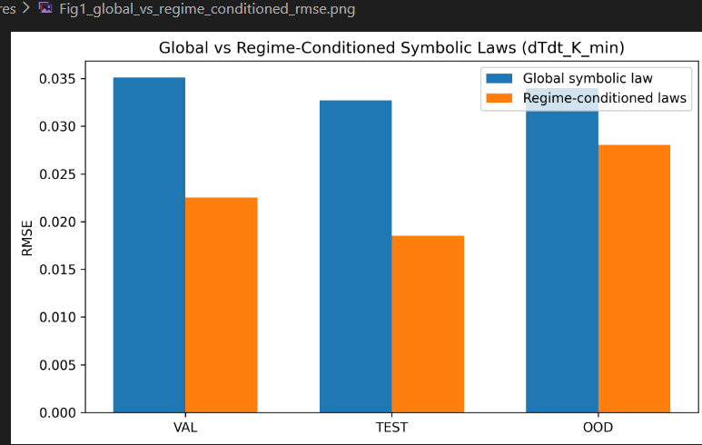

Lower Root Mean Squared Error noticed

Regime-conditioned laws predict dTdt better than one global law.
This graph directly supports our main claim.

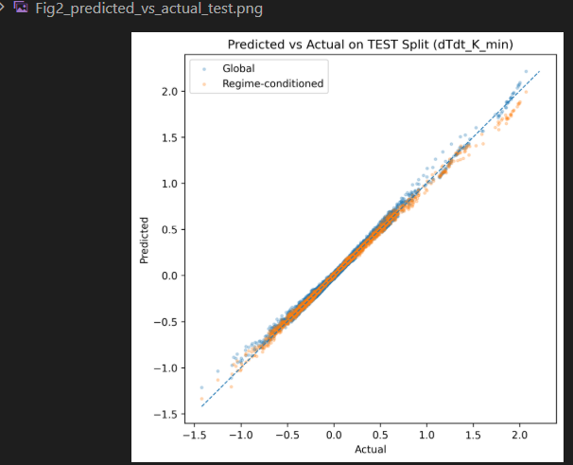
The regime-conditioned points are tighter around the diagonal than the global model.
Dashed line- perfect prediction.

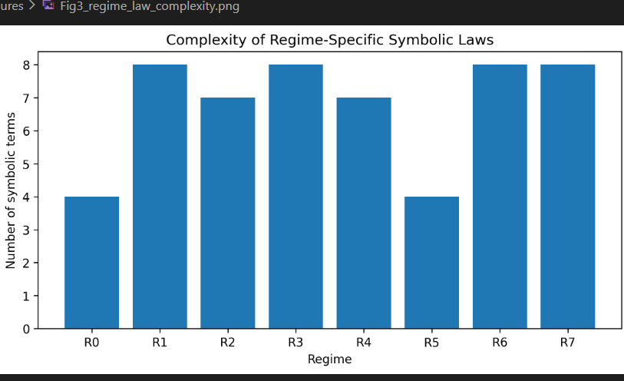

MODULE 4:
Proposed , not yet built

Frozen dataset
↓
Module 2 regime assignments
↓
Module 3 Safe RC-PhySR symbolic laws
↓
Counterfactual physical interventions
↓
Predict dT/dt under altered physics
↓
Compare global law vs regime-conditioned law
↓
Evaluate physical consistency and robustness

Regime-conditioned symbolic laws respond more physically and robustly than a single global symbolic law under counterfactual stress conditions.

Module 1:
Validated physics-consistent polymerization digital twin

Module 2:
PI-MambaRegime hidden regime discovery

Module 3:
Safe RC-PhySR regime-conditioned symbolic law learning

Module 4:
Counterfactual Regime-Law Digital Twin validation

