Support for password authentication was removed on August 13, 2021. Please use a personal access token instead.

Github changed login process

Instead of providing password at git commit push n pull we have to provide PAT (personal access token).

Process to generate PAT

1. Can follow this url

<https://docs.github.com/en/github/authenticating-to-github/connecting-to-github-with-ssh/generating-a-new-ssh-key-and-adding-it-to-the-ssh-agent>

first execute this command

ssh-keygen -t ed25519 -C "*your_email@example.com*"

[*your_email@example.com*](mailto:your_email@example.com)*: please provide here ur github registered email*

*for me*

ssh-keygen -t ed25519 -C "*asifaftab87@mail.com*"

then it will ask question like provide passphrase etc

just enter don’t give any value

above command will generate private and public key

Location of key files : /c/Users/you/.ssh/id_ed25519

Users is a folder in C drive

In may case

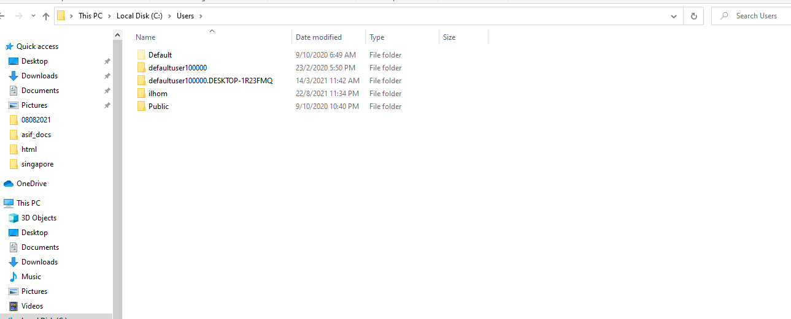

Ilhom is my username folder of my laptop

For you please check what is your username

Sometime our folder is in hidden format

If you cannot see .ssh inside your user_name folder then plz make hidden folder visible

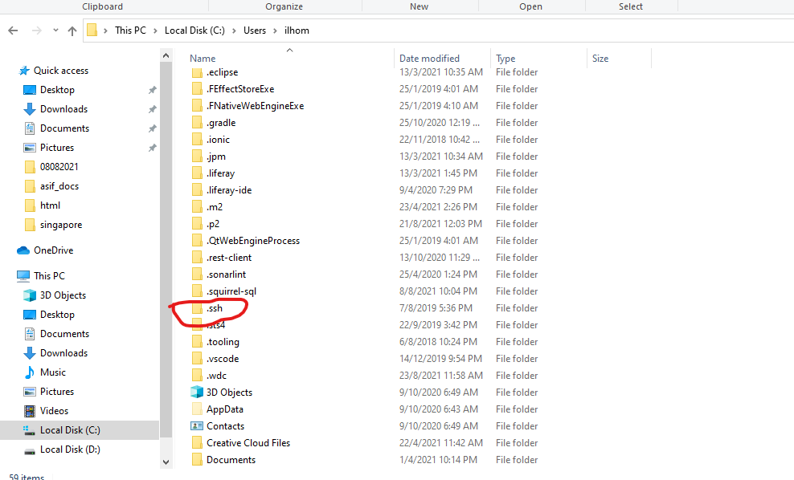

In image u can see that I am inside ilhom folder which is inside Users folder then I have one .ssh folder.

In below image we can see three files

id_ed25519 is our private key

id_ed25519.pub is public key

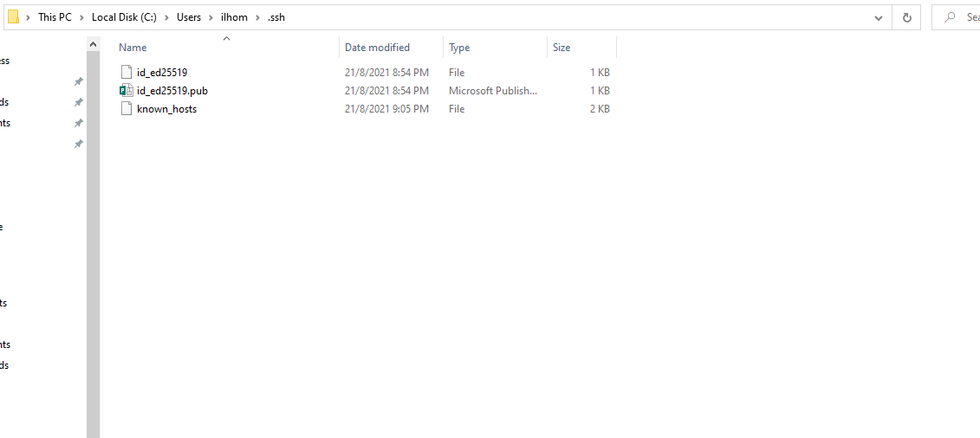

After generation of ssh keys we have to sure that our ssh agent is running

Plz execute this command

eval "$(ssh-agent -s)"

above command will produce this: Agent pid 59566

here pid value may be different

now we have to add our ssh key to our ssh agent

please use this command

ssh-add ~/.ssh/id_ed25519

now our computer ssh key generation and adding to ssh agent done

Next step is to add this ssh key to our github account

Please open github in browser and login

Please go through this url

<https://docs.github.com/en/github/authenticating-to-github/connecting-to-github-with-ssh/adding-a-new-ssh-key-to-your-github-account>

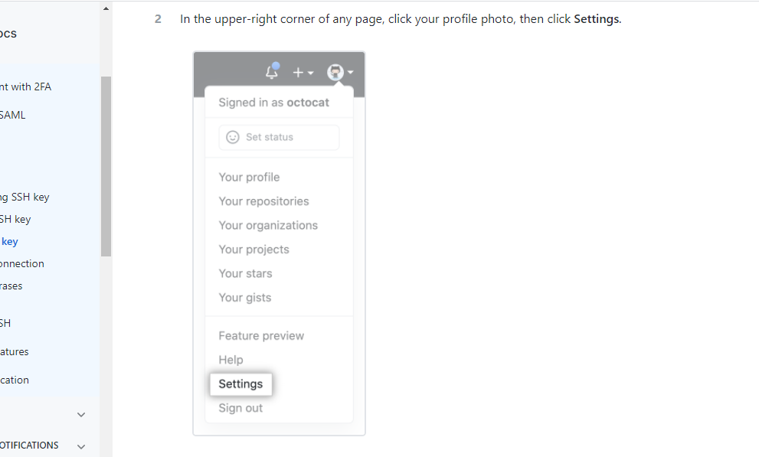

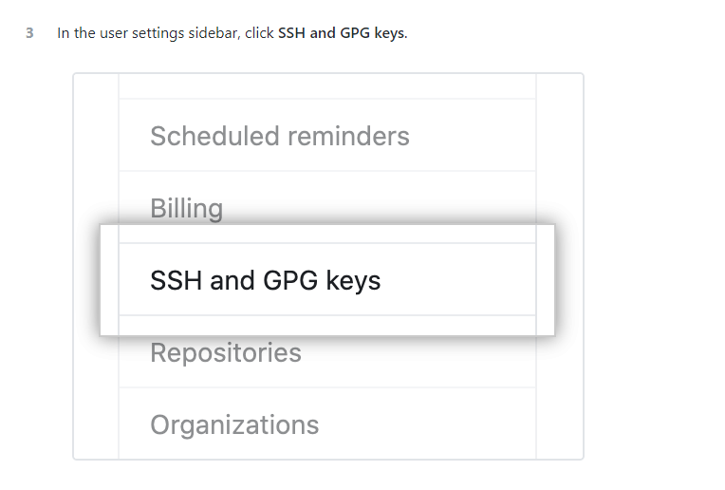

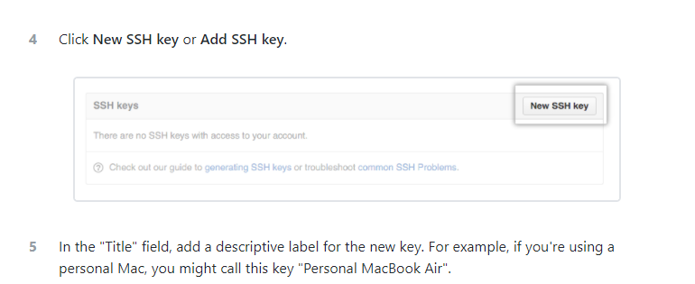

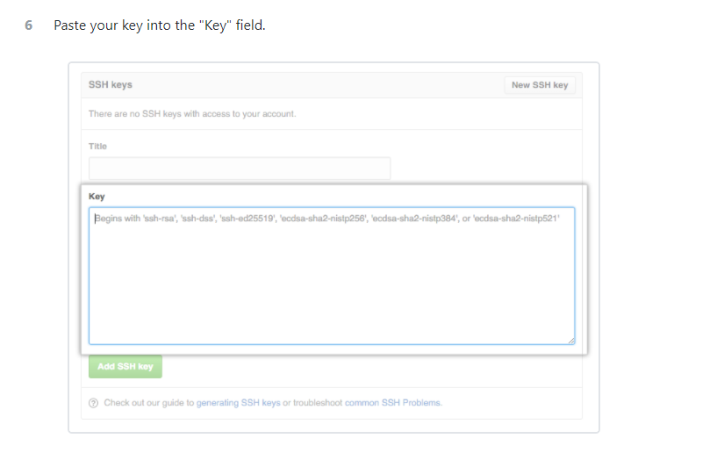

In above image we have to add our public key value

Go to ur C:\Users\ilhom\.ssh folder

For your case only ilhom will change

Right click on id_ed25519.pub file

Edit with notepad++

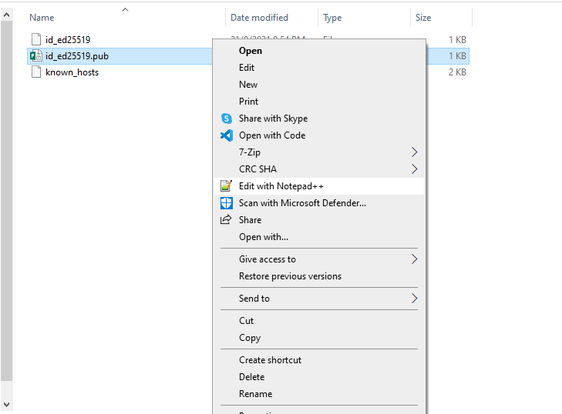

Then copy paste the content of this file to



Here

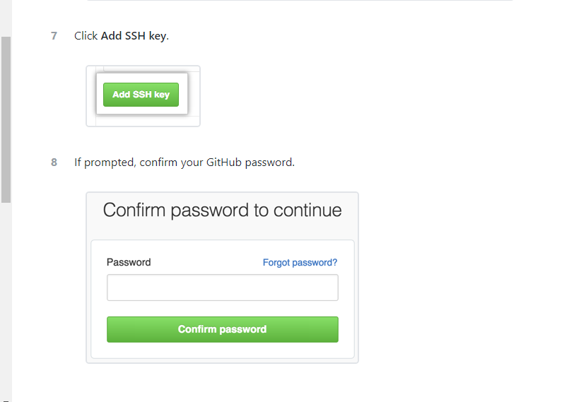

For testing that our ssh working fine

ssh -T git@github.com

execute this command

now we have to create a personal access token PAT

plz go through this url

<https://docs.github.com/en/github/authenticating-to-github/keeping-your-account-and-data-secure/creating-a-personal-access-token>

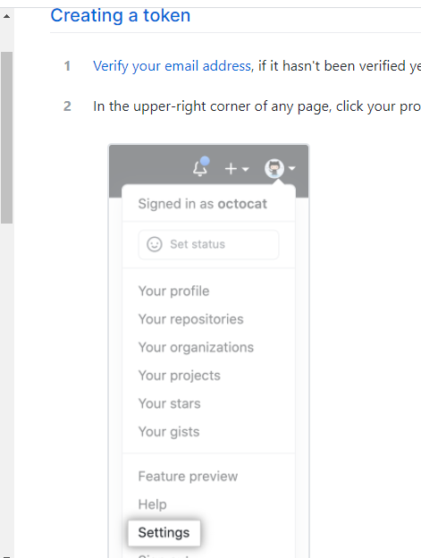

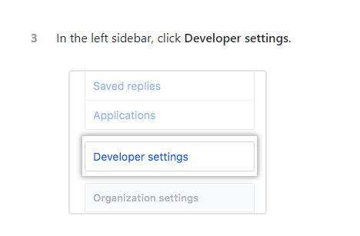

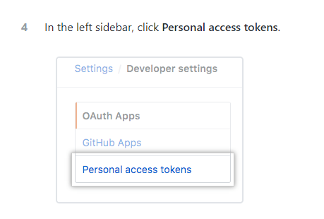

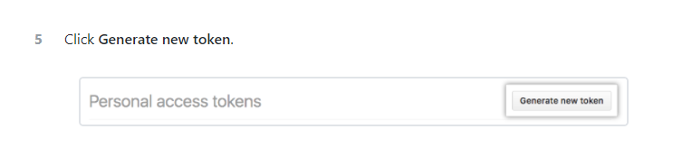

This token once generate then u can see after that you cannot see this token.

So please copy paste in any good place so in future u can use it

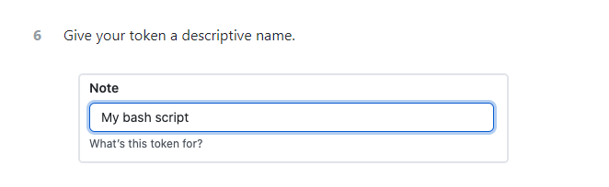

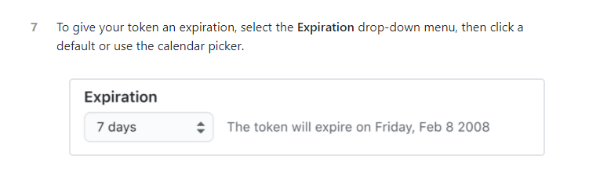

Please select option never expire token

Select all checkboxes

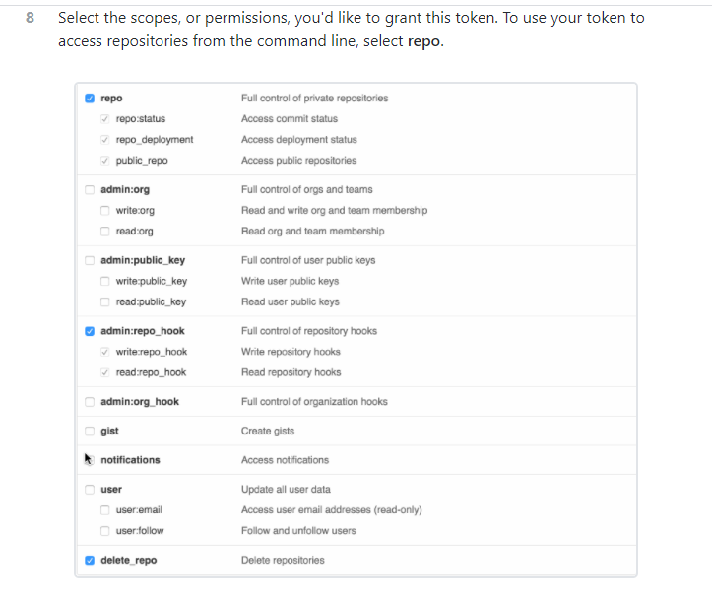

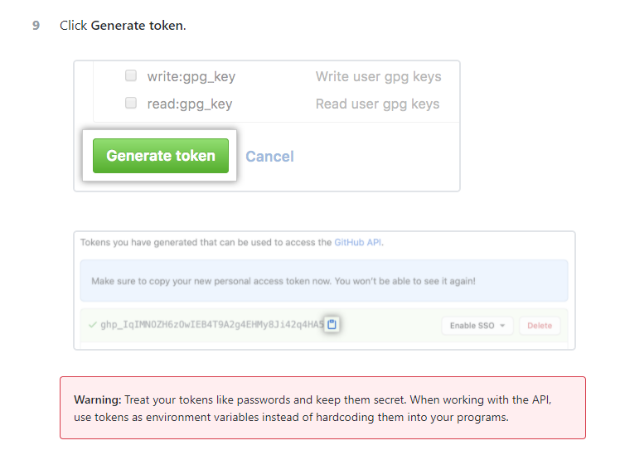

Now clone newly and provide this pat as your password

Means instead of password we have to use token as password.