

STM32F411-BASED USB AUDIO DAC
WITH REAL-TIME SPECTRUM VISUALIZER

A MINI PROJECT REPORT FOR THE COURSE

EC23733 - EMBEDDED AND REAL TIME SYSTEMS

Submitted by
ASIF AHAMED S | (2116230801024)

in partial fulfillment for the award of the degree of

BACHELOR OF ENGINEERING
in
ELECTRONICS AND COMMUNICATION ENGINEERING

DEPARTMENT OF ELECTRONICS AND COMMUNICATION ENGINEERING RAJALAKSHMI ENGINEERING COLLEGE (AUTONOMOUS),
CHENNAI - 602 105


NOV 2026

TABLE OF CONTENTS

CHAPTER NO. | TITLE
1 | ABSTRACT
2 | INTRODUCTION
3 | OBJECTIVES
4 | SYSTEM REQUIREMENTS
5 | BLOCK DIAGRAM AND WORKING
6 | ALGORITHM / PROGRAM LOGIC/ PSEUDOCODE
7 | RESULTS AND DISCUSSION
8 | CONCLUSION AND FUTURE ENHANCEMENT
9 | REFERENCES

1. ABSTRACT
This mini project presents an STM32F411-based USB Audio Digital-to-Analog Converter (DAC) with a real-time spectrum visualizer. The system receives 48 kHz, 16-bit mono digital audio from a host computer through a USB Audio Class 1.0 interface. The received audio samples are buffered within the microcontroller and transferred through the Inter-IC Sound (I2S) interface using Direct Memory Access (DMA). A MAX98357A digital-input DAC and Class-D amplifier converts the audio data into an amplified output to drive a speaker. An ST7735S TFT display provides a graphical representation of the audio frequency spectrum using Fast Fourier Transform (FFT) processing. The firmware combines interrupt-driven audio handling with display updates, allowing playback and visualization within a dedicated embedded system. The project demonstrates USB communication, peripheral interfacing, sample buffering, clock synchronization, DMA-based data transfer, and digital signal processing. It provides a practical platform for studying continuous audio streaming and timing requirements in embedded and real-time systems.

2. INTRODUCTION
Embedded audio systems combine digital communication, signal processing, and hardware interfacing to reproduce sound from digital data. Unlike a general-purpose computer, a dedicated audio device performs a specific set of operations: receiving audio samples, buffering them, and transferring them to an output interface at a controlled rate. This project implements these operations using an STM32F411 microcontroller, a USB audio interface, and an external digital-input audio amplifier. [4, 7]
The STM32F411-based USB Audio DAC receives 48 kHz, 16-bit mono audio from a host computer through a USB Audio Class 1.0 interface. The received samples pass through a ring buffer before being transmitted over the Inter-IC Sound (I2S) interface using Direct Memory Access (DMA). A MAX98357A module performs digital-to-analog conversion and Class-D amplification to drive a speaker. This arrangement connects the host computer’s digital audio stream to a dedicated embedded playback system. [5–7]
In addition to audio playback, the system incorporates an ST7735S TFT display for spectrum visualization. Fast Fourier Transform (FFT) processing converts a block of audio samples into frequency-domain information, which is represented as graphical bands on the display. This feature provides a visual indication of changes in the frequency content of the audio being played. [7]
Continuous playback introduces timing requirements because samples must reach the audio output before its existing buffer contents are consumed. The firmware uses a ring buffer to accommodate differences between USB data delivery and I2S consumption, while circular DMA allows one output-buffer half to be refilled as the other is transmitted. Matching the audio clock to the incoming sample rate is also important to prevent sustained buffer depletion or accumulation. The project therefore demonstrates peripheral interfacing, interrupt-driven execution, buffering, clock synchronization, and the coordination of audio playback with display processing. [7]
Related open-source projects demonstrate audio playback and spectrum visualization using the STM32F411 Black Pill. The har-in-air project implements USB Audio Class 1.0 playback using external I2S DACs and endpoint feedback for sample-rate synchronization [1]. TobiasVanDyk documents a PCM5102A-based USB audio DAC implementation with development and assembly instructions [2]. The k-pitaliya project demonstrates microphone-based FFT processing and frequency-band visualization on the STM32F411 [3]. These projects provide related implementation examples, while the present design combines 48 kHz mono USB audio playback through a MAX98357A with spectrum visualization on an ST7735S TFT [7].

3. OBJECTIVES
- To develop an STM32F411-based USB Audio Class 1.0 device for receiving 48 kHz, 16-bit mono audio from a host computer.
- To implement a ring buffer for managing audio samples between USB reception and I2S transmission.
- To configure the I2S interface with Direct Memory Access (DMA) for continuous audio output.
- To interface a MAX98357A digital-input DAC and Class-D amplifier with the microcontroller for speaker playback.
- To process audio samples using the Fast Fourier Transform (FFT) and display frequency-spectrum bands on an ST7735S TFT.
- To study clock synchronization, interrupt-driven execution, buffering, and timing requirements in an embedded audio system.
- To validate USB device detection, audio playback, and spectrum-display operation through practical testing.

4. SYSTEM REQUIREMENTS

4.1 Hardware Requirements
Component | Specification | Purpose
Microcontroller board | STM32F411CEU6 Black Pill | Receives USB audio, buffers samples, and controls audio output and visualization
Audio DAC and amplifier | MAX98357A I2S-input Class-D amplifier module | Converts digital audio and amplifies it for speaker playback
Speaker | 8 Ω speaker | Produces the mono audio output
TFT display | ST7735S, 128 × 128 pixels, SPI interface | Displays the audio-frequency spectrum
USB cable | Data-capable cable compatible with the board | Connects the board to the host computer for USB audio communication
Programmer/debugger | ST-Link V2 | Programs and debugs the STM32 firmware
Host computer | Computer with USB audio support | Supplies the digital audio stream and runs development tools
Power supply | USB supply with suitable module power connections | Powers the microcontroller and connected modules
Connecting wires | Jumper wires and prototype connections | Connects the microcontroller, amplifier, and display

Table 4.1 – Hardware requirements of the USB audio DAC system.

4.2 Software Requirements
The firmware is developed in Embedded C using STM32 HAL drivers and the STM32 USB Device middleware. STM32CubeMX provides the peripheral-configuration project, while the Arm GNU toolchain and Make compile and link the firmware. The st-flash utility programs the microcontroller through an ST-Link V2. The firmware includes modules for USB audio handling, ring-buffer management, I2S output, FFT processing, and TFT visualization. Host-side tests are provided for the ring buffer, FFT processing, and font rendering. [7]
Software/tool | Purpose
STM32CubeMX | Configures clocks and peripherals and generates initialization code
Arm GNU toolchain (arm-none-eabi-gcc) | Compiles and links the STM32 firmware
GNU Make | Executes the project’s build commands
STM32 HAL and USB Device middleware | Provides peripheral drivers and USB device functionality
st-flash | Uploads firmware using the ST-Link V2
Native C compiler for host tests | Builds and runs the supplied host-side test programs
USB-audio-capable operating system and audio player | Sends test audio to the device

Table 4.2 – Software requirements of the USB audio DAC system.

5. BLOCK DIAGRAM AND WORKING
The system consists of an STM32F411 microcontroller connected to a host computer, a MAX98357A audio DAC and amplifier module, a speaker, and an ST7735S TFT display. The host computer supplies digital audio through USB. The microcontroller buffers the received samples and transfers them to the MAX98357A through I2S using DMA. A separate processing path uses the playback samples to generate an audio-frequency spectrum for the TFT display. [7]
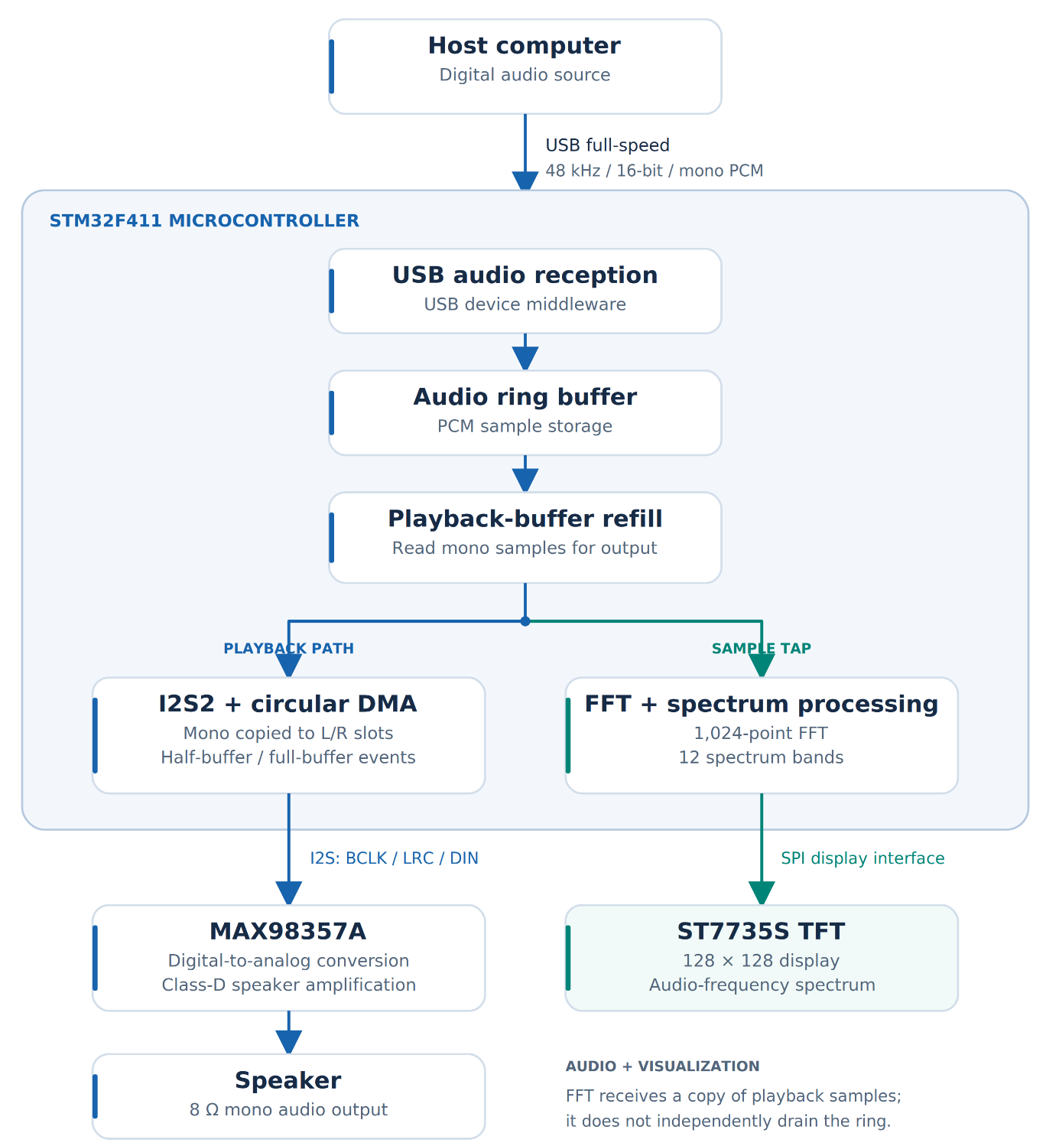
Fig. 5.1 – Block diagram of the STM32F411-based USB audio DAC with spectrum visualizer.

5.1 Working Principle
- On power-up, the firmware initializes the system clocks, audio buffers, USB interface, I2S/DMA output, FFT processing, and TFT display. The FFT buffers are initialized before audio DMA begins.
- The microcontroller enumerates as a USB Audio Class 1.0 device, allowing the host computer to select it as an audio playback output.
- The host transmits 48 kHz, 16-bit mono PCM audio through the USB audio interface.
- The firmware transfers received audio samples into a ring buffer, which separates USB data delivery from I2S consumption.
- DMA half-transfer and transfer-complete events trigger refilling of the corresponding output-buffer half while the other half continues transmitting.
- During refill, mono samples are supplied to the FFT collection buffer and duplicated into the left and right slots of the I2S output frames. The source audio remains mono.
- The MAX98357A receives the I2S data and produces an amplified speaker output.
- The visualizer processes collected samples using a 1,024-point FFT and represents the frequency content as 12 spectrum bands on the TFT.
- Audio transfer continues through interrupt-driven DMA handling, while the main loop performs visualizer updates.

6. ALGORITHM/ PROGRAM LOGIC / PSEUDOCODE

6.1 ALGORITHM
- Start the system and configure the microcontroller clocks and peripheral interfaces.
- Initialize the ring buffer and FFT collection buffers before starting audio DMA.
- Initialize the USB Audio Class 1.0 interface, I2S output, circular DMA, and TFT display.
- Allow the host computer to detect and configure the device for audio playback.
- Receive 48 kHz, 16-bit mono PCM samples through the USB audio interface.
- Transfer received samples into the ring buffer through the USB audio middleware’s playback handling.
- On a DMA half-transfer or transfer-complete event, perform the required USB audio synchronization before refilling the corresponding output-buffer half.
- Read available mono samples from the ring buffer into a temporary playback buffer.
- Supply a copy of these samples to the FFT collection buffer, then duplicate the mono samples into the left and right I2S frame slots.
- Continue I2S transmission through DMA to the MAX98357A, which drives the speaker.
- In the main loop, service the visualizer; when an FFT frame is ready and a display update is due, process the samples and update the spectrum bands.
- Repeat interrupt-driven audio handling and main-loop visualization while the system operates.

6.2 PROGRAM LOGIC
The firmware separates continuous audio transfer from display processing. USB middleware manages the incoming audio stream, while the ring buffer stores samples awaiting playback. DMA half-transfer and transfer-complete events identify which section of the I2S output buffer can be refilled. The audio synchronization routine must run before the corresponding refill operation so that newly delivered audio is available to the playback path. [7]
During refill, the firmware reads mono samples into a temporary buffer. It feeds a copy to the FFT collection path before duplicating the samples into the left and right I2S slots. This duplication does not create stereo audio; both slots carry the same mono signal. The main loop services the spectrum visualizer, keeping FFT computation and TFT drawing outside the time-critical audio-refill operation. [7]

6.3 PSEUDOCODE
BEGIN
Initialize system clocks and peripheral interfaces
Initialize audio ring buffer
Initialize FFT collection buffers
Initialize I2S and circular DMA
Initialize USB audio device
Initialize TFT and visualizer

REPEAT continuously
Call Visualizer_Update()
Process a pending FFT frame when ready
Update TFT when the display-update interval is due
END REPEAT
END

ON USB AUDIO PLAYBACK DATA DELIVERY
Write received mono PCM samples into ring buffer
END EVENT

ON DMA HALF-TRANSFER EVENT
Synchronize USB middleware for the half-buffer event
Refill output-buffer half A
END EVENT

ON DMA TRANSFER-COMPLETE EVENT
Synchronize USB middleware for the full-buffer event
Refill output-buffer half B
END EVENT

PROCEDURE REFILL OUTPUT-BUFFER HALF
Read available mono samples into temporary playback buffer
Feed a copy of samples to FFT collection buffer
Duplicate mono samples into left and right I2S slots
Update the selected DMA output-buffer half
END PROCEDURE
The indented operations beneath Visualizer_Update() describe work performed inside that routine, not a second processing pass. This explanatory pseudocode represents the normal USB playback path and omits diagnostic modes and detailed fault handling [7].

7. RESULTS AND DISCUSSION

7.1 Implementation Results
The STM32F411-based USB Audio DAC with spectrum visualization was assembled and functionally tested. The host computer detected the device as a USB audio playback output, and audio supplied by the host was reproduced through the MAX98357A amplifier and speaker. The ST7735S TFT displayed frequency-spectrum bands that responded to the audio input. These observations confirmed the operation of the implemented USB reception, audio-output, and visualization functions.
The firmware is configured for 48 kHz, 16-bit mono PCM audio. Received samples are buffered and transferred through I2S using circular DMA. A copy of the playback samples is supplied to the FFT processing path, which generates 12 spectrum bands from a 1,024-point FFT. Although the mono samples are duplicated into the left and right I2S frame slots, the system remains a mono playback device [7].
Function tested | Functional observation | Result
USB device detection | The host recognized the board as an audio playback device | Passed
USB audio playback | Host audio was reproduced through the speaker | Passed
I2S audio-output path | The MAX98357A and speaker operated during playback | Passed
TFT display | The display presented the spectrum visualization | Passed
Spectrum response | The displayed bands changed with the audio input | Passed
Combined operation | Audio playback and spectrum visualization operated together | Passed
Table 7.1 – Functional validation results of the USB audio DAC system.
These results represent functional observations from the prototype demonstration. The configured sample rate and FFT size are firmware parameters, not independently measured performance results. Quantitative measurements of playback latency, distortion, acoustic response, and output power are outside the scope of the reported functional validation.

7.2 Discussion
The functional test demonstrated the complete signal path from the host computer to the speaker, together with the parallel visualization path. USB audio reception supplies PCM samples to the firmware, while the ring buffer temporarily stores samples awaiting playback. Circular DMA transfers the prepared I2S output buffer, and half-transfer and transfer-complete events allow the available buffer half to be refilled [7].
Clock configuration is important because a persistent difference between the incoming sample rate and output consumption rate can gradually deplete or fill the buffer. The firmware uses a configuration designed for 48 kHz I2S output, matching the declared USB audio format [7]. Related USB audio implementations also address sample-clock differences through synchronization mechanisms such as endpoint feedback; that mechanism belongs to the cited implementation and is not claimed as a feature of this project [1].
The visualizer receives a copy of playback samples rather than independently removing samples from the audio ring buffer. FFT processing and display updates are serviced through the main-loop visualizer routine, while audio-buffer handling occurs through interrupt-driven execution. This separation supports the coordination of continuous audio output and graphical display processing [7].
The TFT spectrum represents the frequency content of the digital samples. It is not a calibrated measurement of the sound produced by the speaker. Nevertheless, its response to changing audio provides a useful visual demonstration of FFT-based signal processing alongside embedded audio playback.

7.3 Demonstration Evidence
The following figures document the assembled prototype, host-side USB audio detection, and spectrum-display operation during the demonstration.

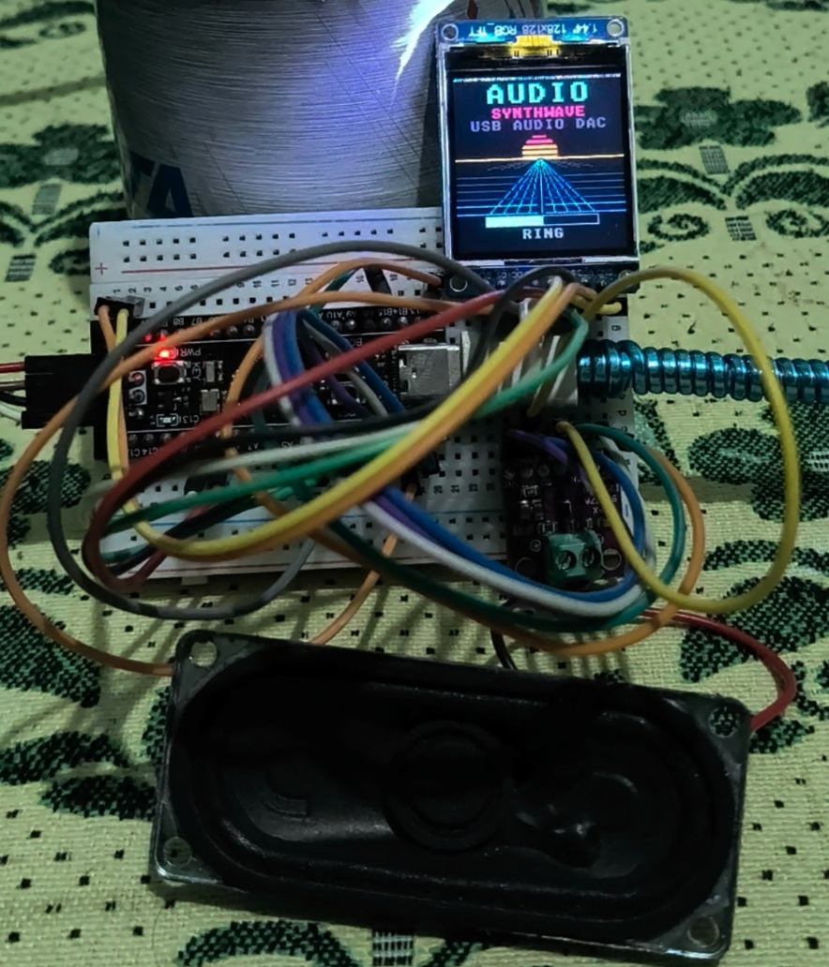
Fig. 7.1 – Hardware prototype of the STM32F411-based USB audio DAC.

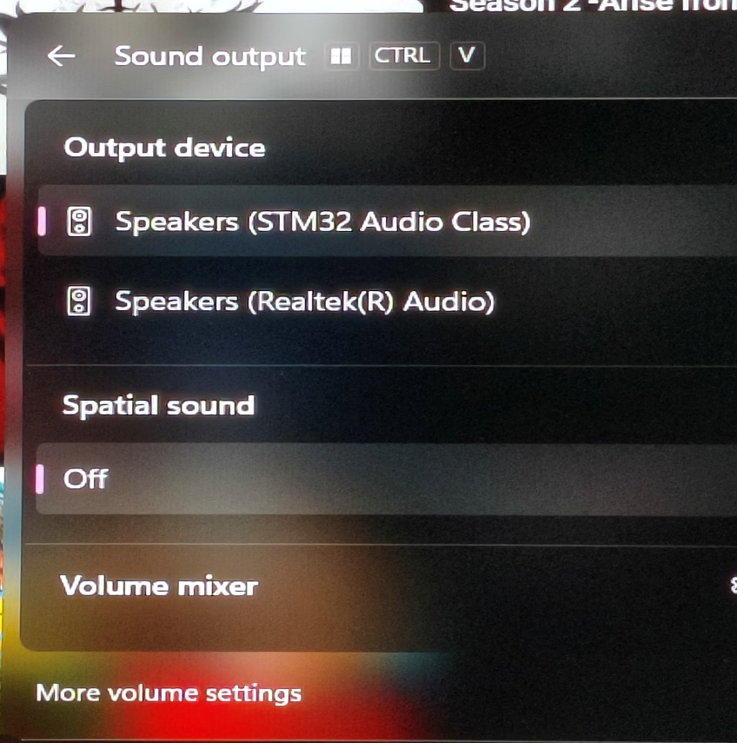
Fig. 7.2 – USB audio device detected by the host computer.

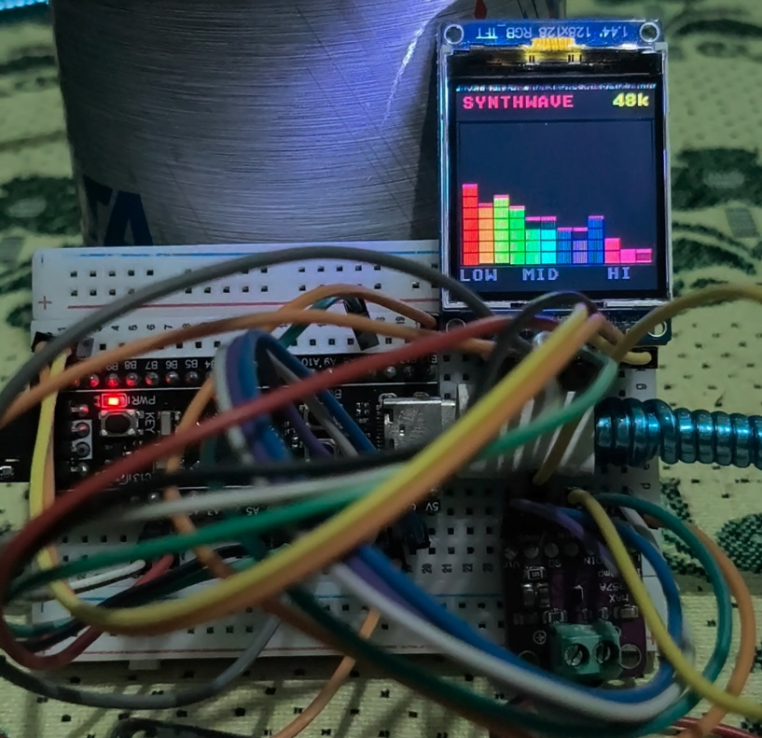
Fig. 7.3 – Spectrum visualization on the ST7735S TFT during audio playback.

8. CONCLUSION AND FUTURE ENHANCEMENT

8.1 Conclusion
An STM32F411-based USB Audio DAC with a real-time spectrum visualizer was developed and functionally tested for the EC23733 Embedded and Real Time Systems mini project. The prototype received digital audio from a host computer, reproduced it through a MAX98357A amplifier and speaker, and displayed a responsive frequency-spectrum visualization on an ST7735S TFT. Functional testing confirmed USB device detection, speaker playback, display operation, and combined playback with visualization.
The implementation demonstrates USB peripheral interfacing, ring-buffer management, I2S transmission, circular DMA, interrupt-driven execution, and FFT-based signal processing. It also illustrates the importance of coordinating sample delivery, output timing, and background display work within a dedicated embedded system [7]. The completed prototype provides a foundation for future volume control, task-based firmware organization, additional audio processing, and quantitative performance evaluation.

8.2 Future Enhancement
The following features are proposed extensions and are not claimed as completed in the present implementation:
- Rotary-encoder volume and mute control: Add an EC11 rotary encoder to adjust software gain and use its push button for muting. This feature is explicitly marked as planned in the repository. [7]
- FreeRTOS integration: Extend the firmware with separate tasks for visualization, user-input handling, and system monitoring while retaining time-critical DMA interrupt handling.
- Additional audio processing: Introduce digital equalization or selectable filter modes, subject to available processing time and memory.
- Improved display interface: Add playback status, volume indication, and selectable visualization styles.
- Hardware refinement: Replace prototype wiring with a dedicated PCB and enclosure for a more compact and mechanically reliable assembly.
- Extended validation: Measure playback latency, sustained-streaming reliability, and audio-output characteristics using suitable test equipment.

9. REFERENCES
[1] har-in-air, “STM32F411_USB_AUDIO_DAC: USB Hi-Res Stereo Audio DAC Using STM32F411/401 Black Pill,” GitHub repository. [Online]. Available: https://github.com/har-in-air/STM32F411_USB_AUDIO_DAC. Accessed: October 4, 2026.
[2] TobiasVanDyk, “STM32F411 PCM5102A 24bit USB Audio DAC,” GitHub repository. [Online]. Available: https://github.com/TobiasVanDyk/STM32F411-PCM5102A-24bit-USB-Audio-DAC. Accessed: October 4, 2026.
[3] k-pitaliya, “Audio Spectrum Analyzer: Real-Time FFT-Based Audio Visualization on STM32F411,” GitHub repository. [Online]. Available: https://github.com/k-pitaliya/audio-spectrum-analyzer-stm32. Accessed: October 4, 2026.
[4] STMicroelectronics, “STM32F411xC STM32F411xE,” microcontroller datasheet. [Online]. Available: https://www.st.com/resource/en/datasheet/stm32f411ce.pdf. Accessed: October 3, 2026.
[5] Analog Devices, “MAX98357A/MAX98357B: Tiny, Low-Cost, PCM Class D Amplifier with Class AB Performance,” datasheet. [Online]. Available: https://www.analog.com/media/en/technical-documentation/data-sheets/max98357a-max98357b.pdf. Accessed: October 3, 2026.
[6] USB Implementers Forum, “Universal Serial Bus Device Class Definition for Audio Devices,” Release 1.0, March 18, 1998. [Online]. Available: https://www.usb.org/sites/default/files/audio10.pdf. Accessed: October 3, 2026.
[7] asifahamed-ece, “UsbAudioDac: STM32F411-Based USB Audio DAC Class 1.0 Project,” GitHub repository, firmware and hardware documentation. [Online]. Available: https://github.com/asifahamed-ece/UsbAudioDac. Accessed: October 3, 2026.

