**E-course interactive learning application**

**(Project Proposal)**

### 

**Project Code**

<Project code assigned by the Project Office>

**Project Advisor**

Dr. Muhammad Ilyas

**Project Manager**

Prof. FahadMaqbool

**Project Team**

Shah Danish BSSE-F10-E051

Asifali BSSE-F10-E040

Muhammad raheel BSSE-F10-E042

**Submission Date**

<Provide the date when the proposal is submitted>

**Table of Contents**

1. Abstract 3

2. Background and Justification 3

3. Research Methodology 3

4. Project Scope 3

5. High level Project Plan 3

6. References 3

# Abstract

**Overview and Brief Background:**

Active involvement of students in teaching, learning process has always been a challenge for educationists. Student assessment plays a vital role in active learning. Lecture based assessments are not as successful as they are supposed. Some possible reasons may include lack of concentration, inactive behavior, talking with each other, or use of mobile phones in class. There should be a mechanism for teachers to assess the students. Educational institutes use excels sheets for student assessment. Teachers have to generate reports of students manually according to student assessment data.So it is possible that they may miss some record which may subject to inconsistency. This methodology is time consuming. And provide no consistency of data. All these methodologies lack group base assessment.

These methodologies for student assessment are accurate up to some extent.Considering these situations there should be some methodology which gives maximum results in minimum time in group base environment.

**Objective:**

Our objective is to get assessment data of student and generate report of each student.

**Steps to Achieve Objectives:**

Following are the steps to achieve objectives:

1. Assessment records of student by teacher
2. Assessment records of student by students.
3. Manage data
4. Locate inconstancies&normalize records
5. Evaluate results on statistical bases
6. Generate reports of each student

# Background and Justification

A university is an institution of higher learning and research. The performance of a university is closely associated with the satisfaction level of students (Topping, 2012).Keith Topping is Professor of Educational and Social Research.His own main research focus is Peer Learning (including peer tutoring, cooperative learning, peer assessment, and so on) and other forms of non-professional tutoring (e.g. by parents, assistants or volunteers) - in core skills (e.g. reading, spelling, writing, thinking skills, science, mathematics, information technology) and across subject boundaries, in all sectors and contexts of education and lifelong learning.

Barbara J. Millis worked in faculty development at the University of Maryland University College. In herresearch, defines active learning, discusses its value, offers suggestions for implementing it, and provides six concrete examples of active learning approaches: Thinking-Aloud Pair Problem-Solving; Three-Step Interview; Think-Pair-Share; Visible Quiz; Value Line; and Send/Pass-a-Problem.

Active learning instructional strategies include a wide range of activities that share the common element of “involving students in doing things and thinking about the things they are doing” (Bonwell & Eison 1991).

**Justification**

Assessment can be started at any time so students will not have any time to think.theywill just assess the other students as they behave. Moreover this assessment will be done on number of computers at a time so it will be time saving. student active participation is a mjor problem as it may lead to wrong evaluation and results.as this applications results will be just shown to the teachers and students will feel it much secure and they will avoid baisinfg or fake ranking because some time students fear to assess correctly due to pressure of other students .

# Research Methodology

As per our objectives, we will use both quantitative as well as qualitative methodologies for our project. We will develop a prototype regarding our objectives. Also in the later part of project, we will try to do some qualitative assessment of data. We will try to develop a hypothesis and will perform certain statistical tests on assessed data. We will also try to compare results achieved through prototype and statistical based assessment.

Following steps will be taken to accomplish our objectives.

1. **Establishment of Business rules:**

Following are the business rules that will be applied to application

1. Student must be registered to the application.
2. Class assessment will be within the student of that class. Student from other class will not be allowed to assess students of any other class.
3. Only teacher can start the assessment test for specific time.
4. Students’ assessment report will only be visible to teachers.
5. **Software framework/Prototype Development:**

We will use php framework to accomplish our prototype. It will be a web base application which is accessible from remote locations. We will use object oriented approach.

1. Development of questionnaire
2. **Gather StudentAssessment Data**

Each student will be assessed by teacher and all studentsthrough questioner. Application will provide separate questioner interfaces for every student and teacher. Teacher’s questioner will be different from student’s questioner. While gathering data through questioner a profile of student under consideration will be displayed to the student who is filling questioner. Questioner will start in a specific time decided by teacher.

1. **Data Refinement/Cleaning**

Assessment Data of each student will be collected through questioner. Then allrecords will be stored into databases.

1. **Locate inconstancies & Normalizedata**

Updated data will be checked for inconsistencies. Inconsistent data in term if student add fake ranking or reputation. Application will check difference between student and teacher assessment records. Inconsistent data will not be considered for further statistical analysis.

1. **Evaluate results on statistical bases**

Collected data will be applied to statistical analysis and the result will be saved to database. In statistical analysis we apply statistics formulas on data to get final assessment data for generating reports.

1. **Locate inconstancies & Normalizedata**
2. **Generate reports of student**

After statistical analysis, we will generate different reports regarding student assessment. the data will be ready for generating reports.Results will be shown on each student’s profile if necessary.All students profile will be visible to the teachers. Teacher will also generate recommendations for students as per results.

# Project Scope

We have to cover following processes:

**Maintain assessment record of each student**

Student will be assessed by the teachers and by other students.These assessment records will be saved on that student profile.

**Locate inconsistencies and remove them.**

A student may give or assign fake ranking to other student due to any reason.This behavior will be located and removed to avoid any inconsistency in data.

**Apply statistical analysis on data.**

After collection of data we will apply statistical analysis to get students reputation or ranking.

**Generate reports**

Reports will be generated for each student after statistical analysisof data which we collect from above steps.

# High level Project Plan

# 

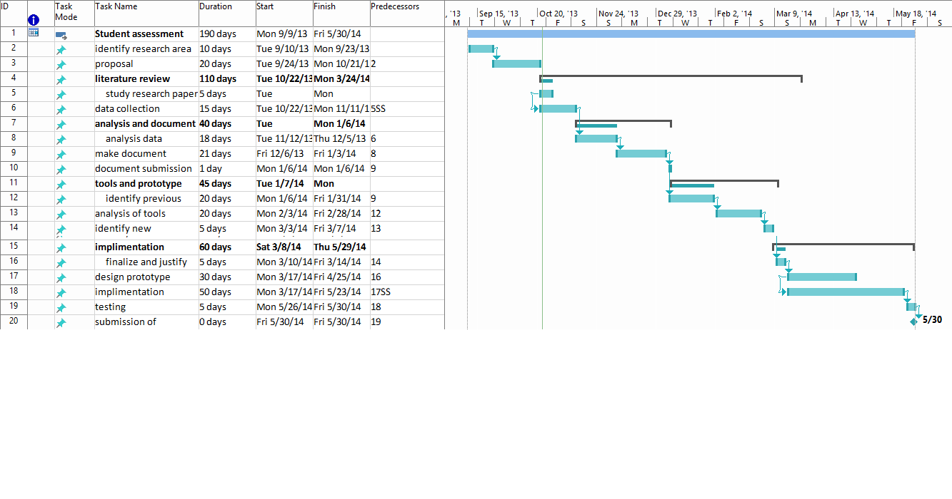

# References

1. Boyle, C. & Topping, K. J. (Eds.) (2012). What works in inclusion? New York & Maidenhead: Open University Press.
2. Active Learning Strategies in Face-to-Face Courses. Barbara J. Millis The University of Texas at San Antonio.
3. Charles C. Bonwell, Ph.D. Active Learning Workshops.