**Perinatal Intensive Care Nursing Program**

**Perinatal Nursing**

### Exam I

**ANSWER COPY**



**Instructions:**

1. Choose the best possible answer for the multiple choice questions.

1. Carefully read the short answer questions. Unless otherwise instructed, you may use point form written answers, but ensure that all pertinent information and explanations are included in your answer.

# Date: ______________________________________

**Name: _______________________________________**

## Student ID: _________________________________

**Phone Number: ________________________________**

1. A level I hospital care centre has the capacity to

a. perform neonatal surgery

b. provide amniocentesis testing

c. monitor a ventilated, 30 weeks gestation neonate

d. provide care for an acutely ill newborn prior to transport to an appropriate facility

2. The Professional Standards, College of Nurses of Ontario (CNO) 2009, provides

a. protective coverage for nursing practice

b. a framework including practice standards and guidelines for nursing practice

c. legal assistance for nurses in the case of malpractice

d. defines the roles and responsibilities of all health care practitioners

3. Bioethics

a. examines the study of self-governance and non‑interference

b. argues the notion that a person gets what he/she deserves

c. clearly defines rules by which to avoid inflicting harm on others

1. is the study of moral issues surrounding the understanding of life
2. The Ethics Practice Standard for nurses published by the CNO in 2009 identified all of the following values as important to nursing care provision except:
3. client well-being
4. fiscal responsibility
5. maintaining commitments
6. privacy and confidentiality

5. If fertilization does not occur during the menstrual cycle

a. the corpus luteum degenerates and becomes the corpus albicans

b. mittelschmerz or mid-cycle pain occurs

c. estrogen and progesterone rapidly increase

d. the pituitary gland stops producing human chorionic gonadotropin

6. Prolactin

a. stimulates uterine contractions

b. is also known as the let-down reflex

c. stimulates milk production

d. is produced within the lactiferous or “milk” ducts

7. Acceptance is a recognized psychological task of pregnancy. Feelings of ambivalence about the pregnancy can be anticipated and expected in:

a. a planned pregnancy

b. an unplanned adolescent pregnancy

c. a pregnancy after years of infertility treatments

d. all of the above situations

8. Ms. Rosario and her partner are worried their relationship with their premature son will be permanently disrupted as he is acutely ill in the NICU and unable to tolerate more than minimal handling. Your teaching will include the following

a. their son’s survival is more important than worrying about how to hold him

b. premature newborns are not developmentally ready for much human interaction

1. attachment is a reciprocal process that takes place over a long period of time

d. the opportunity to bond at birth has been missed but counseling can occur during the years of follow-up clinic visits

9. Circulating maternal blood volume increases during pregnancy:

1. by 40% to 50%
2. by less than 10%
3. to meet the need for increased maternal glomerular filtration rate
4. increases the risk of postpartum complications for the woman with an existing cardiac pathology

a. 2

b. 1 and 3

c. 2, 3 and 4

d. 1, 3 and 4

10. A "physiologic anemia" occurs during pregnancy because of an

a. increase in plasma volume which dilutes the red blood cell concentration

b. increase in plasma volume and a decreased number of red blood cells

c. unchanged plasma volume and a decreased number of red blood cells

d. decrease in plasma volume and a decreased number of red blood cells

11. Theories explaining the cause of uterine labour contractions include

1. placental aging

2. a decrease in fetal adrenal gland function

3. an increase in uterine distension

4. cervical ripening

a. 1 and 3

b. 3 and 4

c. 1, 3 and 4

d. all of the above

12. The station of the fetus in utero refers to

a. the widest diameter of the presenting part passing through the pelvic inlet

b. the relationship of the long axis of the fetus to the long axis of the mother

c. the part of the fetus that lies nearest the cervix

d. none of the above

13. Ms. Bortsov is a Gravida III, Para II. Which of the following best explains this statement?

a. She has just given birth to her third child

b. She is pregnant for the third time, and has had two other viable pregnancies

c. She is pregnant for the second time, and has had three other pregnancies

d. She is pregnant for the third time, and has had three other pregnancies

14. Baby girl Eligia's position upon delivery was ROA. This means

1. her sacrum faced to the front and right of the pelvis

2. her occiput faced to the front and right of the pelvis

3. is a common presentation at delivery

1. may lead to increased labour pain

a. 1 and 3

b. 2 and 4

c. 2 and 3

d. none of the above

15. Ms. Khan had a prolonged second stage of labour. The second stage

a. involves cervical dilation up to 7 cm

b. consists of contractions 10 minutes apart

c. begins with complete cervical dilation and ends with the birth

d. begins after the birth and ends with the expulsion of the placenta

16. Clomiphene (Clomid)

1. stimulates the ovaries directly to induce ovulation

2. enhances the hypothalamic‑pituitary stimulation of the ovaries

3. increases the risk of developing ovarian cysts

4. is given by injections

a. 2 and 3

b. 1 and 3

c. 2 and 4

d. 1, 3 and 4

17. Which of the following represents the greatest risk for female infertility?

a being 5% under or over an ideal body weight

b. delaying childbearing until after age 35

c. early onset of puberty and menarche, before age 13

d. using safer sexual practices to avoid sexually transmitted infections

18. Ms. Benito is about to undergo in vitro fertilization. She asks you for a review of the information her doctor has given her. Your explanation would include that

a. semen is deposited at the cervical os

b. the fertilized eggs are allowed to grow in the lab for 24 hours

c. a drug such as Pergonal will be given prior to the procedure to induce ovulation

d. a fertilized ovum is removed from her body and allowed to be grown in the lab for 48 hours

19. Culturally sensitive family centered care includes

a. restricting family rituals and cultural behaviours

b. acquiring the skills necessary to care for families from various cultures

c. educating others on acceptable childbirth practices and beliefs

d. recognizing that cultural practices should be limited to activities within the home

20. Sexual intercourse would be contraindicated for a pregnant woman and her partner if

1. she is bleeding vaginally

2. she has a current vaginal infection

3. she had a past spontaneous abortion

4. the amniotic membranes have ruptured

a. 4 only

b. 1 and 3

c. 1, 2 and 3

d. 1, 2 and 4

21. A pregnant woman will be offered

a. amniocentesis as part of routine screening

b. blood tests only to screen for Trisomy 21

c. prenatal genetic investigations dependent on gestational age at first prenatal visit

d. none of the above

22. The most common site for an ectopic pregnancy to occur is

a. within a fallopian tube

b. within an ovary

c. within the cervix

d. within the endometrium of the uterus

23. An ectopic pregnancy can mimic

a. appendicitis

b. placenta previa

c. endometriosis

d. abruptio placenta

24. A spontaneous abortion

a. is performed by a physician in an approved facility

b. may be indicated for fetal conditions (i.e. rubella)

c. occurs within the first 12 weeks of pregnancy

d. may be due to an abnormal genetic composition of the fetus

25. Ms. Greenberg is ten weeks pregnant and is complaining of vaginal bleeding and cramping. Upon examination her cervix is dilated. Her diagnosis is likely to be

a. threatened abortion

b. inevitable abortion

c. incomplete abortion

d. missed abortion

26. The embryonic ectoderm, mesoderm and endoderm combine to form the

a. trophoblast

b. notochordal process

c. embryonic disc

d. prochordal plate

27. The primitive streak is

1. the structure around which the vertebral column forms

2. the cellular rod that develops from the notochordal process

3. a thickened band of embryonic epiblast

4. a structure which diminishes and disappears

a. 1 and 2

b. 2 and 3

c. 3 and 4

d. all of the above

28. Organogenesis

a. is the development during the fetal period

b. refers to the products of conception

c. refers to organ formation from week nine to term

d. refers to organ formation from day 15 to 56

29. The cardiovascular system of a developing embryo

a. begins to develop in the first three weeks of pregnancy

b. is necessary to provide blood flow to the placenta

c. has distinct heart beats by day 20

d. none of the above

30. The truncus arteriosus

a. is the opening between the pulmonary artery and the aorta

b. divides into the pulmonary artery and the aorta

c. eventually develops into the fetal foramen ovale

d. separates the atrium and the ventricle in the primitive heart

31. In fetal circulation, approximately 90% of blood in the right ventricle flows through the pulmonary trunk and then through the

1. ductus venosus
2. ductus arteriosus
3. pulmonary arteries to the lungs
4. pulmonary veins to the lungs

32. The ductus venosus is a fetal circulatory structure located between the

1. pulmonary trunk and the pulmonary veins
2. umbilical artery and the portal vein
3. umbilical vein and inferior vena cava
4. pulmonary artery and descending aorta

33. In utero, fetal blood circulation follows the path of least resistance through unique fetal circulatory structures. Understanding that blood flows from an area of higher pressure to lower pressure explains why a greater percentage of fetal blood flows more easily from

1. the right atrium to the left atrium through the foramen ovale
2. the left atrium to the right atrium through the crista dividens
3. pulmonary arteries to the low pressure lung vasculature
4. pulmonary trunk through the ductus arteriosus
5. 1 only
6. 1, 4
7. 2, 3
8. 2, 4
9. 1, 3, 4

34. If the muscular sphincter controlling the blood flow through the ductus venosus is relaxed, more blood flows to the

1. portal vein
2. inferior vena cava
3. descending aorta
4. umbilical arteries

35. At birth, the first breath causes

1. the pulmonary vascular resistance to increase

2. the pulmonary vascular resistance to decrease

3. the blood pressure to increase in the inferior vena cava

4. the pressure in the left atrium to be greater than in the right atrium

a. 1 and 3

b. 2 and 4

c. 3 and 4

d. 2, 3, and 4

36. The neural tube

a. differentiates into the peripheral nervous system

b. gives rise to the axial skeleton

c closes first in the thoracic region

d. gives rise to a teratoma if remnants persist

37. The blood brain barrier in infants

1. has a decreased permeability
2. is made up of the protein myelin
3. is necessary for the conduction velocity of the axon
4. allows an increased penetration of certain substances into the brain

38. The laryngo-tracheal tube gives rise to the

1. larynx

2. trachea

3. lungs

4. esophagus

a. 3 only

b. 1 and 2

c. 1, 2 and 3

d. all of the above

39. The methyl‑transferase pathway of surfactant synthesis is present at approximately

a. 23 weeks

b. 30 weeks

c. 35 weeks

d. 40 weeks

40. Surfactant supports the work of breathing by

a. equalizing alveolar surface tension

b. decreasing pulmonary vascular tension

c. increasing alveolar surface tension with exhalation

d. decreasing alveolar surface tension during exhalation

41. Baby Singh is 28 weeks gestation, and therefore his lung development period is

a. alveolar

b. canalicular

c. terminal sac

d. pseudoglandular

42. The sequence of the intestinal movements of the embryonic midgut are

a. herniation, return, and fixation

b. elongation, rotation, and return

c. projection, flexion, and fixation

d. descent, protrusion, and rotation

43. The cloaca in the embryo

1. is a primitive structure which gives rise to the uterus

2. is divided by a urorectal septum

3. is a chamber in which fecal and urinary elements collect

4. is an extension of the hindgut

a. 2 only

b. 1, 2 and 4

c. 2, 3 and 4

d. all of the above

44. Baby boy Addis has an omphalocele. This

a. is a twisting of the intestines

b. does not involve the umbilical cord

c. is an appendage of the ileum

d. results from failure of the intestines to return to the abdomen in utero

45. Characteristics of the renal system in the neonate include

1. an increased glomerular filtration rate

2. a limited ability to excrete hydrogen ions

3. an inability to concentrate urine

4. an increased urea clearance

a. 1 and 3

b. 2 and 3

c. 1, 2 and 4

d. all of the above

46. Baby Yani has hypospadius. You explain to his mother that this occurs when

* 1. the urethra opens on the ventral surface of the penis
  2. the bladder protrudes through the abdominal wall
  3. the urethra opens on the dorsal surface of the penis
  4. one or both kidneys are abnormally positioned

47. The neonatal skeletal system includes

a. somites

b. mostly cartilaginous bones

c. fully fused and ossified bones

d. a small skull in relation to the remainder of the skeleton

48. Ms. Lexon asks why she requires a full bladder prior to a fetal ultrasound exam. You explain that it is necessary

* 1. to locate the placenta
  2. to avoid the transducer hitting the fetus
  3. in order to displace the uterus from the pelvis
  4. to enhance the sound waves and improve image quality

49. Mrs. Chang has had a fetal ultrasound at 15 weeks and she asks you what the doctor meant by "biparietal diameter". You respond:

a. It is a measurement of the fetal skull, used only during the first trimester

b. It is a calculation of fetal size, utilizing the femur length and abdominal girth

c. It is the length from the top of the fetal head to the sacrum

d. It is the widest diameter of the fetal skull and correlates with gestational age

50. Reasons for an ultrasound during pregnancy include

1. to determine chromosomal composition

2. to determine placental grading

3. to aid in completion of an intrauterine transfusion

4. to identify non-uterine implantation

a. 1, 2 and 3

b. 1, 3 and 4

c. 2, 3 and 4

d. all of the above

51. Amniocentesis

1. detects fetal chromosomal and biochemical abnormalities.

2. is performed only on pregnant women over 35 years of age

3. involves removing 50 ml. of amniotic fluid

4. is performed at 8 to 10 weeks

a. 1 only

b. 1 and 2

c. 1, 2 and 3

d. all of the above

52. Complications of chorionic villi sampling include

1. rupture of membranes

2. spontaneous abortion

3. fetal/maternal infection

4. pregnancy induced hypertension

a. 1 and 2

b. 1 and 3

c. 1, 2 and 3

d. all of the above

53. Percutaneous umbilical blood sampling (PUBS)

a. is done at the cord fetal insertion site

b. is also known as cordocentesis

c. utilizes a cannula inserted through the cervix

d. is done at 6 to 8 weeks gestation

54. Factors that may result in decreased variability on a fetal heart rate tracing are

1. the influence of a maternal narcotic

2. maternal obesity

3. anencephaly

4. physiological sleep

a. 1, 3 and 4

b. 2, 3 and 4

c. 1, 2 and 3

d. all of the above

55. A fetal non-stress test is classified as normal when

a. the fetal heart rate accelerates with a uterine contraction

b. the fetal heart rate accelerates with movement

c. the fetal heart rate decelerates with a uterine contraction

d. the fetal heart rate decelerates with movement

56. A sinusoidal pattern on a fetal heart rate tracing usually indicates

a. fetal sleep

b. normal beat to beat variability

c. significant fetal distress

d. umbilical cord compression

57. Late decelerations on a fetal heart tracing are caused by

a. fetal sympathetic activity

b. mild transient hypoxia

c. fetal head compression

d. utero-placental insufficiency

58. Fetal tachycardia on a fetal heart tracing of your patient shows a

a. baseline fetal heart rate above 160 bpm for 10 minutes

b. baseline fetal heart rate above 180 bpm for 10 minutes

c. baseline fetal heart rate above 160 bpm for 15 minutes

d. baseline fetal heart rate above 180 bpm for 15 minutes

59. Ms. Anuradha is experiencing variable decelerations on the fetal heart tracing. These

1. are usually abrupt, with a sudden drop in the heart rate

2. may be corrected by providing oxygen to the mother

3. may be corrected by re-positioning the mother

4. occur at the peak of the contraction

a. 1 only

b. 1, 2 and 3

c. 1 and 4

d. all of the above

60. The Biophysical Profile as an assessment of fetal wellbeing includes evaluation of the following parameters:

1. fetal tone
2. fetal breathing
3. fetal crown-rump length
4. amniotic fluid volume
5. 2, 4
6. 1, 2, 3
7. 1, 2, 4
8. 1, 3, 4

61. Maternal alcohol consumption can cause which of the following in the newborn?

1. cleft palate
2. hypoglycemia
3. respiratory depression
4. behavioral and learning difficulties

62. Maternal heroin consumption is associated with which of the following in the newborn?

1. symptoms of neonatal abstinence, usually within the first 24 hours of life
2. neural tube defects
3. congenital heart disease
4. lethargy and poor muscle tone

63. Maternal tobacco smoking can cause which of the following in the newborn?

1. yellow teeth
2. small for gestational age
3. severe withdrawal symptoms
4. lethargy and respiratory depression

64. A mother in labour who received an opioid, may deliver an infant with

1. increased tone
2. VACTERAL syndrome
3. fetal phenytoin syndrome
4. neonatal respiratory depression

65. Pregnancy Drug Risk Categories

1. include risk factors assigned to all ingested products
2. outline medications that are safe during breastfeeding
3. describe only animal studies that show risk to a developing fetus
4. are based on the level of risk that the drug poses to the fetus during pregnancy

66. Maternal rubella during the first trimester can cause effects on the fetus including

1. death

2. deafness

3. cataracts

4. congenital heart disease

a. 1 and 2

b. 2 and 3

c. 1, 2 and 3

d. all of the above

67. Ms. Burbank is pregnant and has a history of cardiac disease. Possible risks include

a. a decreased circulatory volume

b. a large for gestational age fetus

c. maternal heart failure

d. hyperemesis gravidarum

68. Intimate partner violence:

1. consists of physical abuse
2. primarily impacts maternal health
3. has a lower risk during pregnancy and higher risk in postpartum
4. crosses all ethnic, racial, religious, and socioeconomic levels

69. Which time period during pregnancy presents the highest risk period for domestic or intimate partner violence?

1. first trimester
2. second trimester
3. third trimester
4. postpartum

70. When a pregnant woman is involved in a traumatic event such as a car accident, the major risk to fetal well-being is related to:

1. placental abruption
2. direct fetal injury
3. seat belt related injuries
4. air bag deployment injuries

71. A common cause of non-lethal traumatic injury during pregnancy is from

1. accidental falls
2. self-inflicted injuries
3. sports activity related trauma
4. domestic or intimate partner violence

72. Cytomegalovirus (CMV) is present in

1. tears
2. cat feces
3. breastmilk
4. cervical secretions
5. 2 only
6. 2, 4
7. 1, 3, 4
8. 1, 2, 3, 4

73. It is important for all pregnant women to be tested for Hepatitis B. This is done by

1. a fecal sample for Hepatitis B
2. a cervical sample for Hepatitis B
3. a blood sample for the presence of the Hepatitis A surface antigen (HAsAg)
4. a blood sample for the presence of the Hepatitis B surface antigen (HBsAg)

74. Surveillance and testing for the Zika virus in pregnant women and women of child-bearing age has taken on international significance and action because

1. there is a high associated risk of fetal microcephaly
2. there is an urgent need to vaccinate this group
3. there is a high maternal morbidity and need for hospitalization if not treated early
4. the virus is mosquito-borne and rapidly spreading throughout warmer climate countries
5. 1, 2
6. 1, 4
7. 2, 3, 4
8. 1, 2, 3, 4

75. The effects of respiratory infections such as H1N1, SARS and MERS during pregnancy

1. are mostly maternal (respiratory) with little effect on the developing fetus

2. result in a significant increased morbidity and mortality for both mother and fetus

3. require watchful waiting and cautious use of antibiotics to avoid fetal teratogen effects

4. are severe enough for an SOGC recommendation to provide a maternal prescription for antiviral medication to be taken within 48 hrs. of the onset of symptoms

a. 1

b. 2

c. 1, 3

d. 2, 4

76. A woman with a pre-existing congenital heart defect or cardiac condition who is considering pregnancy may expect all of the following management strategies except

a. prophylactic antibiotics are avoided during labour

b. planning for the birth to be in a hospital providing level II or III care

c. counselling that notes pregnancy outcomes are generally positive if the defect has been corrected

d. counselling against pregnancy if an uncorrected defect includes episodes of cyanosis

77. Maternal cancer during pregnancy

1. may require a therapeutic abortion

2. often results in accelerated tumour growth

3. will be a contraindication for breast feeding

4. will often metastasize to the developing fetus

a. 1

b. 2, 3

c. 1, 2, 4

d. 2, 3, 4

78. The management of maternal cancer in pregnancy includes all of the following except

a. delaying the use of radiation until the third trimester or after the birth of the infant

b. surgical excision of the tumour, if possible, as the first option for treatment

c. administering chemotherapy in the second or third trimester in advanced cases

d. chemotherapy drugs are Category D or X and teratogenic and contraindicated until after the birth of the infant

79. Lupus erythematous in women

1. is characterized by skin and joint inflammation
2. may cause heart block in the mother or fetus
3. is an autosomal recessive disorder
4. is suppressed during pregnancy and postpartum

80. Predictors of post-partum mood disorders include

1. low self esteem

2. relationship discord

3. difficult infant temperament

4. planned pregnancy and family support

a. 3

b. 1, 2

c. 1, 2 and 3

1. all of the above

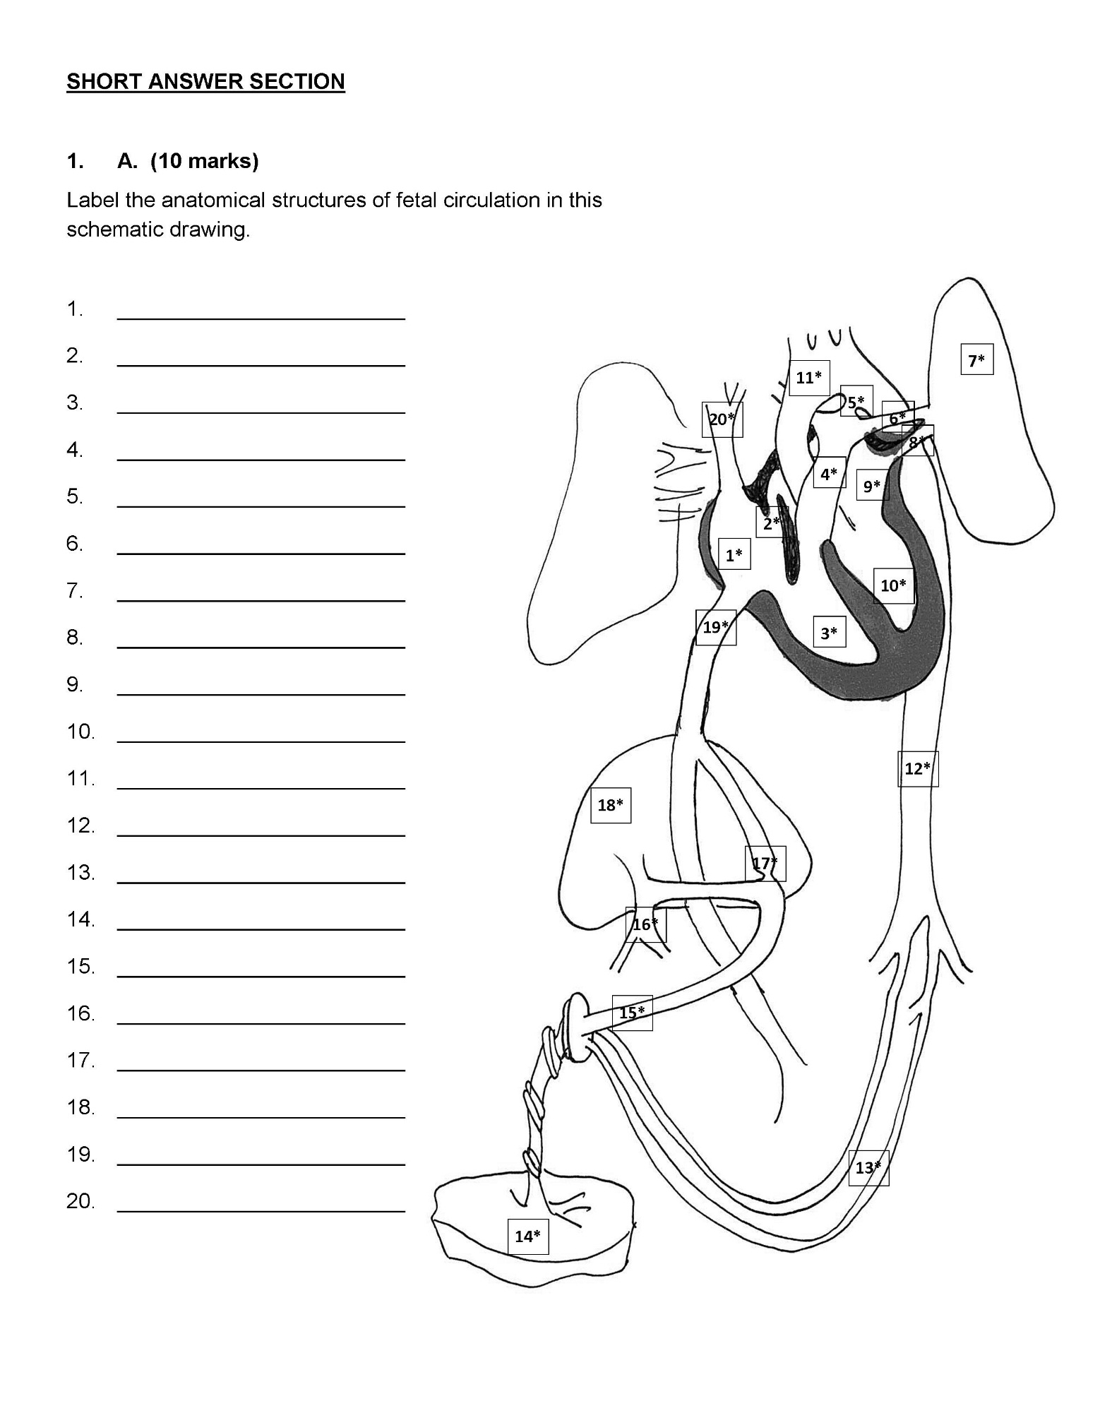

1. Right atrium
2. Foramen ovali
3. Right ventricle
4. Pulmonary artery/trunk
5. Patent ductus arteriosus
6. Pulmonary artery
7. Left lung
8. Pulmonary vein
9. Left atrium
10. Left ventricle
11. Aorta
12. Descending aorta
13. Umbilical arteries
14. Placenta
15. Umbilical vein
16. Portal vein
17. Ductus venosus
18. Liver
19. Inferior vena cava
20. Superior vena cava
21. Isabella LaMarche is a 17 year old G1 P0 woman whose fetus has an abdominal wall defect. You are the antenatal clinic nurse seeing Isabella during her routine prenatal appointment. Discuss physical, psychological, and social factors or issues that you might anticipate with Isabella’s pregnancy and include rational about why adolescents are considered high-risk obstetrical clients. **(10 marks)**

Physical

* Pelvis bony development not complete until early 20’s, therefore increased risk of cephalopelvic disproportion (CPD) leading to prolonged labour and increased risk of caesarian birth, interventions such as vacuum cap extraction, forceps, episitomy or vaginal/perineal lacerations
* Anemia secondary to inadequate iron intake or lack of adequate iron stores
* Nutrition – lack of knowledge or compliance with changing needs, increased needs may not be met contributing to inadequate or excessive weight gain complications
* Increased risk of hypertensive disorders of pregnancy

Psychological

* Developmental tasks of adolescence are interrupted by the demands of pregnancy and assumption of adult tasks in parenting
* Denial or lack of acceptance of reality of the pregnancy and the self-care requirements
* May not seek or have access to prenatal education
* May not have familial support
* Peer support is inadequate and tends to be transient when the realities and limitations of postpartum and parenting become everyday responsibilities
* Adolescence is often a time of challenging the status quo and experimenting with roles and risks: may have an increased risk of substance use – alcohol, tobacco, other drugs. This may place increased risk to mother and baby if it occurs before knowledge of pregnancy during the period of organogenesis development

Social

* Interruption to education
* Housing
* Support – peer and family support may be limited or at risk, especially if the pregnancy is associated with shame – culturally or religious beliefs
* Stigma in society and health care still exists
* Financial constraints and career challenges with pregnancy and child rearing responsibilities