PRACTISING

i = annual rate/number of times a year

n = number of per year x term in years

2. Each investment in the table below earns compound interest. Complete the table by filling in the blanks.

Write I as a decimal to five places, where appropriate.

|  |  |  |  |  |  |
| --- | --- | --- | --- | --- | --- |
| Principal  ($) | Time  (years) | Annual  Interest | Equivalent  Interest Rare, i | Number of  Compounding  Periods, n | Future Value ($) |
| 1. 400 | 15 | 5%  Compounded  annually | i = _____  = _______ %  = ________ | n = ___ x ____  = ______ | A = P (1 + i)n |
| 1. 750 | 5 | 13%  Compounded  Semi-annually | i = _____  = ______%  = ______ | n = ____ x ___  = _____ | A = P (1 + i)n  = ___ (_____)__  = _______ |
| 1. 350 | 8 | 2.45%  Compounded  monthly | i = _____  = ______ %  = _________ | n = ___ x ____  = _______ | A = P (1 + i)n  = ___ (___)___  = _______ |
| 1. 150 | 3 | 7.6%  Compounded  quarterly | i = ____  = ______ %  = _________ | n ___ x ____  = _______ | A = P (1 + i)n  = __ (____)___  = ______ |
| 1. 1000 | 4 | 4.75%  Compounded  daily | i = _____  = _____ %  = ________ | n = ____ x ___  = ________ | A = P (1 + i)n  = ___ (___)___  = _______ |

5. Joel invests $5000 in a compound interest account for 10 years. The account earns 14.6% per year compounded annually. How much will he have at the end of the term?

Use the given information to complete the timeline.

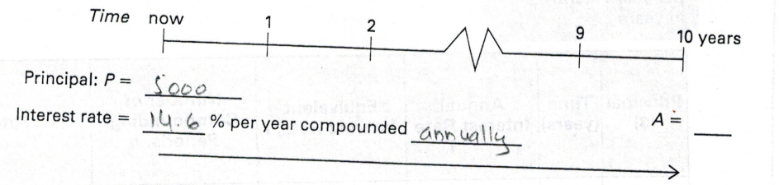

Calculate the equivalent interest rate and number of compounding periods. Start by filling in the blanks.

i = annual rate/number of times a year

= ________ %

= ________ %

= _______

N = number of compounding periods per year X term

= _______ X ______

= ______

Calculate the future value. Start by filling in the blanks.

A = P(1 + i)n

= _______________ (_______________)____

= ______________

Write a conclusion. How much will Joel have at the end of the term?

________________________________________

_________________________________________

Calculate the present value.

PV = R [ 1 – (1 + i)-n] /i

= ________________________

= _________________

Write a conclusion. How much does Mary need in her account now to pay for the textbooks?

___________________________________________

___________________________________________

8. Clair buys a snowboard and pays $35 at the end of each month for 1.5 years. The store charges 16% per year compounded monthly. What was the selling price of the snowboard?

Calculate the equivalent interest rate and the number of compounding periods. Start by filling in the blanks.

i = annual rate/number of times a year

= ________

= ________%

= ___________

n = number of compounding periods per year X term in years

= _______ X _____

= _______

PRACTISING

5. Mary is going to university in one year. She needs $750 a year for 3 years to buy textbooks. Her bank account earns 4% per year compounded annually.

How much does she need in her account now to pay for the textbooks?

Calculate the equivalent interest rate and number of compounding periods. Start by filling in the blanks.

i = annual rate/ number of times a year

= ________

= ________%

= _______

Use the given information to complete the timeline.

Interest rate = ________ % per year compounded ___________

= __________

Time now 1 2 3 years

Payment: R = ______ ______ ________

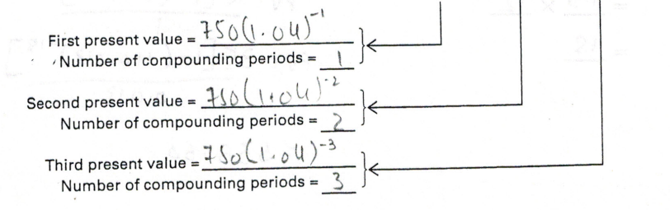

Lesson 8.6: Regular Annuities: Determining Present Value