Front End Website System Architecture

We have a two-layer system:
- Canvas Layer (Backend/Processing): Converts JSON → C# Models
- Rendering Layer (Frontend/Website): Converts C# Models → HTML

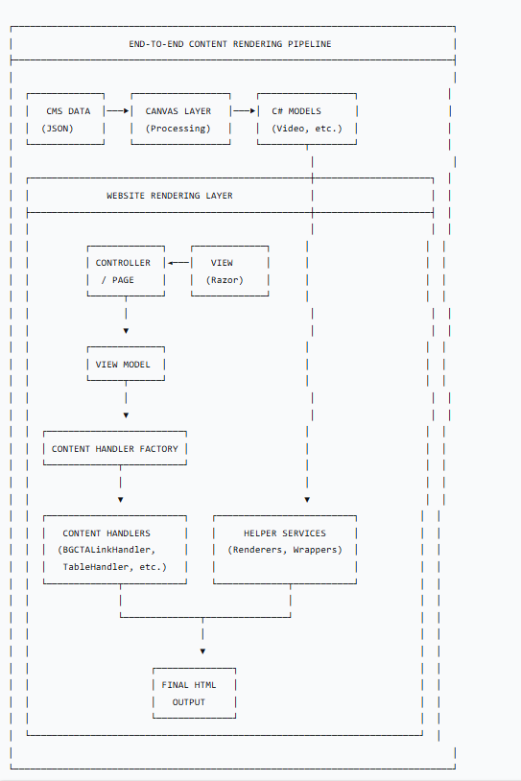

HOW THE TWO LAYERS CONNECT
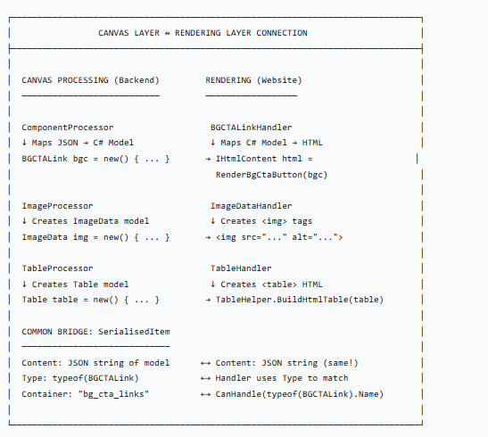

COMPLETE DATA FLOW WITH CODE EXAMPLES
Step 1: CMS Data to Canvas Processing
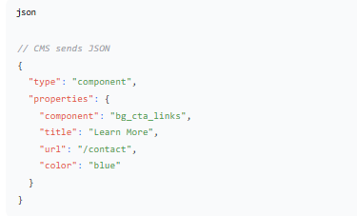

Step 2: Canvas Layer Processes It
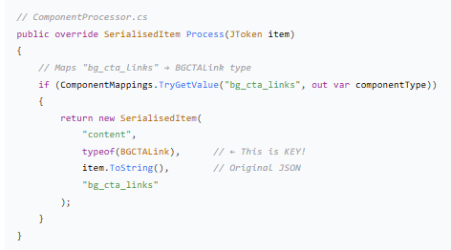

Step 3: Website Receives SerialisedItem

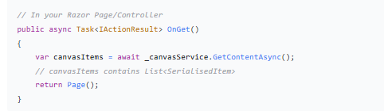

Step 4: Razor View Uses Handlers
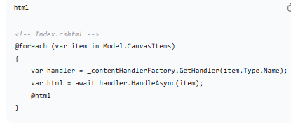

Step 5: Handler Factory Routes to Correct Handler
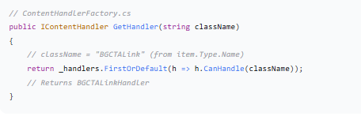
Step 6: Handler Renders HTML
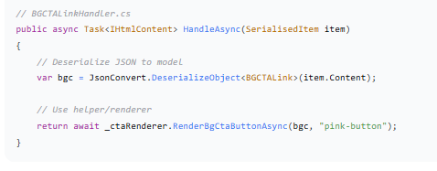
Step 7: Renderer Creates Final HTML
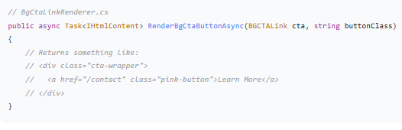

ARCHITECTURE PATTERNS IDENTIFIED
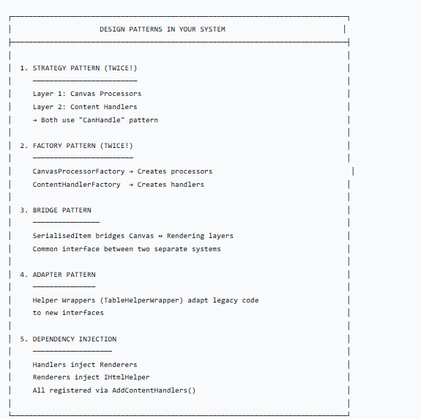

DIRECTORY STRUCTURE MAPPING
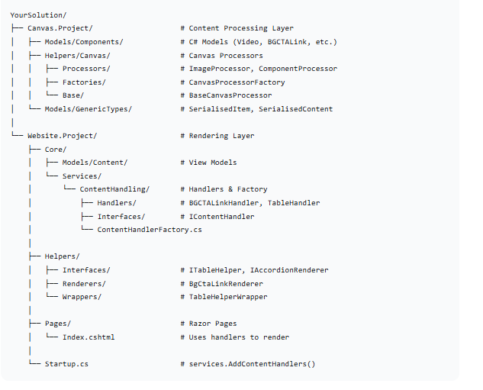

KEY CONNECTION POINTS
1. Type Name Matching
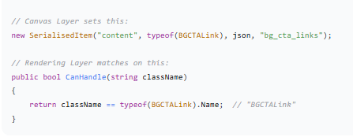

2. JSON Serialization Bridge
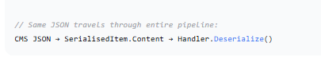
3. Dependency Injection Setup
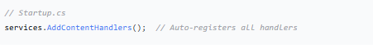
4. Handler Registration Flow
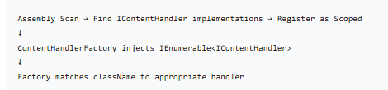

ADDING A NEW CONTENT TYPE (COMPLETE EXAMPLE)
Step 1: Add Model to Canvas Layer
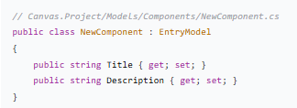
Step 2: Add to ComponentProcessor Mappings
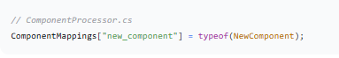

Step 3: Create Handler in Website
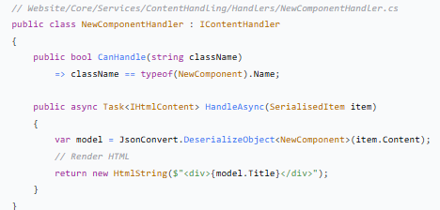

Step 4: (Optional) Create Helper/Renderer
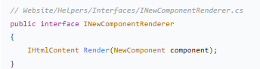

That's it! The system automatically:
- Processes CMS JSON into NewComponent model
- Routes to NewComponentHandler via factory
- Renders HTML without changing any existing code

PERFORMANCE & BEST PRACTICES
- Caching: Consider caching SerialisedItem results
- Async: Your handlers are async-ready for I/O operations
- Error Handling: Good error handling in handlers
- Scoped Lifetime: Handlers are scoped (good for per-request state)
- Separation: Clear separation between processing and rendering

SUMMARY
The system is architected with:
- Clear Separation: Canvas (backend processing) vs Website (frontend rendering)
- Extensible: Add new content types without touching existing code
- Type-Safe: Strong typing throughout the pipeline
- Testable: Handlers and processors can be unit tested independently
- Maintainable: Each component has a single responsibility

