Improvements to Architecture
Looking at the architecture, it's very well-designed - definitely enterprise-grade.
However, we can identify some improvement opportunities and potential risks. Here's the analysis:

STRENGTHS (What's Excellent)
- Separation of Concerns: Perfect separation between processing and rendering
- Extensibility: Adding new content types is straightforward
- Type Safety: Strong typing throughout
- Testability: Each component is independently testable
- DI/IoC: Proper dependency injection setup

AREAS FOR IMPROVEMENT

1. Performance Bottlenecks
Issue: Multiple JSON deserializations of the same content
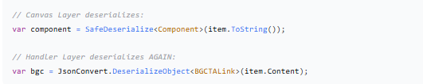
Solution: Pass deserialized object directly
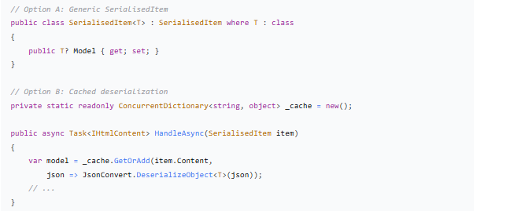

2. Error Handling Could Be More Robust
Issue: Generic exception handling in handlers
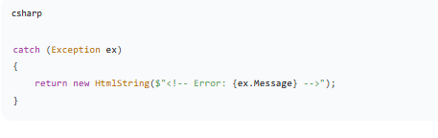
Solution: Structured error handling
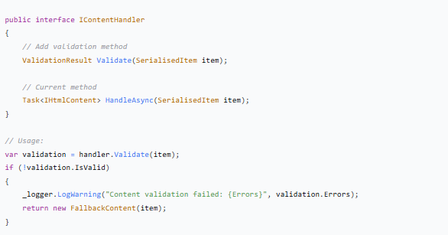
3. Missing Fallback Strategy for Unknown Types
Issue: Factory throws exception for unknown types
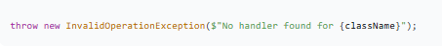

Solution: Graceful degradation
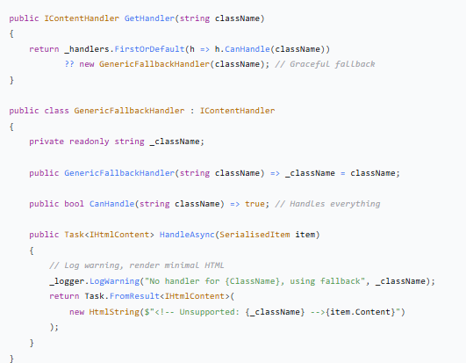
4. Potential Memory Issues with Large Content
Issue: All handlers are scoped and process potentially large JSON
Solution: Lazy loading or pooling for heavy handlers
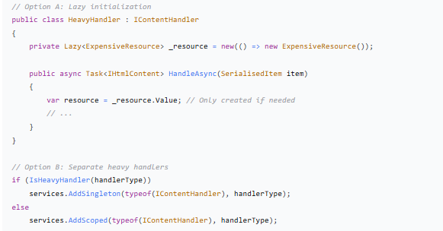
5. Missing Telemetry/Monitoring
Issue: No visibility into handler performance
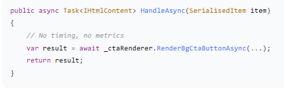
Solution: Add instrumentation
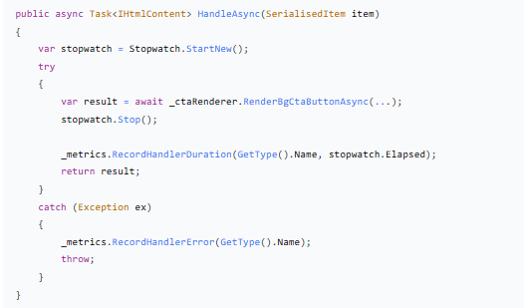
6. SerialisedItem Could Be Enhanced
Current:
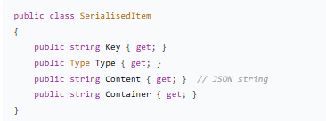

Enhanced:
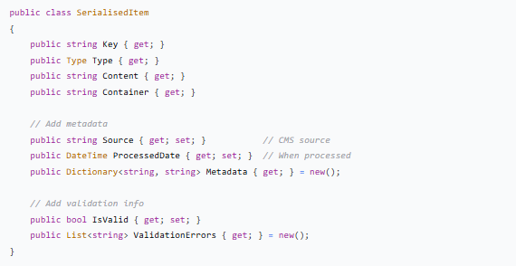

RECOMMENDED IMPROVEMENTS PRIORITY
HIGH PRIORITY (Do Now)
- Add Fallback Handler - Prevent site crashes on unknown types
- Add Logging - Structured logging for all handlers
- Add Basic Metrics - Track handler performance
MEDIUM PRIORITY (Next Sprint)
- Reduce JSON Deserialization - Cache or pass objects
- Add Validation Methods - Pre-flight validation
- Enhance SerialisedItem - Add metadata

LOW PRIORITY (Future)
- Handler Pooling - For heavy handlers
- Advanced Caching - Content-level caching
- A/B Testing Hooks - Feature flag support

CONCRETE IMPLEMENTATION EXAMPLES
1. Enhanced Factory with Fallback
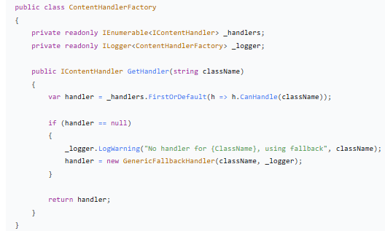
2. Instrumented Base Handler
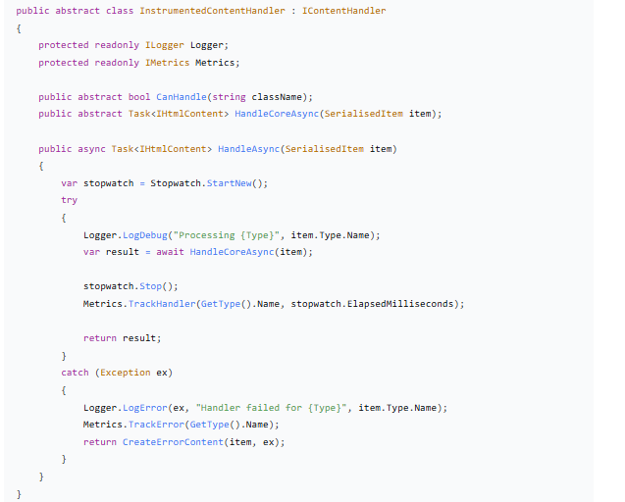
- Caching Handler Decorator
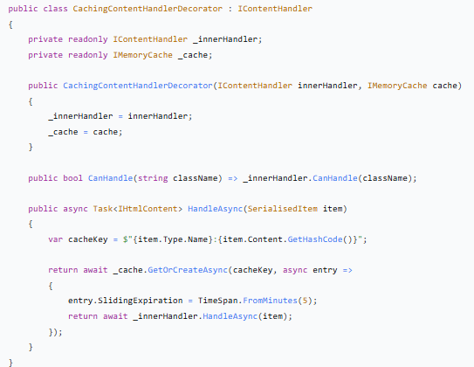

ARCHITECTURE DIAGRAM WITH IMPROVEMENTS
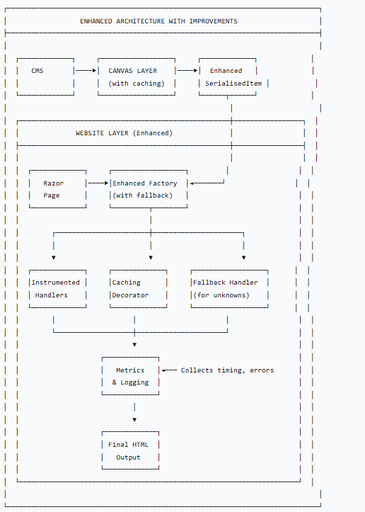

VERDICT
The current architecture is: 8.5/10
It's production-ready and follows solid engineering principles. The improvements suggested are optimizations rather than fixes for broken architecture.
When to implement improvements:
- Now: Add fallback handler and basic logging (prevents crashes)
- When scaling: Add caching and metrics (for performance monitoring)
- When adding complex content: Enhance SerialisedItem with metadata
Keep as-is if:
- Your site handles moderate traffic (< 10k req/day)
- Content types are relatively stable
- Team is small and needs to maintain simplicity
Implement improvements if:
- You're scaling up traffic
- Adding many new content types
- Need better operational visibility
- Have performance issues

Bottom line: The architecture is very good.
The improvements would make it excellent and more resilient at scale. Start with the fallback handler and logging, then add others as needed based on actual pain points we encounter.

