**Url:** <http://dah.xpanxion.co.in:9008/time-series>

**Environment** : QA

**Tile** : Time Series

**Observation 1:** User is able to view output (similar to) ‘Progress Bar’ under Results section when 'Enter No of Prediction' value is '0' / ‘100000’ / ‘jcshfhsfs@%^%^%&’ and Filters are kept as Default selected **OR** all Filters are selected **OR** No filters are selected

**Steps: (Refer TC – 8)**

1. Tap on section 'Enter No of Prediction' and add value as '0'

2. Keep Default selected Filters as is

3. Try to tap on button ' Submit' and verify the result

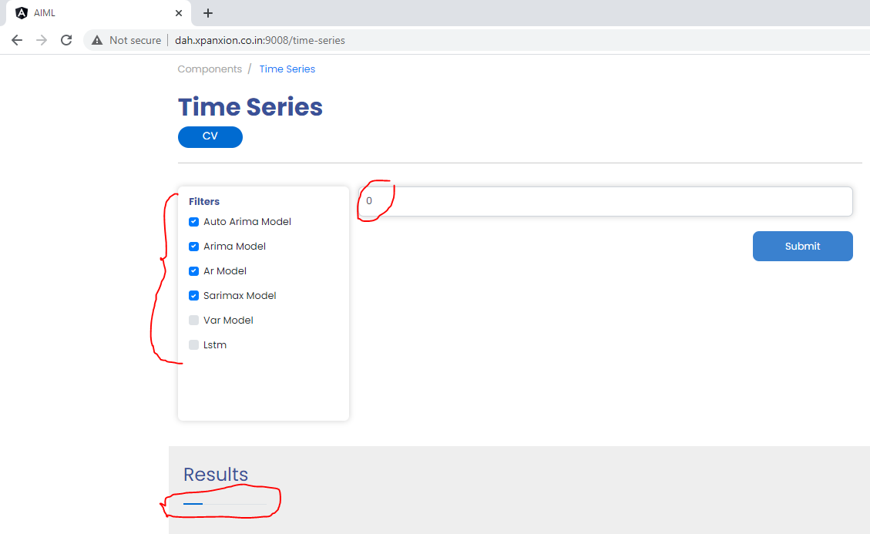

**Steps: (Refer TC – 17)**

1.keep focus/ pointer on Section 'Enter No of Prediction' and add value : 100000

2.Select All Filters

3.Try to tap on button ' Submit' and verify the result

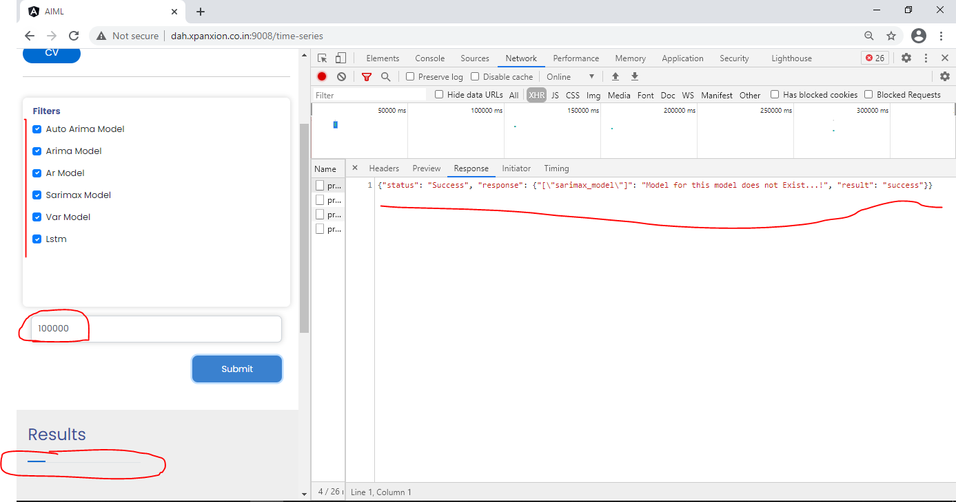

**Steps : (Refer TC – 18)**

1.keep focus/ pointer on Section 'Enter No of Prediction' and add value : jcshfhsfs@%^%^%&

2.Select All Filters

3.Try to tap on button ' Submit' and verify the result

**Note** : Observed incorrect sequence of models for Error displayed on Console (if compared with Web portal’s Model sequence)

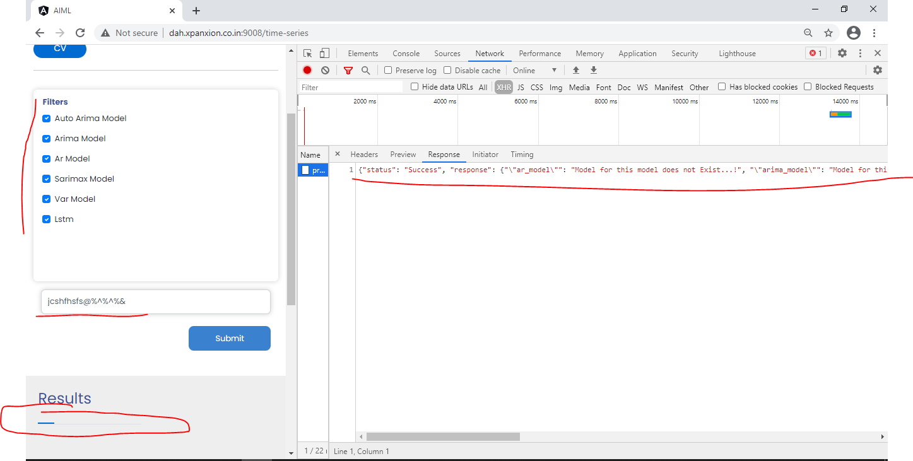

**Steps : (Refer TC – 19)**

1.keep focus/ pointer on Section 'Enter No of Prediction' and add value : < Only add Space>

2.Select all filters

3.Try to tap on button ' Submit' and verify the result

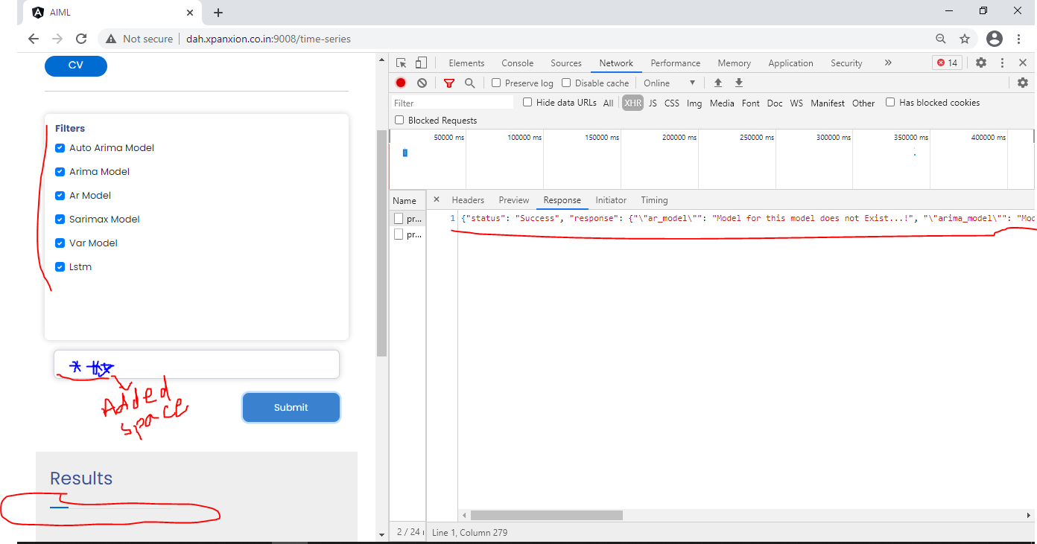

**Steps : (Refer – TC 20, 21,22)**

1.keep focus/ pointer on Section 'Enter No of Prediction' and add value : 100000

2.Do not select any filter option

3.Try to tap on button ' Submit' and verify the result

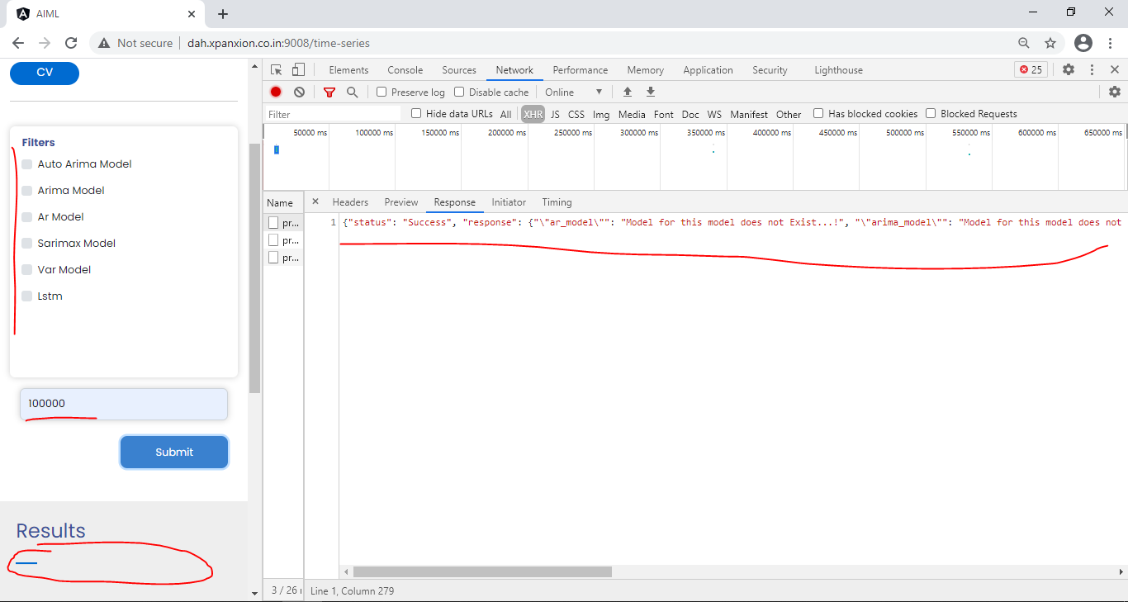

**Observation 2:** User is able to view Result as "Error: Parameter not Passed...!" as well as found discrepancy in the Error displayed on Console and Web Portal.

**Steps: (Refer TC – 6)**

1. Do not keep focus/ pointer on Section 'Enter No of Prediction'

2. Unchecked Default selected Filters

3. Try to tap on button ' Submit' and verify the result

**Steps: (Refer TC – 7)**

1. Keep focus/ pointer on Section 'Enter No of Prediction'

2. Unchecked Default selected Filters

3. Try to tap on button ' Submit' and verify the result

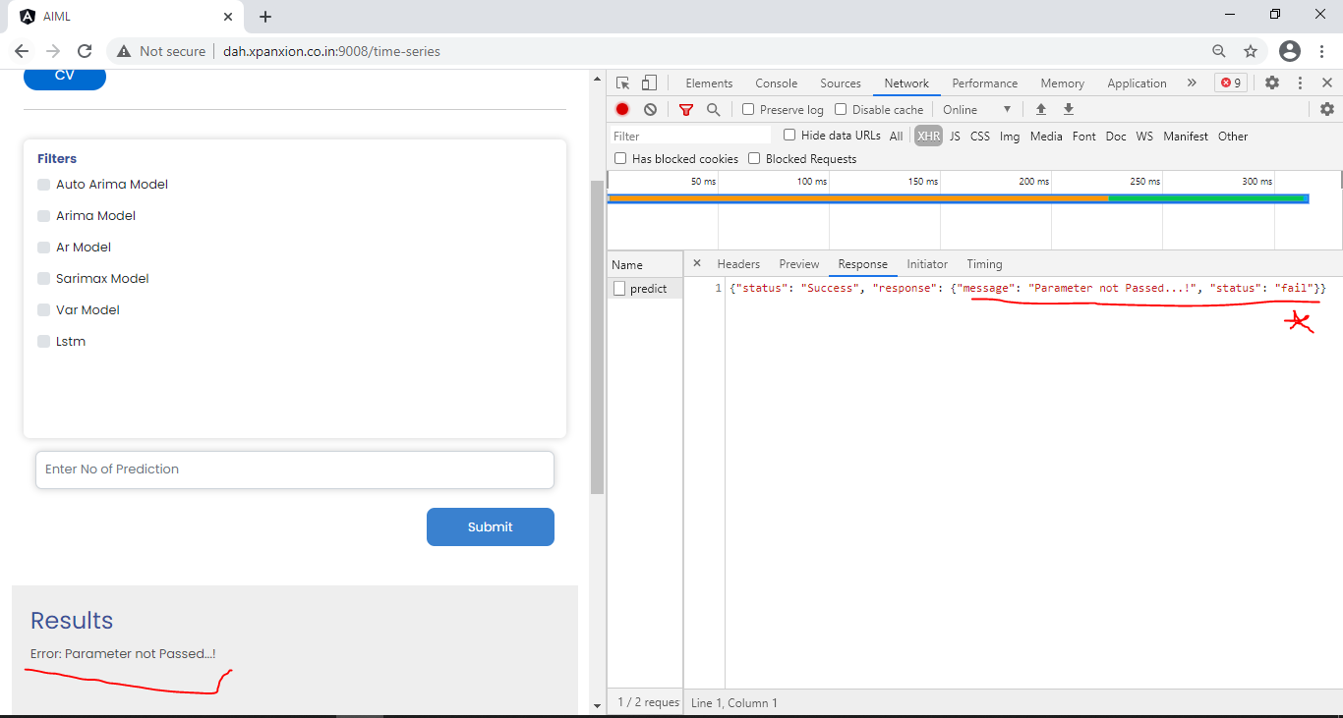

**Observation 3:** Found cosmetic discrepancy in ‘Placeholder’ and ‘Validation message’.

**Steps: (Refer TC – 5)**

1. Do not keep focus/ pointer on Section 'Enter No of Prediction'

2. Keep Default selected Filters as is

3. Try to tap on button ' Submit' and verify the result

**Actual Result :**



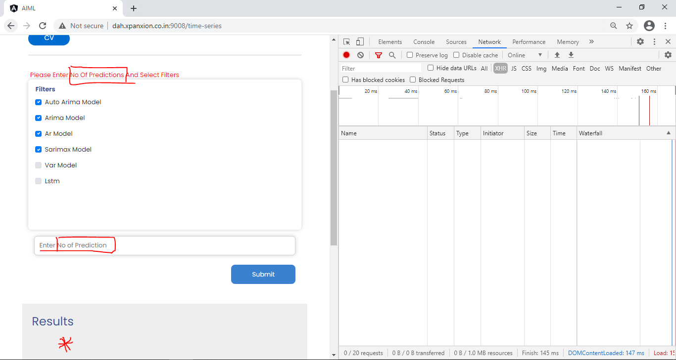

**Query :** Can we show the Validation message as part of ‘Results’ section as this is Blank? @Vijaya

**Observation 4** : Observed progress bar when selected Filter value : <Refer Steps> and 'Enter No of Prediction' : <Refer Steps>

**Note :** Same is observed when added value for prediction is : '100'/ 'hghgfdsda' / 'Days'

**Steps : (Refer TC-9)**

1. Tap on section 'Enter No of Prediction' and add value as '0'

2. Selected filter : 'Auto Arima Model'

3. Try to tap on button ' Submit' and verify the result

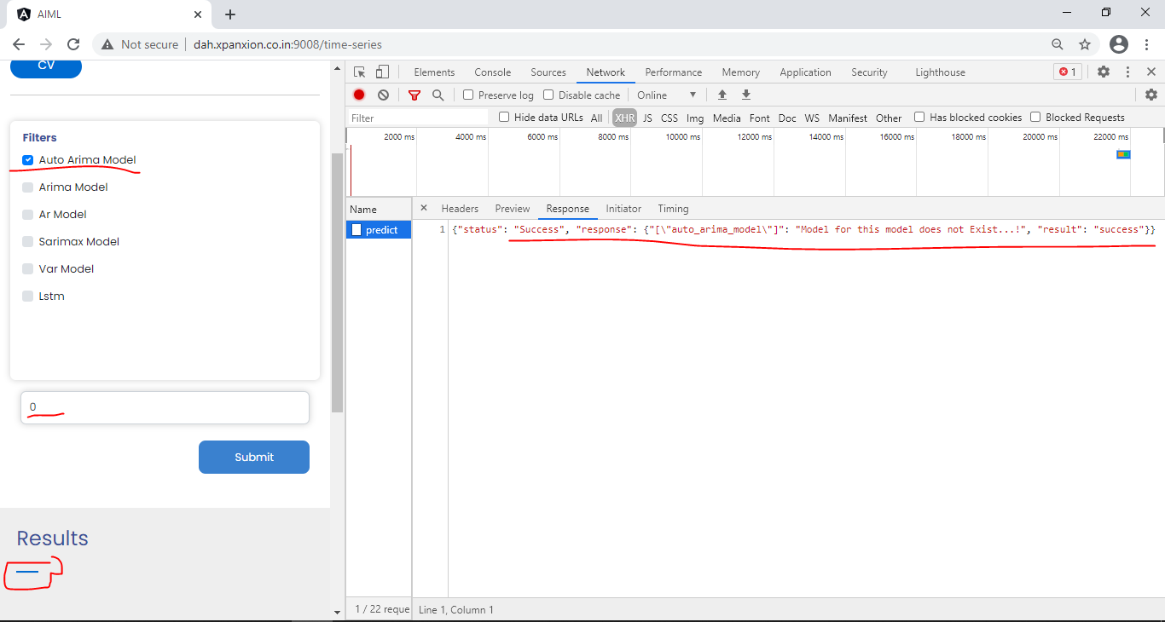

**Steps : (Refer TC – 10)**

1.Tap on section 'Enter No of Prediction' and add value as '0'

2.Selecte filter : 'Arima Model'

3.Try to tap on button ' Submit' and verify the result

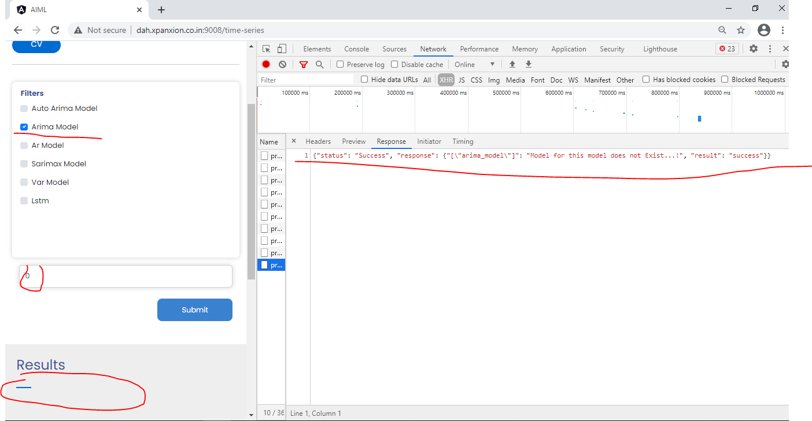

**Steps : (Refer TC -11)**

1.Tap on section 'Enter No of Prediction' and add value as '0'

2.Select filter : 'Ar Model'

3.Try to tap on button ' Submit' and verify the result

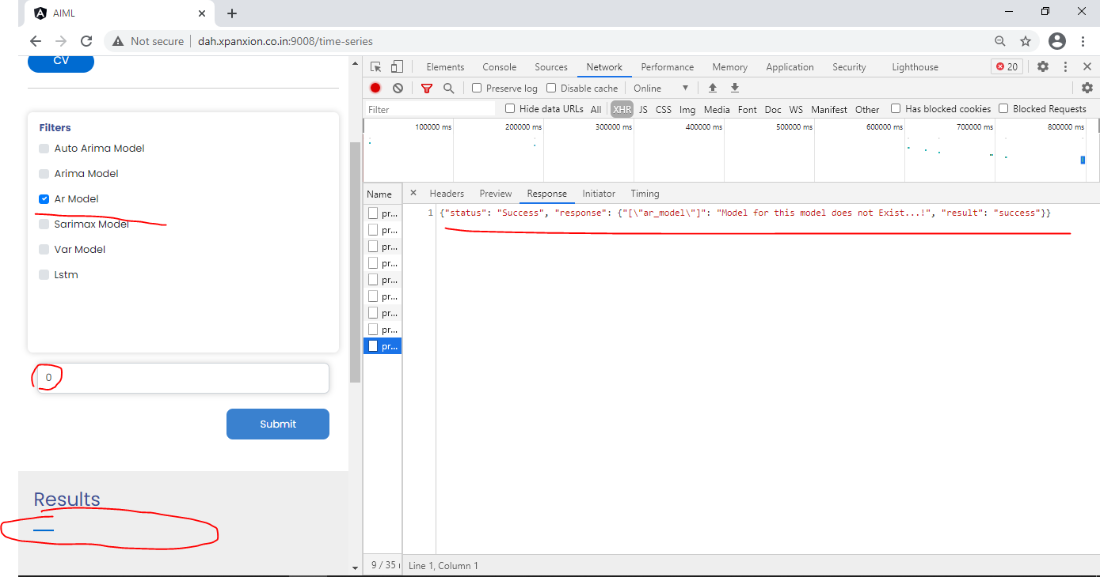

**Steps : (Refer TC -12)**

1.Tap on section 'Enter No of Prediction' and add value as '0'

2.Select filter : 'Sarimax Model'

3.Try to tap on button ' Submit' and verify the result

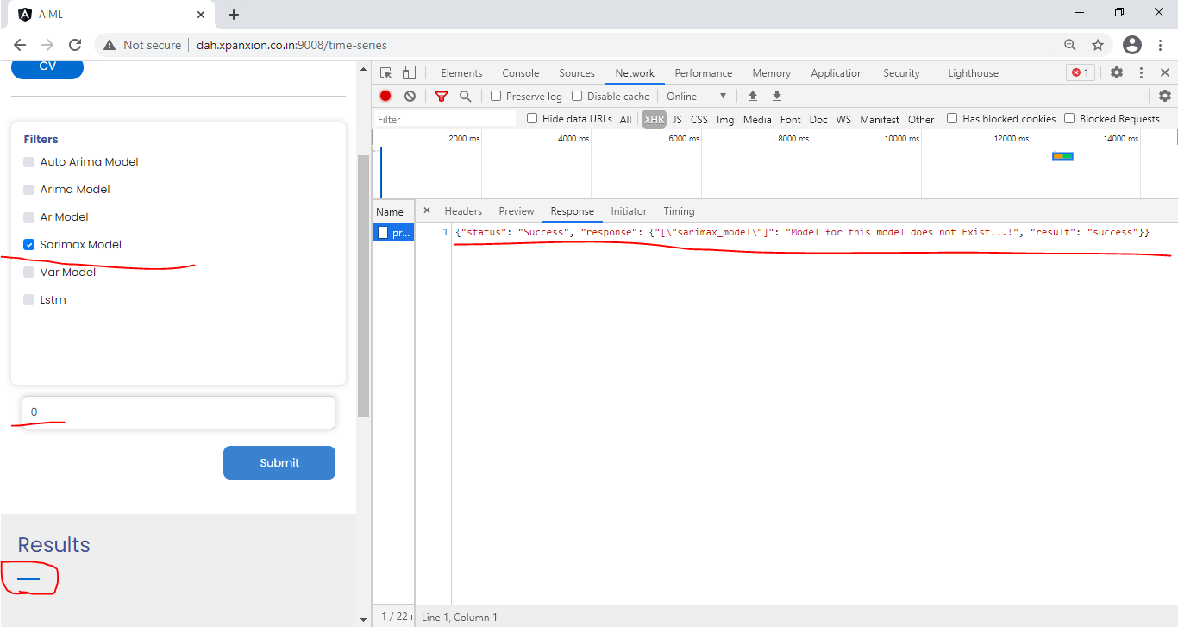

**Steps : (Refer TC -13)**

1.Tap on section 'Enter No of Prediction' and add value as '0'

2.Select filter : 'Var Model'

3.Try to tap on button ' Submit' and verify the result

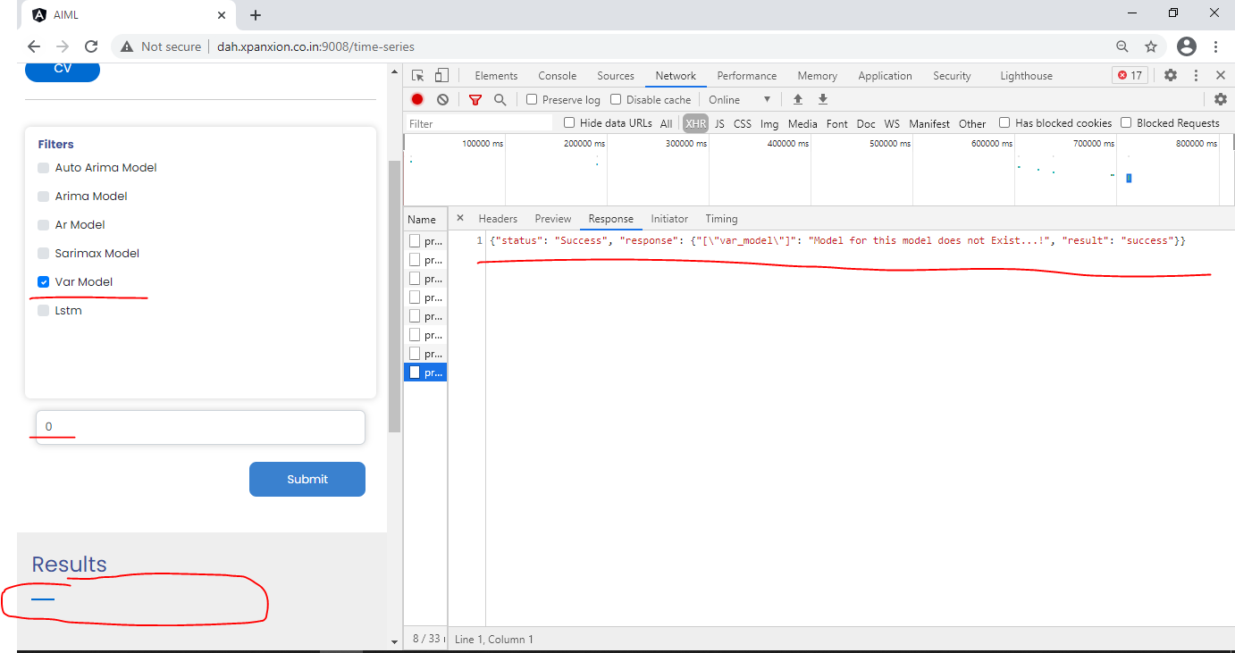

**Steps : (Refer TC -14)**

1.Tap on section 'Enter No of Prediction' and add value as '0'

2.Select filter : 'Lstm'

3.Try to tap on button ' Submit' and verify the result

