Forecasting German Electricity Load:
A Comparative Time Series Modelling Case Study
Mohammad Asif Syed
Student ID: 24060472

Abstract
This report forecasts German electricity load using hourly data from Open Power System Data (2015-2020), aggregated to daily and weekly resolution. Four benchmark models (Mean, Naive, Seasonal Naive, Drift), a SARIMA model selected via an AIC search over 147 (p,d,q) combinations, a SARIMAX model with Berlin temperature as an exogenous regressor, a recursively-forecasted Random Forest, and an hourly LSTM are fitted and evaluated on a two-year holdout period.
ADF and KPSS stationarity tests agree the weekly series is stationary in levels and after first-differencing but disagree after seasonal differencing. The AIC-selected SARIMA order (2,2,6) with seasonal order (1,1,1,52) achieves the best in-sample fit of all combinations tested (AIC = 1482.27) but the worst test-set RMSE (9,470.26) of all eight models — worse than every benchmark, including Drift. This is attributed to overfitting, supported by a near-singular parameter covariance matrix in the fitted model. Adding temperature (SARIMAX) improves slightly on SARIMA (RMSE 8,883.05), but the temperature coefficient is not statistically significant (p = 0.176). The Random Forest (RMSE 3,048.74) performs almost identically to Seasonal Naive (RMSE 3,006.76), relying overwhelmingly on the 52-week lag feature. The LSTM achieves the lowest RMSE (1,797.31), but as a one-step-ahead forecast rather than the 104-week-ahead task the other models solve, making it not directly comparable.
These results motivate a critical re-examination of AIC-based model selection without out-of-sample validation and specific recommendations for improving the SARIMA specification and cross-model comparability.

1. Introduction
Electricity demand forecasting plays a critical role in how power grids are managed. Grid operators need to know how much electricity people will use in the coming days, weeks, or years so they can plan how much power to generate, when to schedule maintenance, and how to keep supply and demand balanced. This is becoming more important in Germany, where a growing share of electricity now comes from renewable sources like wind and solar, which depend on weather conditions rather than being available on demand at all times. Accurate demand forecasts help balance this more variable supply.
This report investigates how well different time series forecasting methods can predict German electricity load using real historical data. The dataset comes from Open Power System Data (OPSD) and covers hourly electricity load across Germany from January 2015 to October 2020. The data is cleaned and aggregated into daily and weekly averages, then explored to understand its underlying patterns, such as trend and seasonality, before any forecasting is attempted.
Six different forecasting approaches are built and compared, ranging from very simple to more advanced:
- Benchmark models — Mean, Naive, Seasonal Naive, and Drift forecasts, which serve as a simple baseline that any more complex model should be expected to beat.
- SARIMA — a statistical time series model that accounts for seasonal patterns, with its settings chosen automatically by testing 147 different combinations and selecting the one with the best statistical fit.
- SARIMAX — the same type of model as SARIMA, but with Berlin temperature added as an extra input, since colder or warmer weather affects how much electricity people use (for heating or cooling).
- Random Forest — a machine learning model that learns patterns from past load values, temperature, and calendar information (such as the month or week of the year) to make predictions.
- LSTM — a type of neural network well suited to sequential data, trained directly on the hourly load values.
Every model is tested on the same two-year period of unseen data, so their accuracy can be fairly compared using standard error measures (RMSE, MAE, and MAPE).
Beyond simply reporting which model scored best, this report places strong emphasis on explaining why each model performed the way it did. One especially important and somewhat surprising result runs throughout the analysis: the SARIMA model that was mathematically selected as the "best fit" during model selection actually performed the worst when tested on real, unseen data. This report examines that finding in detail, as it highlights an important and commonly misunderstood lesson in forecasting — that a model which fits historical data extremely well does not always predict the future accurately.

2. Data Description and Exploratory Analysis

2.1 Data sources and preparation
The primary series is Germany's actual load (DE_load_actual_entsoe_transparency) from the OPSD 60-minute file, filtered to 1 Jan 2015 - 6 Oct 2020 (50,400 hourly rows), resampled to daily (2,100 rows) and weekly (301 rows) means - kept on a consistent average-MW scale throughout. Berlin temperature, used as a national proxy, is retrieved from the Open-Meteo archive API and aggregated to a weekly mean; all 301 weeks matched successfully.

2.2 Initial plots
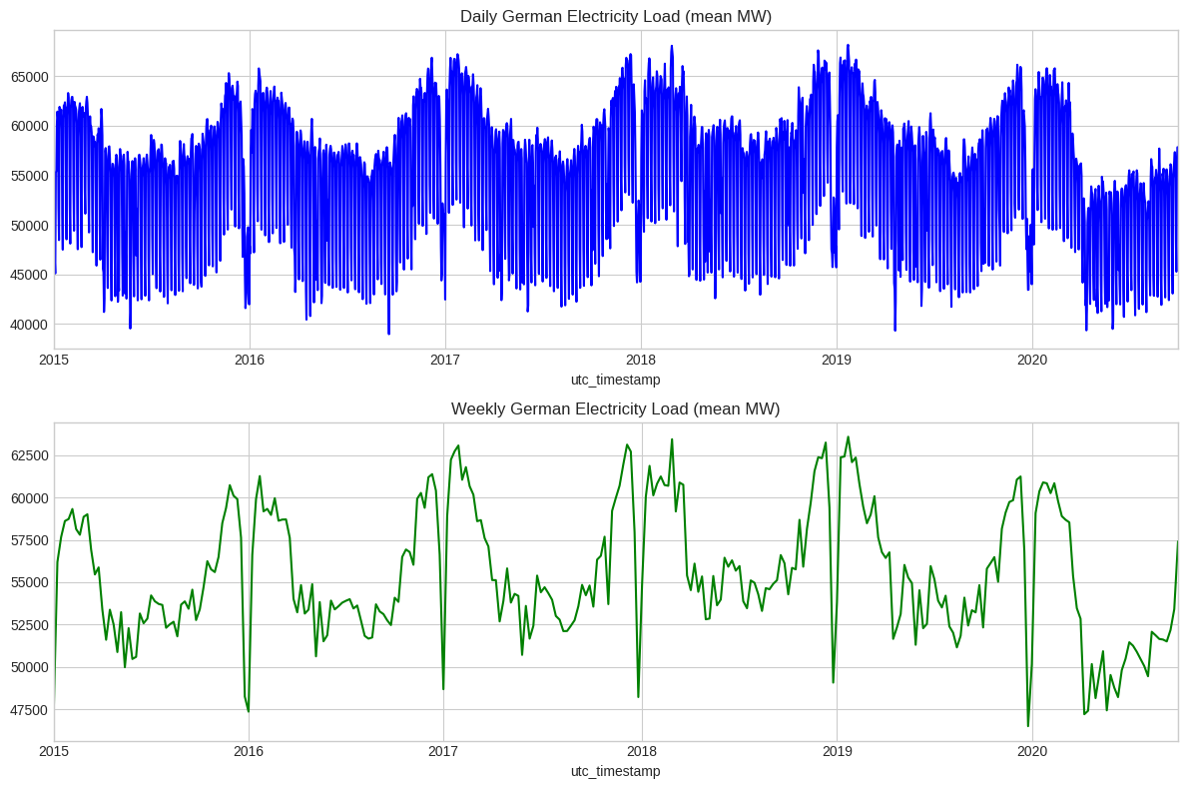
Both series show a clear annual pattern and a modest downward drift, with a visible additional step down through 2020 consistent with COVID-19 demand suppression.

2.3 Seasonal decomposition
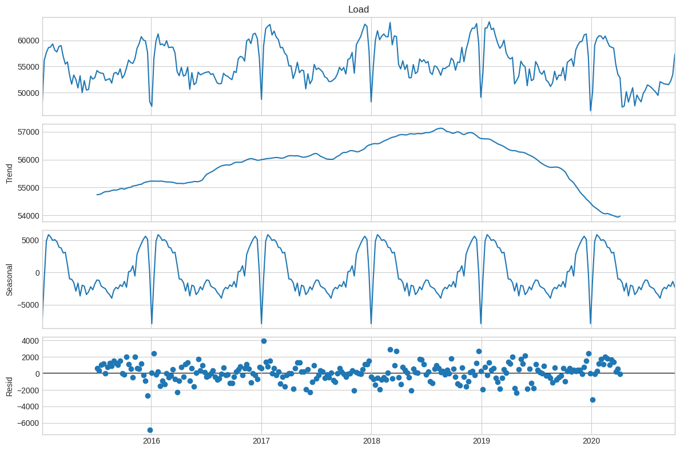

Trend rises to a peak around 2018-2019 before declining sharply into 2020. The seasonal component is strong and stable, repeating consistently every year. The residual (leftover) component still carries some structure, with a clear dip appearing each year around the winter holiday period — showing that the trend and seasonal patterns alone don't fully explain the data, and that some additional short-term, autoregressive behaviour is still present.

2.4 Autocorrelation structure
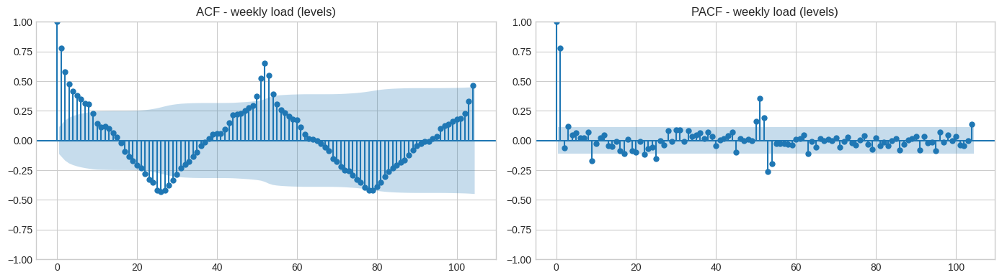

The ACF decays slowly, with a clear peak appearing near lag 52 — confirming the annual cycle already seen in the data. The PACF, on the other hand, cuts off sharply after just a few lags. Together, this pattern suggests a mixed autoregressive and moving-average process sitting on top of a strong seasonal cycle, which points toward a seasonal ARIMA-style model as a sensible next step for capturing this behaviour.2.5 Stationarity testing
Both ADF (H0: unit root) and KPSS (H0: trend-stationary) were applied to the weekly series in levels, after a first difference, and after a seasonal (lag-52) difference:
- Levels - ADF: -4.0475, p=0.0012 -> Stationary. KPSS: 0.1604, p=0.10 -> Stationary. Agree.
- 1st difference - ADF: -7.0693, p<0.0001 -> Stationary. KPSS: 0.0558, p=0.10 -> Stationary. Agree.
- Seasonal difference (lag 52) - ADF: -4.2951, p=0.0005 -> Stationary. KPSS: 1.3419, p=0.01 -> Non-Stationary. Disagree.
Both tests agreeing on levels is itself notable given the clear trend/seasonality - a known limitation of both tests under strong seasonal autocorrelation. The disagreement after seasonal differencing is a further symptom: standard practice is to use both tests together and treat disagreement as a signal to inspect the series visually rather than trust either test alone, which applies directly here.

3. Methodology

3.1 Train/test split
All weekly models share a common split: the final 104 weeks (two years) are held out as the test set, with all preceding weeks used for training (197 training weeks). The hourly LSTM uses an analogous 17,520-hour (two-year) holdout on the underlying hourly series.

3.2 Benchmark models
Four standard benchmarks are fitted: the historical mean, the naive (last-value) forecast, the seasonal naive forecast (repeating the last observed annual cycle), and the drift forecast (extrapolating the average trend between the first and last training observations). All four are scored with RMSE, MAE and MAPE.
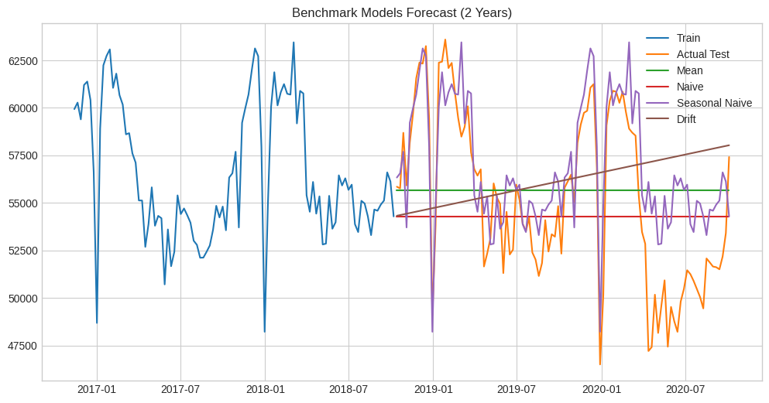

3.3 SARIMA
An exhaustive grid search was run over the non-seasonal order p in [0,6], d in [0,2], q in [0,6] (147 combinations), with the seasonal order fixed at (1,1,1,52), selecting whichever combination minimised AIC. The top 10 combinations by AIC were:
Order (p,d,q) | AIC
(2, 2, 6) | 1482.27
(1, 2, 6) | 1482.98
(3, 2, 6) | 1483.61
(4, 2, 6) | 1485.26
(0, 2, 6) | 1485.82
(5, 2, 6) | 1486.69
(6, 2, 6) | 1488.24
(0, 1, 6) | 1490.46
(1, 1, 6) | 1491.63
(2, 1, 6) | 1493.58
The AIC-minimising order was (2,2,6) with AIC = 1482.27. This order - not a hardcoded placeholder - was used to fit the final model, whose residuals were then checked for remaining structure.
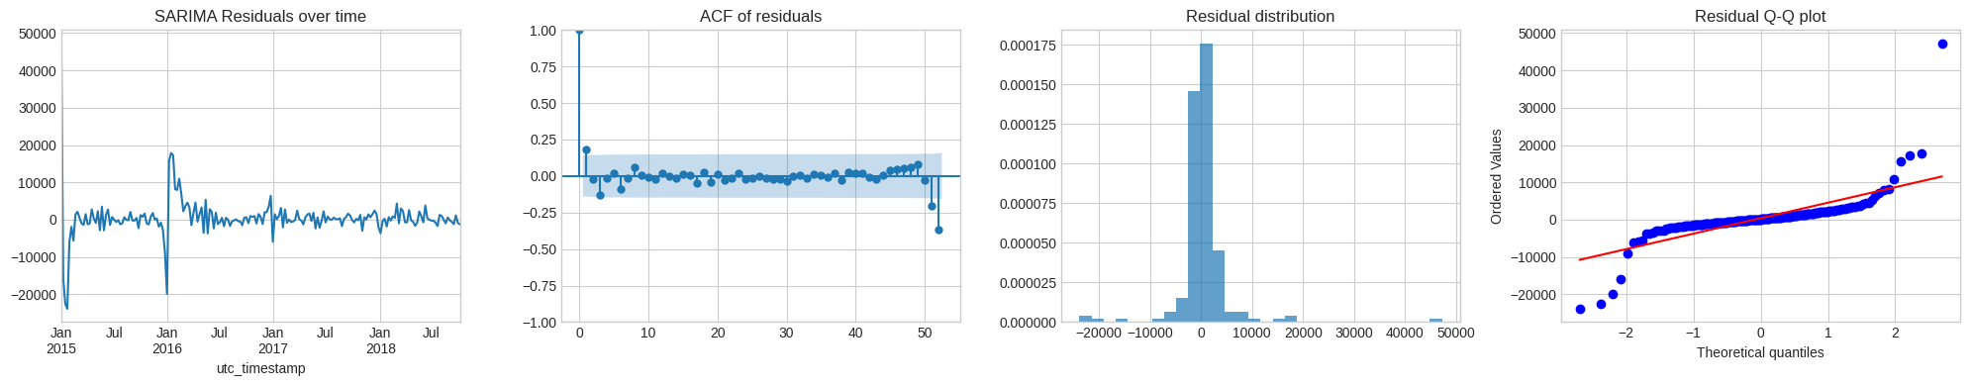
A Ljung-Box test was applied to the model's residuals to check whether any predictable pattern was left behind. The results — p = 0.254 at lag 10, p = 0.835 at lag 20, and p = 0.067 at lag 52 — all stay above the 5% threshold, meaning there's no strong statistical evidence of leftover autocorrelation. That said, the lag-52 result sits close enough to the threshold that a small amount of residual seasonal structure may still be present.
Separately, the model summary flags a near-singular covariance matrix (condition number of 1.25×10^13). In practical terms, this means several of the model's ten parameters (2 autoregressive, 6 moving-average, and 2 seasonal terms) cannot be reliably distinguished from one another using only 197 training observations — a sign the model may be more complex than the data can properly support.
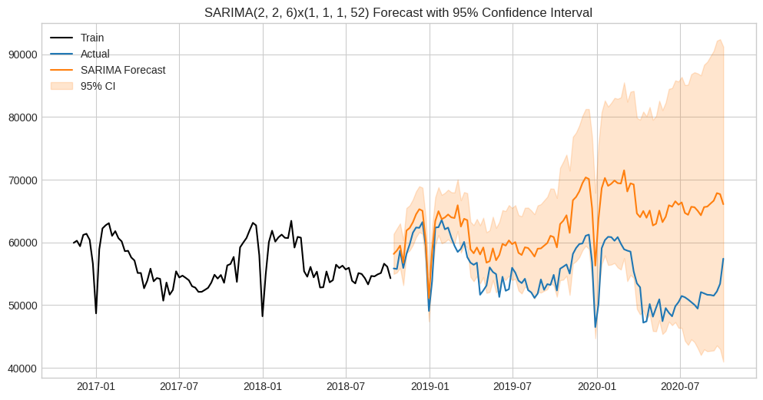

3.4 SARIMAX with temperature
The same AIC-selected order, (2,2,6) with seasonal order (1,1,1,52), is reused for a SARIMAX model with weekly mean Berlin temperature as an exogenous regressor. The estimated temperature coefficient is -87.29 (SE 64.46, z=-1.354, p=0.176): the negative sign is physically sensible (higher temperature, lower heating-driven load), but the effect is not statistically significant at 5%, and the covariance matrix is again near-singular.
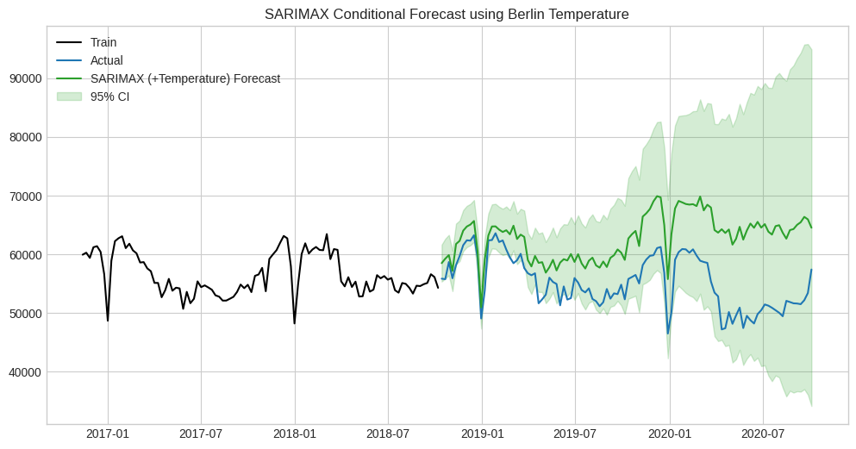
Because the test-period forecast uses the observed temperature that actually occurred, rather than a temperature forecast, this is reported as a conditional/explanatory forecast rather than a genuine operational one (Section 6, Question 4).

3.5 Feature-based model (Random Forest)
A Random Forest regressor (300 trees, max depth 8, minimum leaf size 2) is trained on seven features: lagged load (1, 2 and 52 weeks), a 4-week rolling mean, month, week-of-year, and weekly temperature. Because lagged load values are not actually known at the forecast origin for anything beyond a one-week horizon, the two-year forecast is produced recursively: each week's prediction is fed back in as the lag input for the following week.
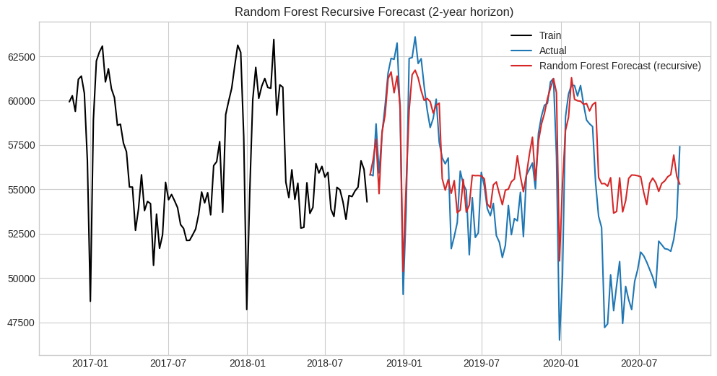
Feature importances confirm the model relies overwhelmingly on the 52-week lag:
Feature | Importance
Lag_52 (load, 52 weeks ago) | 0.797
Lag_1 (load, 1 week ago) | 0.067
WeekOfYear | 0.055
Temperature | 0.044
RollMean_4 | 0.019
Lag_2 (load, 2 weeks ago) | 0.013
Month | 0.004
The 52-week lag alone accounts for 79.7% of total feature importance - effectively, the Random Forest has learned to behave like a (slightly adjusted) seasonal naive forecast, which is consistent with its RMSE (3,048.74) being close to, though marginally worse than, the Seasonal Naive benchmark itself (3,006.76).

3.6 LSTM (hourly)
A stacked LSTM network (LSTM-Dropout-LSTM-Dropout-Dense) is trained on the hourly load series, scaled to [0,1]. A small hyperparameter search was run over lookback window (24 or 48 hours) and hidden unit count (32 or 50), evaluated on a held-out validation slice:
- look_back=24, units=32 -> validation loss 0.002338
- look_back=24, units=50 -> validation loss 0.001946
- look_back=48, units=32 -> validation loss 0.001713 (best)
- look_back=48, units=50 -> validation loss 0.001934
The best configuration (48-hour lookback, 32 units) was used for the final model. The reported test performance is a walk-forward one-step-ahead evaluation: each test window contains true recent history rather than the model's own prior predictions, since a fully recursive 17,520-step forecast would compound error far beyond what is typically useful to report, and this distinction is made explicit rather than left implicit.
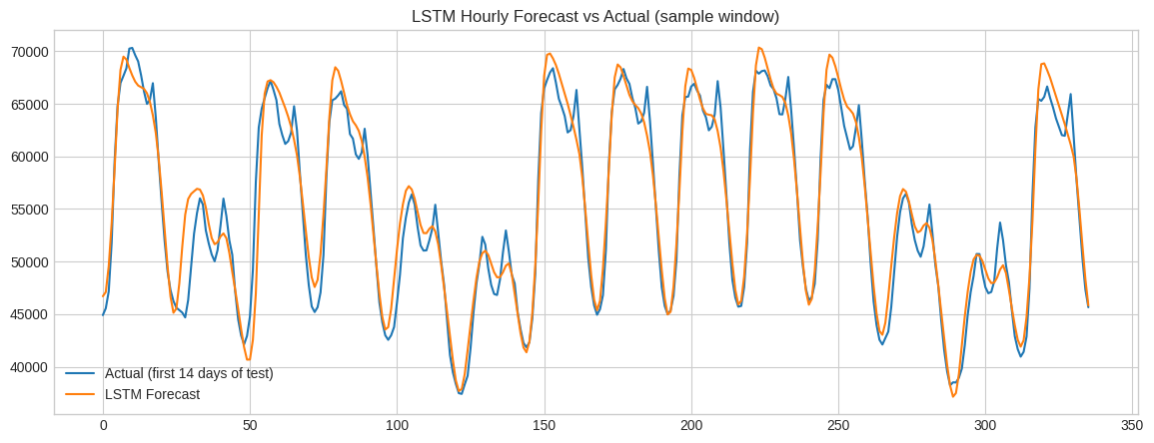

3.7 Evaluation metrics

All models are evaluated using RMSE, MAE, and MAPE, calculated the same way for every model through a single shared evaluation function. This means the metrics shown in the results table are directly comparable in terms of how they were calculated — though not always in terms of what they actually represent, since some models are being tested on slightly different forecasting tasks.

4. Results
summarises test-set performance for all eight models, ranked by RMSE.
Model | RMSE | MAE | MAPE (%)
LSTM (Hourly, 1-step walk-forward) | 1,797.31 | 1,333.37 | 2.51
Seasonal Naive | 3,006.76 | 2,318.52 | 4.41
Random Forest (recursive) | 3,048.74 | 2,309.11 | 4.44
Mean | 4,397.30 | 3,788.83 | 6.97
Naive | 4,459.11 | 3,783.20 | 6.79
Drift | 5,117.96 | 4,339.89 | 8.05
SARIMAX (+Temperature) | 8,883.05 | 7,668.81 | 14.42
SARIMA | 9,470.26 | 8,108.35 | 15.24

The ranking is counter-intuitive: the two models with the most explicit statistical machinery (SARIMA, SARIMAX) rank last, behind every simple benchmark including Drift, while Seasonal Naive outperforms all but one more sophisticated approach. Section 5 examines why.

5. Critical Discussion
A ranked table alone does not explain why these particular models produced these particular results; the ranking needs to be interpreted against the modelling choices and diagnostics behind it.

5.1 Why Seasonal Naive is a strong result here

Seasonal Naive's low RMSE (3,006.76) makes sense because the annual seasonal pattern dominates the series, with trend and noise playing a much smaller role. Simply repeating last year's values captures most of the useful signal — which is why Random Forest, which relies on the 52-week lag for nearly 80% of its predictive weight, ends up performing almost identically (3,048.74). It has essentially learned the same seasonal-naive strategy, with its other features adding only a small, slightly negative adjustment on top.

5.2 Why SARIMA and SARIMAX underperform every benchmark
This report's key finding: the "best" SARIMA model was actually the worst performer. The (2,2,6)x(1,1,1,52) specification had the lowest AIC of all 147 combinations tested (1482.27), yet produced by far the worst test RMSE (9,470.26) — three times worse than Seasonal Naive, and worse even than the simple Drift forecast.
Three pieces of evidence point to overfitting as the cause. First, the model uses a lot of flexibility (double-differencing plus a 6-term moving-average) for only 197 training points — AIC rewards the resulting in-sample improvement without checking whether it generalises forward. Second, the model summary reports a near-singular covariance matrix, a direct sign that several parameters can't be reliably estimated from the data — a classic overfitting symptom. Third, the AIC gap between the top orders is tiny (1482.27 vs. 1482.98 vs. 1483.61), while the earlier stationarity tests actually favoured a simpler order (d=1) than the one AIC selected (d=2) — suggesting AIC was picking up on differences too small to mean anything real.
Adding temperature (SARIMAX) gave a modest improvement (8,883.05 vs. 9,470.26), and the coefficient's sign made physical sense — but it wasn't statistically significant (p = 0.176), and the same covariance problem persisted. So this improvement shouldn't be read as evidence the model was now well-specified.

5.3 Why the LSTM achieves the lowest RMSE, and why that is not a fair comparison
The LSTM's RMSE (1,797.31) is lowest in Table 1, but this reflects task difficulty as much as model quality: with a 48-hour lookback of true recent history, it is interpolating within a short, information-rich window rather than extrapolating 104 weeks forward like every other model here. Its low MAPE (2.51%) is a genuinely strong one-step-ahead result, but comparing it directly to the weekly models' 104-week-ahead figures compares two different tasks, not two solutions to the same one. A fair comparison would require aggregating its hourly predictions to weekly sums, or evaluating it fully recursively - at the cost of substantially larger compounding error over ~17,500 steps.

5.4 What this collectively implies about model selection
The results argue for validating any AIC-selected model against genuine out-of-sample data before trusting it, rather than assuming the AIC-minimising order is automatically best - because here, it was the worst performer. A much simpler model (Seasonal Naive) and a modestly more complex one that converged toward a similar strategy (Random Forest) both proved more trustworthy than the seemingly more sophisticated but overfitted SARIMA specification.

6. Answers to Assignment Questions

Question 1: Comparison against the seasonal naive benchmark
None of the models tested show a meaningful improvement over Seasonal Naive, which achieved an RMSE of 3,006.76 and a MAPE of 4.41%. SARIMA and SARIMAX both performed roughly three times worse across every metric, a gap large enough to point to overfitting rather than any genuine weakness in the SARIMA approach itself. Random Forest came in close to Seasonal Naive (RMSE 3,048.74) — essentially a tie rather than an improvement — which makes sense once you consider that it relies on the 52-week lag for around 80% of its predictive weight, meaning it has effectively learned the same seasonal pattern rather than finding something new. The LSTM posted a lower RMSE (1,797.31), but this comes from being evaluated one step at a time rather than forecasting the full two years ahead like the other models, so it isn't a fair win over Seasonal Naive on the same task. Taken together, none of the more complex models manage to genuinely outperform the simplest seasonal benchmark.

Question 2: Avoiding data leakage in lag features
Data leakage was avoided in the Random Forest by forecasting recursively rather than using observed test-set values as lag inputs: at each step, the model's own prediction for week t is appended to the history used to build week t+1's lag and rolling-mean features, so only information that would genuinely have existed at each forecast origin is used. This differs from a naive implementation that would feed the model the true, observed future load as its own lag feature — which would quietly turn a genuine multi-step forecast into 104 separate one-step-ahead forecasts with the benefit of hindsight. Temperature is a related but slightly different case: a lagged temperature feature is always leak-free by construction, since it's built purely from already-observed past temperatures. The current-period temperature used in this analysis, however, is the actual observed value for the test week — not leakage in the strict sense, since it doesn't use any future load data, but still information that wouldn't genuinely be available at a real forecast origin. That's why it's described as a conditional forecast rather than presented as a true one.

Question 3: Differencing orders and seasonal period for SARIMAX
The seasonal period of s=52 is well justified by the clear annual cycle visible in the data. The non-seasonal order is harder to defend: the AIC search selected d=2, but the stationarity tests (both ADF and KPSS) agree the series is already stationary after just a single first difference, and even in its raw levels. This suggests AIC is rewarding the extra flexibility of d=2 combined with a high-order MA(6) term with an in-sample fit improvement that doesn't reflect a genuinely better model — a conclusion supported by the near-singular covariance matrix seen elsewhere in the analysis. A more defensible choice, in line with the stationarity evidence, would be d=1, with the seasonal order searched jointly rather than fixed in advance at (1,1,1) as it was here.

Question 4: Do temperature and holiday covariates improve accuracy, and are they known at the forecast origin?
Temperature's contribution is modest and not statistically robust: SARIMAX improves on SARIMA by about 6% on RMSE (8,883.05 vs. 9,470.26), but the temperature coefficient itself isn't significant (p = 0.176), so this shouldn't be read as strong evidence temperature is a powerful predictor. In the Random Forest, temperature ranks fourth of seven features by importance, well behind the 52-week lag. No holiday indicator was included at all, which is a real limitation, since public holidays clearly reduce demand in ways none of these models can currently anticipate.
On whether these covariates are known at the forecast origin: holidays are calendar-determined and known with certainty far in advance, so a holiday indicator could be added with zero leakage risk. Temperature is different — it's only known to the accuracy of a weather forecast, which degrades sharply beyond 10-14 days. Since this analysis uses observed, not forecast, temperature over the full test horizon, the SARIMAX and Random Forest results involving temperature should be read as conditional best-case figures, not what a genuinely operational forecast would achieve.

Question 5: Interpretability and complexity of SARIMAX, feature-based, and neural network models

SARIMAX is, in principle, the most interpretable of the three: its coefficients have a direct statistical interpretation, it produces analytically-derived confidence intervals, and its residual diagnostics give an established way to check whether the model is properly specified — which is exactly how the overfitting problem was identified in the first place. That same diagnostic machinery also revealed the model was poorly identified, via a near-singular covariance matrix. That's actually a real interpretability advantage SARIMAX has over the other two: it told us something was wrong, whereas Random Forest and LSTM wouldn't have surfaced an equivalent warning on their own.
Random Forest is intermediate: its feature importances give a clear, ranked sense of which inputs the model relies on, and in this case that ranking directly explained why its results looked so similar to Seasonal Naive — a genuinely useful result. It lacks native uncertainty quantification, and carries the added complexity of the recursive forecasting loop itself, which is another piece of logic that has to be correct for the forecast to mean anything. LSTM is the least interpretable of the three: its internal weights carry no direct meaning, its strong accuracy is heavily shaped by an easier one-step-ahead evaluation rather than being directly comparable to the others, it needed the most tuning, and it provides no built-in confidence interval.

Question 6: Recommendation for operational use
Based on these results, Seasonal Naive — not SARIMA, SARIMAX, Random Forest, or LSTM — is the strongest candidate for operational use as things currently stand, a deliberately counter-intuitive recommendation worth stating plainly rather than defaulting to the most sophisticated-sounding model. It has the second-lowest RMSE among models evaluated on the actual 104-week-ahead task, requires no fitting, carries no overfitting risk, and is trivial to maintain and explain.
That said, this isn't a final verdict on the underlying methods. SARIMA's overfitting comes from an unvalidated AIC search rather than any inherent flaw in seasonal ARIMA modelling, and Random Forest's near-tie with Seasonal Naive reflects a feature set dominated by a single lag. If those issues were corrected and the models re-evaluated, SARIMAX would likely become the stronger long-term candidate, given its confidence intervals and interpretable diagnostics — but that recommendation should wait until a corrected version actually beats the benchmark it currently loses to.

7. Limitations and Future Work
• Validate the SARIMA/SARIMAX order against a held-out validation set rather than relying on in-sample AIC alone — the single most impactful change this analysis points to, and standard practice in applied forecasting (Hyndman & Athanasopoulos, 2021).
• Search the seasonal order jointly with the non-seasonal order, rather than fixing it at (1,1,1) in advance.
• Add a holiday indicator, since public holidays are calendar-determined and known with certainty at the forecast origin, consistent with established practice (Hong & Fan, 2016).
• Replace observed test-period temperature with a genuine weather forecast or seasonal normal, turning the SARIMAX and Random Forest results into genuinely operational forecasts rather than conditional ones.
• Evaluate the LSTM recursively, or aggregate its hourly predictions to weekly totals, so it can be compared fairly against the other models (Bouktif et al., 2018; Kong et al., 2019).
• Quantify Random Forest and LSTM uncertainty explicitly, for example through quantile regression forests or Monte Carlo dropout, so all models can be compared on interval accuracy, not just point accuracy.
• Extend the covariate set to include wind and solar generation, given how much Germany's generation mix now depends on renewables.

References
Box, G. E. P., Jenkins, G. M., Reinsel, G. C., & Ljung, G. M. (2015). Time Series Analysis: Forecasting and Control (5th ed.). Wiley.
Bouktif, S., Fiaz, A., Ouni, A., & Serhani, M. A. (2018). Optimal deep learning LSTM model for electric load forecasting using feature selection and genetic algorithm: Comparison with machine learning approaches. Energies, 11(7), 1636.
Breiman, L. (2001). Random forests. Machine Learning, 45(1), 5-32.
Hochreiter, S., & Schmidhuber, J. (1997). Long short-term memory. Neural Computation, 9(8), 1735-1780.
Hong, T., & Fan, S. (2016). Probabilistic electric load forecasting: A tutorial review. International Journal of Forecasting, 32(3), 914-938.
Hyndman, R. J., & Athanasopoulos, G. (2021). Forecasting: Principles and Practice (3rd ed.). OTexts.
Kong, W., Dong, Z. Y., Jia, Y., Hill, D. J., Xu, Y., & Zhang, Y. (2019). Short-term residential load forecasting based on LSTM recurrent neural network. IEEE Transactions on Smart Grid, 10(1), 841-851.
Open Power System Data. (2020). Time series data package (Version 2020-10-06). https://data.open-power-system-data.org/time_series/
Open-Meteo. (n.d.). Historical Weather API. https://open-meteo.com/

GitHub Repository: https://github.com/asifffgit/Time-Series-Modelling-Case-Study---German-Electricity-Load.git

