**Haiat, Md. Asif**

**17-34664-2**

**Software Engineering (B)**

**Software System**

Super Shop Management System

**Features**

Features are listed below.  **High**, **Medium** and **Low** are used to indicate the importance of each feature.

|  |  |  |  |
| --- | --- | --- | --- |
| **Feature ID** | **Description** | **Priority** | **Requester** |
| **FE01** | Web based application and it is accessed from anywhere with the help of any devices by connected internet. | High |  |
| **FE02** | Accessible only to authenticated and authorized users | High |  |
| **FE03** | Super Shop Management System for example:  personal details, product details, customer information and manager/staff information and so on.  It will also allow different kinds of product search and viewing product list. | High |  |
| **FE04** | The information of all the products purchased by the customer will be given accurately. | High |  |
| **FE05** | Product management and auditing user activities. | High |  |
|  |  |  |  |

**Use case diagram**

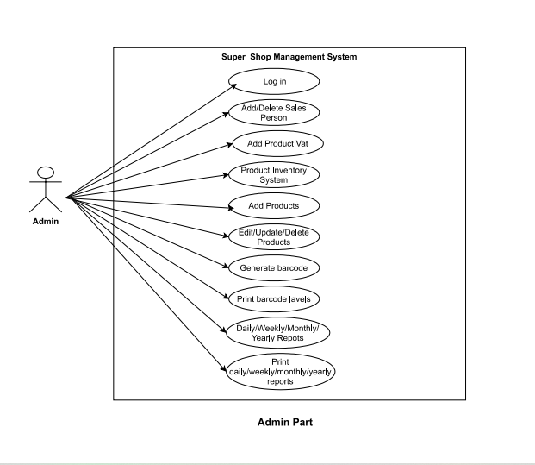

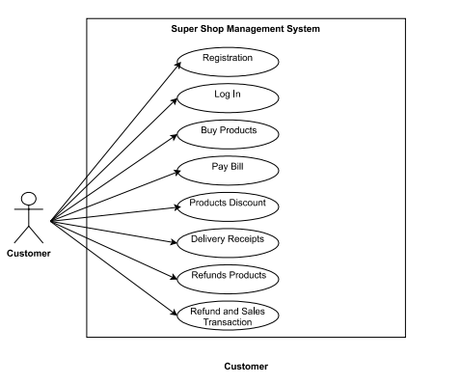

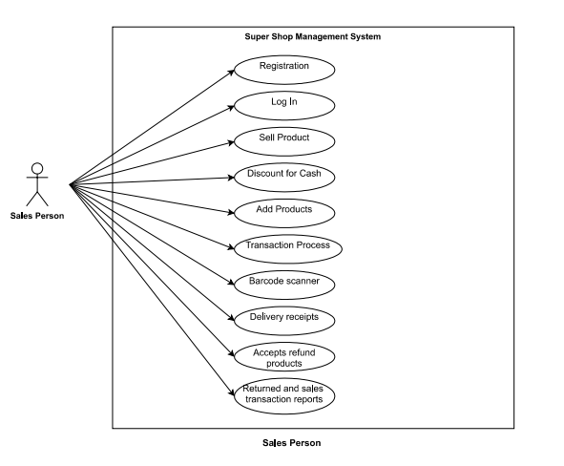

**Use Cases**

|  |  |
| --- | --- |
| **FE02 - Authentication and authorization** | |
| **FE02_UC01** - User authentication | |
| **Brief Description** | The user opens up the portal and the portal shows the login form for access. |
| **Pre-condition/s** | * User is not logged in already * User has an account in the system |
| **Priority** | High |
| **Actor/s** | Users of all classes. |
| **Main Success Scenario** | 1. User opens up the web portal 2. The system displays a login form 3. User enters his/her user id and password 4. The system matches user credentials against its date store 5. The system then redirects user to the appropriate page based on user class. |
| **Alternative Scenario** | * The system cannot find a match for the user and re-displays the login form with an error message. * The system runs into internal error (i.e. database unavailable) and notifies user and asks the user to contact administrator |
| **Notes/Questions** | Must need clarification on dashboard for each user type. |

|  |  |
| --- | --- |
| **FE03 – Super Shop Management System** | |
| **FE03_UC01** - Add new products/sales person | |
| **Brief Description** | Admin wants to add a new sales person and products the system displays. |
| **Pre-condition/s** | * Admin must be logged in * Admin must have authorization to add new products and sales person. |
| **Priority** | High |
| **Actor/s** | ADMIN. |
| **Main Success Scenario** | 1. The system displays a form with all the necessary fields required to collect products and all history information. These fields will be Name, Date of Birth, Present Address, Permanent Address, E-mail Id, Contact Number, Products information, Details on sales person, Sales person experience, Monthly/Weekly/Yearly transaction information and so on. 2. The system automatically generates a Sales ID to the new employer. 3. The system automatically generates Products ID to the new store. 4. If a ‘must be filled’ field is bypassed an immediate warning with a red text is displayed underneath the information box. 5. Authentication for email. 6. Authentication for contact number. 7. When all the information is put the system generates a successful operation message and updates all the information properly in the database. |
| **Alternative Scenario** | * The system is unable to store the information in database and generates operation not complete message. |
| **Notes/Questions** | The system will not store information from incomplete form. A form will be incomplete when all the ‘must be filled’ fields are not filled. |
|  | |
| **FE03_UC02** - View Product list | |
| **Brief Description** | The system will display all information of products. |
| **Priority** | High |
| **Actor/s** | ADMIN. |
| **Main Success Scenario** | 1. The user will be able to see everything as he/she wishes. 2. The products list will be displayed in a single organized page. |
| **Alternative Scenario** | * The system is unable to extract products information from the database and generates error message. |
| **Notes/Questions** | All products will have code on them and the user will be able to see it very easily. |

**Non-Functional requirements**

**1.**  We can guarantee all the information of the user through this system.

**2.** The user’s transaction will be confidential and the system will provide his/her personal information, product purchase information security.