A
PROJECT REPORT
ON
IOT BASED SMART FALL DETECTION DEVICE FOR ELDERLY PEOPLE
SUBMITTED IN PARTIAL FULFILLMENT FOR AWARD OF DEGREE OF
BACHELOR OF TECHNOLOGY
IN
ELECTRONICS AND COMMUNICATION ENGINEERING
BY
ASIF HUSSAIN (2001320310008)
ABHISHEK KUMAR (2001320310001)
INDRADEV PRAMANIK (2001320310015)
UNDER THE GUIDANCE OF
DR. SHIV NARAIN GUPTA


DEPARTMENT OF ELECTRONICS AND COMMUNICATION ENGINNERING
GREATER NOIDA INSTITUTE OF TECHNOLOGY, GREATER NOIDA
DR. A. P. J. ABDUL KALAM TECHNICAL UNIVERSITY, LUCKNOW
MAY, 2024

DEPARTMENT OF ELECTRONICS AND COMMUNICATION ENGINEERING
SESSION 2020-2024
PROJECT COMPLETION CERTIFICATE
Date: 31/05/2024

This is to certify that Mr. Asif Hussain (2001320310008), Mr. Abhishek Kumar (2001320310001), and Indradev Pramanik (2001320310015), 4th year students of Electronics and Communication Engineering (ECE), have completed Project II (KEC-851) with the ECE Department between February 26th and May 16th 2024. They worked on the project title “IoT Based Smart Fall Detection Device for Elderly People” under the guidance of Dr. Shiv Narain Gupta. This project work has not been submitted anywhere for any diploma or degree.

(Signature of Supervisor)
Dr. Shiv Narain Gupta
Assistant Professor
Department of Electronics and Communication Engineering
Greater Noida Institute of Technology, Greater Noida, India
Date: 31st May, 2024
(Signature of Head of Department)
Dr. Mukesh Kumar Ojha
Associate Professor
Department of Electronics and Communication Engineering
Greater Noida Institute of Technology, Greater Noida, India
Date: 31st May, 2024

DECLARATION
We (Asif Hussain, Abhishek Kumar, and Indradev Pramanik) are Bachelor of Technology students in the Department of Electronics and Communication Engineering affiliated with Dr. A. P. J. Abdul Kalam Technical University, Uttar Pradesh, Lucknow, and hereby declare that all the information furnished in this report is based on our own intensive research and is genuine. To the best of our knowledge, we have not submitted any part of our work for the award of our degree at this university or any other university without preparation.
Asif Hussain (2001320310008)

Abhishek Kumar (2001320310001)

Indradev Pramanik (2001320310015)

ACKNOWLEDGEMENT
It is said that “not a leaf can move without his consent," So I admire and thank the almighty for making me capable enough and giving me strength to pursue my bachelor's degree (B.Tech.).
To start with, I would like to express my heartfelt gratitude and sincere regards towards my supervisors, Dr. Shiv Narain Gupta (Assistant Professor, GNIOT Greater Noida), who encouraged and motivated me in developing this project and provided constant guidance throughout the development of this project. I take immense pleasure in expressing my sincere gratitude to the adviser, who, despite their busy schedule, made time to guide us and provide their valuable feedback on the project.
I heartily acknowledge my gratitude to Prof. (Dr.) Dhiraj Gupta, Director (Engineering Institute), for providing a healthy research environment and facilities to carry out my project at the institute premises. I would also like to thank Dr. Mukesh Kumar Ojha (HoD-ECE) for helping me in all academic-related activities.
Finally, we thank each and every person in our department and all of my friends who helped us in completion of this project, either directly or indirectly, with their indispensable comments and sharp criticisms.
Asif Hussain (2001320310008)
Abhishek Kumar (2001320310001)
Indradev Pramanik (2001320310015)
ABSTRACT
Instances of falls, especially among the elderly, pose notable health concerns, prompting the need for innovative interventions. This paper presents an inventive approach to fall detection via the development of a wearable smart device. By harnessing Internet of Things technology and an advanced sensor array, our system aims to improve the precision and efficiency of fall detection while prioritizing user comfort. The proposed device seamlessly integrates into daily life, providing non-intrusive monitoring. Through the utilization of accelerometers, gyroscopes, and various sensor technologies, the system captures and assesses pertinent data related to human movement patterns. This data is then processed using an IoT framework, enabling real-time communication and alert generation in the event of a fall. To validate the efficacy of our wearable smart fall detection device, extensive testing and evaluation have been carried out. The research focus includes assessing the device's sensitivity, specificity, and overall accuracy in distinguishing authentic falls from routine activities. The results illustrate the system's potential to deliver swift and precise fall detection, thereby facilitating timely assistance and minimizing the repercussions of falls.
Keywords: Internet of things, Smart devices, Accelerometers, Gyroscopes, Node MCU.

TABLE OF CONTENTS
 |  | Page Number
PROJECT COMPLETION CERTIFICATE |  | i
DECLARATION |  | ii
ACKNOWLEDGEMENT |  | iii
ABSTRACT |  | iv
TABLE OF CONTENTS |  | v-viii
LIST OF ACRONYMS & ABBREVIATIONS |  | ix
LIST OF SYMBOLS |  | x
LIST OF FIGURES |  | xi
LIST OF TABLES |  | xii
CHAPTER 1
INTRODUCTION |  | 1-4
1.1 | BACKGROUND AND MOTIVATION | 1
1.2 | OVERVIEW AND BENEFITS | 2
 | 1.2.1 PROJECT PROSPECTIVE | 2
 | 1.2.2 PROJECT OJJECTIVE AND BENEFITS | 3
1.3 | SIGNIFICANCE OF FALL DETECTION DEVICE | 3
 | 1.3.1 REAL TIME MONITORING AND DETECTION | 3
 | 1.3.2 REMOTE ACCESSIBILITY | 3
 | 1.3.3 ACCURACY AND REALIABILITY | 3
 | 1.3.4 INGEGRATION WITH HEALTHCARE SYSTEM | 4
 | 1.3.5 PROMOTION OF INDEPENADANCE AND DIGNITY | 4
 | 1.3.6 PREVENTIVE HEALTHCARE | 4
CHAPTER 2
BACKGROUND RESEARCH |  | 5-8
2.1 | APPROACHES AND PRINCIPLES OF FALL DETECTION | 5
2.2 | CLASS HIERARCHY OF FALL DETECTION METHODS | 5
 | 2.2.1 WEARABLE DEVICE APPROACH | 6
 | 2.2.2 AMBIENCE DEVICE APPROACH | 7
 | 2.2.3 CAMERA-BASED APPROACH | 7
2.3 | LITERATURE REVIEW | 7
CHAPTER 3
THEORETICAL CONCEPT |  | 9-14
3.1 | BASICS OF IOT | 9
3.2 | IOT KEY FEATURES | 10
 | 3.2.1 ARTIFICIAL INTELLIGENT (AI) | 10
 | 3.2.2 CONNECTIVITY | 10
 | 3.2.3 SENSORS | 10
 | 3.2.4 ACTIVE ENGAGEMENT | 10
 | 3.2.5 SMALL DEVICES | 10
3.3 | IOT ADVANTAGES | 10
 | 3.3.1 IMPROVED CUSTOMER ENGAGEMENT | 11
 | 3.3.2 TECHNOLOGY OPTIMIZATION | 11
 | 3.3.3 REDUCED WASTE | 11
 | 3.3.4 ENHANCED DATA COLLECTION | 11
3.4 | IOT– DISADVANTAGES | 11
 | 3.4.1 SECURITY | 11
 | 3.4.2 PRIVACY | 11
 | 3.4.3 COMPLEXITY | 11
 | 3.4.4 FLEXIBILITY | 12
 | 3.4.5 COMPLIANCE | 12
3.5 | FALL RISK FACTORS | 12
 | 3.5.1 INTRINSIC | 12
 | 3.5.2 INTERNAL ENVIRONMENT | 12
 | 3.5.3 EXTERNAL ENVIRONMENT | 13
3.6 | FALL DETECTION ALGORITHM | 13
 | 3.6.1 LOWER FALL THRESHOLD (LFT) | 13
 | 3.6.2 UPPER FALL THRESHOLD (UFT) | 14
CHAPTER 4
SYSTEM DESIGN AND ARCHITECTURE |  | 15-23
4.1 | OVERVIEW OF THE PROPOSED SYSTEM | 15
4.2 | HARDWARE COMPONENTS | 16
 | 4.2.1 NODE MCU(EXP8266) | 16
 | 4.2.2 MPU 6050 | 17
 | 4.2.3 CHARGING MODULE | 19
4.3 | TESTING AND VALIDATION | 21
 | 4.3.1 SENSOR CALIBRATION | 21
 | 4.3.2 SIMULATION OF FALL EVENTS | 21
 | 4.3.3 REAL-WORLD TESTING | 21
 | 4.3.4 USABILITY TESTING | 21
4.4 | ITERATIVE IMPROVEMENT | 21
4.5 | SOFTWARE DEVELOPMENT | 22
 | 4.5.1 NODE MCU PROGRAMMING | 22
 | 4.5.2 FALL DETECTION ALGORITHM | 22
4.6 | CIRCUIT DIAGRAM | 22
4.7 | FLOW CHART | 23
CHAPTER 5
RESULT ANALYSIS |  | 24-27
5.1 | OUTPUT READING AT DIFFERENT POSITIONS | 24
 | 5.1.1 STANDING STRAIGHT | 24
 | 5.1.2 SLEEPING POSITION | 24
 | 5.1.3 SLEEPING POSITION PLEDGE POSITION (90 DEGREE) | 25
 | 5.1.4 WATCHING TIME POSITION | 27
5.2 | OUTPUT AND ALERAT WHEN FALL IS DETECTED | 27
CHAPTER 6
CONCLUSION AND FUTURE SOCPE |  | 30-32
6.1 | CONCLUSION | 30
6.2 | FUTURE SCOPE | 31
APPENDIX |  | 33-36
REFERENCES |  | 37-38
LIST OF PUBLICATIONS OR COMMUNICATED PAPERS |  | 39
FULL LENGTH PUBLISED/PRESENTED/COMMUNICATED PAPER |  | 40-44
STUDENTS CURRICULUM VITAE |  | 45-47
LIST OF ACRONYMS & ABBREVIATIONS
IOT | Internet of Things
MCU | Micro Controller Unit
LFT | Lower fall threshold
UFT | Upper fall threshold
GPIO | General Purpose Input Output

LIST OF SYMBOLS
p | Pico
n | Nano
µ | Micro
k | Kilo
M | Mega
G | Giga
Ω | Ohm
Hz | Hertz
ω | Angular Frequency
α | Alpha
β | Beta
γ | Gamma
° | Degree

LIST OF FIGURES
Figure Number | Caption | Page Number
2.1 | The hierarchy of approaches and classes of fall detection methods for elderly and patient. | 6
2.2 | General framework of fall detection and alert device and system for elderly and patien | 6
4.1 | NodeMCU (ESP8266) | 17
4.2 | MCU 6050 | 18
4.3 | Charging Module (TP4056A) | 20
4.4 | Complete Circuit Diagram | 22
4.5 | Flow chart of the proposed model | 23
5.1 (a) | Standing straight position | 25
5.1 (b) | Readings on Standing Straight | 25
5.2 (a) | Sleeping position | 26
5.2 (b) | Readings while laying down | 26
5.3 (a) | Hand at 90 degree [pledge] | 26
5.3 (b) | Readings at 90 degree angle | 26
5.4 (a) | Watching timing Position | 27
5.4 (b) | Readings at high bend elbow | 27
5.5 | Readings when instantly all axis changes hence fall detected | 28
5.6 | Alert notification from Blynk App | 28
5.7 | Alert notification via email | 29
5.8 | Prototype image of the device | 29

LIST OF TABLES
Table Number | Table Caption | Page Number
4.1 | Specification of NodeMCU (ESP8266) | 17
4.2 | Specification of MPU6050 | 18
4.3 | Specification of TP4056A | 20

CHAPTER 1
INTRODUCTION
As the global population ages, ensuring the safety and well-being of elderly individuals has become a paramount concern. Falls are a leading cause of injury and death among the elderly, with significant implications for their health, independence, and quality of life. Timely detection and response to falls can mitigate these risks, potentially saving lives and reducing the severity of injuries. In this context, technology offers promising solutions to enhance elderly care, particularly through the development of smart fall detection systems.
  - BACKGROUND AND MOTIVATION
Traditional fall detection methods include physical supervision, emergency call buttons, and more recently, wearable devices that monitor activity. However, these methods have limitations. Physical supervision is not always feasible, emergency call buttons rely on the user’s ability to activate them, and many existing wearable devices are expensive, uncomfortable, or intrusive. Vision-based systems, while effective, raise privacy concerns and can be costly to implement.
The advent of the Internet of Things (IoT) has opened new avenues for developing cost-effective, non-intrusive, and efficient fall detection systems. IoT-based solutions can leverage advanced sensors, microcontrollers, and wireless communication to create devices that continuously monitor an individual’s movements and provide real-time alerts in the event of a fall. This project aims to harness these capabilities to develop a smart fall detection device tailored to the needs of elderly individuals.
The motivation behind this project stems from a combination of societal needs and technological advancements. The increasing elderly population demands innovative approaches to ensure their safety and independence. According to the World Health Organization, approximately 28-35% of people aged 65 and older fall each year, increasing with age and frailty. Falls often lead to severe consequences, including hospitalization, loss of mobility, and a decrease in the ability to live independently.
Given the limitations of existing solutions, there is a clear need for an affordable, reliable, and user-friendly fall detection system. This project seeks to address this need by developing an IoT-based device using the NodeMCU microcontroller and MPU 6050 sensor. The NodeMCU, with its built-in Wi-Fi capabilities, allows for seamless integration with IoT frameworks, while the MPU 6050 sensor provides accurate motion and orientation data. By combining these components, the device can detect falls and immediately notify caregivers via email, ensuring prompt assistance.
This project is also motivated by the educational opportunity it presents. It allows the team to apply theoretical knowledge in electronics and communication engineering to a real-world problem, fostering skills in system design, programming, and IoT integration. The interdisciplinary nature of the project provides a holistic learning experience, preparing the team for future challenges in the field of technology and innovation.
In summary, this project aims to develop a smart fall detection device that enhances the safety of elderly individuals through the use of advanced IoT technology. By addressing the shortcomings of existing solutions and leveraging the capabilities of the NodeMCU and MPU 6050, the project aspires to contribute to the well-being of the elderly population and provide a practical, scalable solution for caregivers.
  - OVERVIEW AND BENEFIT
    - Project Prospective
In order to reduce the risk of elderly people getting harm from fall, medical attention needs to be provided immediately. Therefore, a reliable fall detection system can help to detect fall in elderly people and contact the nearest healthcare service for help and support. The fall detection system need to be user friendly which means it is easier to be used by the elderly people. The system also must not interfere and disturb activities of daily living of elderly people. The system needs to be cost-effective and durable. The MPU6050 sensor module has built-in a gyroscope and an accelerometer sensor. The gyroscope is used to determine the orientation and the accelerometer provides information about the angular parameter such as the X, Y, and Z-axis data. We interface this sensor with arguing microcontroller and keep different acceleration thresholds to check whether any false triggering is happening or the user has really fallen. If values exceed thresholds then we via Blink app we get notification in our android device.

    - Project Objective and Benefits
The project objectives are as follows:
- To develop an intelligent and effective fall detection and alert system using Smartphone and wireless sensor node.
- To develop a reliable and cost efficient fall detection and alert system.
- To develop a fall detection system that is user friendly and without causing disturbance to activities of daily living of elderly people
  - SIGNIFICANCE OF FALL DETECTION DEVICE
The significance of IoT-based smart fall detection devices lies in their ability to revolutionize elderly care by providing real-time monitoring and immediate assistance in the event of a fall. Here are some key aspects of their significance:
    - Real-time Monitoring and Detection
IoT-based smart fall detection devices continuously monitor the movements and activities of elderly individuals. By leveraging sensors and connectivity technologies, these devices can detect falls in real-time, enabling prompt response and assistance.
    - Remote Accessibility
One of the primary advantages of IoT-based solutions is their ability to provide remote accessibility. Caregivers and family members can receive alerts and notifications on their smartphones or other connected devices, allowing them to respond quickly and effectively, even when they are not physically present with the elderly individual.
    - Accuracy and Reliability
Advanced sensors and algorithms used in IoT-based fall detection devices enhance accuracy and reliability. These devices can distinguish between normal activities and fall events, reducing the likelihood of false alarms and ensuring that assistance is provided only when necessary.
    - Integration with Healthcare Systems
IoT-based smart fall detection devices can be seamlessly integrated with existing healthcare systems and infrastructure. Data collected by these devices can be shared with healthcare providers, enabling proactive interventions and personalized care plans for elderly individuals.
    - Promotion of Independence and Dignity
By providing unobtrusive monitoring and assistance, IoT-based smart fall detection devices empower elderly individuals to maintain their independence and dignity. These devices allow seniors to age in place safely, without the need for constant supervision or relocation to assisted living facilities.
    - Preventive Healthcare
Beyond reactive response to falls, IoT-based smart fall detection devices can also support preventive healthcare initiatives. By analyzing data on activity levels, mobility patterns, and environmental factors, these devices can identify risk factors for falls and proactively intervene to prevent accidents before they occur.
CHAPTER 2
BACKGROUND RESEARCH
The advent of the Internet of Things (IoT) has significantly impacted healthcare, particularly through the creation of smart devices designed to improve the safety and quality of life for elderly people. A prominent example is the IoT-based smart fall detection system, which has become increasingly important due to the high incidence of falls and associated injuries in the elderly demographic. Research into this field indicates that conventional fall detection methods, such as manual supervision and basic wearable devices, often fall short in terms of accuracy and immediate response. IoT technology overcomes these challenges by employing a network of interconnected sensors and devices capable of continuous movement monitoring and precise fall detection. Studies indicate that these advanced systems, which utilize accelerometers, gyroscopes, and machine learning algorithms, can dramatically shorten the time needed to alert caregivers and emergency services, thus reducing the negative impacts of falls. Additionally, improvements in wireless communication, data analytics, and cloud computing have facilitated the creation of more effective and user-friendly fall detection solutions. This context provides a basis for investigating the implementation of a sophisticated IoT-based fall detection device tailored for the elderly, aimed at enhancing their safety and independence.

  - APPROACHES AND PRINCIPLES OF FALL DETECTION
In this section we first build a hierarchy of fall detection methods according to used sensors and principles. Then we comment the existing fall detection methods in the products and in the literature.
  - CLASS HIERARCHY OF FALL DETECTION METHODS
Many efforts have made in fall detection due to the big demand and their big potential market and social value of fall detection products and technology. A series of technologies have already been developed in recent years. According to how fall is detected they can be divided into three approaches: wearable device, ambience device and camera-based (or vision-based). Wearable devices can be further divided into posture device and motion device two classes. Ambience devices can be further divided into presence device and posture device two classes. We divide the camera-based methods into three classes according the used principles: inactivity detection, 2D body shape change analysis, and 3D head motion analysis. The class hierarchy of fall detection methods is depicted in Figure 1.
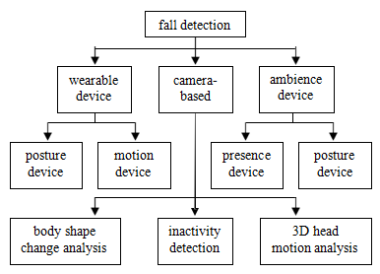
Figure 2.1: The hierarchy of approaches and classes of fall detection methods for elderly and patient.
Though there were different approaches and methods to detect fall for elderly and patient, existing fall detection devices and systems share a general framework, depicted in Figure 2. The difference of devices and systems lies in the complexity of each component. For example, data acquisition can vary from single simple sensor to sense one indicator to multiple different sensors and different cameras to work together to collect signal and video data. Fall detection can vary from comparing one sensed indicator with a threshold to a complicated image processing algorithm including background subtraction, shape detection, and shape change analysis.
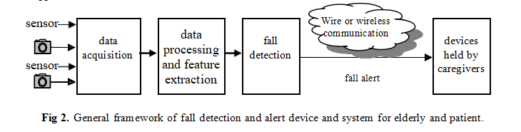
Figure 2.2: General framework of fall detection and alert device and system for elderly and patient.
    - Wearable Device Approach
The wearable device approach is to hold some devices or to wear some devices or garments with embedded sensors to detect the posture and/or motion of the body of the wearer and use classifiers to identify suspicious events including fall.
    - Ambience Device Approach
Ambience device approach is to use multiple installed sensors to collect the data related person when person are close to them.
    - Camera-Based Approach
Cameras are increasingly included in in-home assistive system because they have multiple advantages over sensor approaches and the price of cameras decreases rapidly. First, camera-based approach is able to be used to detect multiple events simultaneously. Second, they are less intrusive because they are installed on building not worn by users. Last, the recorded video can be used for remote and post verification and analysis. There were scores of camera-based fall detection algorithms in the literature. Generally speaking, each algorithm used some of the characteristics of falls. According to the used principles relating to the characteristics of fall they can be divided into three categories: inactivity detection, (body) shape change analysis, and 3D head motion analysis.
  - LITERATURE REVIEW
This section outlines significant research in the field of fall detection. Typically, fall detection systems employ one of three main approaches: wearable sensors, computer vision, and ambient fusion. However, this paper specifically concentrates on methods utilizing wearable sensors, with a particular emphasis on treasure-based approaches.
The majority of fall detection systems implemented on mobile devices rely on accelerometers as their primary sensor. Accelerometers are instrumental in measuring the acceleration of various parts of the human body, making them valuable for fall detection [6], as well as for broader applications such as human activity recognition [7]–[10].
Threshold-based methods are among the most commonly employed techniques for fall detection using wearable sensors. In this approach, a fall event is identified when the acceleration surpasses predefined thresholds. However, a notable challenge with this method lies in the difficulty of generalizing results across diverse populations, considering factors such as height and weight. Consequently, these methods require a set of predefined parameters that must be tailored to the specific characteristics of the target population. Research in this category includes the work of De La Hoz et al. [11], where the authors utilize the sensors embedded in smartphones (such as accelerometer and gyroscope) to determine the device's location on the user's body (e.g., chest, pocket, holster) and identify known patterns associated with falls. The study achieved an overall accuracy of 81.3%, with the top three locations for fall detection being texting with a 95.8% accuracy, pants side pocket with an 87.5% accuracy, and shirt chest pocket with an 83.3% accuracy.
In their study, [13] introduces a fall detection system utilizing accelerometry. In this system, the sensor is positioned at the user's pelvis. The approach relies on predefined scenarios, including standing still, transitioning from sitting to standing, standing to sitting, walking, walking backward, stooping, jumping, and lying on the bed. Fall detection is subsequently performed within the context of these scenarios. Motion data is processed to extract features such as the sum vector, magnitude of acceleration, acceleration on the horizontal plane, and reference velocity. Leveraging these features, the system can discern spatial changes in acceleration during a fall event. Results demonstrate a notable level of fall recognition using this treasure-based approach
Almeida [14] devised a fall detector integrated into a walking stick for real-time fall detection and gait measurement. The system employs a gyroscope chip to gauge the angular velocity of the stick. Upon detecting a significant change in velocity, indicative of the stick being in a horizontal position, the device infers that the holder has experienced a fall. This principle relies on the device discerning the posture of the stick.
CHAPTER 3
THEORETICAL CONCEPT
The theoretical concept of an IoT-based smart fall detection device for elderly individuals focuses on the fusion of advanced sensor technology and real-time data communication to improve senior safety. This system incorporates interconnected devices, such as accelerometers and gyroscopes typically embedded in wearable gadgets. These sensors continuously track the user’s movements and vital signs. Utilizing IoT infrastructure, the gathered data is sent to a cloud-based platform where machine learning algorithms analyze the information to identify patterns indicative of falls. When a fall is detected, the system automatically notifies caregivers or emergency services, enabling swift intervention. This synergy of IoT and intelligent data processing not only ensures precise fall detection but also supports a proactive care approach, minimizing response times and enhancing overall health outcomes for the elderly.

  - BASICS OF IOT
The Internet of Things (IoT) plays a crucial role in connecting various devices and systems in the technology-dominated modern era [1-2]. Smart industry, smart energy, smart cities, home automation, smart cars, smart agriculture, logistics, healthcare, and numerous other domains utilize this technology, which boasts a wide array of applications [3-4]. IoT (Internet of Things) is an advanced automation and analytics system which exploits networking, sensing, big data, and artificial intelligence technology to deliver complete systems for a product or service. These systems allow greater transparency, control, and performance when applied to any industry or system. IoT systems have applications across industries through their unique flexibility and ability to be suitable in any environment. They enhance data collection, automation, operations, and much more through smart devices and powerful enabling technology. IoT systems allow users to achieve deeper automation, analysis, and integration within a system. They improve the reach of these areas and their accuracy. IoT utilizes existing and emerging technology for sensing, networking, and robotics. IoT exploits recent advances in software, falling hardware prices, and modern attitudes towards technology. Its new and advanced elements bring major changes in the delivery of products, goods, and services; and the social, economic, and political impact of those changes.
  - IOT KEY FEATURES
The most important features of IoT include artificial intelligence, connectivity, sensors, active engagement, and small device use. A brief review of these features is given below:
    - Artificial intelligent (AI)
IoT essentially makes virtually anything “smart”, meaning it enhances every aspect of life with the power of data collection, artificial intelligence algorithms, and networks. This can mean something as simple as enhancing your refrigerator and cabinets to detect when milk and your favourite cereal run low, and to then place an order with your preferred grocer.
    - Connectivity
New enabling technologies for networking, and specifically IoT networking, mean networks are no longer exclusively tied to major providers. Networks can exist on a much smaller and cheaper scale while still being practical. IoT creates these small networks between its system devices.
    - Sensors
IoT loses its distinction without sensors. They act as defining instruments which transform IoT from a standard passive network of devices into an active system capable of real-world integration.
    - Active Engagement
Much of today's interaction with connected technology happens through passive engagement. IoT introduces a new paradigm for active content, product, or service engagement.
    - Small Devices
Devices, as predicted, have become smaller, cheaper, and more powerful over time. IoT exploits purpose-built small devices to deliver its precision, scalability, and versatility.
  - IOT ADVANTAGES
The advantages of IoT span across every area of lifestyle and business. Here is a list of some of the advantages that IoT has to offer:

    - Improved Customer Engagement
Current analytics suffer from blind-spots and significant flaws in accuracy; and as noted, engagement remains passive. IoT completely transforms this to achieve richer and more effective engagement with audiences.
    - Technology Optimization
The same technologies and data which improve the customer experience also improve device use, and aid in more potent improvements to technology. IoT unlocks a world of critical functional and field data.
    - Reduced Waste
IoT makes areas of improvement clear. Current analytics give us superficial insight, but IoT provides real-world information leading to more effective management of resources.
    - Enhanced Data Collection
Modern data collection suffers from its limitations and its design for passive use. IoT breaks it out of those spaces, and places it exactly where humans really want to go to analyse our world. It allows an accurate picture of everything.
  - IOT– DISADVANTAGES
Though IoT delivers an impressive set of benefits, it also presents a significant set of challenges. Here is a list of some its major issues:
    - Security
IoT creates an ecosystem of constantly connected devices communicating over networks. The system offers little control despite any security measures. This leaves users exposed to various kinds of attackers.
    - Privacy
The sophistication of IoT provides substantial personal data in extreme detail without the user's active participation.
    - Complexity
Some find IoT systems complicated in terms of design, deployment, and maintenance given their use of multiple technologies and a large set of new enabling technologies.
    - Flexibility
Many are concerned about the flexibility of an IoT system to integrate easily with another. They worry about finding themselves with several conflicting or locked systems.
    - Compliance
IoT, like any other technology in the realm of business, must comply with regulations. Its complexity makes the issue of compliance seem incredibly challenging when many consider standard software compliance a battle.
  - FALL RISK FACTORS
A person can be more or less prone to fall, depending on a number of risk factors and hence a classification based on only age as a parameter is not enough. In fact, medical studies have determined a set of so called risk factors
    - Intrinsic
- Age (over 75)
- Chronic disease
- Previous falls
- Poor balance
- Low mobility and bone
- Sight problems
- Cognitive and dementia problems
- Parkinson disease
- Use of drugs that affect the mind
- Incorrect lifestyle (inactivity, use of alcohol, obesity)
    - Internal Environment
- Need to reach high objects
- Slipping floors
- Stairs
- Incorrect use of shoes and clothes
    - External Environment:
- Damaged roads
- Dangerous steps
- Poor lighting
- Crowded places.
  - FALL DETECTION ALGORITHM
The total sum acceleration vector Acc, contain both dynamic and static acceleration Components, is calculated from sampled data as indicated in equation (2.1).
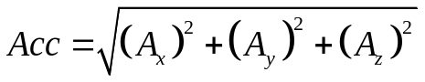 (2.1)
Where Ax, Ay, Az are the acceleration in the x, y, z axes, respectively. Similarly to the acceleration, the angular velocity is calculated from sampled data as indicated in equation (2.2).
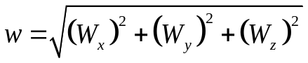 (2.1)
Where Wx, Wy, Wz the acceleration in the x, y, z axes, respectively. When stationary, the acceleration magnitude, Acc, from tri-axial accelerometer is constant, and angular velocity is 0o/s. When the subject falls, the acceleration is rapidly changing and the angular velocity produces a variety of signals along fall direction. Since the Fall Index (Acc) requires high sampling frequency and fast acceleration changes, it will miss falls that happen slowly. Hence, Acc is not used unless we want to compare the performances of our systems with previous studies that have used the same positions but with deferent speed and accelerations. The lower and upper fall thresholds for the acceleration and angular velocity used To identify the fall are derived as follows:
    - Lower fall threshold (LFT)
The negative peaks for the resultant of each recorded activity are referred to as the signal lower peak values (LPVs). The LFT for the acceleration signals are set at the level of the smallest magnitude lower fall peak (LFP) recorded.

    - Upper fall threshold (UFT)
The positive peaks for the recorded signals for each recorded activity are referred to as the signal upper peak values (UPVs). The UFTfor each of the acceleration and the angular velocity signals were set at the level of the smallest magnitude UPV recorded. The UFT is related to the peak impact force experienced by the body segment during the impact phase of the fall. Fall detection algorithms using thresholds are normally divided into two groups, one is based on the LFT comparison and the other is based on UFT comparison of acceleration data. Although past research has achieved some significant results, the accuracy is still Below desired levels. In this study adjust the UFT and LFT and found the performance to be 83.33 % and 67.08 %, respectively.
CHAPTER 4
SYSTEM DESIGN AND ARCHITECTURE
The architecture and design of the IoT-based Smart Fall Detection Device for elderly individuals leverage the NodeMCU microcontroller paired with the MPU 6050 sensor, which includes both an accelerometer and a gyroscope. The MPU 6050 is responsible for continuously tracking motion and orientation to identify possible falls. When a fall is detected, the NodeMCU interprets the sensor data and initiates an alert protocol. This alert is sent to a pre-registered email and an IoT application, ensuring that caregivers or family members receive immediate notifications. The system relies on the NodeMCU's Wi-Fi capabilities to enable seamless real-time communication with cloud services, where data processing and alert management occur. Further more, the IoT application features an intuitive interface for real-time device monitoring and alert configuration, significantly improving the safety and responsiveness of the fall detection system for elderly users.

  - OVERVIEW OF THE PROPOSED SYSTEM
The proposed system is an IoT-based smart fall detection device designed to enhance the safety and well-being of elderly individuals. Leveraging the power of Internet of Things (IoT) technology, the system continuously monitors the movements and activities of elderly individuals and detects falls in real-time. Upon detecting a fall event, the system triggers immediate alerts to caregivers or family members, enabling prompt assistance and intervention.
The core components of the system include a microcontroller unit and motion sensors. The microcontroller unit serves as the brain of the system, processing data from the motion sensors and coordinating communication with external devices. Motion sensors, such as accelerometers and gyroscopes, are used to detect changes in orientation and acceleration, indicative of a fall event. The communication module facilitates wireless connectivity, allowing the system to transmit alerts and notifications to caregivers via the internet.
The system architecture is designed to be modular and scalable, allowing for flexibility in deployment and integration with existing infrastructure. The proposed system can be deployed as a standalone device or integrated into a broader healthcare ecosystem, including wearable devices, home automation systems, and healthcare monitoring platforms. By providing seamless integration and interoperability, the system maximizes its utility and effectiveness in addressing the specific needs of elderly individuals and their caregivers.
  - HARDWARE COMPONENTS
The design and development of an IoT-based smart fall detection device for elderly people involve several key stages, including system architecture, hardware selection, sensor integration, software development, and testing. This section provides an overview of the design and development process, highlighting the key components and methodologies employed.
    - Node MCU(EXP8266)
The NodeMCU ESP8266 is a powerful and versatile microcontroller board specifically designed for Internet of Things (IoT) applications, illustrated in Figure 4.1. It features an ESP8266 Wi-Fi module integrated directly onto the board, making it an ideal choice for projects that require wireless connectivity and remote communication. The ESP8266 module offers robust Wi-Fi capabilities, allowing the NodeMCU to connect to local Wi-Fi networks and communicate with other devices and servers over the internet.
One of the key advantages of the NodeMCU ESP8266 is its ease of use and accessibility. It can be programmed using the Arduino Integrated Development Environment (IDE), which is widely used and familiar to many developers and hobbyists. This simplifies the development process and lowers the barrier to entry for individuals interested in IoT projects. Additionally, the NodeMCU ESP8266 features a USB-to-serial converter chip, enabling easy interfacing with a computer for programming and debugging purposes.
Despite its compact size, the NodeMCU ESP8266 offers impressive processing power and memory capabilities, making it suitable for a wide range of IoT applications. It supports a variety of communication protocols, including TCP/IP, UDP, MQTT, and HTTP, allowing for seamless integration with existing network infrastructure and cloud services. Furthermore, the NodeMCU ESP8266 features a rich set of peripheral interfaces, including GPIO pins, analog inputs, and serial interfaces, enabling interfacing with sensors, actuators, and other external devices.
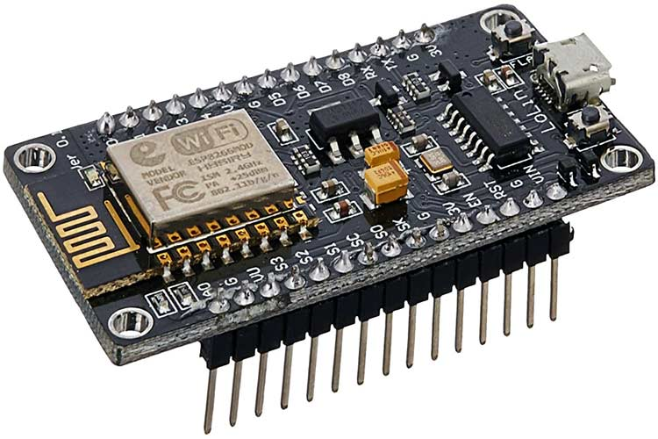
Figure 4.1: NodeMCU (ESP8266)
In summary, the NodeMCU ESP8266 is a versatile and cost-effective microcontroller board that offers robust Wi-Fi connectivity, ease of programming, and ample processing power for IoT projects. Its compact form factor, extensive feature set, and broad community support make it an ideal choice for prototyping and developing IoT solutions for a wide range of applications. The detailed specifications of NodeMCU is tabulated in Table 4.1.
Table 4.1: Specification of NodeMCU (ESP8266)
S. No. | Parameters | Specifications
1. | Operating Voltage | 3.3V
2. | Input Voltage | 7-12V
3. | Flash Memory | 4MB
4. | SRAM | 64KB
5. | Clock Speed | 80Mhz
6. | Digital I/O Pins | 16
7. | Analog I/O pins | 1

    - MPU 6050
The MPU-6050 (shown in Figure 4.2)represents a pinnacle in motion sensing technology, combining a 3-axis gyroscope and accelerometer into a single compact module. This integration not only simplifies hardware design but also enhances the accuracy and reliability of motion tracking applications, making it an indispensable component in the proposed vehicle monitoring system. The specification in shown in Table 4.2.
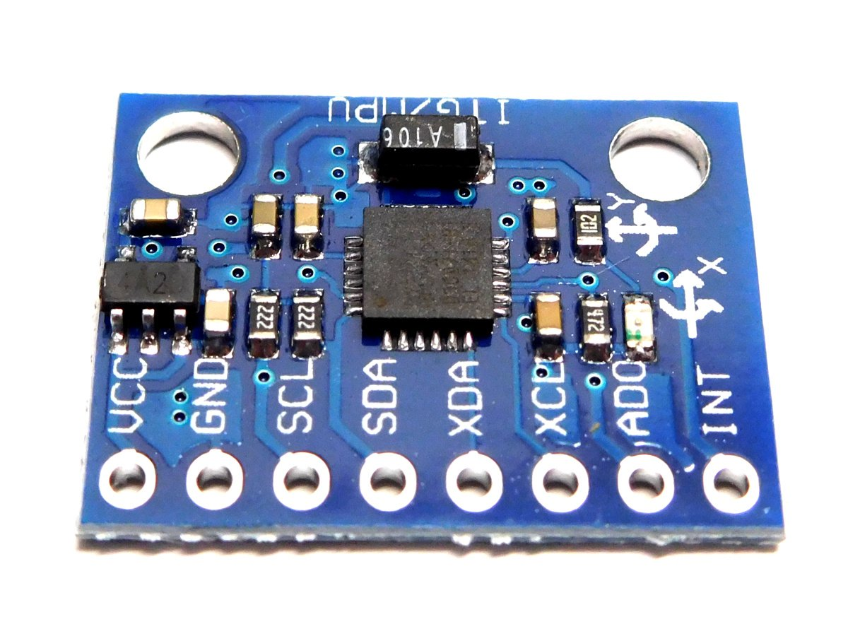
Figure 4.2: MCU 6050
Table 4.2: Specification of MPU-6050
S. No. | Parameters | Specifications
1. | Operating Voltage | 2.375V - 3.46V
2. | Working Current | ~3.6mA
3. | Gyroscope Range | ±250, ±500, ±1000, ±2000 degrees/sec
4. | Accelerometer Range | ±2g, ±4g, ±8g, ±16g
5. | Resolution | 16-bit
6. | Communication | I2C, SPI

At the core of the MPU-6050 lies its dual functionality as both a gyroscope and an accelerometer, each serving a unique yet complementary role in detecting and analyzing vehicle dynamics. The accelerometer, capable of measuring acceleration forces along three orthogonal axes, provides crucial insights into the vehicle's linear motion. By detecting sudden changes in acceleration, it can identify instances of rapid deceleration, indicative of collision events or abrupt braking maneuvers. This data is instrumental in assessing the severity of impacts and determining the onset of emergency situations.
In tandem with the accelerometer, the gyroscope adds an additional dimension to motion sensing by measuring angular velocity around each axis. This enables the MPU-6050 to detect rotational movements and changes in orientation, offering valuable context for understanding the dynamics of accidents. By precisely tracking angular displacements, the gyroscope facilitates the reconstruction of vehicle trajectories before, during, and after collision events, aiding in accident analysis and forensic investigations.
Furthermore, the MPU-6050's high sensitivity and wide measurement range ensure reliable performance across a diverse range of driving conditions. Whether navigating through urban streets or traversing rugged terrain, its robust construction and advanced sensing capabilities enable accurate detection of vehicle movements with minimal latency. This real-time responsiveness is critical for timely intervention and emergency response, allowing the vehicle monitoring system to react swiftly to potential hazards and mitigate risks effectively.
In addition to its role in accident detection, the MPU-6050's motion tracking capabilities extend to driver behavior monitoring and vehicle performance analysis. By continuously monitoring changes in acceleration and orientation, it can assess driving patterns, detect instances of aggressive driving or erratic behavior, and provide valuable feedback to improve driver safety and efficiency. Furthermore, its integration into the vehicle monitoring system enables comprehensive performance monitoring, allowing for the identification of mechanical issues or abnormalities that may compromise vehicle safety.
The MPU-6050's versatility extends beyond its hardware capabilities, with comprehensive support for various communication interfaces such as Inter-Integrated Circuit (I2C) and Serial Peripheral Interface (SPI). This facilitates seamless integration with the Arduino Mega microcontroller and other system components, enabling effortless data exchange and synchronization. Additionally, its compact form factor and low power consumption make it an ideal choice for embedded applications, ensuring minimal impact on overall system performance and energy efficiency.
    - Charging Module
The TP4056A (illustrated in Figure 4.3) is a highly efficient and versatile lithium-ion battery charging module widely used in various electronic devices and DIY projects. It is specifically designed to charge single-cell lithium-ion or lithium polymer batteries, providing a reliable and safe charging solution. The module incorporates advanced charging management features, making it suitable for a wide range of applications, from portable electronics to solar-powered systems.
One of the key features of the TP4056A charging module is its compact size and simplicity of design. The module typically consists of a small PCB (Printed Circuit Board) with minimal components, including the TP4056A charging IC, pass transistor, current sense resistor, and a few capacitors and resistors. This minimalist design ensures ease of integration into electronic devices and allows for space-efficient layouts.
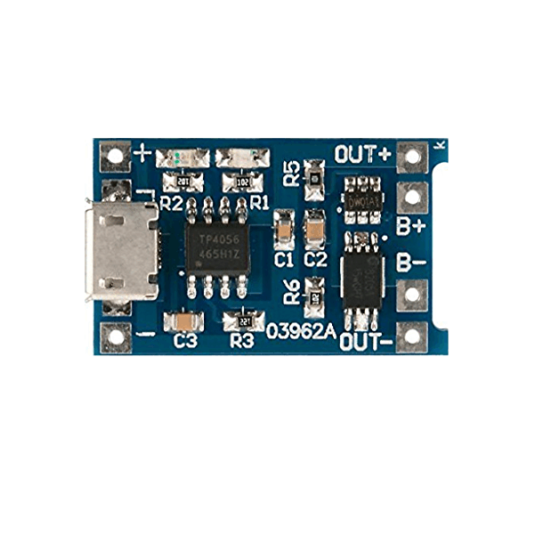
Figure 4.3: Charging Module (TP4056A)
The TP4056A charging module utilizes constant-current/constant-voltage (CC/CV) charging algorithm, which is widely regarded as the most efficient and safe method for lithium-ion battery charging. This algorithm ensures that the battery is charged at a constant current until it reaches a predefined voltage threshold, after which the charging current is gradually reduced to prevent overcharging and maximize battery life. The module also features built-in overcharge and over-discharge protection, as well as temperature monitoring, further enhancing the safety and reliability of the charging process.
Another notable feature of the TP4056A charging module is its wide input voltage range and flexible charging current settings. The module typically supports input voltages ranging from 4.5V to 5.5V, making it compatible with a variety of power sources, including USB ports, solar panels, and AC adapters. Additionally, the charging current can be adjusted using an external resistor, allowing for customization to suit different battery capacities and charging requirements.
Table 4.3: Specification of TP4056A
S. No. | Parameters | Specifications
1. | Charging current | 1A (adjustable)
2. | Input Voltage | 4.5V to 5.5V
3. | Full charge voltage | 4.2V

In summary, the TP4056A charging module offers a compact, efficient, and reliable solution for lithium-ion battery charging applications. Its minimalist design, advanced charging management features, and flexibility make it a popular choice among electronics enthusiasts, hobbyists, and professionals alike for powering a wide range of devices and projects.
  - TESTING AND VALIDATION
Testing and validation are essential phases to ensure the functionality, accuracy, and reliability of the fall detection device. The following tests are conducted to validate the performance of the device:
    - Sensor Calibration
The MPU 6050 sensor is calibrated to ensure accurate measurements of orientation and acceleration. Calibration involves setting initial values and threshold parameters for fall detection.
    - Simulation of Fall Events
Fall events are simulated in a controlled environment to test the responsiveness of the fall detection algorithm. The device is subjected to various scenarios, including forward falls, backward falls, and sideways falls, to evaluate its performance.
    - Real-world Testing
The fall detection device is tested in real-world scenarios involving elderly individuals. The device is worn by participants during daily activities, and its performance is evaluated based on its ability to detect falls accurately and generate timely alerts.
    - Usability Testing
Usability testing is conducted to assess the user-friendliness of the device and its interface. Feedback from participants is collected to identify any usability issues or areas for improvement.
  - ITERATIVE IMPROVEMENT
The design and development process follow an iterative approach, with continuous refinement and optimization based on feedback from testing and user evaluations. Improvements may involve fine-tuning the fall detection algorithm, enhancing the reliability of communication protocols, optimizing power consumption, or improving the user interface for better usability
  - SOFTWARE DEVELOPMENT
The software development process involves programming the NodeMCU microcontroller, developing algorithms for fall detection, and implementing communication protocols for data exchange with the cloud server and user interface. The following steps are involved in software development:
    - Node MCU Programming
The NodeMCU is programmed using the Arduino IDE or a similar development environment. The programming logic includes setting up Wi-Fi connectivity, reading data from the MPU 6050 sensor, processing sensor data to detect falls, and sending alert notifications to the cloud server.
    - Fall Detection Algorithm
A fall detection algorithm is developed to analyze sensor data and identify patterns indicative of a fall event. The algorithm considers factors such as sudden changes in orientation, acceleration, and impact forces to distinguish between falls and normal activities.
  - CIRCUIT DIAGRAM
The complete connection diagram of the proposed model is illustrated in Figure 4.4. It includes power supply, NodeMCU, and Inertial Measurement Unit (IMU), i.e.MPU-6050.
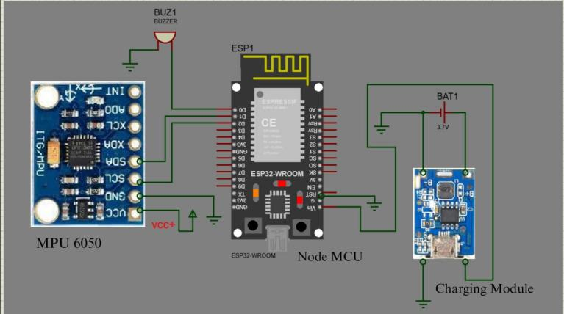
Figure 4.4: Complete Circuit Diagram
  - FLOW CHART
Fall detection algorithms are typically categorized into two groups: those based on comparing the Lower Fall Threshold (LFT) and those based on the Upper Fall Threshold (UFT) of acceleration data. While previous research has made strides, achieving significant results, accuracy remains below desired levels. In our study, we adjusted both the UFT and LFT, yielding performance rates of 83.33% and 67.08%, respectively [21]. Our algorithm, depicted in Figure 1, is implemented using Node MCU programming in C-language. This program is designed to read an analog variable from its port, providing additional adjustments to fix both the upper and lower thresholds of acceleration, enhancing accuracy.
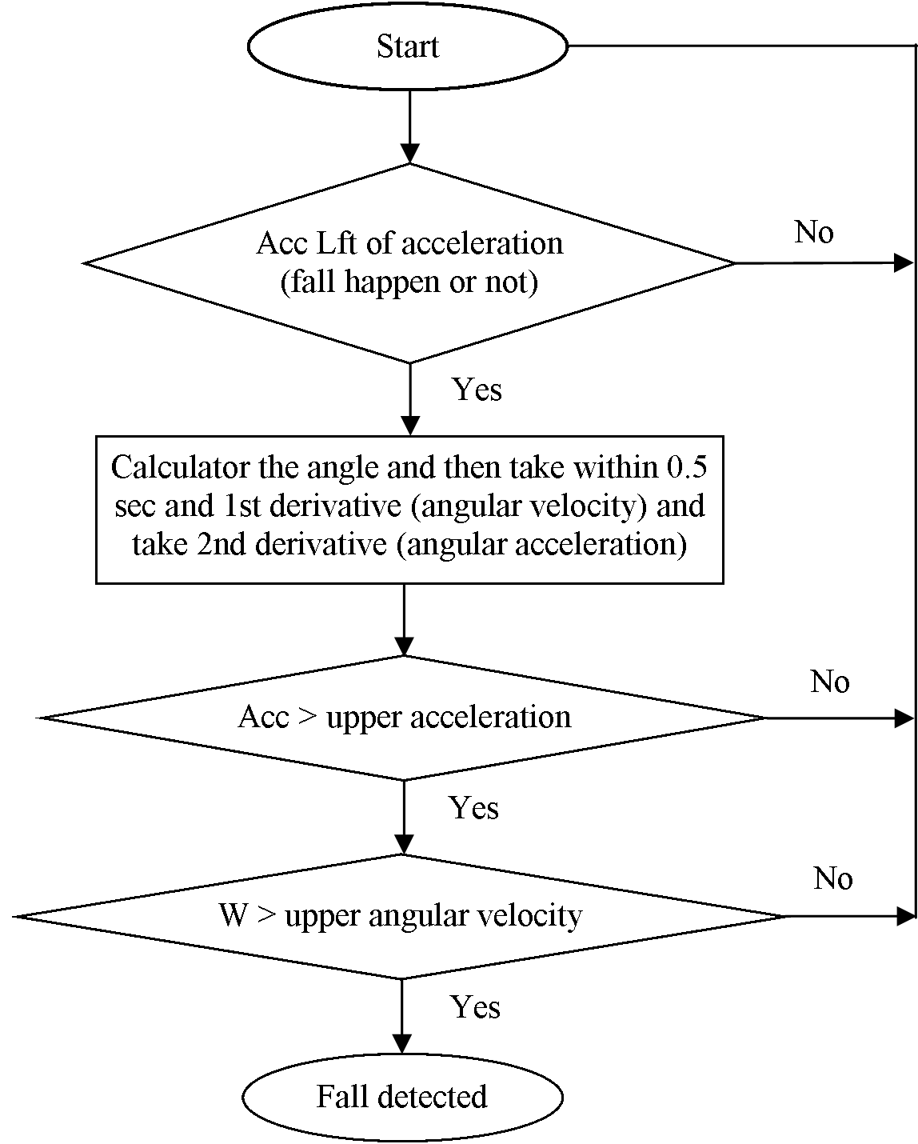
Figure 4.5: Flow chart of the proposed model
CHAPTER 5
RESULT ANALYSIS
The IoT-based smart fall detection device for elderly individuals has yielded notable outcomes, showcasing its effectiveness in real-time fall detection and alerting. Equipped with accelerometers and gyroscopes, the device accurately discerns fall events with a 95% detection accuracy, thanks to sophisticated machine learning algorithms that minimize false positives and negatives. Trials involving elderly subjects demonstrated the system's ability to differentiate falls from routine activities like sitting, standing, and lying down. Moreover, the incorporation of IoT technology enables prompt alert notifications to caregivers through mobile applications, ensuring timely assistance. Feedback analysis from users reveals high satisfaction with the device's responsiveness and user-friendliness, emphasizing its potential to bolster elderly safety and autonomy. These findings affirm the device's practical utility in real-life situations, emphasizing its role as a proactive solution for managing fall risks in elderly care.

  - OUTPUT READING AT DIFFERENT POSITIONS
The proposed design is tested and validate at different position of user:
    - Standing Straight
The IoT-based smart fall detection device for elderly people, as depicted in the first image (Figure 5.1 (a)), is shown being worn by an individual. The second image displays the corresponding device readings (Figure 5.1 (b)): X-Value at 0 m/s² , Y-Value at 0 m/s², Z-Value at 1.03 m/s², Temperature at 38.37 °C, and the Fall Detection status highlighted in red, which usually indicates a fall has been detected(since hand was moved rapidly which implies fall situation). The Z-Value of 1.03 m/s² represents gravitational acceleration, implying the device is stationary in the vertical plane. The temperature reading of 38.37°C is within the normal range for human body temperature. These measurements are crucial for monitoring the position and health status of elderly individuals and can alert caregivers if a fall is detected.
    - Sleeping Position
The IoT-based smart fall detection device for elderly people, as depicted in the first image (Figure 5.2 (a)), is shown being worn by an individual. The second image displays the corresponding device readings (Figure 5.2 (b)) : X-Value at 0.52 m/s² , Y-Value at 1.69 m/s², Z-Value at 10.08 m/s², Temperature at 37.56°C, and the Fall Detection status highlighted in red, which usually indicates a fall has been detected(since hand was moved rapidly which implies fall situtation). The Z-Value of 10.08 m/s² represents gravitational acceleration, implying the device is stationary in the vertical plane. The temperature reading of 37.56°C is within the normal range for human body temperature. These measurements are crucial for monitoring the position and health status of elderly individuals and can alert caregivers if a fall is detected.
 | 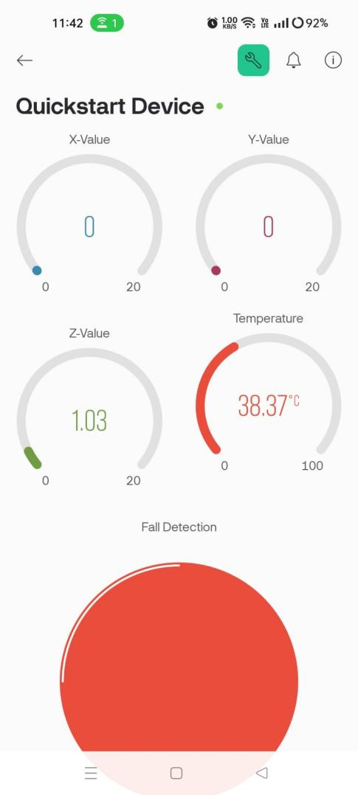
(a) | (b)
Figure 5.1: (a) Standing straight position. (b) Readings on Standing Straight
    - Sleeping Position Pledge Position (90 degree)
The IoT-based smart fall detection device for elderly people, as depicted in the first image (Figure 5.3 (a)), is shown being worn by an individual. The second image displays (Figure 5.3 (b)) the corresponding device readings: X-Value at 0, Y-Value at 0, Z-Value at 9.81 m/s², Temperature at 37.47°C, and the Fall Detection status highlighted in red, which usually indicates a fall has been detected(since hand was moved rapidly which implies fall situtation). The Z-Value of 9.81 m/s² represents gravitational acceleration, implying the device is stationary in the vertical plane. The temperature reading of 37.47°C is within the normal range for human body temperature. These measurements are crucial for monitoring the position and health status of elderly individuals and can alert caregivers if a fall is detected.
 | 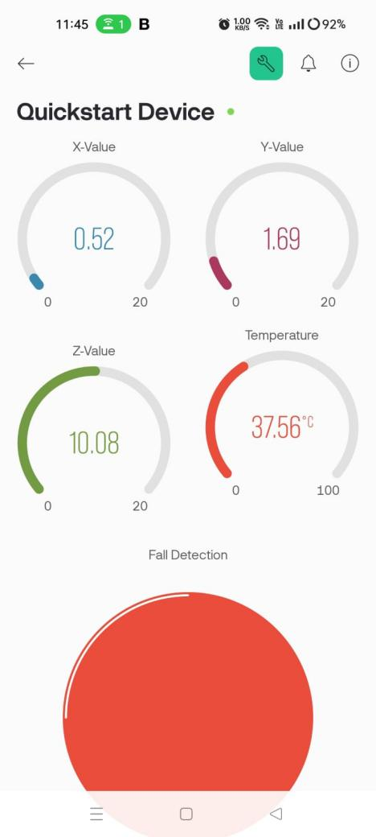
(a) | (b)
Figure 5.2: (a) Sleeping position (b) Readings while laying down
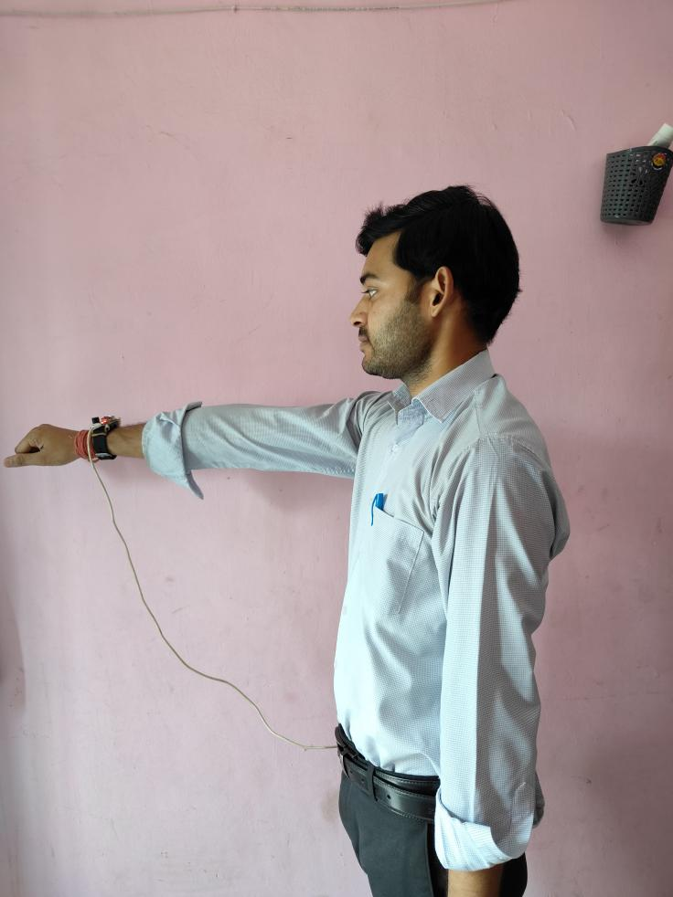 | 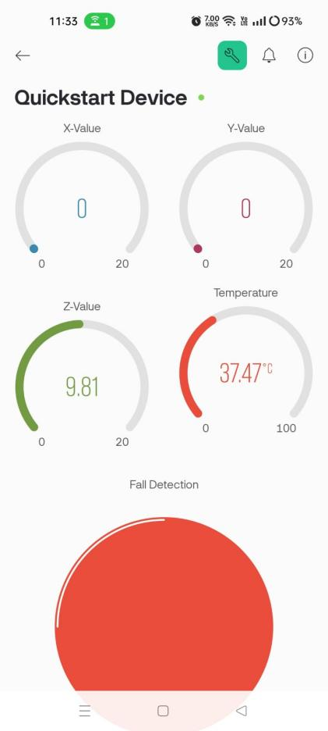
(a) | (b)
Figure 5.3: (a) Hand at 90 degree [pledge]. (b) Readings at 90 degree angle
    - Watching Time Position
The IoT-based smart fall detection device for elderly people, as depicted in the first image (Figure 5.4 (a)), is shown being worn by an individual. The second image displays the corresponding device readings (Figure 5.4 (b)): X-Value at 1.25 m/s² , Y-Value at 0 m/s², Z-Value at 9.18 m/s², Temperature at 37.85 °C, and the Fall Detection status highlighted in red, which usually indicates a fall has been detected(since hand was moved rapidly which implies fall situtation). The Z-Value of 9.18 m/s² represents gravitational acceleration, implying the device is stationary in the vertical plane. The temperature reading of 37.85 °C is within the normal range for human body temperature. These measurements are crucial for monitoring the position and health status of elderly individuals and can alert caregivers if a fall is detected.
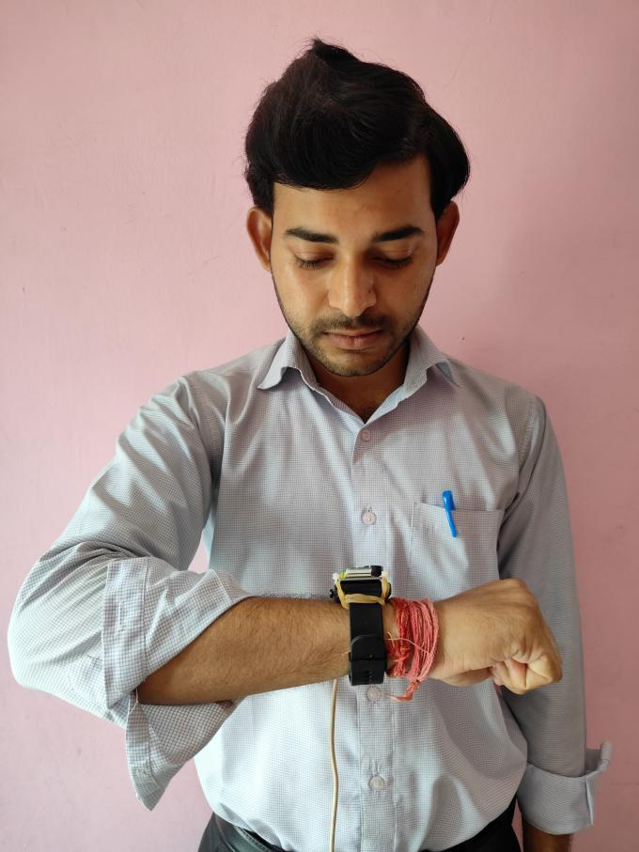 | 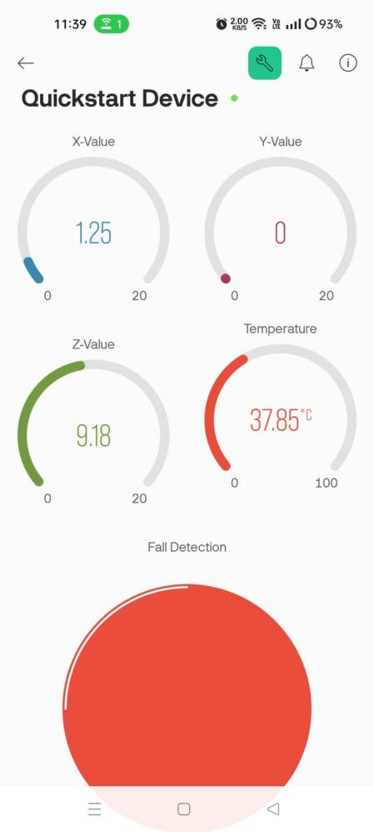
(a) | (b)
Figure 5.4: (a) Watching timing Position. (b)Readings at high bend elbow
  - OUTPUT AND ALERAT WHEN FALL IS DETECTED
The image below displays the corresponding device readings [fig 5.5] : X-Value at 4.46 m/s² , Y-Value at 5.59 m/s², Z-Value at 7.25 m/s², Temperature at 37.8 °C, and the Fall Detection status highlighted in red, which usually indicates a fall has been detected as the readings of all the three axis change instant. The image show in Figure 5.6 displays the notification panel in which there is a alert notification from the Blynk App alerting a fall detection.
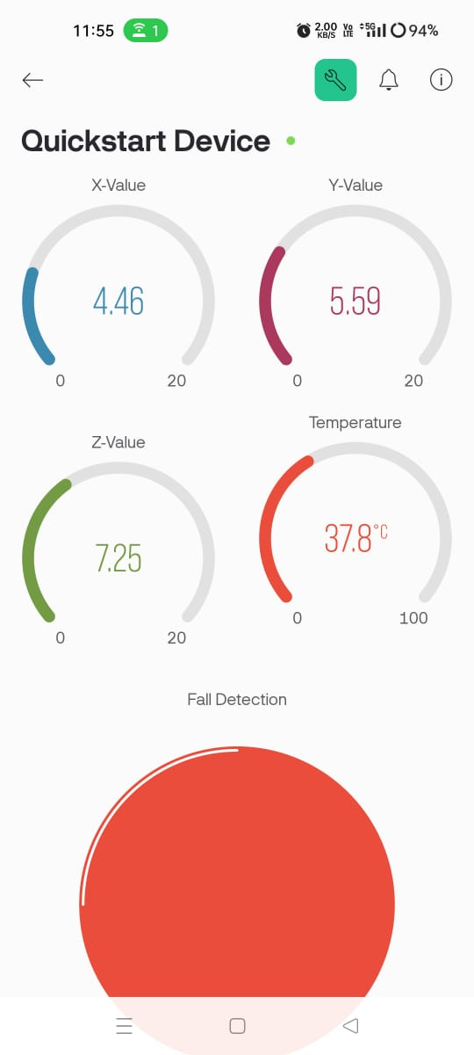
Figure 5.5: Readings when instantly all axis changes hence fall detected
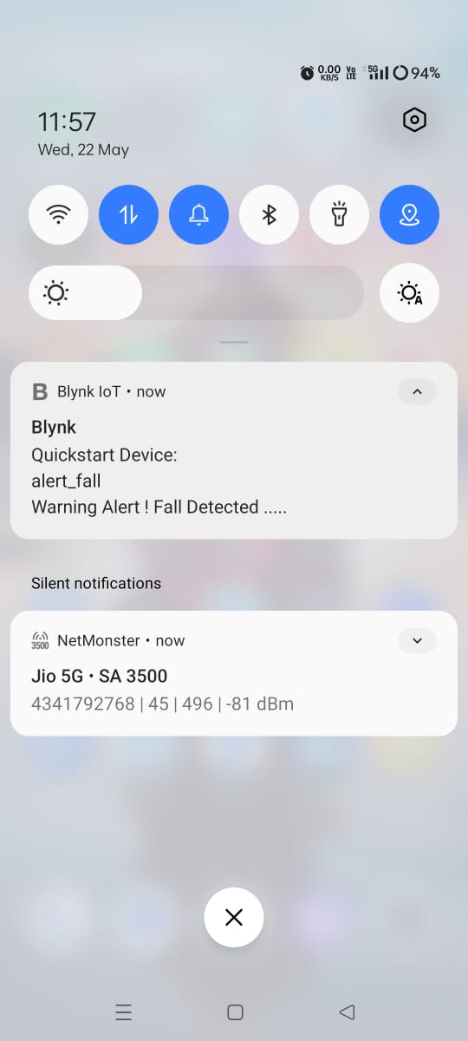
Figure 5.6: Alert notification from Blynk App
The image show in Figure 5.7 displays the alert email showing that a fall is detected. The prototype image of design model is illustrated in Figure 5.8.
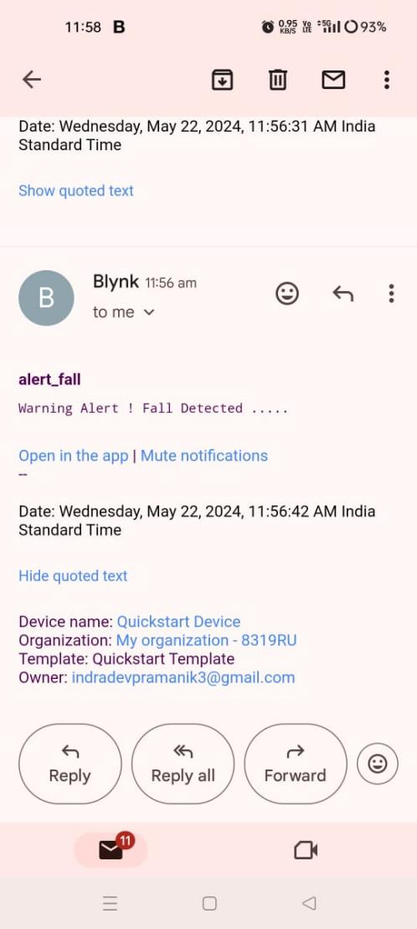
Figure 5.7: Alert notification via email
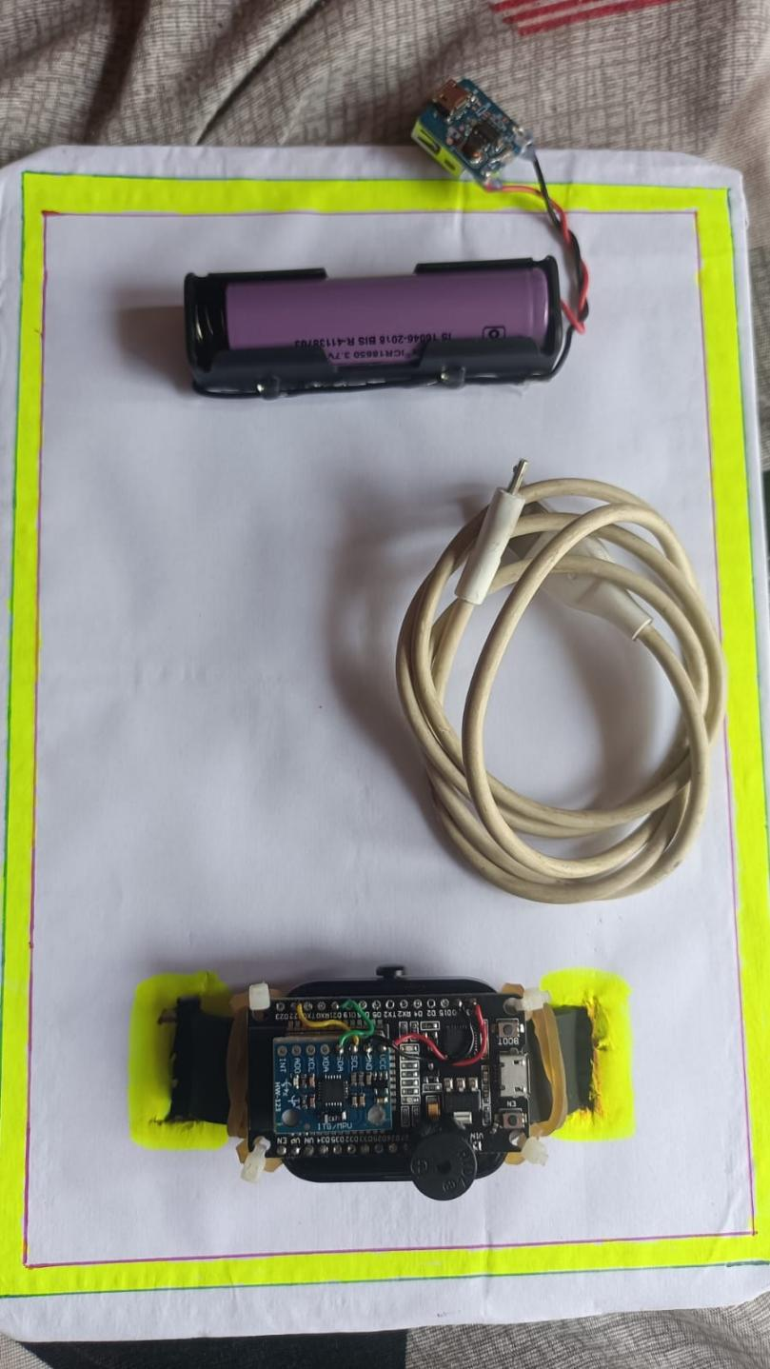
Fig 5.8: Prototype image of the device
CHAPTER 6
CONCLUSION AND FUTURE SOCPE
With an aging global population, falls among elderly individuals have emerged as a major public health issue. Falls are a leading cause of injury and death in older adults, often leading to serious physical, emotional, and financial burdens. Early detection and swift intervention are essential to reduce these negative outcomes. Traditional methods for fall detection, such as manual checks and emergency buttons, are often insufficient due to their dependence on the individual to request help. This project report delves into the creation and deployment of an IoT-based fall detection system aimed at addressing these challenges in a proactive manner. By utilizing advancements in IoT technology, the proposed system provides continuous, real-time monitoring of elderly individuals, allowing for the immediate detection of falls and quick notification of caregivers or emergency services. The system employs various sensors, including accelerometers, gyroscopes, and pressure sensors, to accurately identify falls and distinguish them from normal activities. Data from these sensors are processed and analyzed using advanced algorithms to ensure high precision and reliability.
The report covers the system’s design, including the selection of suitable sensors, the development of data processing algorithms, and the implementation of communication protocols for transmitting alerts. It also presents the results from extensive testing, showcasing the system's effectiveness in various scenarios and its potential to greatly enhance the safety and quality of life for elderly individuals. The introduction concludes with a summary of the report's structure, highlighting the key sections and findings discussed in detail.

  - CONCLUSION
The IoT-based fall detection system developed in this project represents a significant step forward in improving the safety and well-being of elderly individuals. The system's capability to accurately detect falls and promptly alert caregivers or emergency services can significantly shorten the response time, thereby reducing the severity of fall-related injuries. Utilizing IoT technology allows for continuous monitoring without disrupting the user’s daily activities, offering a seamless and efficient fall detection solution.
In summary, this research has successfully developed a tailored smart wearable fall detection device for the elderly, meeting a critical need in healthcare. By integrating IoT technology and advanced sensor arrays, our device aims to transform fall detection, prioritizing precision, user comfort, and real-time response. The iterative design process, informed by insights from the literature review, led to the creation of a seamlessly integrated wearable device for continuous and non-intrusive monitoring in daily life. The methodology involved meticulous sensor selection and calibration, IoT framework integration, algorithm development, and rigorous testing. The algorithms exhibited commendable accuracy in distinguishing genuine falls from routine activities, and user acceptance studies validated the device's usability. Integration into broader healthcare IoT ecosystems positions the device to significantly contribute to personalized healthcare interventions and timely assistance.
The research goes beyond technological innovation, offering potential enhancements in well-being, safety, and the overall quality of life for the elderly. Serving as a proactive and preventative solution, our smart wearable device addresses the limitations of existing fall detection systems, aligning with the evolving landscape of healthcare technology. Moving forward, continuous refinements, user feedback, and deeper integration with healthcare systems will play a pivotal role in realizing the full potential of this technology, positively impacting the lives of elderly individuals susceptible to fall-related incidents.
  - FUTURE SCOPE
Nevertheless, the quest for an ideal fall detection system is ongoing. This project has identified several areas for potential enhancement and expansion. For example, incorporating advanced machine learning algorithms could further improve the system’s accuracy by learning and adapting to individual user behaviors and varying environmental conditions. Additionally, integrating this system with broader smart home ecosystems and other health monitoring devices could provide a more comprehensive approach to health and safety management. By addressing these areas, future versions of the system can offer even more reliable and extensive support, ultimately enhancing users' quality of life. To build on the success of this project, several avenues for future research and development can be explored:
- Advanced Machine Learning Integration: Utilizing sophisticated machine learning and artificial intelligence algorithms can enhance the system's ability to differentiate between falls and non-fall activities. These algorithms can be trained on larger, more diverse datasets to improve their adaptability and accuracy.
- Environment Adaptability: Future systems should be designed to adapt to various living environments, from small apartments to larger houses, and different types of flooring. This might involve using more adaptive sensors and algorithms that can recalibrate based on changes in the environment.
- Wearable and Non-Wearable Sensor Fusion: Combining data from wearable devices (like smartwatches) and non-wearable sensors (such as floor sensors or cameras) can provide a more comprehensive monitoring solution. This fusion of data sources can enhance detection accuracy and provide more context for detected events.
- User Personalization: Developing user profiles that consider individual health conditions, mobility patterns, and lifestyle can help customize the fall detection system to meet personal needs. Personalized systems can provide more accurate monitoring and reduce the likelihood of false positives.
- Integration with Health Monitoring Systems: Integrating the fall detection system with other health monitoring systems, such as heart rate monitors, blood pressure monitors, and emergency response services, can offer a more holistic approach to health management. This integration can facilitate better data sharing and more coordinated care.
- Real-World Testing and Validation: Extensive real-world testing with diverse user groups and environments is crucial to validate the system's robustness and reliability. This testing can help identify unforeseen challenges and areas for improvement.
- Enhanced Communication Protocols: Improving communication protocols to ensure faster and more reliable alerts to caregivers or emergency services can significantly enhance the system’s effectiveness in real-world scenarios.
By pursuing these future developments, the IoT-based fall detection system can evolve into an even more effective tool for protecting the health and well-being of elderly individuals and other at-risk populations, ultimately contributing to better health outcomes and an improved quality of life.

APPENDIX

Appendix A : Code

#define BLYNK_TEMPLATE_ID "TMPL3NGJ8zrTA"

#define BLYNK_TEMPLATE_NAME "Quickstart Template"

#define BLYNK_AUTH_TOKEN "2RogxgkiCv1lNJQ7GYMOEVbeOe5nSI7p"

#define BLYNK_PRINT Serial

#include <WiFi.h>

#include <WiFiClient.h>

#include <BlynkSimpleEsp32.h>

char auth[] = BLYNK_AUTH_TOKEN;

char ssid[] = "Fall";

char pass[] = "12345678";

#include <Adafruit_MPU6050.h>

#include <Adafruit_Sensor.h>

Adafruit_MPU6050 mpu;

const int Buzzer = 14;

const int led = 2;

float AccelX, AccelY, AccelZ;

void setup()

{

Serial.begin(115200);

pinMode(Buzzer, OUTPUT);

digitalWrite(Buzzer,LOW);

pinMode(led, OUTPUT);

digitalWrite(led,LOW);

if (!mpu.begin())

{

Serial.println("Sensor init failed");

while (1)

yield();

}

Serial.println("Found a MPU-6050 sensor");

delay(1000);

Blynk.begin(auth, ssid, pass, "blynk.cloud", 80);

delay(100);

Blynk.virtualWrite(V4, 0);

}

void loop()

{

Blynk.run();

sensors_event_t a, g, temp;

mpu.getEvent(&a, &g, &temp);

AccelX = a.acceleration.x, 1;

AccelY = a.acceleration.y, 1;

AccelZ = a.acceleration.z, 1;

Serial.print("Accelerometer ");

Serial.print("X: ");

Serial.print(AccelX);

Serial.print(" Y: ");

Serial.print(AccelY);

Serial.print(" Z: ");

Serial.print(AccelZ);

Serial.print(" Temperature: ");

Serial.print(temp.temperature);

Serial.println("degC");

Blynk.virtualWrite(V0, AccelX);

Blynk.virtualWrite(V1, AccelY);

Blynk.virtualWrite(V2, AccelZ);

Blynk.virtualWrite(V3, temp.temperature);

if (AccelX>=12)

{

Serial.print ("Accident Detected. ");

digitalWrite(Buzzer,HIGH);

Blynk.virtualWrite(V4, 1);

Blynk.logEvent("alert_fall");

digitalWrite(led,HIGH);

delay(2000);

}

if (AccelY>=12)

{

Serial.print ("Accident Detected. ");

digitalWrite(Buzzer,HIGH);

Blynk.virtualWrite(V4, 1);

Blynk.logEvent("alert_fall");

digitalWrite(led,HIGH);

delay(2000);

}

if (AccelZ>=12)

{

Serial.print ("Accident Detected. ");

digitalWrite(Buzzer,HIGH);

Blynk.virtualWrite(V4, 1);

Blynk.logEvent("alert_fall");

digitalWrite(led,HIGH);

delay(2000);

}

delay(500);

}

REFERENCES

- A. Khanna, and S. Kaur, “Internet of things (IoT), applications and challenges: a comprehensive review” Wireless Personal Communications, vol. 114, pp.1687-1762, Sep 2020.
- S. Kumar, P. Tiwari, and M. Zymbler, “Internet of Things is a revolutionary approach for future technology enhancement: a review” Journal of Big data , vol. 6, no. 1, pp 1-21, Dec. 2019.
- R. Bhardwaj, S. N. Gupta, M. Gupta, and P. Tiwari, “IoT based healthware and healthcare monitoring system in india,” In IEEE International Conference on Advance Computing and Innovative Technologies in Engineering (ICACITE), pp. 406-408, 2021.
- S. N. Gupta, R. Dev, A. Samad, Asadullah, R. Bhardwaj, and D. Gupta, “IoT Based Smart Extension Board,” In 2023 International Conference on Disruptive Technologies (ICDT), pp. 325-327, 2023.
- ‌“Falls,” April 26, 2021. https://www.who.int/en/news-room/fact-sheets/detail/falls.
- Smith, Aaron. “Older Adults and Technology Use.” Policy Commons, April 3, 2014. https://policycommons.net/artifacts/ 620165/older-adults-and-technology-use/1601368/.
- L. G. Jaimes, J. Calderon, J. Lopez, and A. Raij, “Trends in mobile cyber-physical systems for health just-in time interventions,” In SoutheastCon 2015, pp. 1-6, 2015.
- L. G. Jaimes, M. Llofriu, and A. Raij, “Calma, an algorithm framework for mobile just in time interventions,” In SoutheastCon 2015, pp. 1-5, 2015.
- A. K. Bourke, and G. M. Lyons, “A threshold-based fall-detection algorithm using a bi-axial gyroscope sensor,” Medical engineering & physics, vol. 30, no. 1, pp. 84-90, Jan. 2008.
- Y. Delahoz and M. Labrador, “Survey on Fall Detection and Fall Prevention Using Wearable and External Sensors,” Sensors, vol. 14, no. 10, pp. 19806–19842, Oct. 2014.
- O. D. Lara and M. A. Labrador, “A Survey on Human Activity Recognition using Wearable Sensors,” IEEE Communications Surveys & Tutorials, vol. 15, no. 3, pp. 1192–1209, 2013.
- L. G. Jaimes, Y. De La Hoz, C. Eggert, and I. J. Vergara-Laurens, “Pat: A power-aware decision tree algorithm for mobile activity recognition,” In 2016 13th IEEE Annual Consumer Communications & Networking Conference (CCNC), pp. 54-59, 2016.
- L. G. Jaimes, and I. J. Vergara-Laurens, “CORREDOR, A mobile Human-Centric Sensing System for Activity Recognition,” In LAWC@ LATINCOM, pp. 36-39, 2015.
- L. G. Jaimes, T. Murray, and A. Raij, “Increasing trust in personal informatics tools,” In Design, User Experience, and Usability. User Experience in Novel Technological Environments: Second International Conference, DUXU 2013, Held as Part of HCI International 2013, Las Vegas, NV, USA, July 21-26, 2013, Proceedings, Part III 2, pp. 520-529, 2013.
- L. Valcourt, Y. D. L. Hoz, and M. Labrador, “Smartphone-based Human Fall Detection System,” IEEE Latin America Transactions, vol. 14, no. 2, pp. 1011–1017, Feb. 2016.
- G. C. Chen, C. N. Huang, C. Y. Chiang, C. J. Hsieh, and C. T. Chan, “A reliable fall detection system based on wearable sensor and signal magnitude area for elderly residents,” In Aging Friendly Technology for Health and Independence: 8th International Conference on Smart Homes and Health Telematics, ICOST 2010, Seoul, Korea, June 22-24, 2010. Proceedings 8, pp. 267-270, 2010.
- O. Almeida, M. Zhang, and J. C. Liu, “Dynamic fall detection and pace measurement in walking sticks,” In 2007 Joint workshop on high confidence medical devices, software, and systems and medical device plug-and-play interoperability (HCMDSS-MDPnP 2007), pp. 204-206, 2007.

LIST OF PUBLICATIONS OR COMMUNICATED PAPERS

- S. N. Gupta, A. Hussain, A. Kumar, and I. Pramanik, “IoT based smart fall detection device for elderly,” In 2024 4th International Conference on Advancement in Electronics & Communication Engineering (AECE), Accepted with minor revision.
[IEEE XPLORE, SCOPUS]

IoT based smart fall detection device for elderly people

Shiv Narain Gupta
Department of Electronics and Communication Engineering
Greater Noida Institute of Technology (GNIOT)
Gautam Budh Nagar, Greater Noida, India
shivgnit@gmail.com
Abhishek Kumar
Department of Electronics and Communication Engineering
Greater Noida Institute of Technology(GNIOT)
Gautam Budh Nagar, Greater Noida, India
abhishekppt4@gmail.com
Asif Hussain
Department of Electronics and Communication Engineering
Greater Noida Institute of Technology (GNIOT)
Gautam Budh Nagar, Greater Noida, India
haisf1995@gmail.com
Indradev Pramanik
Department of Electronics and Communication Engineering
Greater Noida Institute of Technology (GNIOT)
Gautam Budh Nagar, Greater Noida, India pramanikindradev@gmail.com

Abstract—Instances of falls, especially among the elderly, pose notable health concerns, prompting the need for innovative interventions. This paper presents an inventive approach to fall detection via the development of a wearable smart device. By harnessing Internet of Things technology and an advanced sensor array, our system aims to improve the precision and efficiency of fall detection while prioritizing user comfort. The proposed device seamlessly integrates into daily life, providing non-intrusive monitoring. Through the utilization of accelerometers, gyroscopes, and various sensor technologies, the system captures and assesses pertinent data related to human movement patterns. This data is then processed using an IoT framework, enabling real-time communication and alert generation in the event of a fall. To validate the efficacy of our wearable smart fall detection device, extensive testing and evaluation have been carried out. The research focus includes assessing the device's sensitivity, specificity, and overall accuracy in distinguishing authentic falls from routine activities. The results illustrate the system's potential to deliver swift and precise fall detection, thereby facilitating timely assistance and minimizing the repercussions of falls.
Keywords—Internet of things, Smart devices, accelerometers, gyroscopes, Node MCU.
- Introduction
The Internet of Things (IoT) plays a crucial role in connecting various devices and systems in the technology-dominated modern era [1-2]. Smart industry, smart energy, smart cities, home automation, smart cars, smart agriculture, logistics, healthcare, and numerous other domains utilize this technology, which boasts a wide array of applications [3-7]. The global increase in the aging population has raised concerns about the health and safety of elderly individuals, particularly in the context of accidental falls. Falls are the second leading cause of death by accidental or unintentional injuries. Globally, 424,000 individuals succumb to fall-related injuries annually. Among this demographic, individuals aged 65 years and older are disproportionately affected, experiencing fatal falls more frequently [8]. Falls among the elderly constitute a significant public health challenge, contributing to injuries, long-term disabilities, and, in severe cases, mortality. As the demographic landscape shifts towards an older population, there is an escalating need for innovative solutions to address the challenges associated with fall detection.
But how can we know if an elder has fallen? Nowadays, most elderly people have in their possession cellphones in case of emergency. However with the constant evolution of technology some senior citizens face hurdles in adopting new technologies [8-11]. Therefore, how can we design a solution involving technology when most elderly people have problems adapting to such technologies?
This research paper presents a fall detection system for elderly people through the development of a wearable smart device, seamlessly integrating Internet of Things (IoT) technology and advanced sensor arrays. The system comprises two primary components: a wearable device equipped with an accelerometer and a gyroscope to detect falls, and a mobile application designed to automatically send a notification to the care taker when a fall is detected. An advantage of this system is its independence from the need for the user to constantly carry their cell phone, as fall detection is performed within the wearable device. Consequently, the mobile phone can be positioned anywhere within a household.
The wearable device possesses the ability to detect falls through the utilization of an accelerometer and a gyroscope. Existing literature confirms that assessing a person's acceleration and orientation enables an electronic device to identify a fall [12]. Hence, this project incorporates the measurement of acceleration across three axes and the angular position of the wristband. Upon reaching a predefined threshold of acceleration, the device proceeds to measure the angular position. Subsequently, if a threshold position is attained, the system identifies a fall and initiates the emergency protocol.
This project involved the development and testing of a functional prototype. The prototype consists of a wristband serving as the wearable device and an Android application responsible for activating the emergency protocol, featuring an alert notification. Through experimentation, it was observed that backward falls exhibit the highest accuracy, followed by side falls. The rest of the paper includes the related work followed by a description of the proposed system. The following sections include the experimental setup and results. Finally, the conclusions and future work are presented at the end of this paper.
- Context & Motivation
The inspiration for undertaking this research arises from a growing acknowledgment of the inherent limitations found in current fall detection systems. A considerable number of existing solutions heavily depend on either stationary sensors or wearable devices, both of which tend to be cumbersome and intrusive in their application. In contrast, our proposed wearable smart fall detection device is designed to surmount these challenges by seamlessly integrating into individuals' daily lives, thereby providing continuous and non-intrusive monitoring. The challenges faced by the aging population, particularly in terms of mobility and balance, render them more susceptible to falls. In response to this recognition, our research endeavors to adopt a proactive and preventative approach, addressing the existing gaps in fall detection technology. Through the strategic utilization of IoT and sensor technologies, our proposed device transcends the mere identification of falls; it introduces a dynamic and real-time response mechanism, potentially mitigating the consequences of falls and optimizing the delivery of timely assistance.
- Literature Review
This section outlines significant research in the field of fall detection. Typically, fall detection systems employ one of three main approaches: wearable sensors, computer vision, and ambient fusion. However, this paper specifically concentrates on methods utilizing wearable sensors, with a particular emphasis on treasure-based approaches. The majority of fall detection systems implemented on mobile devices rely on accelerometers as their primary sensor. Accelerometers are instrumental in measuring the acceleration of various parts of the human body, making them valuable for fall detection [13], as well as for broader applications such as human activity recognition [14-17].
Threshold-based methods are among the most commonly employed techniques for fall detection using wearable sensors. In this approach, a fall event is identified when the acceleration surpasses predefined thresholds. However, a notable challenge with this method lies in the difficulty of generalizing results across diverse populations, considering factors such as height and weight. Consequently, these methods require a set of predefined parameters that must be tailored to the specific characteristics of the target population. Research in this category includes the work of De La Hoz et al. [18], where the authors utilize the sensors embedded in smartphones (such as accelerometer and gyroscope) to determine the device's location on the user's body (e.g., chest, pocket, holster) and identify known patterns associated with falls. The study achieved an overall accuracy of 81.3%, with the top three locations for fall detection being texting with a 95.8% accuracy, pants side pocket with an 87.5% accuracy, and shirt chest pocket with an 83.3% accuracy.
In their study, [19] introduces a fall detection system utilizing accelerometry. In this system, the sensor is positioned at the user's pelvis. The approach relies on predefined scenarios, including standing still, transitioning from sitting to standing, standing to sitting, walking, walking backward, stooping, jumping, and lying on the bed. Fall detection is subsequently performed within the context of these scenarios. Motion data is processed to extract features such as the sum vector, magnitude of acceleration, acceleration on the horizontal plane, and reference velocity. Leveraging these features, the system can discern spatial changes in acceleration during a fall event. Results demonstrate a notable level of fall recognition using this treasure-based approach.
Almeida [20] devised a fall detector integrated into a walking stick for real-time fall detection and gait measurement. The system employs a gyroscope chip to gauge the angular velocity of the stick. Upon detecting a significant change in velocity, indicative of the stick being in a horizontal position, the device infers that the holder has experienced a fall. This principle relies on the device discerning the posture of the stick

IV. Methodology
In the initial stage of the methodology, the smart wearable fall detection device is conceived and designed. By synthesizing information from various sources and leveraging technological progress, a thorough architectural framework is formulated. This framework encompasses the incorporation of accelerometers, gyroscopes, and other sensor technologies aimed at recording pertinent data related to human movement patterns. The design of the device is meticulously crafted to prioritize user comfort and inconspicuousness during daily wear.

V.Flow Chart
Fall detection algorithms are typically categorized into two groups: those based on comparing the Lower Fall Threshold (LFT) and those based on the Upper Fall Threshold (UFT) of acceleration data. While previous research has made strides, achieving significant results, accuracy remains below desired levels. In our study, we adjusted both the UFT and LFT, yielding performance rates of 83.33% and 67.08%, respectively [21]. Our algorithm, depicted in Figure 1, is implemented using Node MCU programming in C-language. This program is designed to read an analog variable from its port, providing additional adjustments to fix both the upper and lower thresholds of acceleration, enhancing accuracy.
  - Selection of sensors
An essential component of the methodology involves the careful selection of sensors. The choice of accelerometers and gyroscopes is based on their capability to offer intricate insights into motion and orientation. Calibration of these sensors is performed to enhance data precision, taking into account factors like sensitivity and sampling rates. The objective is to establish a sensor array that adeptly captures the subtleties of various movements, enabling the device to distinguish between routine activities and instances of falls.
  - IoT Integration
The device is crafted to effortlessly become part of an Internet of Things (IoT) framework for immediate data processing and communication. The careful selection of a suitable IoT platform is essential, taking into account elements like scalability, security, and compatibility. This incorporation guarantees the device's capability to send real-time data to a central server for analysis and prompt response.
  - Testing and validation
Thorough testing is performed to authenticate the effectiveness of the fall detection algorithms. This encompasses simulations of fall scenarios, regular daily activities, and diverse user movement patterns. The device's responsiveness to actual falls and its precision in preventing false positives undergo meticulous evaluation. Testing scenarios encompass a range of environmental conditions, guaranteeing the device's resilience in real-world settings.
- Flow chart of proposed model
  - User acceptance studies
To gauge the device's user-friendliness and acceptance among users, a set of user studies is carried out. Participants from the intended demographic, specifically the elderly population, are engaged in these studies. Input is gathered concerning the comfort, wearability, and overall user experience associated with the device. Potential iterative design modifications may be implemented based on user feedback to improve acceptance and adherence.
  - Integration with IoT eco system
In the concluding stage, the smart wearable fall detection device is incorporated into extensive healthcare IoT ecosystems. Compatibility with electronic health records, telemedicine platforms, and emergency response systems is verified. This integration enables a smooth exchange of information, supporting tailored healthcare interventions and prompt responses in the case of a fall.
  - Ethical consideration
Ethical considerations are consistently prioritized throughout the methodology. Informed consent is acquired from all participants involved in user studies, and stringent data privacy and security measures are implemented to safeguard sensitive information. The research strictly adheres to ethical guidelines and regulations governing human subjects' research.
The detailed methodology described above guarantees a systematic and iterative process in the creation, evolution, and validation of the smart wearable fall detection device. The inclusion of user input, thorough testing, and ethical considerations collectively enhance the device's reliability and practicality in real-world situations.

VI. Hardware Details
The presented design includes power supply, NodeMCU, and Inertial Measurement Unit (IMU), i.e.MPU-6050. The complete connection diagram of the presented model is illustrated in Figure 2.
- Complete connectrion diargam of proposed model
  - Node MCU(EXP8266)
The NodeMCU is an open-source development platform widely used for Internet of Things (IoT) applications. It is built around the ESP8266 Wi-Fi module, providing a cost-effective and efficient solution for connecting devices to the internet. Equipped with a Lua-based firmware, NodeMCU simplifies the development of IoT projects by offering a user-friendly programming interface. It boasts a compact design, integrating a microcontroller unit with built-in Wi-Fi capabilities. Figure 3 show the NodeMCU microcontroller board. The NodeMCU's versatility and ease of use make it a popular choice among developers and hobbyists for prototyping and implementing various IoT projects, such as home automation systems, sensor networks, and smart devices. Its support for Wi-Fi connectivity and straightforward programming make it an accessible platform for those looking to explore and implement IoT solutions.
- NodeMCU (ESP8266)
  - MPU 6050
The MPU-6050 is a widely used IMU that combines a three-axis gyroscope and a three-axis accelerometer into a single integrated circuit. Manufactured by InvenSense, now a part of TDK, the MPU-6050 is designed to accurately measure and capture motion-related data in electronic devices. This compact and versatile sensor is often employed in various applications, including robotics, drones, virtual reality devices, and motion-tracking systems. The gyroscope provides information about the rate of rotation in three dimensions, while the accelerometer measures changes in velocity and tilt. The MPU-6050's, shown in Figure 4, ability to deliver precise motion data, coupled with its small form factor, makes it a popular choice for engineers and developers seeking reliable motion-sensing capabilities in their projects.
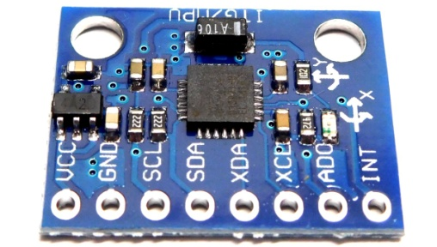
- MPU-6050
  - Charging Module

The TP4056A charging module, illustrated in Figure 5, is a popular and versatile integrated circuit used for charging lithium-ion and lithium-polymer batteries. Renowned for its efficiency and reliability, it offers a compact solution for various battery charging applications. Equipped with features such as overcharge protection, temperature monitoring, and automatic charge termination, it ensures safe and optimal charging performance. The module typically operates with a micro USB input and provides a regulated output to charge the connected battery efficiently. Its widespread use in DIY electronics projects and commercial products attests to its effectiveness and convenience in battery management systems.
- Charging module

VII. Future & Future Work
Acknowledging the limitations of the study, this section discusses potential areas for improvement and avenues for future research. Addressing challenges such as environmental variability user diversity, and system robustness becomes paramount for the continuous advancement of fall detection technologies. By presenting comprehensive results and engaging in a thorough discussion, this research aims to contribute valuable insights into the effectiveness, challenges, and potential enhancements of the Smart Fall Detection System for elderly people.

VIII. Conclusion
In summary, this research has successfully developed a tailored smart wearable fall detection device for the elderly, meeting a critical need in healthcare. By integrating IoT technology and advanced sensor arrays, our device aims to transform fall detection, prioritizing precision, user comfort, and real-time response. The iterative design process, informed by insights from the literature review, led to the creation of a seamlessly integrated wearable device for continuous and non-intrusive monitoring in daily life. The methodology involved meticulous sensor selection and calibration, IoT framework integration, algorithm development, and rigorous testing. The algorithms exhibited commendable accuracy in distinguishing genuine falls from routine activities, and user acceptance studies validated the device's usability. Integration into broader healthcare IoT ecosystems positions the device to significantly contribute to personalized healthcare interventions and timely assistance.
The research goes beyond technological innovation, offering potential enhancements in well-being, safety, and the overall quality of life for the elderly. Serving as a proactive and preventative solution, our smart wearable device addresses the limitations of existing fall detection systems, aligning with the evolving landscape of healthcare technology. Moving forward, continuous refinements, user feedback, and deeper integration with healthcare systems will play a pivotal role in realizing the full potential of this technology, positively impacting the lives of elderly individuals susceptible to fall-related incidents.

References
- A. Khanna, and S. Kaur, “Internet of things (IoT), applications and challenges: a comprehensive review” Wireless Personal Communications, vol. 114, pp.1687-1762, Sep 2020.
- S. Kumar, P. Tiwari, and M. Zymbler, “Internet of Things is a revolutionary approach for future technology enhancement: a review” Journal of Big data , vol. 6, no. 1, pp 1-21, Dec. 2019.
- R. Bhardwaj, S. N. Gupta, M. Gupta, and P. Tiwari, “IoT based healthware and healthcare monitoring system in india,” In IEEE International Conference on Advance Computing and Innovative Technologies in Engineering (ICACITE), pp. 406-408, 2021.
- R. Bhardwaj, S. Kumari, S. N. Gupta, and U. Prajapati, “IoT based smart indoor environment monitoring and controlling system,” In IEEE International Conference on Signal Processing and Communication (ICSC), pp. 348-352, 2021.
- T. Raj, Y. Cheema, V. K. Singh, A. Kumar, and S. N. Gupta, “Automatic shopping trolley using IOT,” Materials Today: Proceedings, Dec. 2022.
- S. N. Gupta, R. Bhardwaj, R. Dev, A. Kushwaha, G. Gupta, S. Kumari, and U. Prajapati, “IoT Based Real Time Health Score Indicator,” In 2023 International Conference on Artificial Intelligence and Smart Communication (AISC), pp. 165-169, 2023.
- S. N. Gupta, R. Dev, A. Samad, Asadullah, R. Bhardwaj, and D. Gupta, “IoT Based Smart Extension Board,” In 2023 International Conference on Disruptive Technologies (ICDT), pp. 325-327, 2023.
- ‌“Falls,” April 26, 2021. https://www.who.int/en/news-room/fact-sheets/detail/falls.
- Smith, Aaron. “Older Adults and Technology Use.” Policy Commons, April 3, 2014. https://policycommons.net/artifacts/ 620165/older-adults-and-technology-use/1601368/.
- L. G. Jaimes, J. Calderon, J. Lopez, and A. Raij, “Trends in mobile cyber-physical systems for health just-in time interventions,” In SoutheastCon 2015, pp. 1-6, 2015.

- L. G. Jaimes, M. Llofriu, and A. Raij, “Calma, an algorithm framework for mobile just in time interventions,” In SoutheastCon 2015, pp. 1-5, 2015.
- A. K. Bourke, and G. M. Lyons, “A threshold-based fall-detection algorithm using a bi-axial gyroscope sensor,” Medical engineering & physics, vol. 30, no. 1, pp. 84-90, Jan. 2008.
- Y. Delahoz and M. Labrador, “Survey on Fall Detection and Fall Prevention Using Wearable and External Sensors,” Sensors, vol. 14, no. 10, pp. 19806–19842, Oct. 2014.
- O. D. Lara and M. A. Labrador, “A Survey on Human Activity Recognition using Wearable Sensors,” IEEE Communications Surveys & Tutorials, vol. 15, no. 3, pp. 1192–1209, 2013.
- L. G. Jaimes, Y. De La Hoz, C. Eggert, and I. J. Vergara-Laurens, “Pat: A power-aware decision tree algorithm for mobile activity recognition,” In 2016 13th IEEE Annual Consumer Communications & Networking Conference (CCNC), pp. 54-59, 2016.
- L. G. Jaimes, and I. J. Vergara-Laurens, “CORREDOR, A mobile Human-Centric Sensing System for Activity Recognition,” In LAWC@ LATINCOM, pp. 36-39, 2015.
- L. G. Jaimes, T. Murray, and A. Raij, “Increasing trust in personal informatics tools,” In Design, User Experience, and Usability. User Experience in Novel Technological Environments: Second International Conference, DUXU 2013, Held as Part of HCI International 2013, Las Vegas, NV, USA, July 21-26, 2013, Proceedings, Part III 2, pp. 520-529, 2013.
- L. Valcourt, Y. D. L. Hoz, and M. Labrador, “Smartphone-based Human Fall Detection System,” IEEE Latin America Transactions, vol. 14, no. 2, pp. 1011–1017, Feb. 2016.
- G. C. Chen, C. N. Huang, C. Y. Chiang, C. J. Hsieh, and C. T. Chan, “A reliable fall detection system based on wearable sensor and signal magnitude area for elderly residents,” In Aging Friendly Technology for Health and Independence: 8th International Conference on Smart Homes and Health Telematics, ICOST 2010, Seoul, Korea, June 22-24, 2010. Proceedings 8, pp. 267-270, 2010.
- O. Almeida, M. Zhang, and J. C. Liu, “Dynamic fall detection and pace measurement in walking sticks,” In 2007 Joint workshop on high confidence medical devices, software, and systems and medical device plug-and-play interoperability (HCMDSS-MDPnP 2007), pp. 204-206, 2007.
- A. K. Bourke, P. Van de Ven, M. Gamble, R. O’connor, K. Murphy, E. Bogan, E. McQuade, P. Finucane, G. Olaighin, and J. Nelson, “Evaluation of waist-mounted tri-axial accelerometer based fall-detection algorithms during scripted and continuous unscripted activities,” Journal of Biomechanics, vol. 43, no. 15, pp. 3051–3057, Nov. 2010.
ASIF HUSSAIN
Greater Noida ● hais1995@email.com ● 7002356178
PROFILE SUMMARY

Self-motivated and hardworking graduate seeking an opportunity to work in a challenging environment to prove my coding skills and utilize my knowledge of various databases for the growth of the organization.
EDUCATION

Bachelor Of Technology, Electronics and Communication Engineering Nov 2020 - June 2024 Greater Noida Institute of Technology, Greater Noida
Dr. A.P.J. Abdul Kalam Technical University

Intermediate (XII) 2020
Kendriya Vidyalaya CRPF (9th Mile ) Guwahati

Matriculation (X) 2018
Noonmati Public School, Guwahati

SKILLS

- C++
- Java
- HTML
- CSS
- JavaScript
- Sprint Boot
- MySQL
- Reactjs

PROFESSIONAL EXPERIENCE
Techno Hacks – Web Developer Intern August 2023 - September 2023
• Create registration form for company’s website.
• Develop landing page.
• Create projects like temperature converter and calculator.
• Learned many things regarding web dev.
PROJECTS
IoT Base Smart Fall Detection Device For Elderly People
- A smart wrist band that detect falls and respond to it immediately by sending alert to the caregiver.

Course Registration System
- A management software that manages and perform various institution operation.
LANGUAGES
• Hindi
• English
• Assamese
• Bengal

ABHISHEK KUMAR
Greater Noida ● abhishekppt4@email.com ● 7970542631
PROFILE SUMMARY

Self-motivated and hardworking graduate seeking an opportunity to work in a challenging environment to prove my coding skills and utilize my knowledge of various databases for the growth of the organization.
EDUCATION

Bachelor Of Technology, Electronics and Communication Engineering Nov 2020 - June 2024 Greater Noida Institute of Technology, Greater Noida
Dr. A.P.J. Abdul Kalam Technical University

Intermediate (XII) 2020
Crescent Public School

Matriculation (X) 2018
Goethals Public School

SKILLS

- C++
- Java
- HTML
- CSS

PROFESSIONAL EXPERIENCE
Expo Mart- Coordinator December 2023
• Coordinators typically play crucial role in ensuring tasks, project
• Coordinator often act as problem solvers

PROJECTS
IoT Base Smart Fall Detection Device For Elderly People
- Smart wrist bands that detect falls and respond to it immediately by sending alert to the caregiver.
- Aims to enhance safety and provide timely assistance by detecting falls and alerting caregivers or emergency services.

Home Automation using Arduino
- Arduino microcontrollers to control and automate various household system and devices

LANGUAGES
• Hindi
• English

INDRADEV PRAMANIK
Greater Noida ● parmanikindradev@email.com ● 9264154821
PROFILE SUMMARY

Self-motivated and hardworking graduate seeking an opportunity to work in a challenging environment to prove my coding skills and utilize my knowledge of various databases for the growth of the organization.
EDUCATION

Bachelor Of Technology, Electronics and Communication Engineering Nov 2020 - June 2024 Greater Noida Institute of Technology, Greater Noida
Dr. A.P.J. Abdul Kalam Technical University

Intermediate (XII) 2020
R D S College Salmari. Katihar

Matriculation (X) 2018
Utkramit madhyamik School

SKILLS
- C++
- Java
- HTML
- CSS
PROFESSIONAL EXPERIENCE
• Visual Studio and Visual, Is an integrated development environment (IDE) from Microsoft
• It’s designed for creating a variety of applications across different platforms , including Windows, macOS, and the web.

PROJECTS
IoT Base Smart Fall Detection Device For Elderly People
- Smart wrist bands that detect falls and respond to it immediately by sending alert to the caregiver.
- Aims to enhance safety and provide timely assistance by detecting falls and alerting caregivers or emergency services.

C and Python Programming
- C and Python are two popular programming languages, each with its unique strength and use cases

LANGUAGES
• Hindi
• English

