Project Document

Asif Irfanullah Masum & Ifrat Zaman

04/13/2023

## Install and load the necessary packages

#install.packages(caTools)  
#install.packages(dplyr)  
#install.packages(nnet)  
#install.packages(e1071)  
#install.packages(ggplot2)  
library(caTools)  
library(dplyr)  
library(nnet)  
library(e1071)  
library(ggplot2)

## Data Preprocessing and Wrangling

### Loading Data and Exploration

crash_dataset <- read.csv("project_dataset.csv", header = TRUE)  
   
# Display the dimensions of the Crash Dataset  
cat("Dimensions for Crash Dataset: ", paste(dim(crash_dataset), collapse = " x "))

## Dimensions for Crash Dataset: 399794 x 30

# Display the structure of the Crash Dataset  
cat("\nStructure for Crash Dataset:\n")

##   
## Structure for Crash Dataset:

str(crash_dataset)

## 'data.frame': 399794 obs. of 30 variables:  
## $ injy_svty_cd : int 5 5 NA 5 NA 5 5 4 NA 5 ...  
## $ crsh_id : int 7497108 7497108 7497147 7497147 7497152 7497152 7497166 7497170 7497170 7497171 ...  
## $ unit_num : int 2 1 2 1 2 1 1 1 2 1 ...  
## $ invl_prty_key : int 3418304 3418303 3418424 3418421 3418441 3418440 3418488 3418494 3418495 3418496 ...  
## $ prty_type : chr "D" "D" "D" "D" ...  
## $ rdwy_area_cd : int 2 2 6 6 6 6 6 6 6 6 ...  
## $ objectid : int 4959 4959 1098 1098 189 189 276 2219 2219 598 ...  
## $ rte_no : chr "M-47" "M-47" "I-94" "I-94" ...  
## $ pr : int 769506 769506 14903 14903 1576405 1576405 581003 580805 580805 580805 ...  
## $ mp : num 1.53 1.53 7.91 7.91 18.42 ...  
## $ milt_time : chr "218" "218" "120" "120" ...  
## $ num_unit : int 2 2 2 2 2 2 1 2 2 1 ...  
## $ crsh_type_cd : int 8 8 11 11 8 8 1 5 5 1 ...  
## $ wthr_cd : int 5 5 5 5 1 1 2 5 5 5 ...  
## $ lit_cd : int 5 5 4 4 1 1 1 1 1 1 ...  
## $ rd_cond_cd : int 4 4 4 4 1 1 3 3 3 4 ...  
## $ num_lns : int 2 2 3 3 3 3 2 2 2 2 ...  
## $ spd_limt : int 70 70 70 70 70 70 70 70 70 70 ...  
## $ mdot_regn_cd : int 4 4 5 5 7 7 5 5 5 5 ...  
## $ lane_dprt_cd : int 0 0 0 0 0 0 1 0 0 1 ...  
## $ vehc_yr : int 1998 2007 NA 2003 1993 2007 1998 2007 NA 2006 ...  
## $ vehc_dfct_cd : int 6 6 6 6 6 6 6 6 6 6 ...  
## $ prty_age : int 17 59 NA 22 NA 42 21 39 NA 21 ...  
## $ rstr_not_used_fail: int 0 0 0 0 0 0 0 0 0 0 ...  
## $ gndr_cd : chr "F" "M" "" "F" ...  
## $ hzrd_actn_cd : int 1 0 0 8 0 16 0 0 0 1 ...  
## $ alch_susp_ind : int 0 0 0 1 0 0 0 0 0 0 ...  
## $ drug_susp_ind : int 0 0 0 0 0 0 0 0 0 0 ...  
## $ year : int 2010 2010 2010 2010 2010 2010 2010 2010 2010 2010 ...  
## $ traffic_volume : int 6699 6699 43750 43750 56423 56423 19321 18050 18050 18058 ...

### Dividing Dataset into Natural Factor and Human Factor Subset

natural_factor_crash <- subset(crash_dataset, select = c(injy_svty_cd, wthr_cd, lit_cd, rd_cond_cd, mdot_regn_cd, invl_prty_key))  
human_factor_crash <- subset(crash_dataset, select = c(injy_svty_cd, vehc_dfct_cd, rstr_not_used_fail, hzrd_actn_cd, alch_susp_ind, drug_susp_ind,invl_prty_key  
))  
  
# Display the dimensions of the Natural Factor Subset  
cat("Dimensions for Natural Factor Subset : ", paste(dim(natural_factor_crash), collapse = " x "), "\n")

## Dimensions for Natural Factor Subset : 399794 x 6

# Display the structure of the Natural Factor Subset  
cat("Structure for Natural Factor Subset :\n")

## Structure for Natural Factor Subset :

str(natural_factor_crash)

## 'data.frame': 399794 obs. of 6 variables:  
## $ injy_svty_cd : int 5 5 NA 5 NA 5 5 4 NA 5 ...  
## $ wthr_cd : int 5 5 5 5 1 1 2 5 5 5 ...  
## $ lit_cd : int 5 5 4 4 1 1 1 1 1 1 ...  
## $ rd_cond_cd : int 4 4 4 4 1 1 3 3 3 4 ...  
## $ mdot_regn_cd : int 4 4 5 5 7 7 5 5 5 5 ...  
## $ invl_prty_key: int 3418304 3418303 3418424 3418421 3418441 3418440 3418488 3418494 3418495 3418496 ...

# Display the dimensions of the Human Factor Subset  
cat("Dimensions for Human Factor Subset : ", paste(dim(human_factor_crash), collapse = " x "), "\n")

## Dimensions for Human Factor Subset : 399794 x 7

# Display the structure of the Human Factor Subset  
cat("Structure for Human Factor Subset :\n")

## Structure for Human Factor Subset :

str(human_factor_crash)

## 'data.frame': 399794 obs. of 7 variables:  
## $ injy_svty_cd : int 5 5 NA 5 NA 5 5 4 NA 5 ...  
## $ vehc_dfct_cd : int 6 6 6 6 6 6 6 6 6 6 ...  
## $ rstr_not_used_fail: int 0 0 0 0 0 0 0 0 0 0 ...  
## $ hzrd_actn_cd : int 1 0 0 8 0 16 0 0 0 1 ...  
## $ alch_susp_ind : int 0 0 0 1 0 0 0 0 0 0 ...  
## $ drug_susp_ind : int 0 0 0 0 0 0 0 0 0 0 ...  
## $ invl_prty_key : int 3418304 3418303 3418424 3418421 3418441 3418440 3418488 3418494 3418495 3418496 ...

### Data Cleaning by removing duplicate and NULL values for Natural Factor Subset

cat("Total number of NULL values in Natural Factor Subset : ", paste(sum(is.na(natural_factor_crash))), "\n")

## Total number of NULL values in Natural Factor Subset : 21655

cat("Total number of duplicate values Natural Factor Subset : ", paste(sum(duplicated(natural_factor_crash))), "\n")

## Total number of duplicate values Natural Factor Subset : 4147

natural_factor_crash <- na.omit(natural_factor_crash)  
natural_factor_crash <- unique(natural_factor_crash)  
  
cat("Dimensions for Natural Factor Subset after data cleaning: ", paste(dim(natural_factor_crash), collapse = " x "), "\n")

## Dimensions for Natural Factor Subset after data cleaning: 374099 x 6

### Data Cleaning by removing duplicate and NULL values for Human Factor Subset

cat("Total number of NULL values in Human Factor Subset: ", sum(is.na(human_factor_crash)), "\n")

## Total number of NULL values in Human Factor Subset: 31125

cat("Total number of duplicate values in Human Factor Subset: ", sum(duplicated(human_factor_crash)), "\n")

## Total number of duplicate values in Human Factor Subset: 4147

human_factor_crash <- na.omit(human_factor_crash)  
human_factor_crash <- unique(human_factor_crash)  
  
cat("Dimensions for Human Factor Subset after data cleaning: ", paste(dim(human_factor_crash), collapse = " x "), "\n")

## Dimensions for Human Factor Subset after data cleaning: 371684 x 7

## Data Visualization for Natural Factors Subset

### Bar plot of Injury Severity Code

ggplot(natural_factor_crash, aes(x = injy_svty_cd)) +  
 geom_bar(color = "cyan", fill = "cyan") +  
 labs(title = "Bar plot of Injury Severity Code")

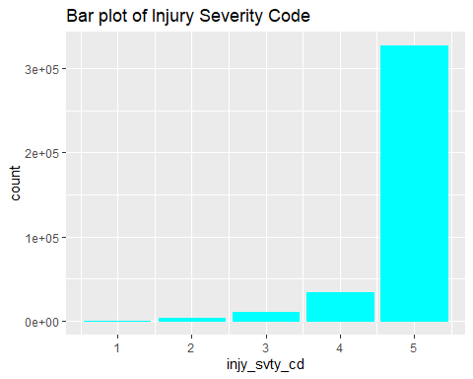

### Bar plot of Weather Code

ggplot(natural_factor_crash, aes(x = wthr_cd)) +  
 geom_bar(color = "lightblue", fill = "lightblue") +  
 labs(title = "Bar plot of Weather Code")

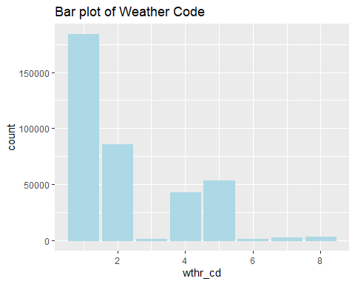

### Bar plot of Lighting Code

ggplot(natural_factor_crash, aes(x = lit_cd)) +  
 geom_bar(color = "lightgreen", fill = "lightgreen") +  
 labs(title = "Bar plot of Lighting Code")

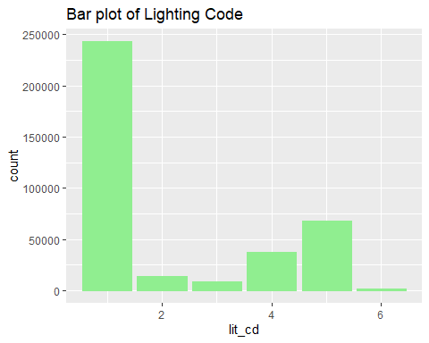

### Bar plot of Road Condition Code

ggplot(natural_factor_crash, aes(x = rd_cond_cd)) +  
 geom_bar(color = "black", fill = "black") +  
 labs(title = "Bar plot of Road Condition Code")

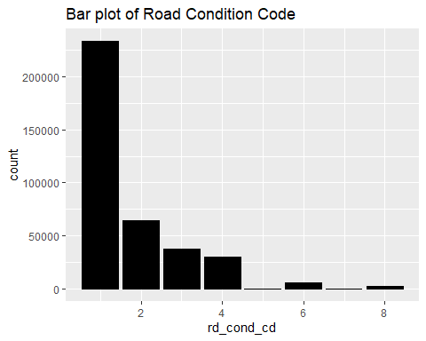

### Bar plot of MDOT Region Code

ggplot(natural_factor_crash, aes(x = mdot_regn_cd)) +  
 geom_bar(color = "yellow", fill = "yellow") +  
 labs(title = "Bar plot of MDOT Region Code")

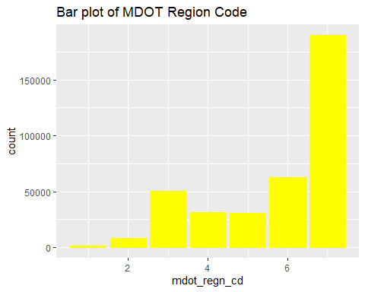

### Scatter plot of Weather Code vs. Injury Severity Code

ggplot(data = natural_factor_crash) +  
 geom_point(mapping = aes(x = injy_svty_cd , y = wthr_cd), color = "orange", position="jitter") +  
 labs(title = "Scatter plot of Weather Code Code vs. Injury Severity Code")

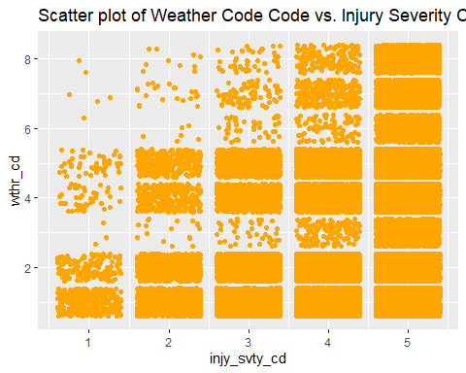

### Scatter plot of Lighting Code vs. Injury Severity Code

ggplot(data = natural_factor_crash) +  
 geom_point(mapping = aes(x = injy_svty_cd, y = lit_cd), color = "orange", position="jitter") +  
 labs(title = "Scatter plot of Lighting Code vs. Injury Severity Code")

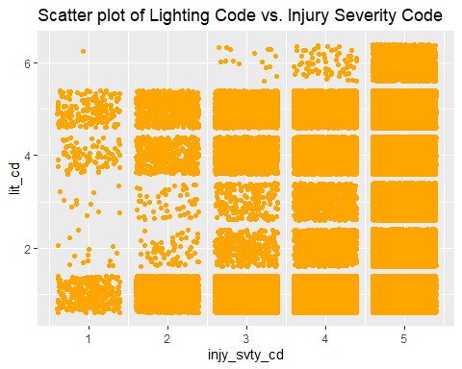

### Scatter plot of Road Condition Code vs. Injury Severity Code

ggplot(data = natural_factor_crash) +  
 geom_point(mapping = aes(x = injy_svty_cd, y = rd_cond_cd), color = "orange", position="jitter") +  
 labs(title = "Scatter plot of Road Condition Code vs. Injury Severity Code")

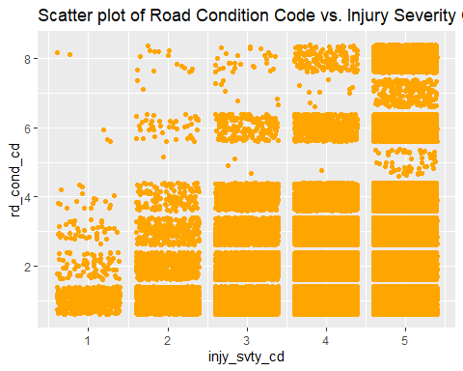

### Scatter plot of MDOT Region Code vs. Injury Severity Code

ggplot(data = natural_factor_crash) +  
 geom_point(mapping = aes(x = injy_svty_cd, y = mdot_regn_cd), color = "orange", position="jitter") +  
 labs(title = "Scatter plot of MDOT Region Code vs. Injury Severity Code")

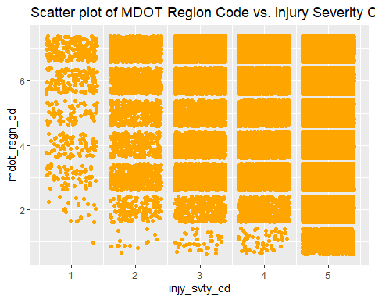

## Data Visualization for Human Factors Subset

### Bar plot of Injury Severity Code

ggplot(human_factor_crash, aes(x = injy_svty_cd)) +  
 geom_bar(color = "cyan", fill = "cyan") +  
 labs(title = "Bar plot of Injury Severity Code")

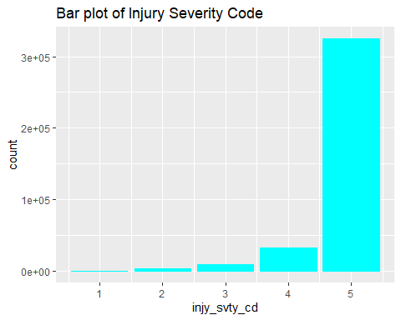

### Bar plot of Vehicle Defect Code

ggplot(human_factor_crash, aes(x = vehc_dfct_cd)) +  
 geom_bar(color = "lightblue", fill = "lightblue") +  
 labs(title = "Bar plot of Vehicle Defect Code")

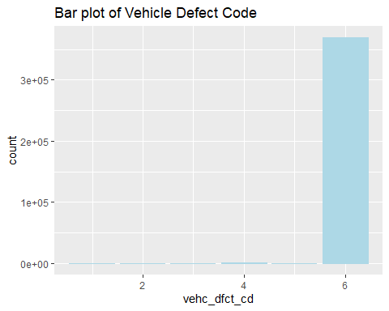

### Bar plot of Restraint Usage Code

ggplot(human_factor_crash, aes(x = rstr_not_used_fail)) +  
 geom_bar(color = "lightgreen", fill = "lightgreen") +  
 labs(title = "Bar plot of Restraint Usage Code")

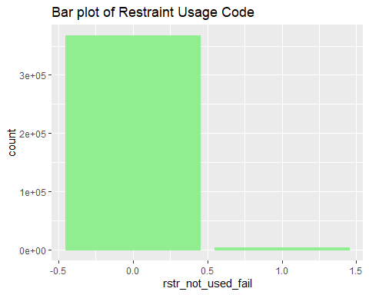

### Bar plot of Hazardous Action Code

ggplot(human_factor_crash, aes(x = hzrd_actn_cd)) +  
 geom_bar(color = "black", fill = "black") +  
 labs(title = "Bar plot of Hazardous Action Code")

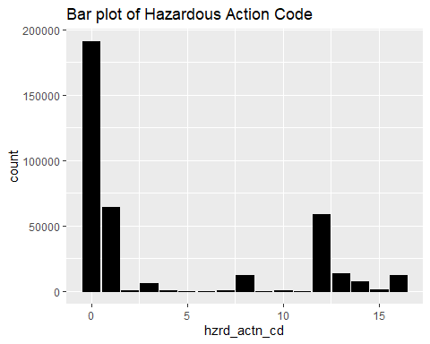

### Bar plot of Alcohol Usage Code

ggplot(human_factor_crash, aes(x = alch_susp_ind)) +  
 geom_bar(color = "yellow", fill = "yellow") +  
 labs(title = "Bar plot of Alcohol Usage Code")

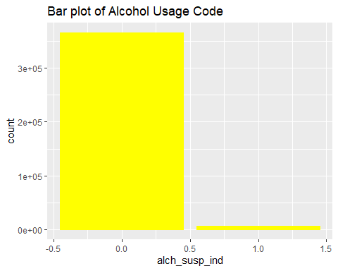

### Bar plot of Drugs Usage Code

ggplot(human_factor_crash, aes(x = drug_susp_ind)) +  
 geom_bar(color = "red", fill = "red") +  
 labs(title = "Bar plot of Drugs Usage Code")

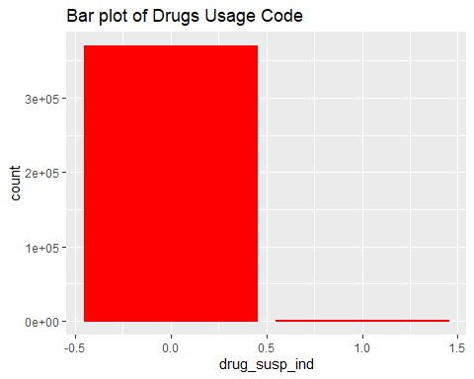

### Scatter plot of Vehicle Defect Code vs. Injury Severity Code

ggplot(data = human_factor_crash) +  
 geom_point(mapping = aes(x = injy_svty_cd , y = vehc_dfct_cd), color = "lightblue", position="jitter") +  
 labs(title = "Scatter plot of Vehicle Defect Code Code vs. Injury Severity Code")

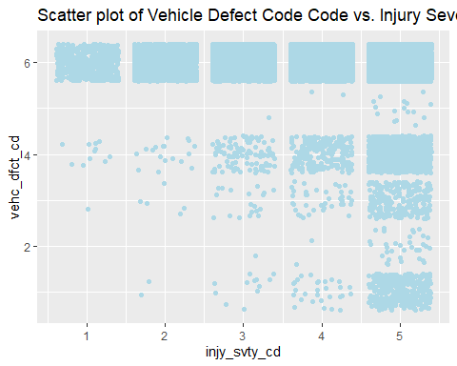

### Scatter plot of Restraint Usage Code vs. Injury Severity Code

ggplot(data = human_factor_crash) +  
 geom_point(mapping = aes(x = injy_svty_cd, y = rstr_not_used_fail), color = "lightblue", position="jitter") +  
 labs(title = "Scatter plot of Restraint Usage Code vs. Injury Severity Code")

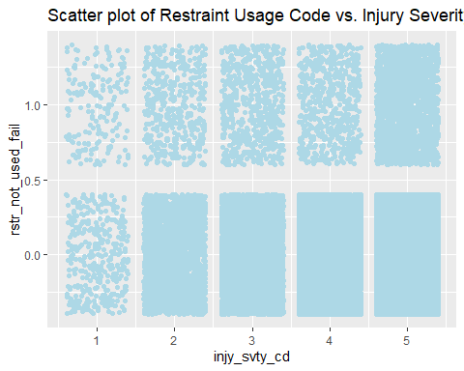

### Scatter plot of Hazardous Action Code vs. Injury Severity Code

ggplot(data = human_factor_crash) +  
 geom_point(mapping = aes(x = injy_svty_cd, y = hzrd_actn_cd), color = "lightblue", position="jitter") +  
 labs(title = "Scatter plot of Hazardous Action Code vs. Injury Severity Code")

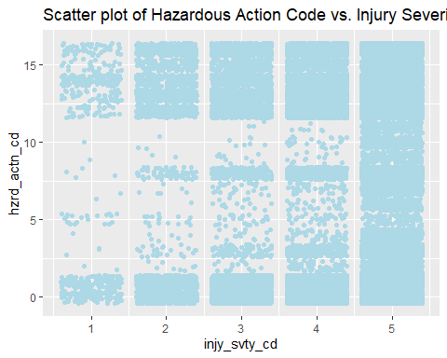

### Scatter plot of Alcohol Usage Code vs. Injury Severity Code

ggplot(data = human_factor_crash) +  
 geom_point(mapping = aes(x = injy_svty_cd, y = alch_susp_ind), color = "lightblue", position="jitter") +  
 labs(title = "Scatter plot of Alcohol Usage Code vs. Injury Severity Code")

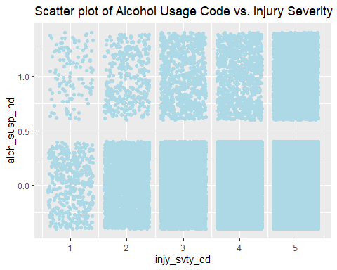

### Scatter plot of Drugs Usage Code vs. Injury Severity Code

ggplot(data = human_factor_crash) +  
 geom_point(mapping = aes(x = injy_svty_cd, y = drug_susp_ind), color = "lightblue", position="jitter") +  
 labs(title = "Scatter plot of Drugs Usage Code vs. Injury Severity Code")

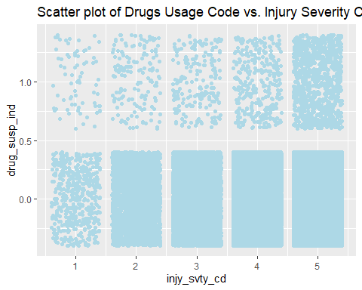

## Spliting Data for Training set and Testing set for Natural Factor Subset

set.seed(123)  
split <- sample.split(natural_factor_crash$injy_svty_cd, SplitRatio = 0.8)  
nfcTrainData <- subset(natural_factor_crash, split == TRUE)  
nfcTestData <- subset(natural_factor_crash, split == FALSE)

## Model Training on Natural Factor Subset

# Train a multi-class logistic regression model  
logRegModel1 <- multinom(injy_svty_cd ~ ., data = nfcTrainData)

## # weights: 35 (24 variable)  
## initial value 481670.968993   
## iter 10 value 195259.691310  
## iter 20 value 187470.499893  
## iter 30 value 177805.371975  
## iter 40 value 158054.669406  
## iter 50 value 148147.898657  
## iter 60 value 145553.604340  
## iter 70 value 144021.686071  
## iter 80 value 143578.067465  
## iter 90 value 143184.319221  
## iter 100 value 142982.508311  
## final value 142982.508311   
## stopped after 100 iterations

# Make predictions on the test data  
predictions1 <- predict(logRegModel1, nfcTestData)  
  
# Check the metrics of the model  
cat("Model Accuracy for Human Factor Subset", mean(predictions1 == nfcTestData$injy_svty_cd), "\n")

## Model Accuracy for Human Factor Subset 0.874325

## Spliting Data for Training set and Testing set for Human Factor Subset

set.seed(123)  
split <- sample.split(human_factor_crash$injy_svty_cd, SplitRatio = 0.8)  
hfcTrainData <- subset(human_factor_crash, split == TRUE)  
hfcTestData <- subset(human_factor_crash, split == FALSE)

## Model Training on Human Factor Subset

# Train a multi-class logistic regression model  
logRegModel2 <- multinom(injy_svty_cd ~ ., data = hfcTrainData)

## # weights: 40 (28 variable)  
## initial value 478561.534946   
## iter 10 value 181692.448513  
## iter 20 value 157729.037185  
## iter 30 value 142862.211717  
## iter 40 value 140793.214581  
## iter 50 value 139894.363715  
## iter 60 value 139317.099253  
## iter 70 value 138957.681012  
## iter 70 value 138957.681012  
## iter 80 value 138902.425241  
## iter 90 value 138810.832523  
## iter 100 value 138770.287396  
## final value 138770.287396   
## stopped after 100 iterations

# Make predictions on the test data  
predictions2 <- predict(logRegModel2, hfcTestData)  
  
# Check the accuracy of the model  
cat("Model Accuracy for Human Factor Subset", mean(predictions2 == hfcTestData$injy_svty_cd), "\n")

## Model Accuracy for Human Factor Subset 0.8745039