**CIVICME**

Requirements v 0.2

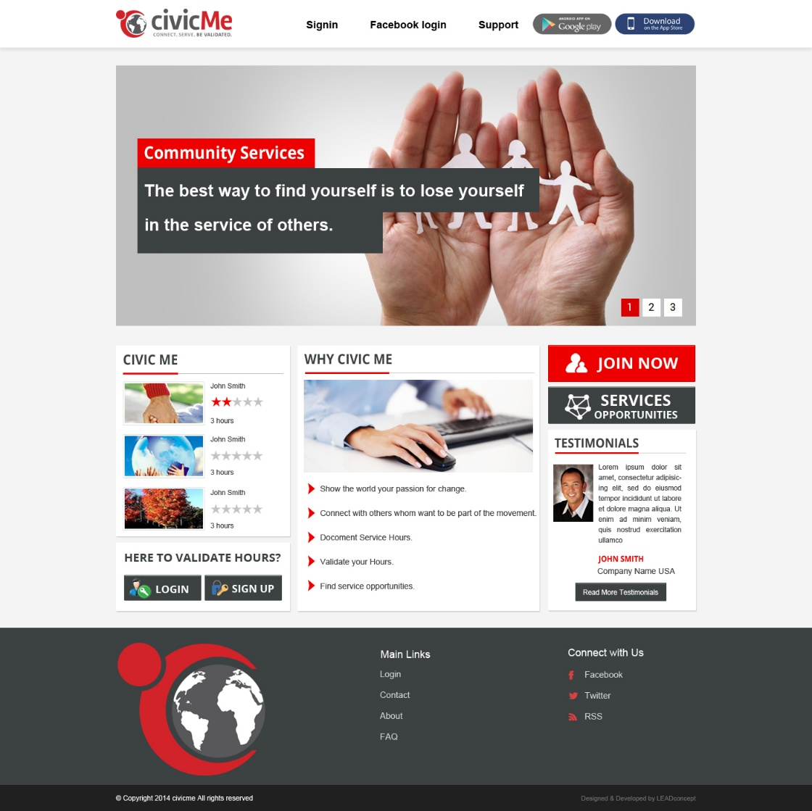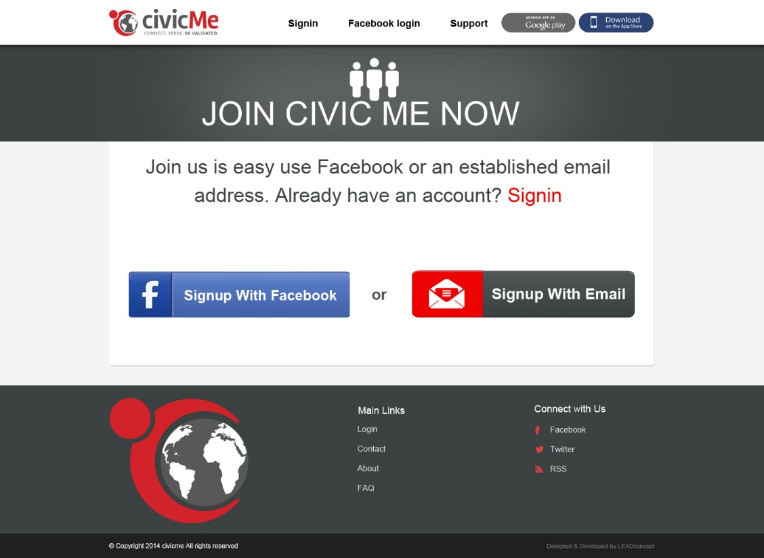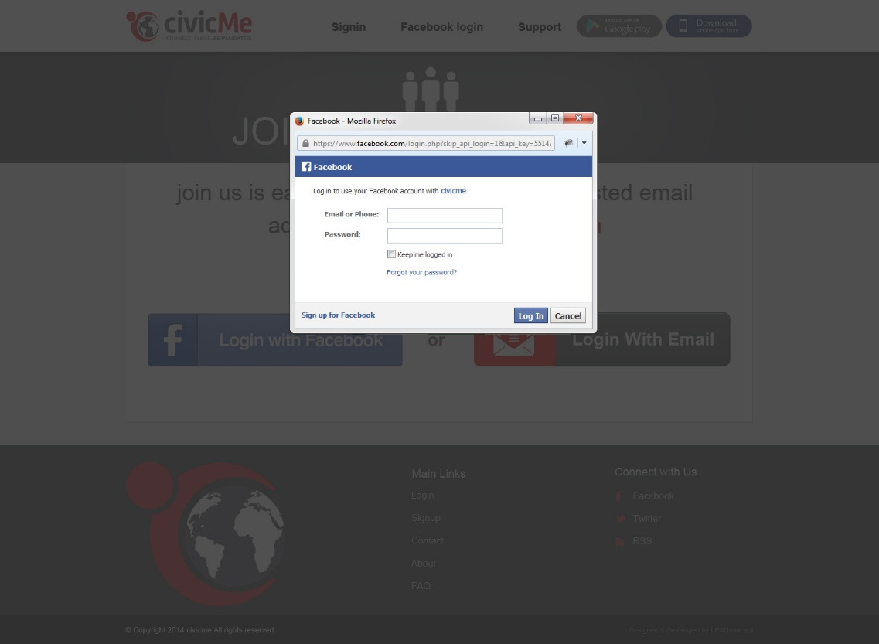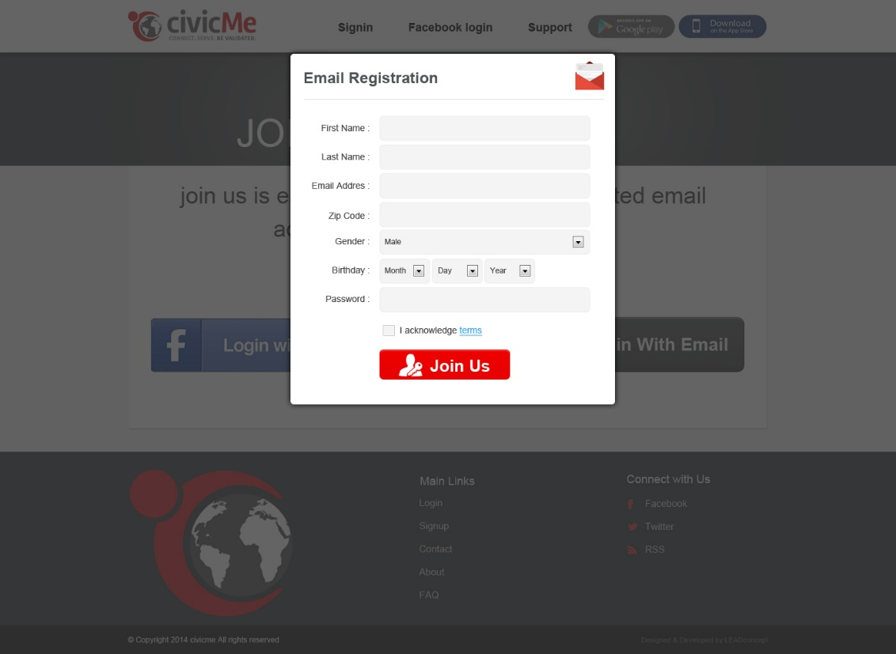

Sign up or login with facebook screen for volunteer/participants.

Main home page of website with gives options to login and signup and also links to apps

Authenticate user/volunteer from facebook using facebook authentication sdk. Everything will be fetched from user facebook profile.

Sign up screen for volunteer. General profile info with confirmation email will be sent to sign up email.

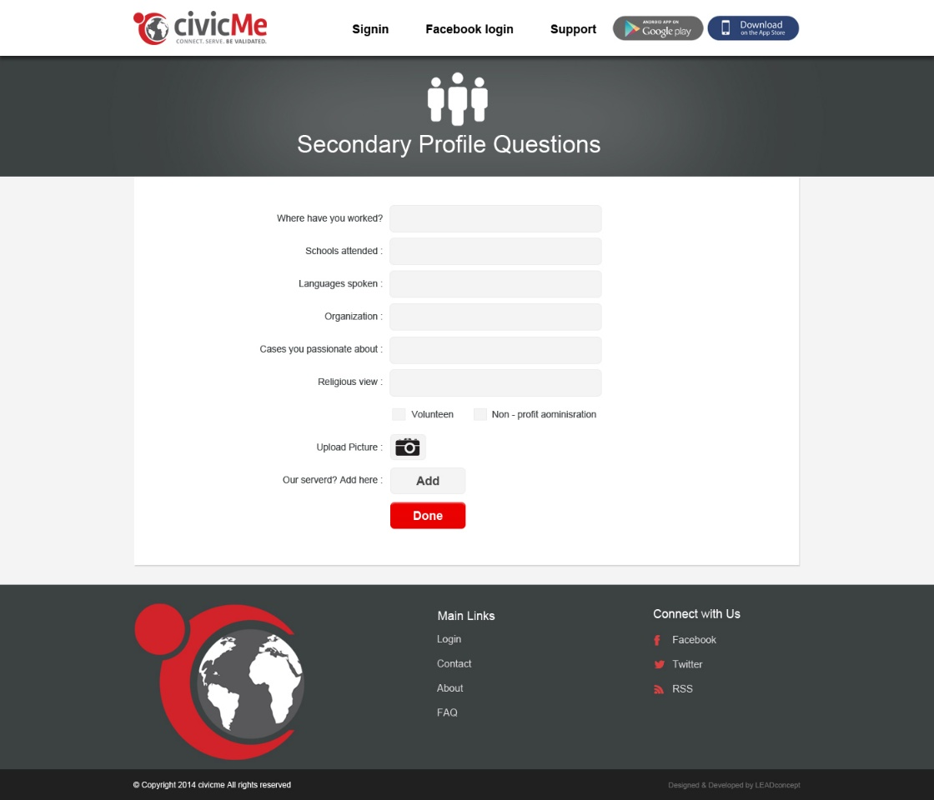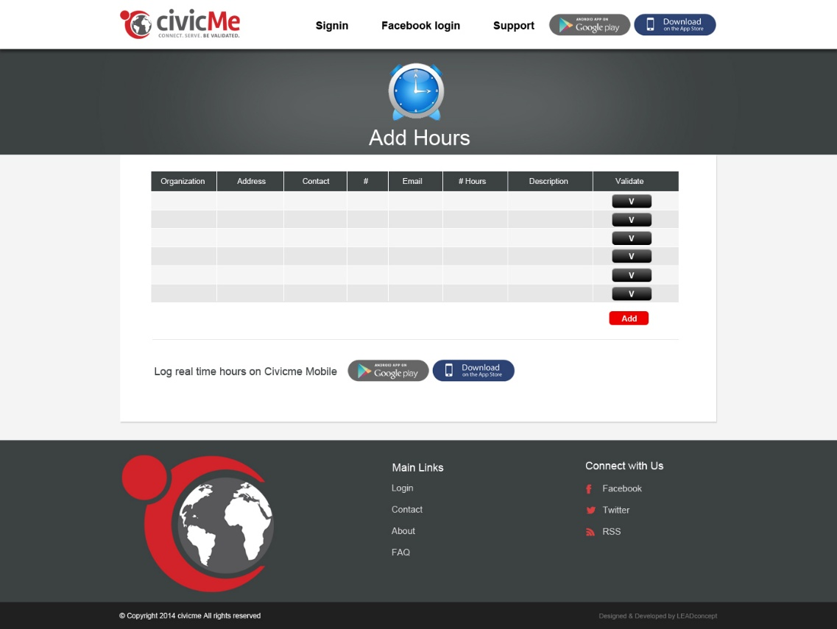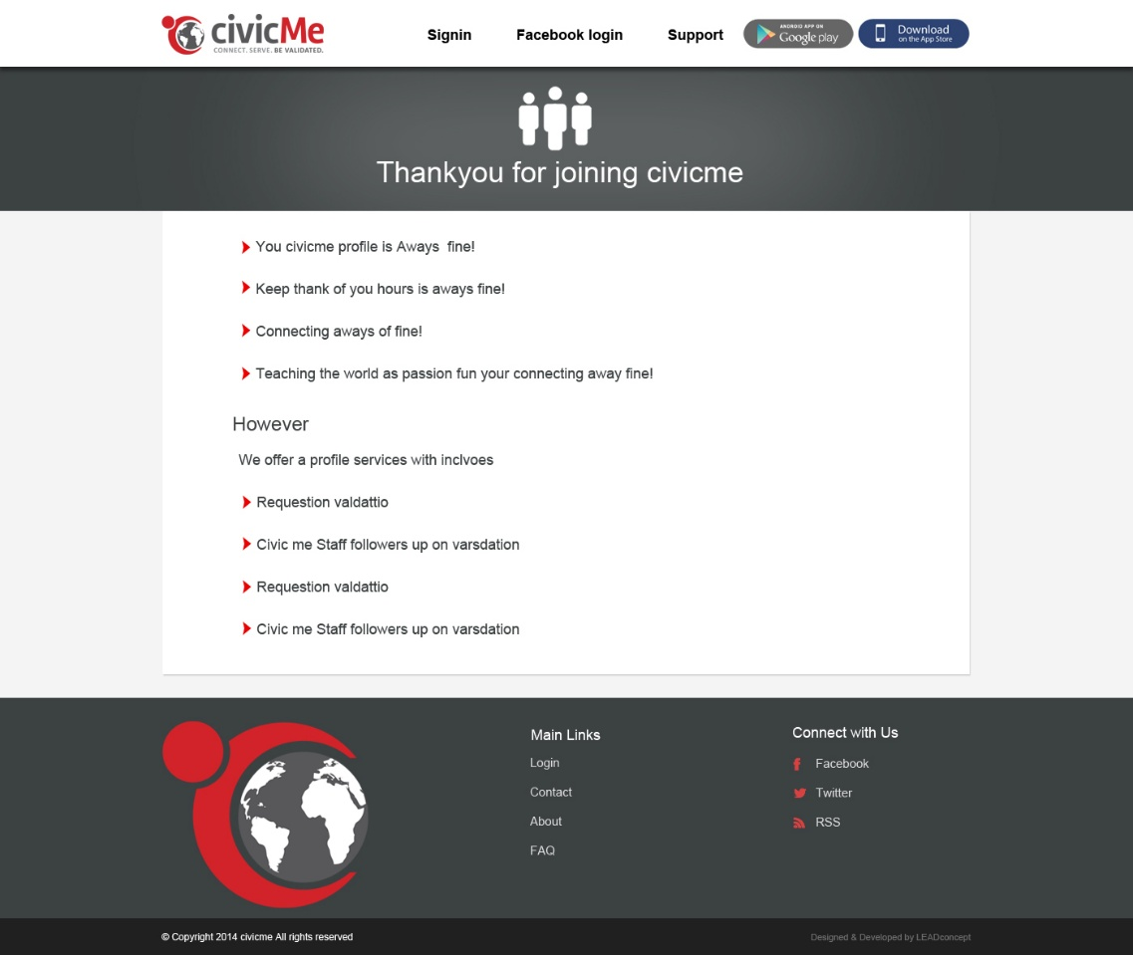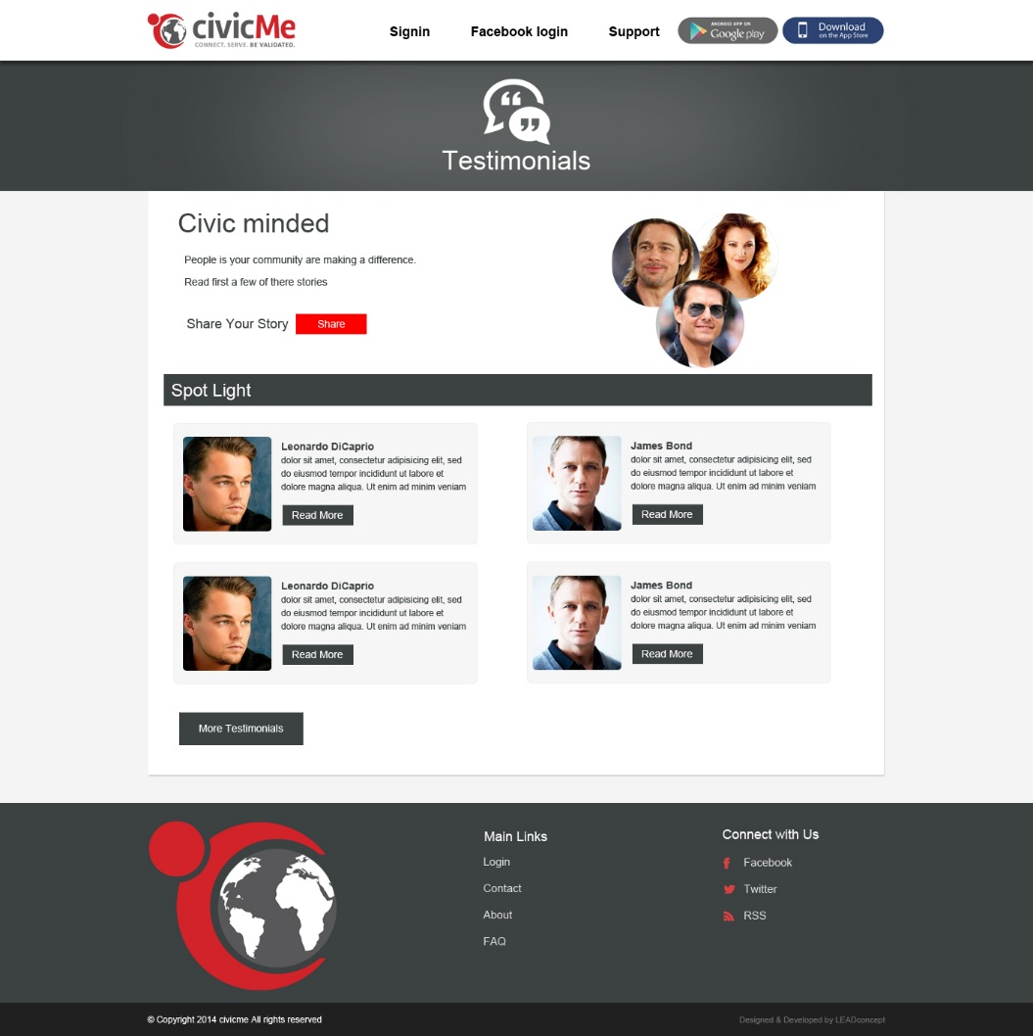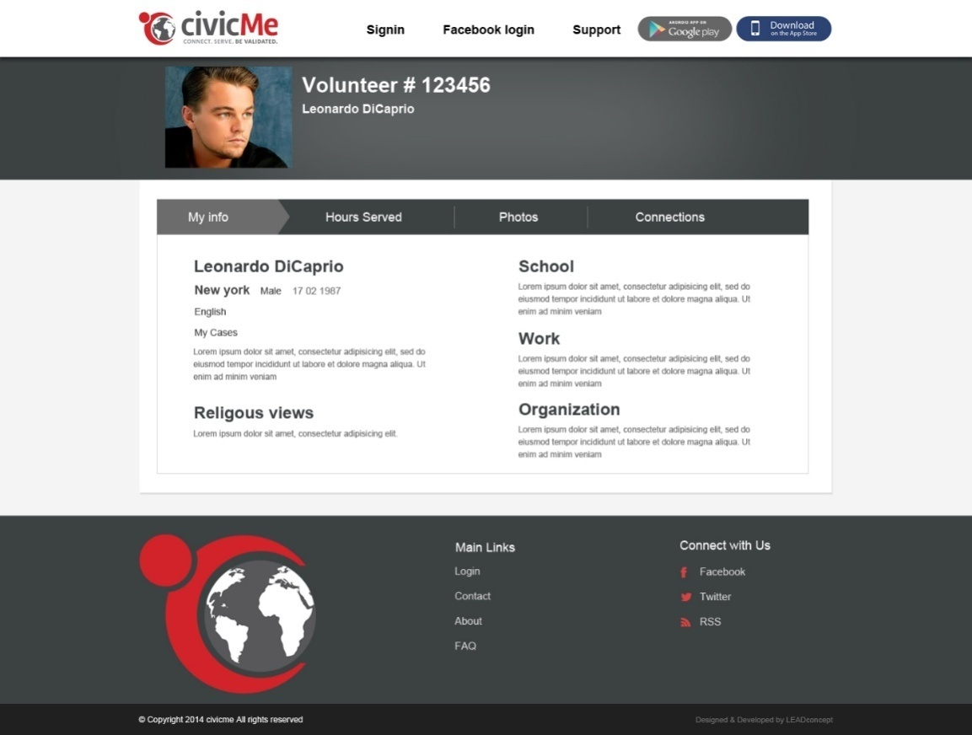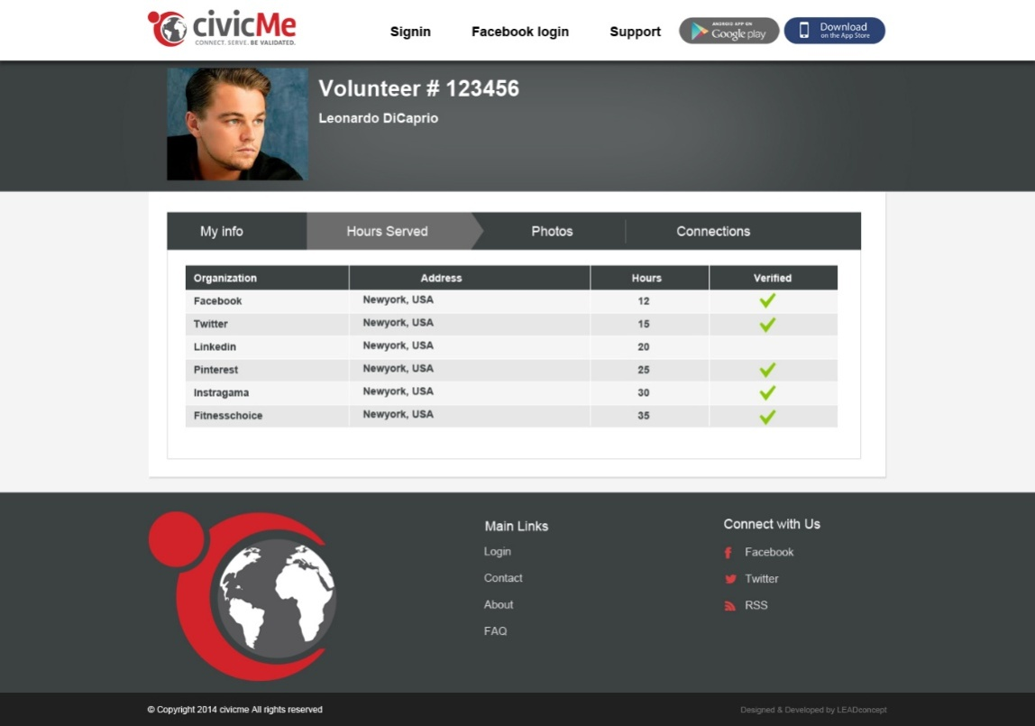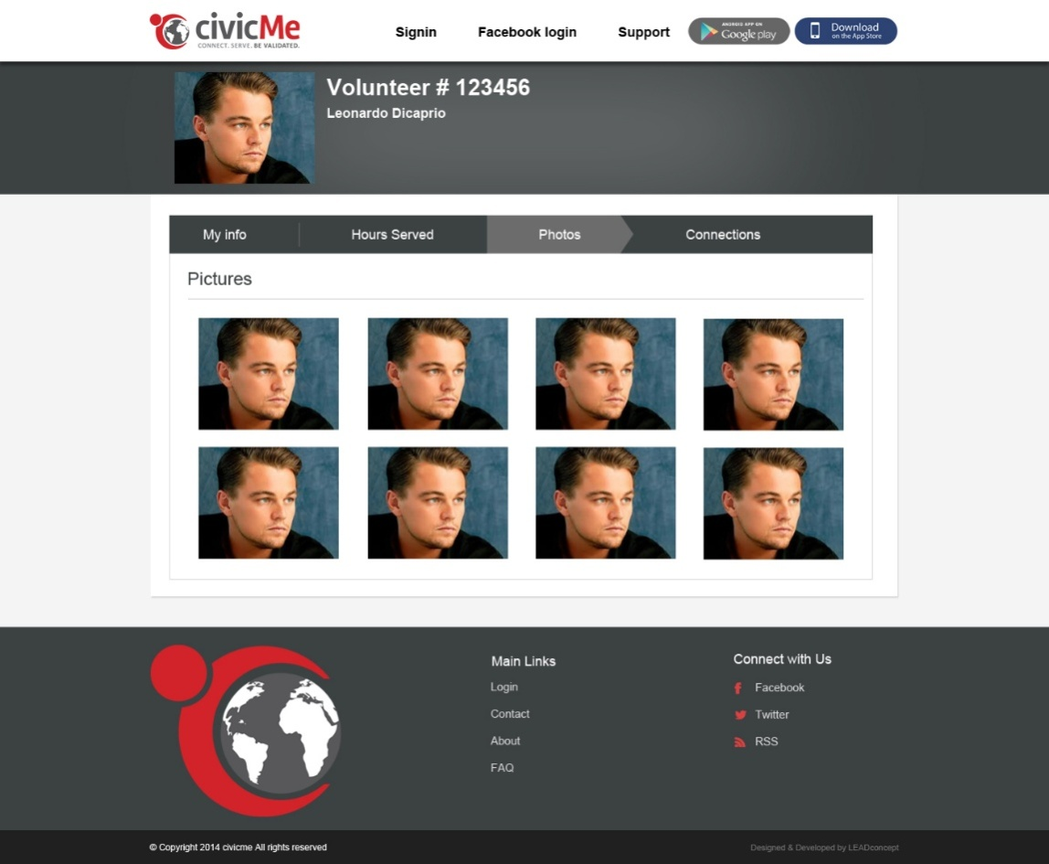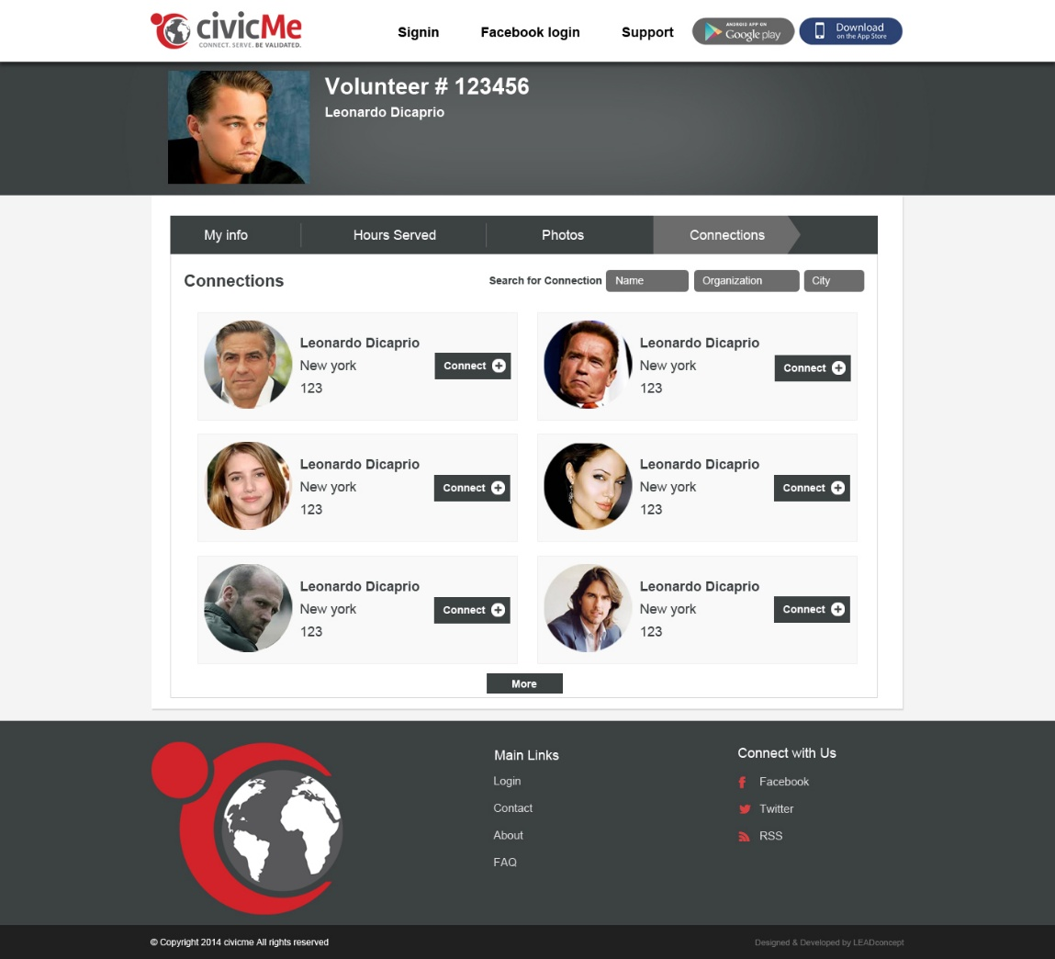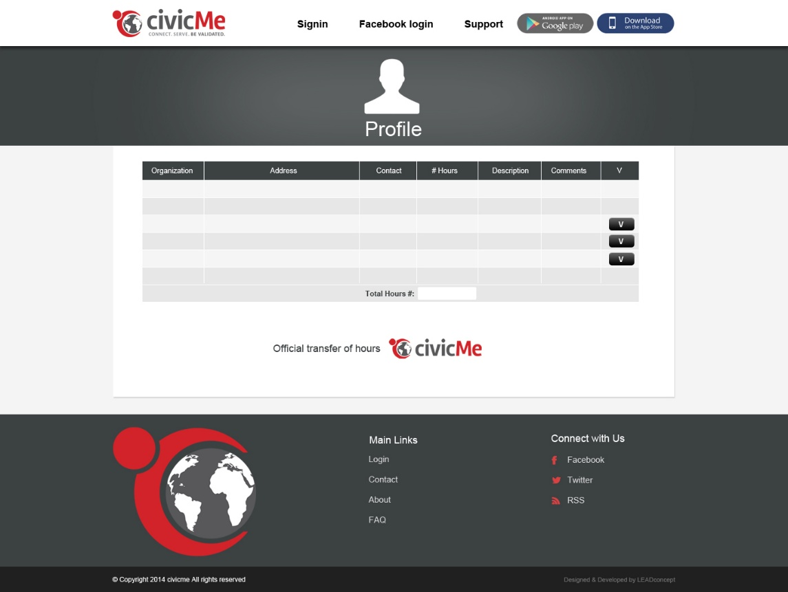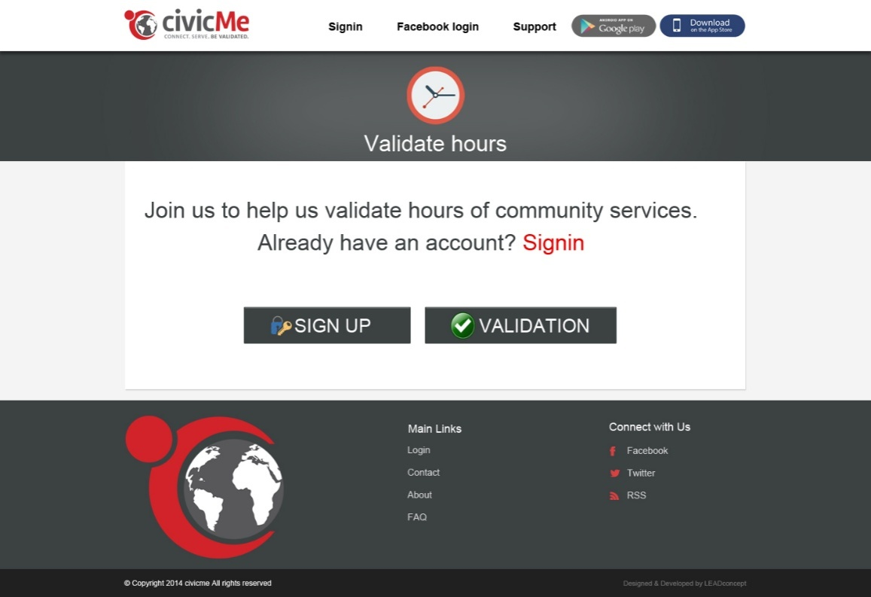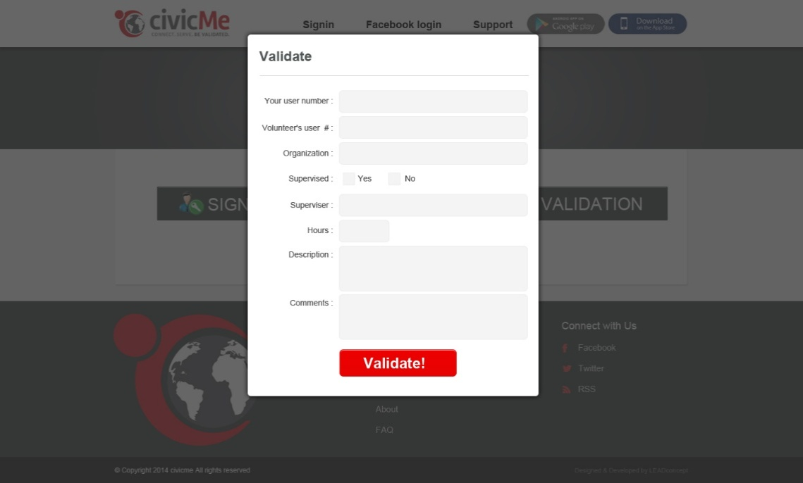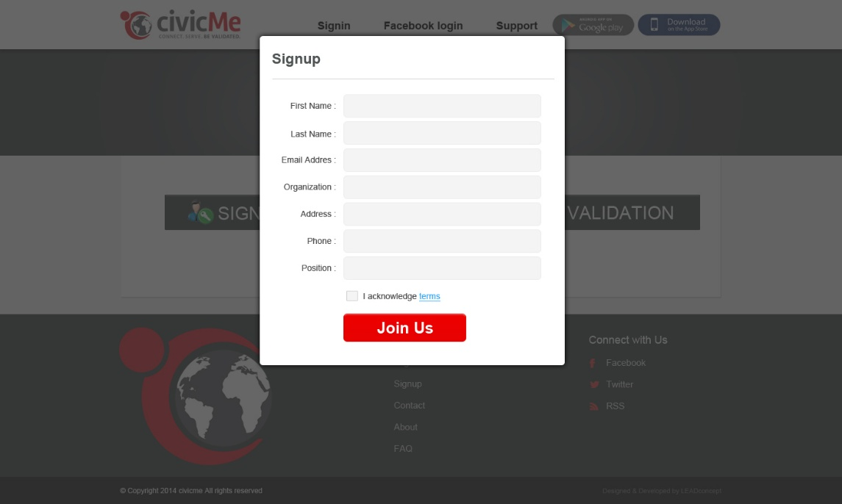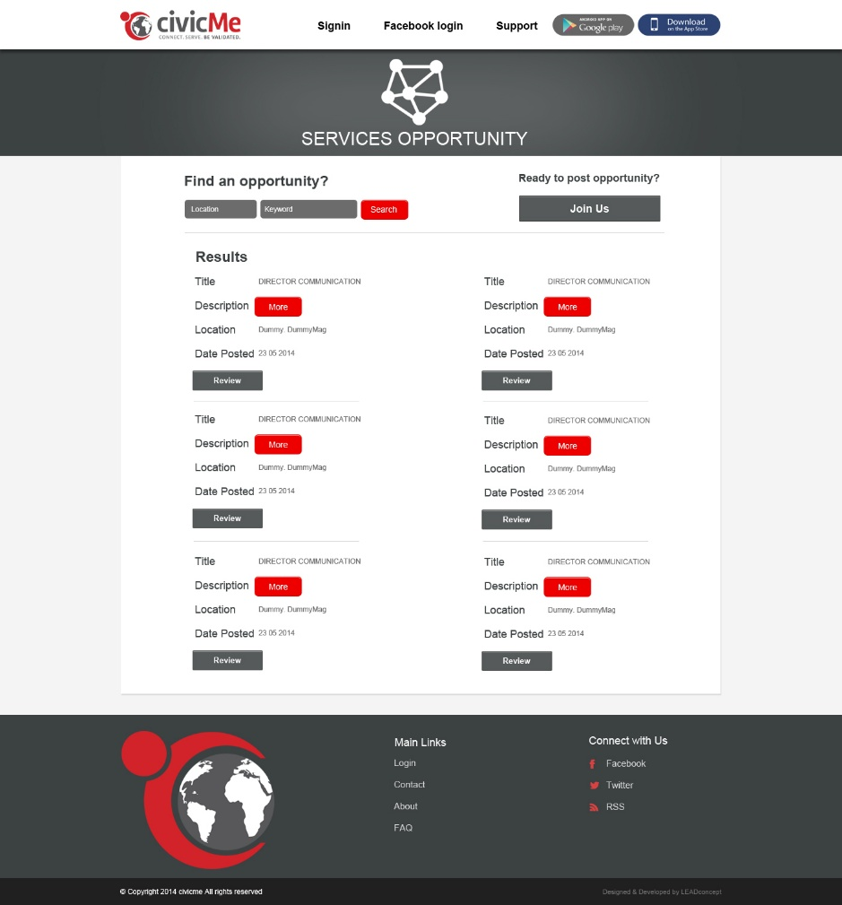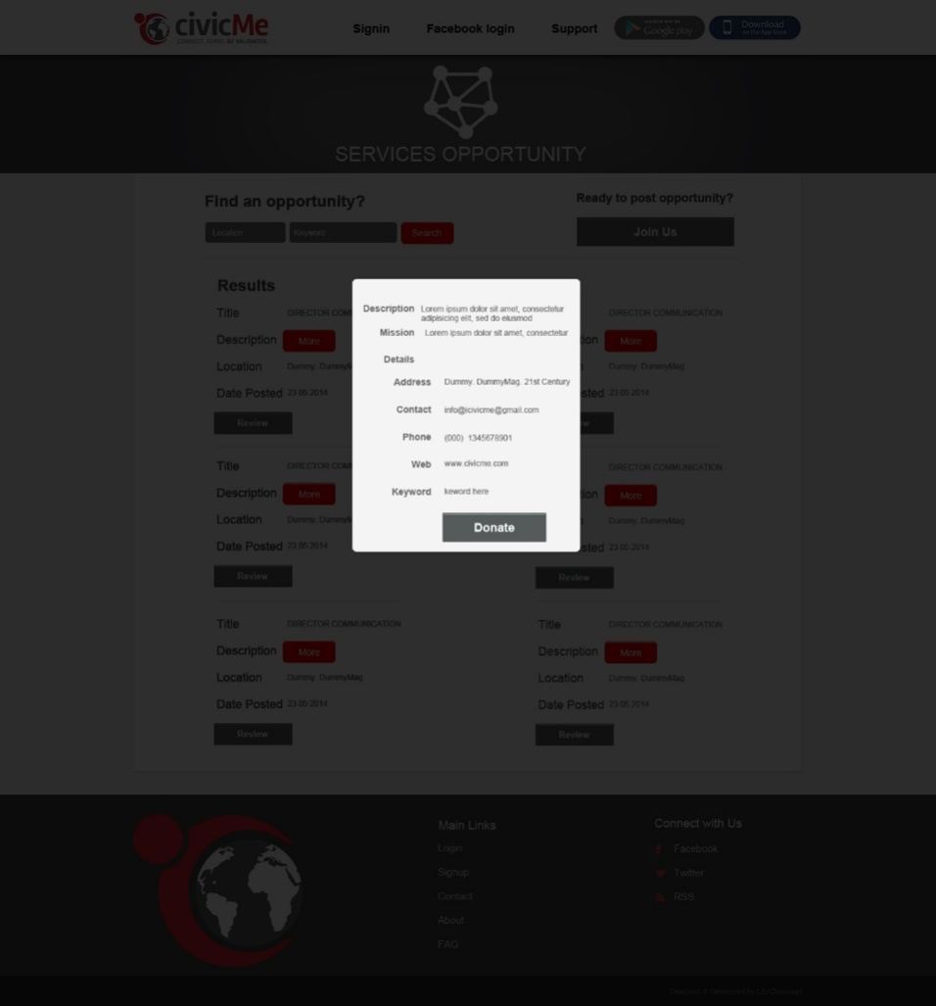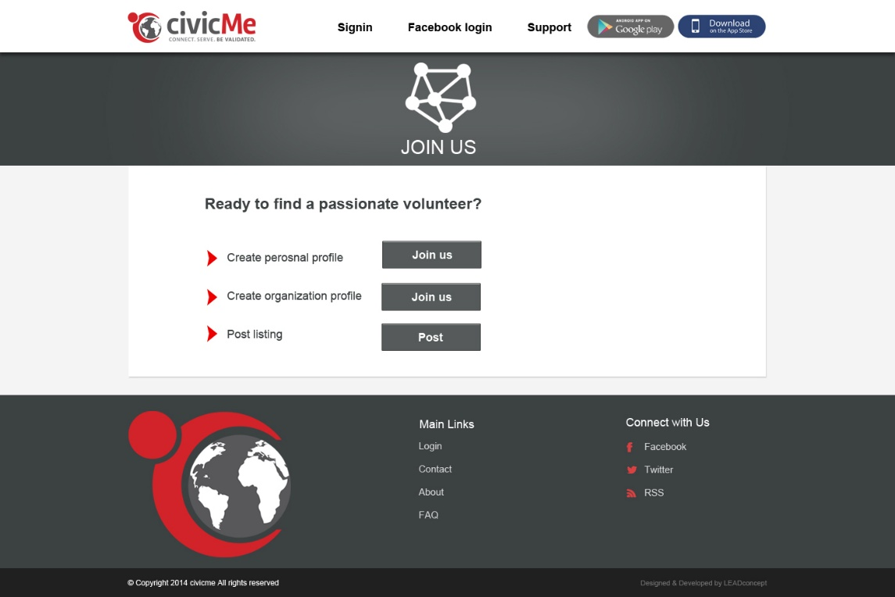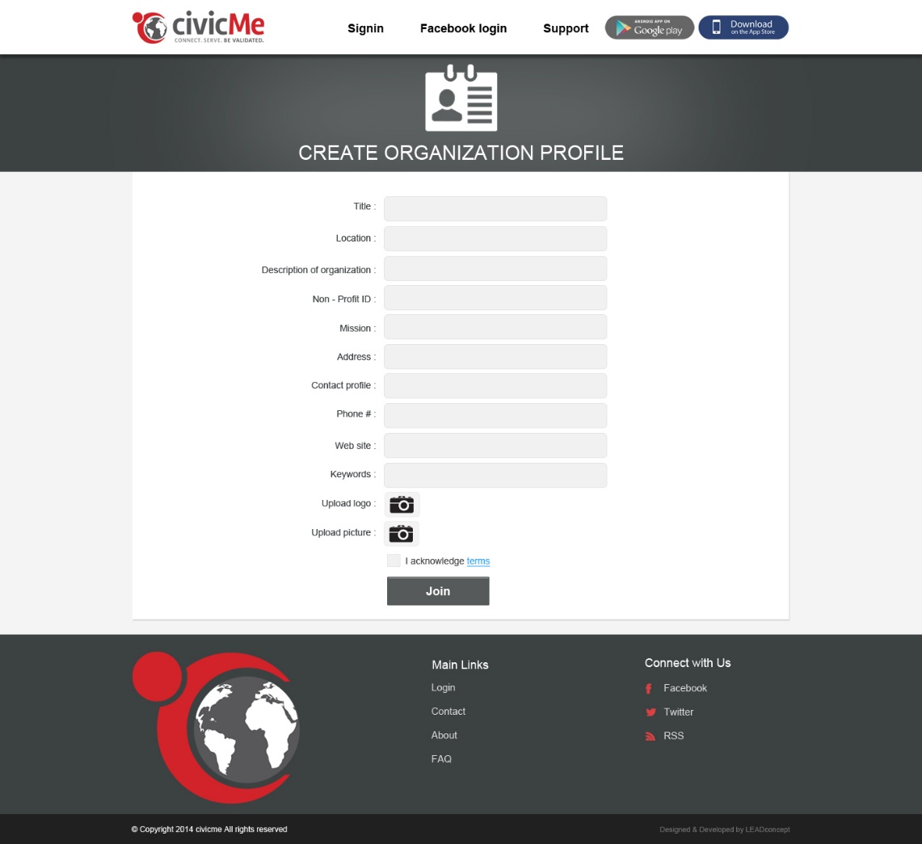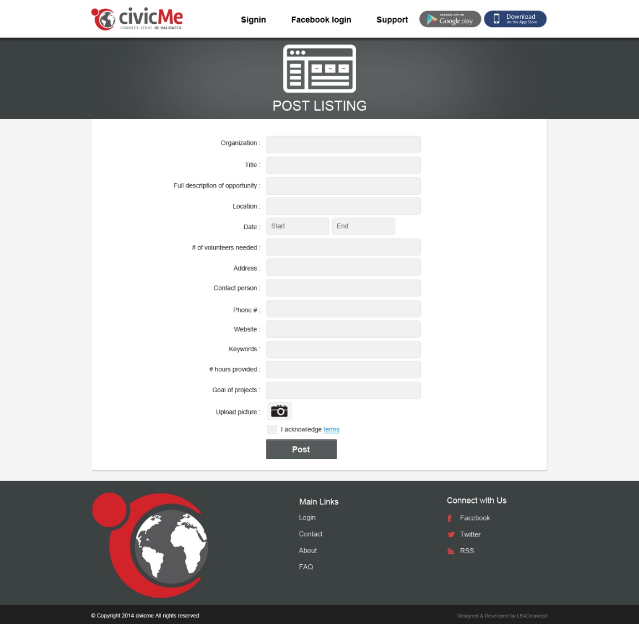

Add the work hours screen while signup for volunteers. Clicking V button will send the email to contact email with details and link to website. Add button will add new row for adding hours to sheet.

Completing profile for volunteer signup with history. Add button will take user to hours sheet.

Completing profile thank you page

Testimonials page, showing testimonials and option to add testimonial by user.

Volunteer Profile page for view by others, default info tab which show user general info and history of work and education.

Volunteer profile, hours sheet show the hours worked and validated by validators.

Volunteer profile pictures uploaded

Volunteer profile connections and option to connect to other volunteers.

User complete Hours sheet.

Validators screen for users to signup/ validate hours.

Popup for validators to signup to website and see details.

Validate hours popup for validator, using this popup makes it easier for validator to validate hours of a volunteer.

Page for volunteers to find opportunity.

Opportunity detail and option to donate to

Page for orginizations and persons to create profile, find volunteers, post opportunities/

Signup page for organizations.

Page for organizations to post opportunities.