Functions

1. This should also show last time logged in, or if they are currently online

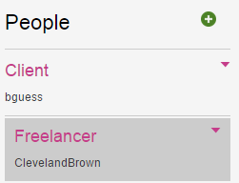

1. The client is not getting the correct amount billed to them.

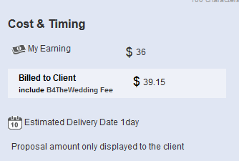

Currently they are getting $36

1. Also this should work either way.

If the freelancer was to enter the “Billed to Client” portion before entering the “My Earnings’”…it should still calculate. Meaning that both options should calculate the amount either way, no matter which one you enter first. The Freelancer might want to enter the “Billed to Client” first so they are able to see how much they will potentially earn.

1. Payment Request is not working properly.
2. This is the message that the client gets when the freelancer requests payment for $50.00



1. Function not working



1. Escrow funding Process is not working properly.

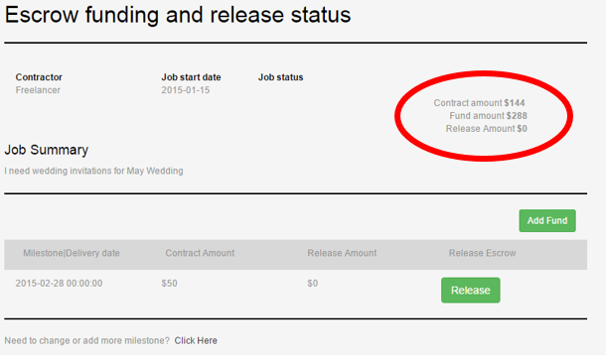

When the client pays the freelancer they need to see the balance/remaining balance due on both pages.

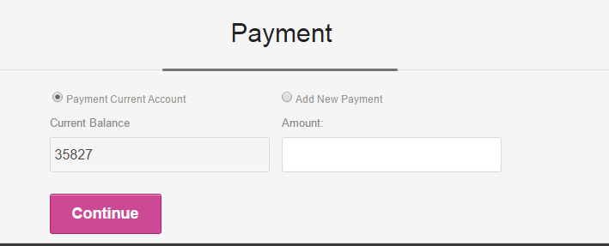

11. After payment has been funded, there should be a confirmation indicating the funds were added successfully.

The client should not be able to pay more than the FULL balance.

Example the client can pay more that the “milestone” balance as long as it isn’t more than the total balanced agreed by both parties.

Example: So if the client attempts to pay $20 for a job that is $15, they should get an error message.

12. Prior to making a payment, or funding the account, the client should have an option to “confirm” that they want to make this payment or fund the account.

13. Transaction History not working for the Freelancer



14. If a client cancels a posting before it has been awarded to a freelancer, then the freelancers must be notified by message/email that the job has been canceled.

15. Job Status hasn’t updated

16. It’ View “Archived” Jobs





17. If you are in any of these options, you can not select another option without getting an error message.

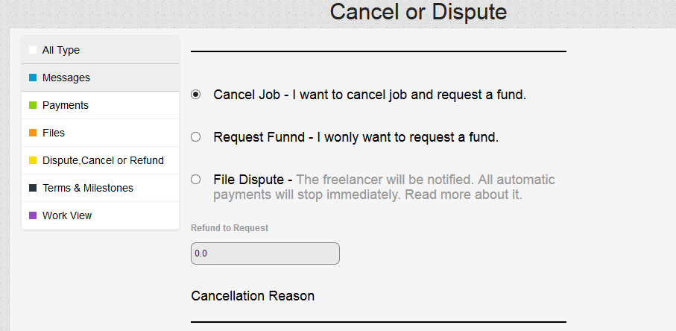

-When I click another option under “All Type”



18. After the client has paid part of a balance owed to the client ( Ex. 1 Milestone out of 4)There needs to be a “Remaining balance” display within these

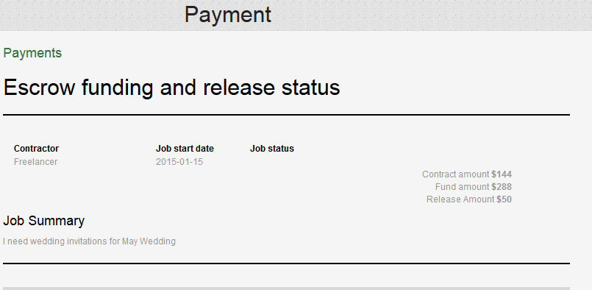

19. Banner is still not working for me in admin section.

20. I know that you are still working on the admin section, but I just wanted to let you know, that no site stats are working, the only thing that works for me is the categories/skill revisions/update portion.

21. Post your job (Small fixes and Revisions)

Please fix the centering of the page, it is currently not centered

-cosmetic Revisions for Post your job.

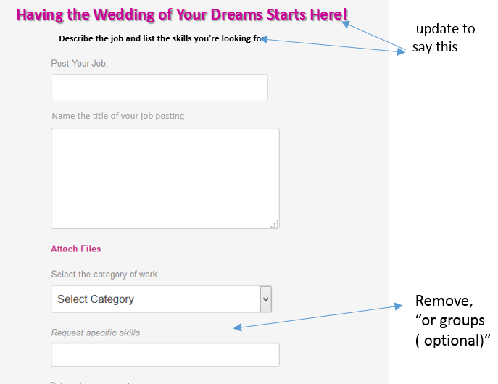

22. Help with the Design.

After the functions are completed, we will really need the help of your designer to update the sites designs. We really want to make everything “Wedding themed” and using as much “wedding words as possible.