1. Click on 

2). You will see this, option. The paypal should be here. The user entering their credit card info here should be directly tied to Paypal API. Hense, if a user enters their credit card information, the payment will still go through my paypal account.

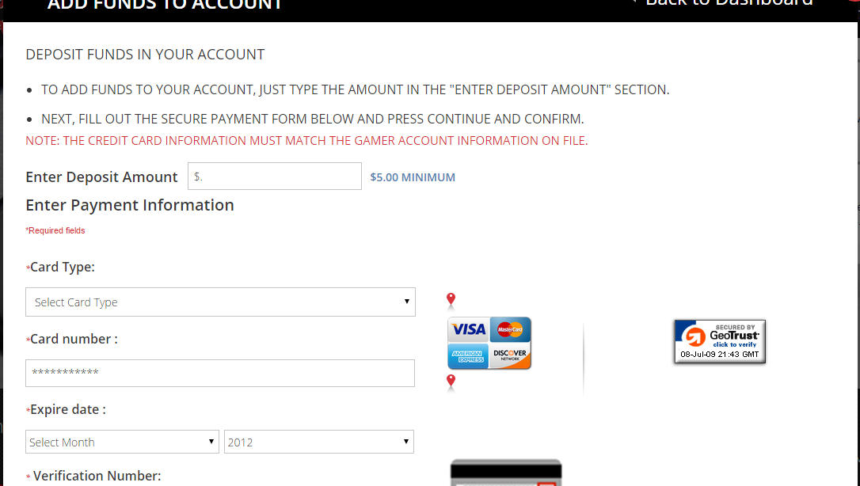

1. There should be a separate option for a user to enter their email address.

This is a mockup of what I am referring to.

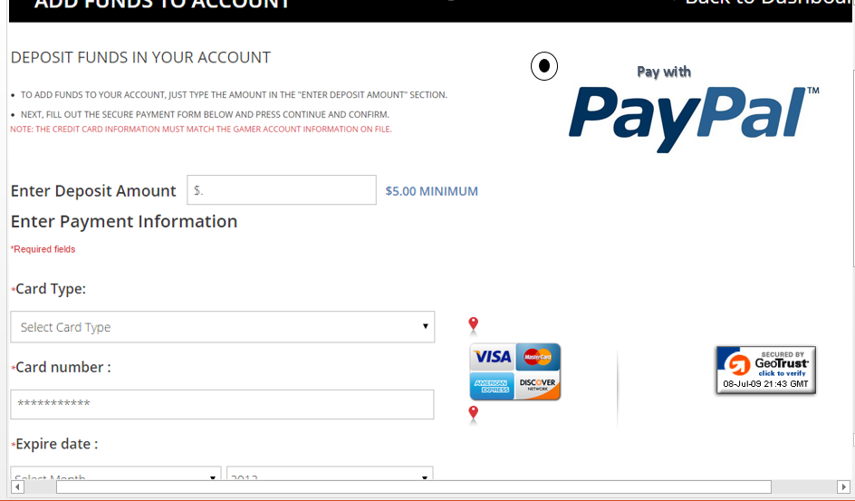

1. If the user clicks on “Pay with Paypal”

Then they would get this a new page displaying this.

