First Step

Domain name is parked in a diffent location than server, So I will need this to be pointed correctly. I have tried, but it stillis not working.

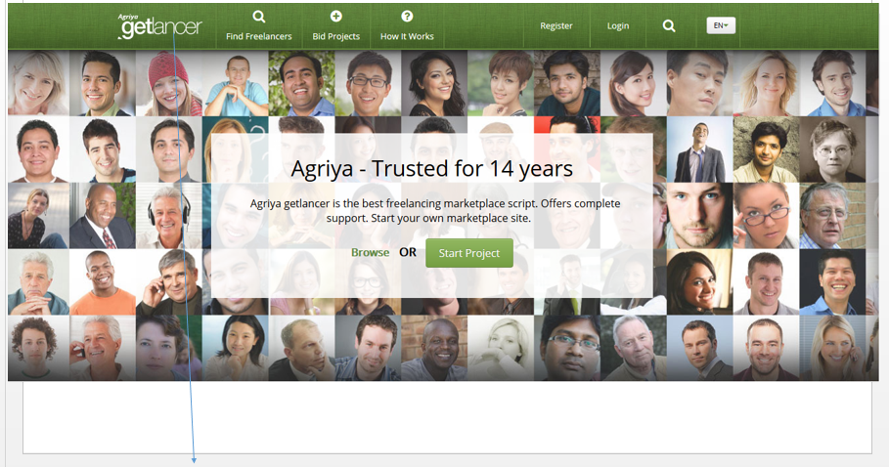

1). Please remove and replace Logo

2). Please remove the Whole section Agriya-Trusted for 14 Years and replace with

**Freelancers…etc. #1 Freelancer Marketplace.**

Freelancers..etc. is the with the #1 Freelancer Marketplace. Locate jobs, hire creative freelancers and work on all of your projects with ease.

3).

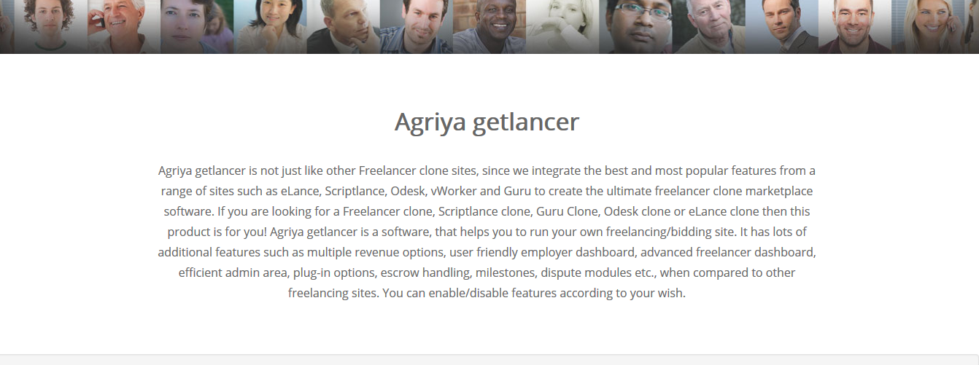

Middle part- Replace with this

**It’s Your Choice, Choose Wisely.**

We provide a glorious gateway to the best freelancing source. Register today to begin new projects, connect with talented freelancers, and discover jobs. Keep within your budget with our bidding features. By naming your own price, our premium freelance marketplace will assist in orchestrating your need on your terms.

4). Remove this completely

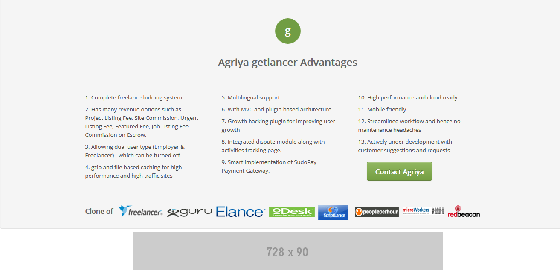

5). Please remove this from all of the pages



