1. Payments “Add a Payment”

There is nothing displaying the current payments already added. Ie:

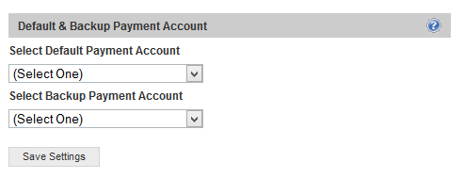

2. If a user has already added a payment method, there needs to be a way for them to edit their current payment options.

3. Add a credit Card

How do we know that the user entered the Credit Card correctly? I tried the payment option and just put in any random numbers and was able to add my card. This can’t happen. It needs to be able to only add valid numbers. Because when users are ready to pay, they need to be able to access their previously stored accounts immediately. So it needs to already be verified that it is working.

4. Add a PayPal Info

-should say “Add PayPal Info”

-This is not the correct way to add the info for paypal. PayPal goes by email, so it would display…Enter Paypal Email Address.

-

“By cicking, you agree to B4TheWedding’s Terms of service”

5. Add Balance

Should Be “Add Funds”

6.If the user goes to the Financial Accounts to add/edit fund, then they should not have an option to enter Credit Card/PayPal on the Add Balance (Funds) page. Because they have already done this on this on the Financial Accounts (Accounts) page.

7. Please change the accounts tab to “Financial Accounts”

8. -It’s “Braintree” and “Payment with Credit Card”, not Braintree

Braintree should not be mentioned.

9. After Login when you click HIRE, it should take you to the list of available jobs.

10. Error Message

When you click search jobs, this comes up

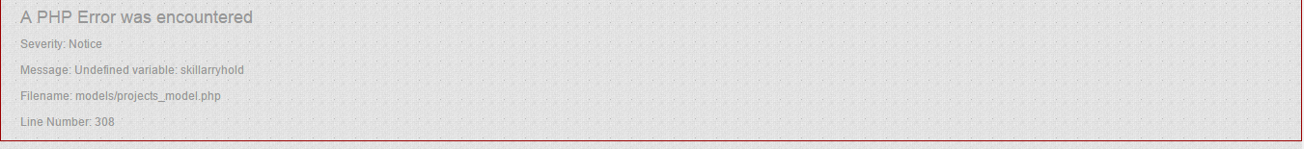

11. Overlapping

.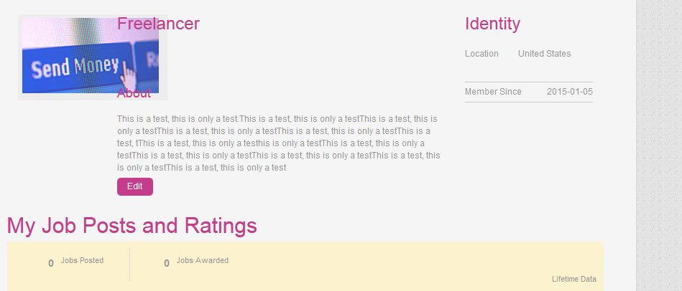

12. These don’t work.

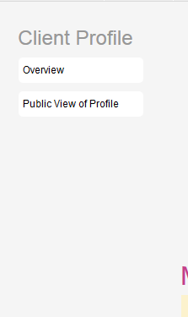

13. 6. 875%

–The current calculation is not correct; please make sure that it is 8.75% that is being deducted

-Also, please remove the “!” next to 1 day.

-And it’s B4TheWedding Fee

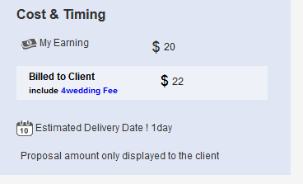

14. There should be A Wedding Freelancer option as well as jobs

-Also, the search option is not working.



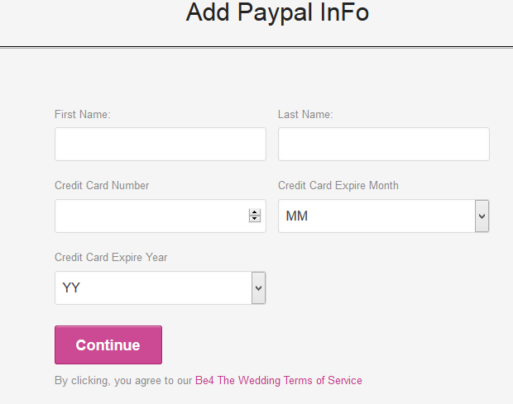

14 . (Continued)

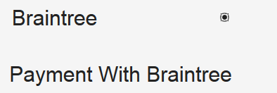

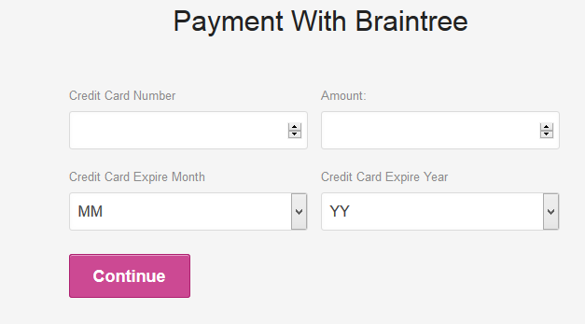

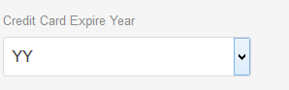 Please Edit the contents inside, it needs fixing

-Withdraw Method 8. (continued)

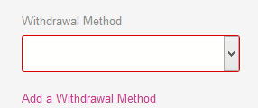 AND Don’t work properly.

15 . After I posted my job, I see I have an option to request payment. I am not sure what this is for, because I have not hired anyone for the job yet.

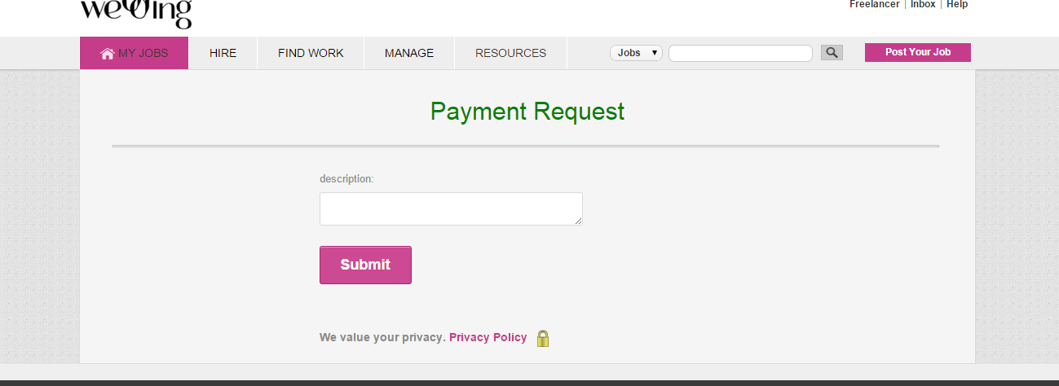

16. Picture not showing

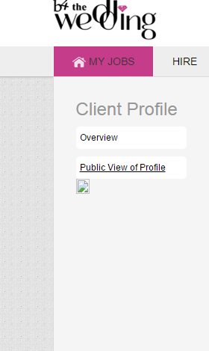

17. If the proposal was submitted successfully, then it should go back to the previous screen. It is hard to tell that it has been submitted. The notice is very small and to the right, and stays on the same screen.

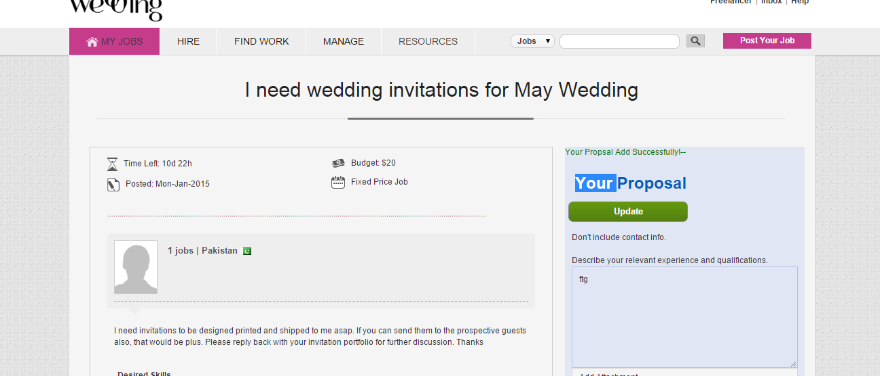

Proposals

Need to have a paperclip (attach option) so the freelancer can send the user their Doc, portfolios of previous work etc. in the proposal.

Messages

Need to have a paperclip (attach option) so freelancers and clients can send documents back and forth.

18. Messages

When I have a message, it is not showing a notification, or how many messages.



-Also I am not receiving a message via email to notify me that someone has sent me one.

19.

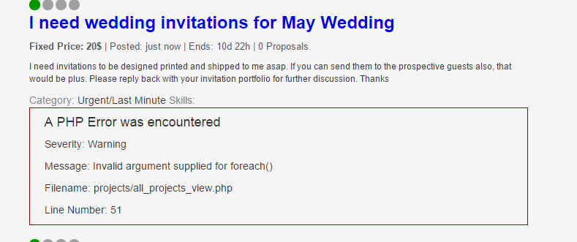

20. Help button.

I will need your team to do this. It has to be explained how this works for freelancers and for clients.

21. Still need logo updated and favicon per last doc I sent to you.

22. Not Working



23. Not Working



24. Please change to US Format for Date and Time



25. Proposals

The current Proposal setup is non-descriptive. It should be more like what I provided in original doc

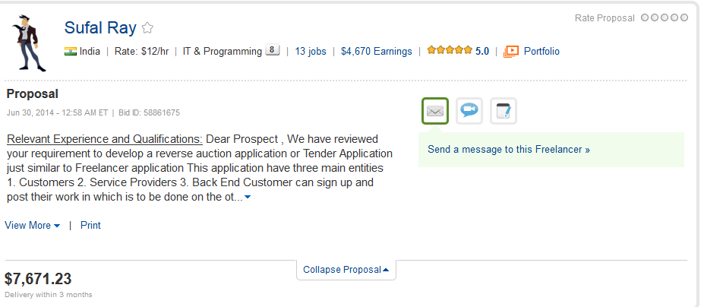

* As this one shows the LOGO, Name of the company,
* Location
* Rate
* What they specialize in.
* How many jobs they have completed
* Rating
* Portfolio
* Earnings (not too much worried about)
* Full Proposal.
* Approach to the job
* You are also able to message them from the actual proposal.

26. Positioning

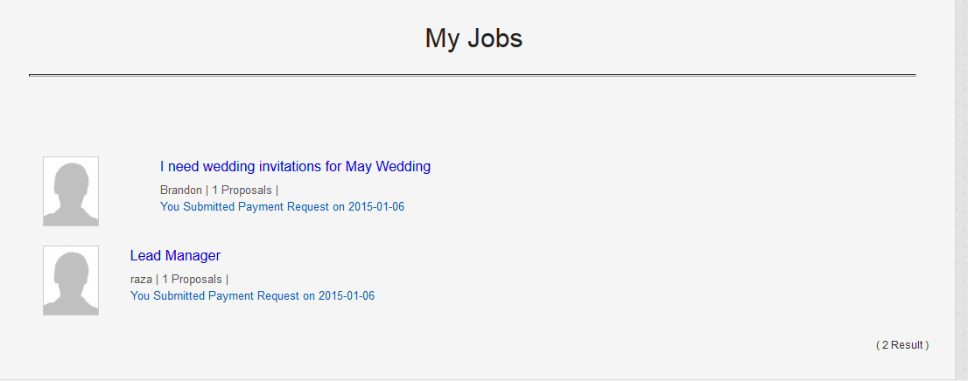

27. Someone should be able to request specific skills even if they don’t see it in the group. Example, a user should be able to enter “Dancer” for example and save that specific skill they are looking for. So if another user went to search, and they typed in “dancer” that job would come up.

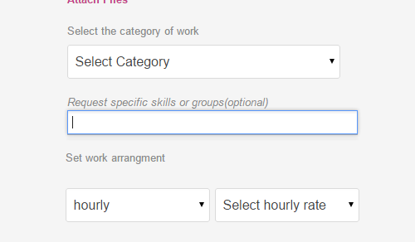

28. Need to show, how much they charge per hour, also needs to show reviews

